UNIVERSITY OF COLORADO BOULDER
Team Project 2 Report
MCEN 5151-001

Ibrahim Alhajji
11/12/2018

This purpose of this report is to provide a thorough explanation of the fourth assignment and first group project (Team Project 2). The intent of this experiment is to generate a steam using dry ice and a fan. The intention was to induce vortex and a steam suction mechanism. Then, capturing the steam that coming up. Also, adding a green laser to add a color and to enhance the visualities of the steam. To execute this experiment perfectly, our team collaborated to obtain the best results. I would like to thank Eli Kopp-Devol, Hana Kieger and Chet Roe.
The set up for this experiment is as follows:
- A plastic bowl a plastic bowl, with a matte white interior surface, was placed on a flat surface.
- This bowl was then filled with water and two medium sized chunks of dry ice were dropped in.
- A small window fan was held roughly a foot above the bowl (pointed upwards) and turned on to cause air currents to begin to flow from around the bowl, up through the fan.
- A laser pointer was then rapidly shook up and down creating a laser sheet.
The diagram below shows the set up.
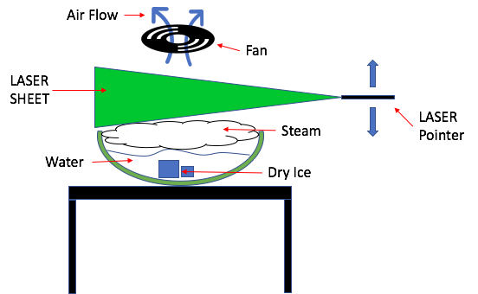
Figure 1: Experiment setup “made by Eli Kopp-Devoi”
To obtain the colored fog, we used dry ice, green laser, and a fan. We put the dry ice in a bow and we poured room-temperature water on it to generate more steam. Then, we positioned the fan on top of the bowl to create a vortex (shown in the diagram above). We used the green laser to make the steam more visual. We kept shaking the laser left and right to cover more area of the steam. We had the entire setup in a dark room. Also, we did not use any light other than the light produced by the laser. A Nikon D80 camera was used to capture the photos. The flash light on the camera was turned off.
To take the picture, we used a NIKON D80 camera. The focal length was 40 mm on the camera and it took the image in 3872 pixels width and 2592 pixels height. the camera was set 18 cm away from the object. This picture was taken using the following specs: Exposure time: 1/15 sec, ISO speed: 800, Aperture: f/10.
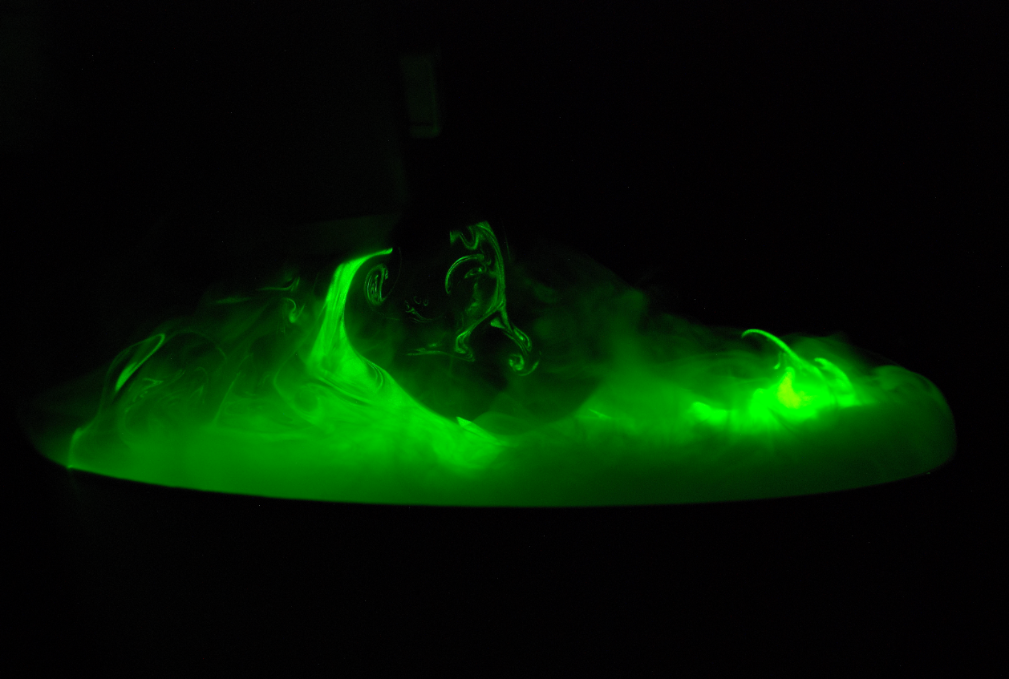
Figure 2: Team project 2 raw picture
Windows Photo application was used to crop the images and enhance the colors and contrast. Below are the images after manipulations.
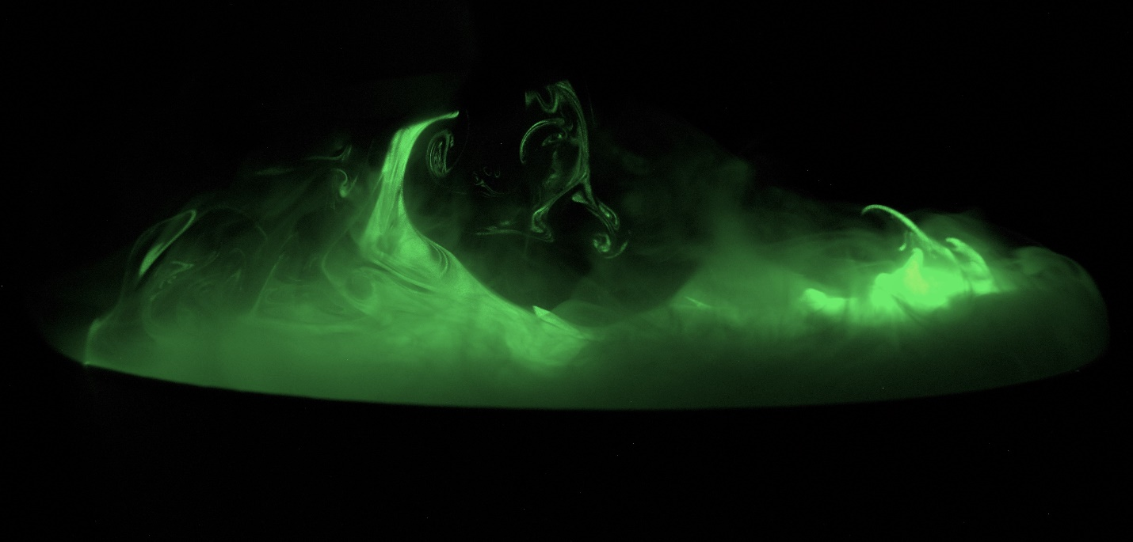
Figure 3: Team project 2 picture after manipulation

