Second Cloud Photo
Greg Collins

This photo was taken 9/4/2018, in my back yard, at 6:41 PM. I believe the cloud was a stratocumulus. I say this because of its size and its height of about 4-6 km. The Skew-T shows that that atmosphere was unstable with a CAPE of 80.
The photo was taken with a Samsung 7 smartphone. The focal length is a 4 mm with a f-stop of 1.7. The shutter speed was 1/281 sec with an iso of 40. Photos are natively taken in jpg form. I think the over all image came out great. It would have been better if the photo was not compressed so didn’t lose extra detail.
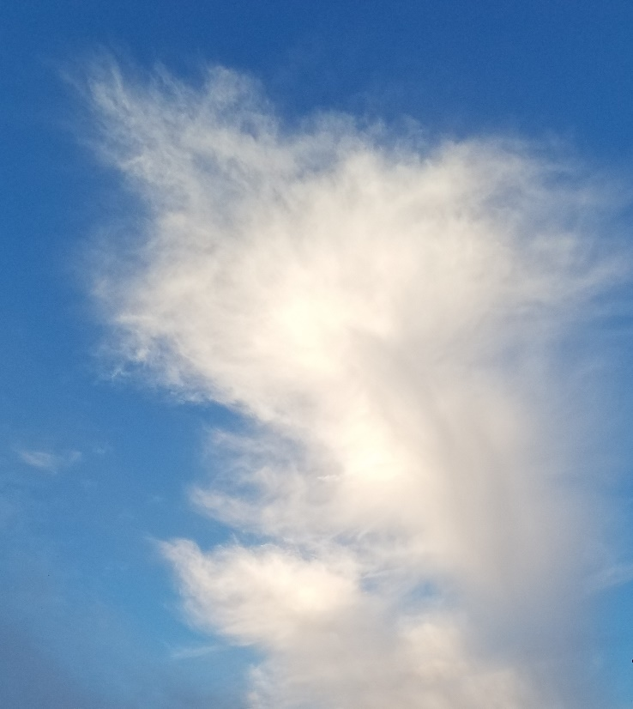
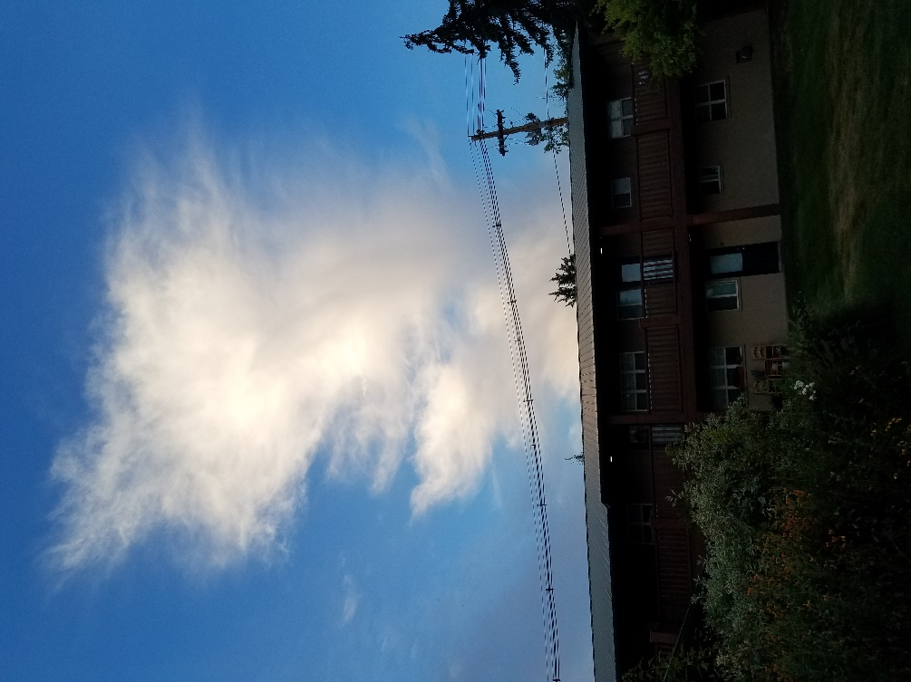
The image itself was cropped and a power cable was removed from the photo with the heal tool in GIMP. A light adjustment to the color curve was used to bright the light spots and darken the contours. This I believed gave better contrast to the details of the cloud. If I was to take this photo again, I wish I zoomed in farther to the focus of the image so there was not so much wasted resolution on things I didn’t care about. This would also allow for a larger image which would be more impactful.
