Cloud First
By: Sam Brown

For this assignment my goal was to capture a cloud formation in a unique way. This was more difficult than I had initially thought due to the simple fact that people see clouds every day. This makes it difficult to capture something interesting. On a scorching day I decided to capture a time lapse of one spot in the sky. This particular day was very hot making the cloud fluctuate in size. The air was extremely stagnate which made capturing this formation easier. With these conditions I was able to capture the shape change of a cloud formation over a long period of time.
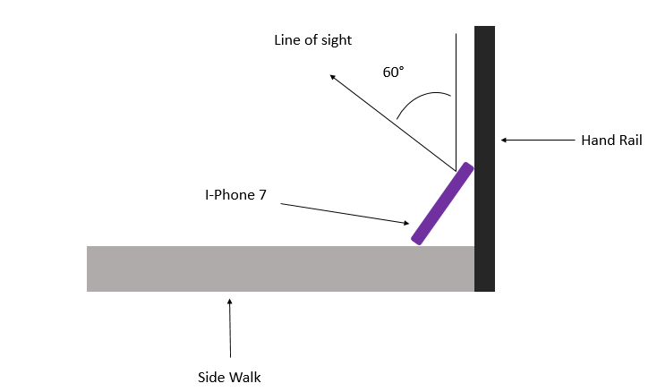
The time lapse was taken on September 2nd, 2019 at 4:05 PM in Littleton Colorado. This September day was producing temperatures upwards of 90 degrees. Because this day was so unbearably hot the clouds in the sky were very interesting. As you can see in the scew-T diagram [1] there was very low winds. This made capturing the cumulus cloud over a period of 36minutes very achievable. The cloud in this video is around 2,000 feet in elevation. I was able to capture this image using an I-Phone 7 set up as depicted in Figure(1).
Figure 1: The above image depicts the set up that was utilized to capture the 36 minute long time lapse. The hand rail provided a steady structure that was utilized similar to a tripod.

Because of the rather fluffy shape of the cloud and the fact that it looks relatively low to the ground, I believe this cloud formation is a cumulus cloud. Cumulus clouds are fluffy clouds with a flat bottom. These clouds float about anywhere from 2,000 – 7,000 feet. In the time-lapse the cloud appears to be as low as 2,000 ft. in the air. After analyzing the scew-T diagram for September 2nd, [1] it is easy to see why I had such good results in capturing a single cloud formation over a long period of time without having it float off screen. At 2,000 ft there almost no wind. Along with this the atmosphere was stable. This agrees closely with what the video depicts.
The photographic technique used to capture this atmospheric phenomena was simply capturing a video of the phenomena. This video captured an image every 2 seconds for 36 minutes. In post processing this video was slowed down again by a factor of 2. This allows for the appearance that the cloud formation is changing rapidly. In reality the cloud formation looked perfectly still to the naked eye. Because I used an I-Phone 7, I had little variability in choosing the exposure or focal length of the lens. I did, however, have control of the time lapse capture speed. As stated earlier I chose to capture an image every 2 seconds and then slow it down again by a factor of 2 making the capture rate every 4seconds. I think anymore slow down would hinder the subtle effects present.
This video accomplishes what I set out to accomplish. I think that capturing an interesting view on something people see daily can be difficult. Despite this I think that I created a very effective demonstration of how a cumulus cloud behaves in an almost zero wind environment that is at high temperatures. Without taking a time lapse of this cloud formation it appears the clouds are not doing anything interesting, when in reality there is very dynamic motion taking place very slowly. Overall I am very happy with this image.

References:
[1] Scew-T Diagram, September 2nd, 2019
