Vortex smoke rings in Air

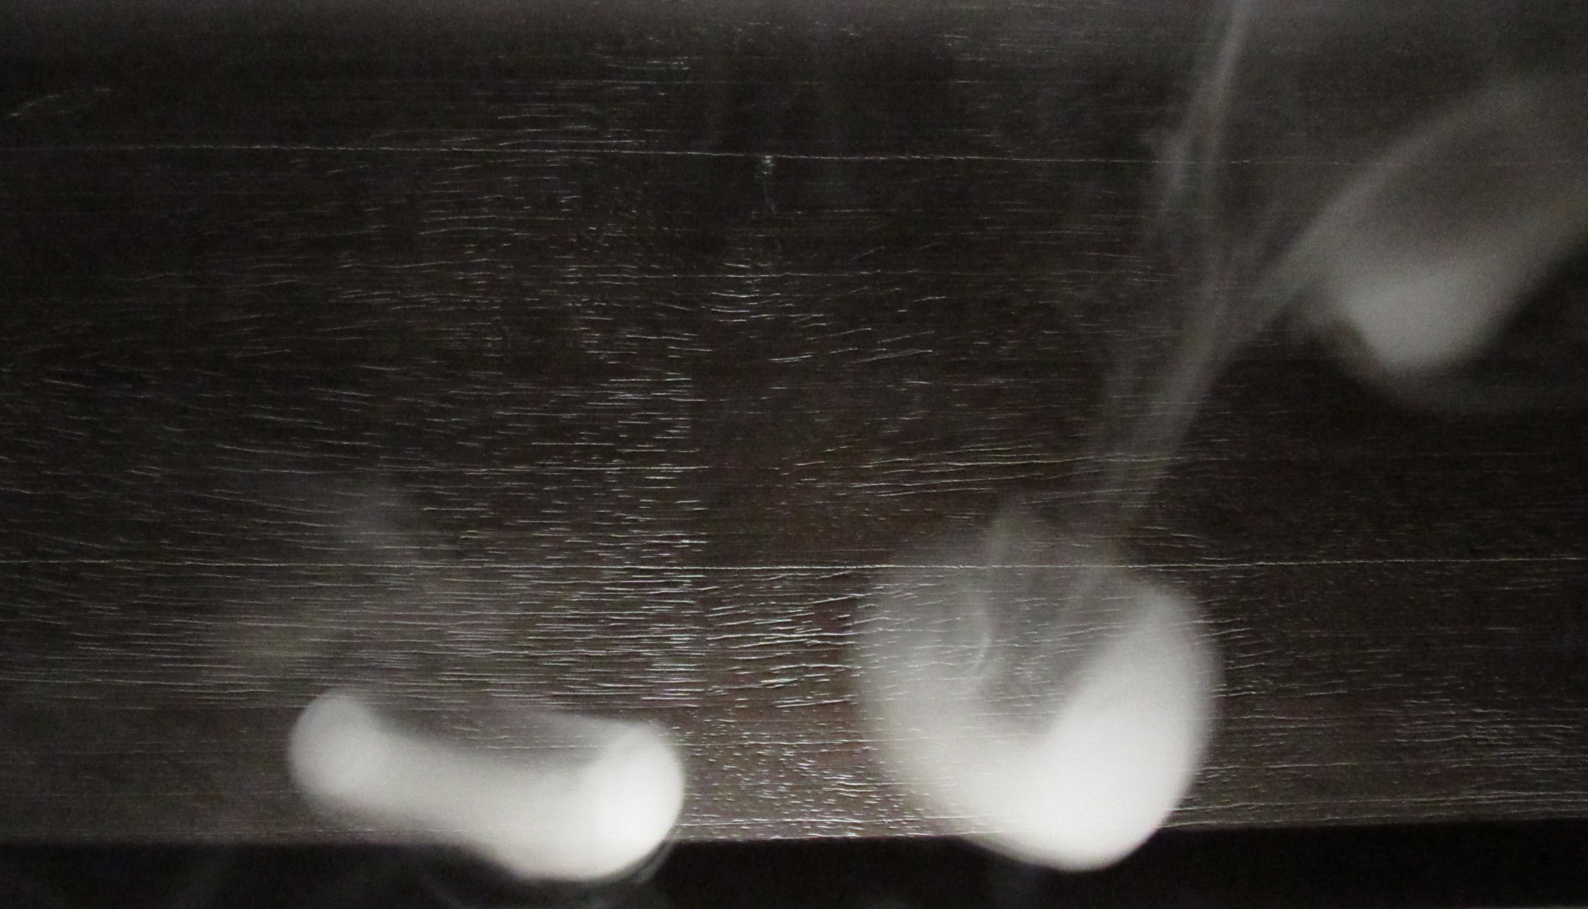

Faisal Alsumairi
Get Wet 2019
Flow Visualization
10/2/2019
Title Information: An actual title is optional, but you must include your name, assignment, course section that you are registered in, and the date of report. Also include the names of everybody who helped you get the shot. Do not include your MEID or any other student ID name or code (this report will be published).

Introduction:
Experiments are fun to make, but with a clear goal towards that experiment, I had a meaningful experience that I learned a lot from and want to share with others. I attempt to create a vortex smoke rings to explore how would the flow can be visualized.

What phenomena?
False starts:
Read by strangers
Acknowledge teammate who helped; what they did?

Par 2:
Par 3:
Par 4:

First Paragraph: Give the context and purpose for the image. For example, second project, group working on flume. Describe the intent of the image, what phenomenon you were trying to see. OK to mention false starts here, but the rest of the report should only deal with the final image. Assume the report will be read by strangers who know nothing of the course. Be sure to explicitly acknowledge any teammates who helped you get the shot, and what they did.
Second Paragraph (or more): Describe flow apparatus used in the image, and refer to a sketch. Engineering students should do the sketch in Powerpoint, Sketchup, or equivalent. Describe the basic flow, i.e. flow over a submerged obstacle, flame impinging on an orange, turbulent boundary layer on a wing, etc. Give size or scale of object, width of channel, etc. Then discuss the flow itself. Expectations for flow discussion vary with student category. All students should think in terms of forces acting on the fluid: why does it look like that? If it is changing with time, why? What forces are making it move? Arts students are expected to describe what they did in enough detail that somebody else could repeat it for a similar result. Engineering students should estimate appropriate nondimensional scales: Reynolds number, Grashof number, etc., as well as the required time and spatial resolution based on flow speed and field of view. Include the symbolic calculation as well as the numbers and units you used. For example (in water):

where the velocity scale was chosen because…. etc.” Please use proper significant figures in the result. Be sure to describe what the scale means in this context. For example, “The Reynolds number was 1500, which means the flow was transitional, and might have been laminar or turbulent. Here we can see large vortexes but no smaller scales suggesting the flow is still laminar….” Engineering students should research the phenomenon at least at the web level. Graduate ME students are expected to discuss additional context for the flow physics and give at least two references to the archival (refereed) technical literature. Finding a fluid property in a textbook is not a sufficient investigation of the physics in the literature. All students should think in terms of forces acting on the fluid: why does it look like that? If it is changing with time, why? What forces are making it move? Any information about the flow that you get from publications or the web needs to be properly cited. See the examples at the end of this document, and Allen (2000).
Third Paragraph: Describe the visualization technique used: Dye, smoke etc. Specify details such as exact source of materials, manufacturer, and any relevant environmental conditions. Give dilutions if appropriate. In second part of paragraph, describe the lighting used: flash on camera, bright sunshine, flame emission, etc. Again, the minimum goal is to provide enough information for the image to be repeated.
Fourth Paragraph: Describe the photographic technique, and why you made the choices you did.
• Size of the field of view
• Distance from object to lens
• Lens focal length and other lens specs.
• Type of camera: film or digital, including original and final image width and height in pixels, then give make and model.
• Exposure specs: Aperture, shutter speed, and ISO setting
• Photoshop or Final Cut processing. Describe manipulations, settings. If used, provide a “before” image too.
Most digital cameras automatically record the exposure and lens specs in the image file as ‘metadata’. Info can be viewed in file properties or Photoshop: File menu, File Info, Section:EXIF.
Fifth Paragraph: Describe what the image reveals. What do you like and dislike about the image? How well are fluid physics shown? What questions do you have? Did you fulfill your intent? What aspect would you like to improve? What direction could you go in developing this idea further?
File Format: Edit text and images in the image post on flowvis.org; the Classic or Back End editors are recommended, and the editor works better in Chrome than Firefox. If you write your report in Word submit the Word file in Canvas, and include a link to a pdf copy in the post. If you use a different program, submit a .pdf, but it must be less than 2 Mb in size. Complete a self assessment of the image and report, and submit it on Canvas with the report, but in a separate file. Assessment forms can be downloaded from the class website.

Note before submitting:
All work must be submitted in Canvas, and in your image post on flowvis.org. The self-assessment document should be submitted as a separate file on Canvas only. If your report is in the form of text and images in your flowvis.org post, you need only upload a link to the post in Canvas. If your report is in a Word document, submit that in Canvas. Be sure you submit to the report assignment, not to the image assignment. The baseline goal of the report is to provide context for the image, and enough documentation that the image could be re-created. Arts students are expected to meet this goal. Undergraduate engineering students will be expected to write the report in a professional fashion including references, and graduate engineering students are expected to produce a document of publishable quality with archival references. The report is expected to be 1 page in length at a minimum, four pages’ maximum. Use a descriptive narrative, rather than a list of items.

