William Conan McHugh
MCEN 4151 – 001
Team Second Report
11 November 2019

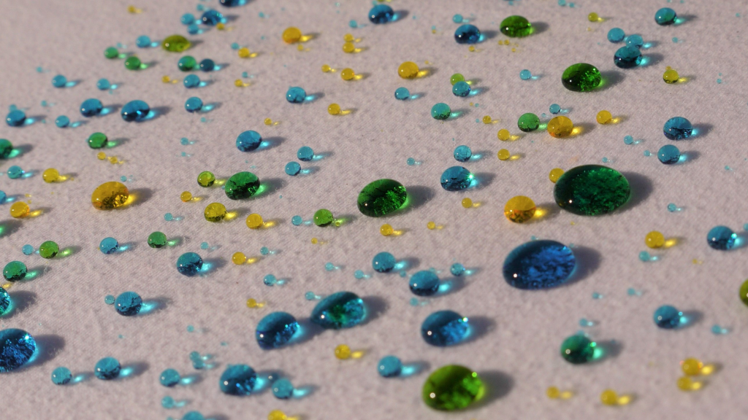
Figure 1: Final image used in post

The purpose of this assignment was for students to take pictures of different types of fluid flow which corresponded to the theme that their team chose. My team chose water as the theme for our images, so I decided to take an image of lots of water droplets with food coloring on a super hydrophobic surface. We decided that using hydrophobic substances would make it easy to see the cohesive nature of water on these surfaces as they bead up. Additionally, we thought that this would be a cool phenomenon to visualize, especially with the food coloring.
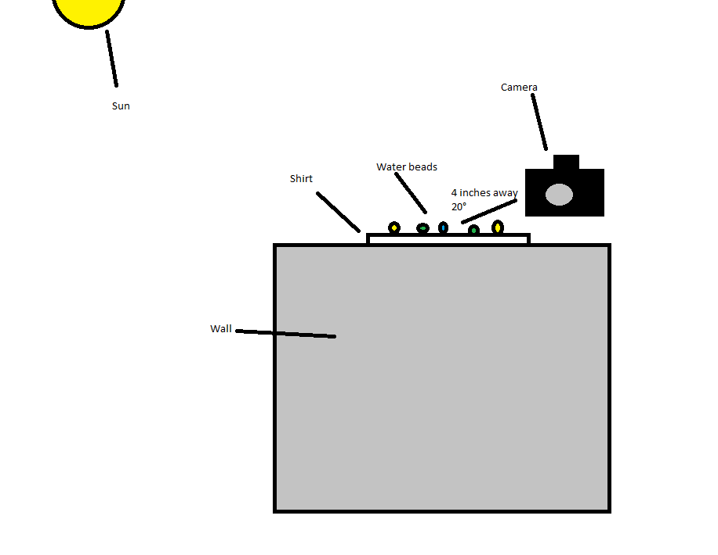
In order to prepare this image, we placed a shirt coated in a super hydrophobic substance on top of a wall outside of the engineering center. We pulled the shirt tight so as to eliminate any wrinkles and isolate the focus on the water beads themselves. Then, we filled a syringe with tap water mixed with food coloring which we used to sprinkle water droplets across the surface of the shirt. We repeated this step for different food colors. The lighting source was completely natural with the shirt being outside and in direct sunlight. From there, I positioned the camera approximately four inches away from the surface of the shirt at an inclination of about twenty degrees.
Figure 2: Setup of experiment
I wanted this image to be very straightforward and focus only on the fluid properties of the water, so I used minimal visualization techniques and editing. The only editing that I actually did was to increase the brightness slightly because my aperture setting was so low when taking the picture. In terms of supplies that were used, we had a regular syringe that can be found at most drug stores, standard food coloring, a plain white t-shirt, and tap water. The camera used was a Panasonic Lumix DMC-GF1 mirrorless camera set on the manual setting with the ISO set to 160, f-stop at f/10, and a shutter speed of 2000.
The thing that I liked most about this image was how the light transmitted through the beads and illuminated the t-shirt. I thought this was very intriguing and the way that the light hits the shirt forms an interesting pattern in that the center of the light is very bright, whereas the edges are darker. I definitely believe that I accomplished my goal of capturing the cohesive force of water because all the beads are very smooth and round, and the very small beads are almost perfect spheres. One thing I would’ve changed is the surface that we sprayed with the hydrophobic substance. The t-shirt worked fine and actually looks good in the image, but it was difficult to try and make it so smooth and eliminate any wrinkles. I think if I had used something more firm it would’ve been easier to setup. One question I have is how do hydrophobic chemicals actually work? What chemicals work to repel water in this manner?

[Image acquired with help from Peter Rosenthal, Mary Rahjes, Jennifer Kracha, and Alejandro Barron Toriello]

