Fluidized Bed
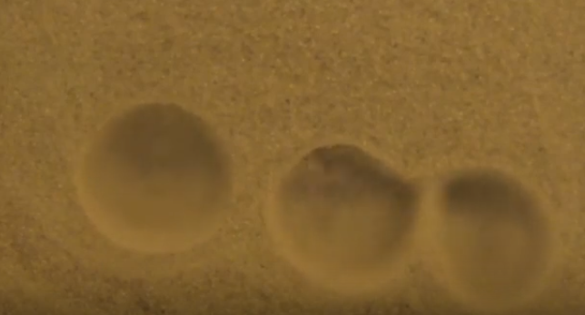
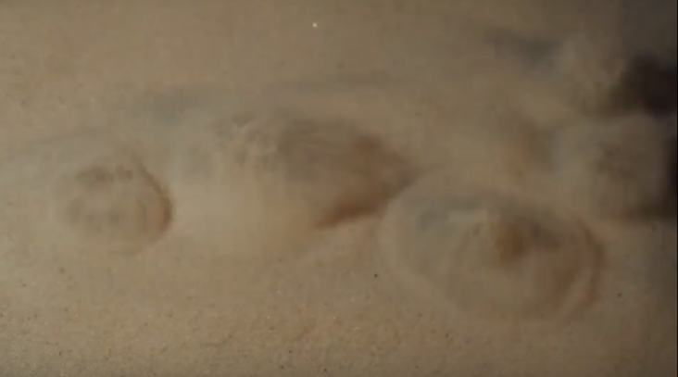
By: Sam Brown

For this experiment our team (Audrey Viland, Faisal Alismail, Dawood Ahmad, Meg Ivy, and I) wanted to capture an exciting fluid phenomenon that happens when one applies highly pressurized air to a mass of small particles such as sand. The idea behind this is that when the air is supplied to the sand, the bed of sand will behave as a liquid. I was intrigued by this idea because intuition suggests that air plus sand does not equal fluid behavior, however this is not the case. What happens instead is sand that looks and feels like a mass of bubbling mud. Interacting with the sand as the air is flowing feels light and very frictionless. Intuition would again suggest that the sensation of the sand would be rather course and uncomfortable, again this is not the case. The governing physics behind a fluidize bed let us know how this phenomenon continues to go against basic intuition.
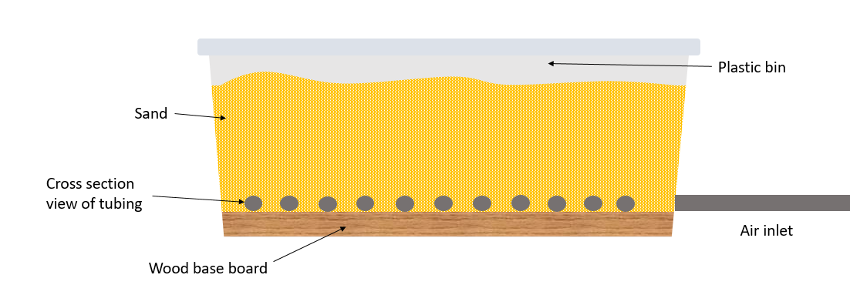
To achieve this phenomenon it is important to understand how the experiment needs to be set up and what variables are at play. In this case we had a few constants; 10 lbs. of fine grit sand, 150 PSI air compressor, ¼ inch diameter flexible tubing, and a 9 X 14 inch plastic bin. The variable at play were; air hole size, air hole spacing, air hole density, sand depth, and inlet air pressure. After fine tuning many different configurations we found the set up described in Figure (1) to be most effective.
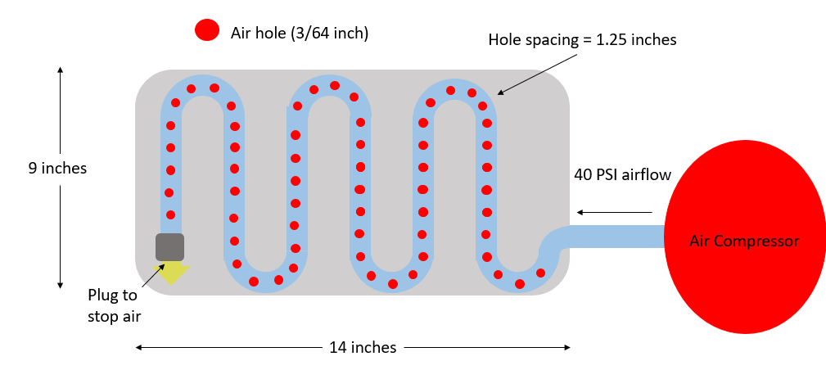
Figure 1: Shown above is the final configuration that allowed us to create liquid sand like characteristics. Here we can see how the tubing was configured underneath the sand.

I found that the more diffused the air coming out of the holes in the tubing was, the better the effect. If the channels were focused too much, the air would blow a straight path out of the sand. This would create a channel of air and not the effect that we desire. To compensate for this I simply laid flat scraps of steel over the holes to disrupt concentrated airstreams. The wood base was utilized as a level platform to mount the tubing onto. If the tubing was not level then the air would favor the high point of the tube. This is because the highest point experiences the least amount of pressure due to the sand, allowing the air an easy way out. This is undesirable because we want consistent airflow through every hole to achieve a uniform fluidized bed. With some trial and error, 40 PSI inlet air pressure resulted in favorable fluidized bed characteristics. To achieve these favorable characteristics, it is important to fully understand what we are trying to achieve. The air from the holes in the tubes need to supply air at a critical velocity to the point when the drag force of a grain of sand and the gravitational forces acting on that grain of sand are equal. This is the critical point when the particles (grains of sand) are suspended within the fluid. If we are to increase the air velocity we get more violent fluid properties and very exciting results.
To capture these exciting results our team thought photographs would not do the phenomenon justice. Because of this, we chose to use video to capture the fluid-like properties of sand. Since we were utilizing a clear plastic bin to house the sand we made use of its see-through walls. We positioned tubing close to the wall of the container to reveal a cross sectional view of the inner workings of the fluid phenomena. This we thought was very effective in showing the inner mechanics of the event.
To capture this video, the team utilized Meg’s Nikon 3300. The ISO setting for this image was set to 359, the aperture was set to f/4.2, and the final video dimensions were 1920 X 1080 pixels. The lighting used in this video was overhead phone lighting as well an incandescent light bulb. The camera was positioned about 6 inches away from the fluid during the cross sectional view and 2 inches away to capture the close up aerial view. In post processing I used IMovie to edit the length of the video as well as add a deeper yellow color to the sand.
I believe this video demonstrates how a fluidized bed behaves. I also think it effectively illustrates the inner mechanics of how the flow beneath the sand develops. I do, however believe that the lighting is very lacking. The lighting of this video doesn’t aid the fluid flow as it should. I also think that the overall video quality is lacking. If I were to repeat this experiment I would want to either make use of a larger air compressor or scale the entire bed down to where a small compressor can fluidize the entire container. I would also enhance the lighting techniques used. I think making use of colored sand to illustrate the flow of the sand, would enhance the aesthetics of the demonstration.

