Cloud Second

By: Sam Brown

For the second cloud assignment I wanted to capture something simple and beautiful. This took some patience to complete because of weather and other circumstances. Last assignment, cloud first, I didn’t have any grounding aspects to the video it was just a shot of the sky. For the second image my main goal was to add a grounding aspect to the image to enhance the aesthetics of the photo more than if it were just of the sky. With the flatirons being close at hand, this was a very achievable goal.

This image was taken on the balcony of the second floor of the ITLL building on the University of Colorado’s campus. This vantage point allowed me to capture a mountain wave cloud above the flatirons. This location also allowed me to capture the silhouette of the engineering center. Both the flatirons and the silhouette of the buildings add to the perspective of the image as well as add a grounding aspect to this image. The image was taken at 12:42 PM on November 12, 2019. November 12th was a fairly cool day at about 55° Fahrenheit with little to no wind. The cloud in this video is around 2,000 feet in elevation. I was able to capture this image using an I-Phone 7 held at 40° above the horizon. This image was captured using a shallow angle to enable me to include both the building as well as the mountains.

The cloud depicted below, seems as though it would be a stratus cumulus cloud due to its fluffy nature and low hanging altitude. However I believe this to be a mountain wave cloud because it is hanging a few hundred feet above the flatirons. Because of this, the cloud is likely to be sitting at roughly 7,000 feet. After analyzing the skew [1], it is easy to understand why the cloud looks this way. At the altitude that this cloud is at there is very little wind but just enough in the North West direction to drag the cloud length wise. This skew-T diagram agrees with the cloud depicted below in **Figure(1).**

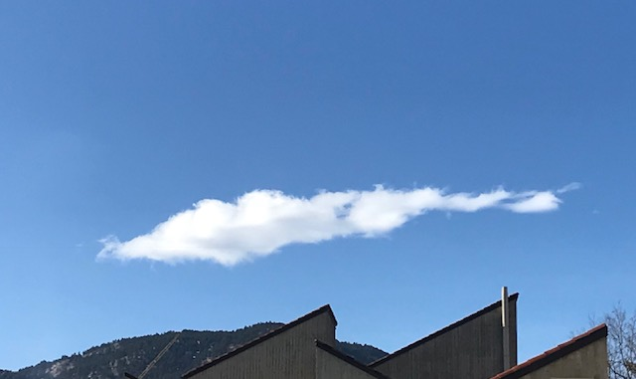

**Figure 1:** Depicted above are the unedited and the edited image, left and right respectively.

The photographic technique used to capture this atmospheric phenomena was simply to utilize my camera phone. This image was captured using an I-Phone 7. Because I was using an I-Phone 7 I had little to no variability when it comes to choosing the exposure or focal length of the lens. In post processing of this image I utilized Darktable to edit the coloration of the image as well as the saturation. Here I tried to make the mountains and building appear as a black silhouette instead of showing all the details of the foreground. This made the foreground less distracting to the cloud itself.

This photo accomplishes what I set out to accomplish. I think that capturing a beautiful perspective on scenes people see every day can be challenging. Despite this I think I created a beautiful image of a mountain wave cloud with a lovely silhouetted foreground. Overall I am very pleased with this image.

**References:**

**[1] Skew-T Diagram, November 12th, 2019 , University of Wyoming.**

