William Conan McHugh
MCEN 4151 – 001
Clouds Second Report
4 DEC 2019

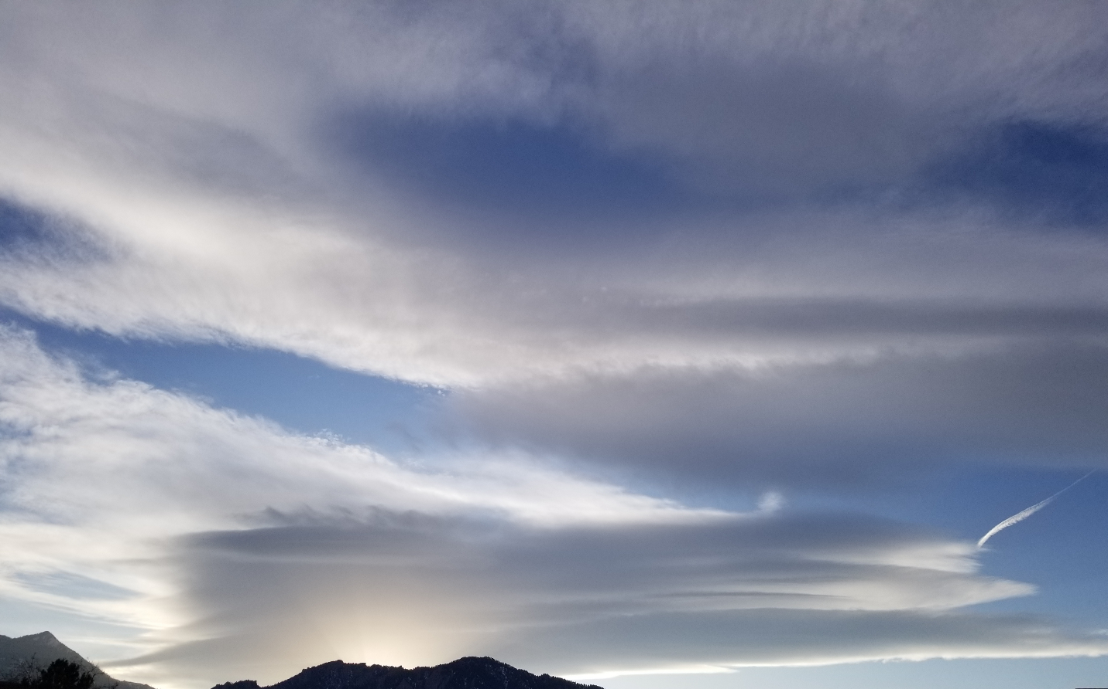
Figure 1: Final image used in post
The purpose of this assignment was for students to take pictures of clouds and describe what type it is and the conditions which led to the cloud’s formation. The clouds in my image were altocumulus lenticularis clouds over the Flatirons at 3:57 PM on 14 November, 2019. The intent of this photo was mostly scientific with a hint of artistic goals; I wanted to capture a cloud that I would be able to describe based off of atmospheric conditions at my specific location, but also looked cool and interesting.
The image was taken using a Samsung Galaxy S8 in pro mode, and the camera settings were as follows: ISO – 50, aperture – F1.7, shutter speed – 3232, focal length – 4.25 mm. There was no setup for this image; I simply framed the image such that no distracting elements were detracting from the clouds themselves. The lighting used was only the light from the sun and, since it was a natural photo of a cloud 21,000 feet away, there was no need or way for me to adjust the fluid phenomenon. Furthermore, because the cloud was so far away at the moment the image was taken and the shutter speed was so high, the cloud travelled a minimal distance in the image. This means that the image itself is as time resolved as it could possibly be given the limitations of the technology used in capturing the cloud.
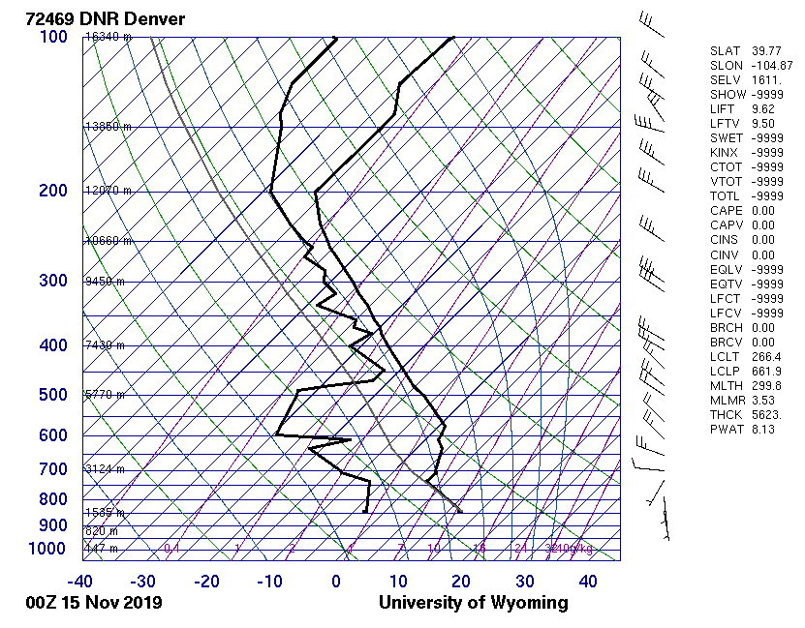
Figure 2: Skew-T plot of atmospheric conditions at time and location of image ^{[1]}
As we can see, the clouds were located at approximately 6500 meters and 8000 meters and the CAPE value was 0.00, which means that the clouds in the image were altocumulus clouds within a stable atmosphere. Additionally, the location of the clouds directly above the mountains make them lenticularis clouds, or mountain wave clouds. Furthermore, we can see that the wind speed was higher a few hundred meters above the clouds location, which could explain why the upper clouds look wispier than the clouds closer to the mountain.
In terms of visualization techniques used, I wanted this to be a relatively simple photo, so all I did was go outside and take a picture of a cloud. I did very minimal editing by just cropping out a building so that the image would be as natural as possible. I like how the image turned out, and my favorite part of it is how the light from the sun hits the clouds and creates lots of different shades. The interaction between the light and the clouds make the clouds look magnificent. I definitely believe that I accomplished my goal of capturing a natural and cool photo. There isn’t anything I would consider changing if I were to take this picture again, except for maybe try to capture the clouds slightly earlier during sunset to see a greater amount of light reflecting off of them.

References
[1] University of Wyoming. (n.d.). Atmospheric Soundings. Retrieved November, 14 2019, from http://weather.uwyo.edu/upperair/sounding.html.

