Oil in Water
By: Sam Brown

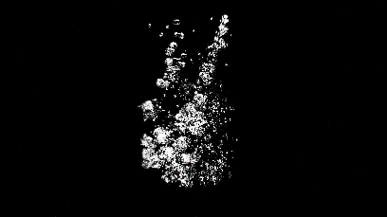
In past team assignments, we have focused on the scientific aspect more so than the aesthetic aspect. This lead to less aesthetically pleasing images as they could have been. Because of this, as a team (Audrey Viland, Faisal Alismail, Dawood Ahmad, Meg Ivy, and I), we wanted to create a simple experiment that we felt confident we could make beautiful. This led us to using oil and water. Squirting oil in water is very simple to do allowing us to focus most of our energy at creating an effective image.
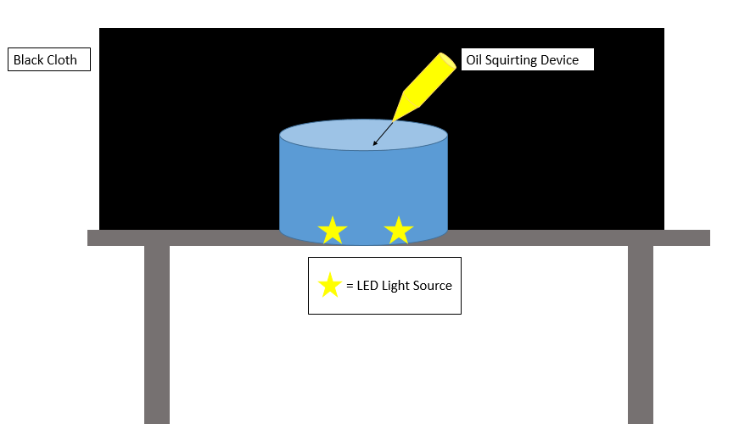
To create a set up that would best allow us to achieve our goals the following setup was used in figure (1).
Figure 1: The above image shows the view of the camera looking at the experiment.
As depicted above the experiment was very simple. It consists of a black cloth used to create a uniform background, a container of water, two LED light sources, and a squirt bottle filled with vegetable oil. The two LED light sources were simply two IPhone flashlights that illuminated our experiment. The phenomenon shown in this experiment is an example of Rayleigh-Taylor instability. This occurs due to two fluids of differing densities interacting. Usually it is caused by the less dense fluid supporting the more dense fluid. This density imbalance causes the more dense fluid to move towards equilibrium. In this case we have a less dense fluid (the vegetable) being forced downward, by the squirt bottle, into the more dense fluid (the water). As the oil is forced down there is a point in which the forces downward become equal to the buoyancy forces the oil experiences. At this point the oil stops moving. This moment creates a great opening for an image because for an instant the bubbles are very still in equilibrium. This was the moment in which the final image was taken at.
The visualization technique that was used for the creation of this image was to use the two LED light sources to illuminate the bubble and just the bubbles. Applying lighting in this fashion allowed us to make the image appear as though the oil is stagnate in a black void. If we were to have applied light in a different manner, we would risk making the water and glass visible. If we were to do this experiment over again, I think it would help to use a brighter, more diffuse light source. The phone LEDs still allowed for us to effectively capture what we set out to capture, however a more diffuse light source would have been better.
The camera used to capture this image was an ILCE-7RM2. The ISO setting that was used for this image was set to 65,535. The F-stop was set to$\frac{F}{4}$. The shutter speed was set to 1/4000 (sec. The bubbles of oil in this image moved very quickly. Because of this we set our shutter speed as high as we could without compromising light intake. In this case we could have made use of a quick flash to give the needed amount of light. This would have allowed us to capture a clearer image. The final image is pretty heavily edited. The first thing that was done was apply a grayscale to the image to create a black and white image. Then I made the black blacker by adjusting the contrast. Next to emit the glass and blurry and distorted bubbles, I used to clone tool to black out the blemishes. In doing these edits I created a very simplistic image. It was hard to tell when to stop editing so I chose a place where I thought represented my goals best.
My goal with this image was to create something very beautiful out of something simple. I believe I have achieved this goal. In the future I would like to make use of a brighter more diffuse source of light and or a flash to help capture a clearer image. Overall I think this image represents beauty in simplicity.

