John Shanley
Image-Video 1
MCEN 4151

In this photo the goal was to display the phenomenon of elliptical axis switching. This was achieved by capturing a still image of coffee pouring out of a coffee pot into a cup located 8” below the pot and the stream. To recreate this experiment one could use a fluid with a relatively low viscosity and pour the liquid from a height into a receptacle below the stream and capture the stream shortly after leaving the initial container.

In this photo the phenomenon of elliptical axis switching can be viewed as the fluid begins to stabilize near the bottom. The liquid jet being viewed is Sam’s Club brand coffee being poured out of a coffee pot being illuminated by ambient lighting in the room and an additional light from the left side of the picture. A black background was used to illuminate the coffee and faces of the ellipses faces as the light reflected off of them as they oscillated between orientations of the plane in which they formed. The length between oscillations, as seen in Image 1, can vary with different fluids of varying surface tensions. As the surface tension decreases the distance to complete a full oscillation will increase linearly¹. Fluids with higher Reynolds numbers would be expected to have longer oscillations as well due primarily to them having lower kinematic viscosities, in this example the Reynolds number would be estimated to be around 800 due to it not being entirely laminar.

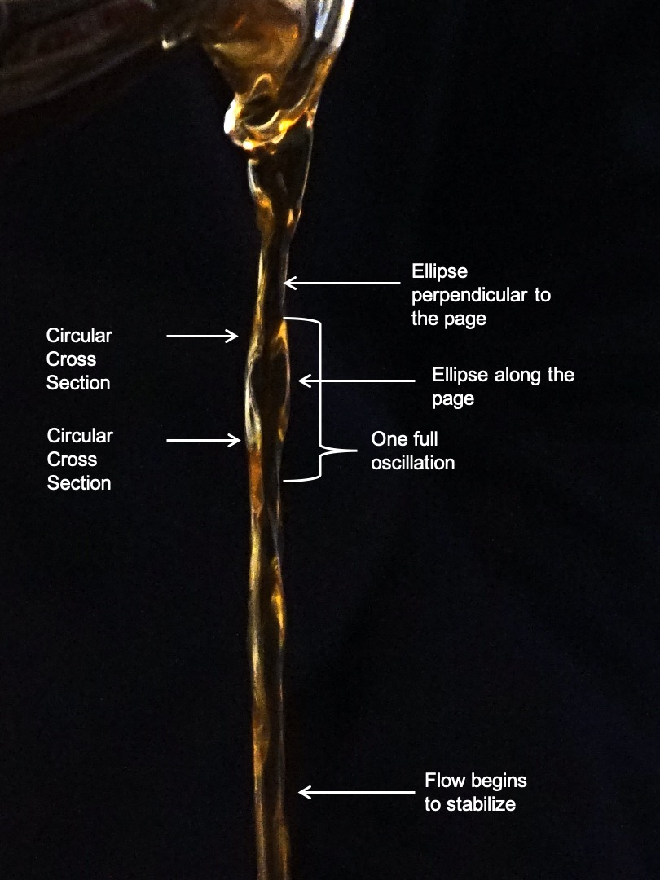
Image 1: Here the flow can be viewed depicting different aspects of the elliptical axis switching.
For this visualization Sam’s Club brand coffee was brewed in a Mr. Coffee and then collected into the coffee pot. Using the ambient light in the room and a standard flashlight I was able to illuminate the plane that is perpendicular to the page allowing the light to reflect off of the oscillations that were facing that direction. I placed a cup below the pot and poured the coffee out of the pot into the cup from a height of 8”. For the background I used a single tone navy blue hoodie. I chose a dark color so that where the light was reflecting wouldn’t be lost in against a lighter background.

To capture this visualization I used a Sony ILCE-6300 with a focal length of 18mm with 1/80th sec exposure time on manual focus. I found that when attempting to capture flowing in auto focus that certain areas in the flow would be in crisp detail whereas the rest of the flow would be more blurry. I chose to sacrifice high definition detail of areas for a little less focus but capturing the entire flow much better. The flow was 3 feet from the lens captured 4000x6000 pixels. In darktable I increased the saturation to create a black background from the original navy blue which also enhanced the browns of the coffee. Other than altering the saturation I changed very little about this photo.

As a novice photographer I was very satisfied with this photo. I enjoy how it’s a very simple image that still is able to capture the elliptical axis switching. In the future I would like to find a way to expand the auto focus so that I can produce a higher resolution image. An interesting direction to take this photo would be to add an oil to see what it looks like when two liquids of varying surface tensions are poured out at the same time to see if there is any difference in the length of the oscillation.

1. Rajesh, K.R., and R. Sakthikumar. ILASS-Asia, 2016, Effect of Liquid Properties on the Oscillation of Elliptical Liquid Jets.

