John Shanley
Cloud 1
MCEN 4151
Date and Time of Photo: 1800 Oct 1, 2020
Cloud Type(s): Cirrus and Cumulus
Location: Looking West ~300ft below the summit of Mt. Antero

This photo was taken after a long day of 4 wheeling with my friends on a 4x4 access trail that took us near the summit of Mt. Antero. We had initially planned to be on the summit much earlier in the day due to concerns of afternoon thunderstorms. However we succumbed to the snooze bar a few too many times and our drive from Aspen and over Independence pass to Buena Vista took a longer than anticipated. We ended up reaching the head of the trail around 2pm. Fortunately it appeared that afternoon storms were not likely to roll in so we continued on keeping an eye on the forming weather. When we reached the top a few clouds, which can be seen in this photo, had begun to form. I took this photo with the camera on my iPhone8 with the intent of capturing the sunset and the forming clouds and the effect of the wind on them. I took this photo initially to capture the view for my own personal memories, but I thought that this photo would fit the criteria of this assignment very well. Because I took this photo just for the sake of memories, this was one a few photos that I took and this was the only attempt that I made to capture this phenomenon.
As previously stated I took this photo on the summit of Mt. Antero on October 1, 2020. The 4x4 access trail that we took ended about 300ft shy of the summit which my friend and I quickly scrambled up. That would put the elevation of this photo at 14,275ft. The photo was taken facing the west, in the evening at 6pm as the sun had begun to set at roughly 10º above the horizontal.
As the temperature began to cool off cumulus clouds and cirrus clouds began to form and can be seen in Image 1. At the time and throughout the night as we drove home the atmosphere appeared to be stable which was confirmed and supported by the Skew-T plot in Image 2. It didn’t appear that a front was approaching and that these clouds were likely a result of afternoon down sloping valley winds that are usually caused by latent heat from the ground condensing at cooler higher altitudes. The peak of the mountain was no windier than any other 14er summit but it appeared that the winds aloft at the higher elevations were moving quicker which could be noticed in the cirrus cloud movements. The cumulus clouds appeared to forming roughly 1000ft overhead and judging by the Skew-T in Image 2 that would be a fair assessment putting the cloud elevation around 15,00ft. The cirrus clouds were much higher and it appeared which would put them around 20,000ft. Another bonus phenomenon that this photo was able to capture were the presence of crepuscular rays, sunlight breaking through the clouds in a beam style shape.
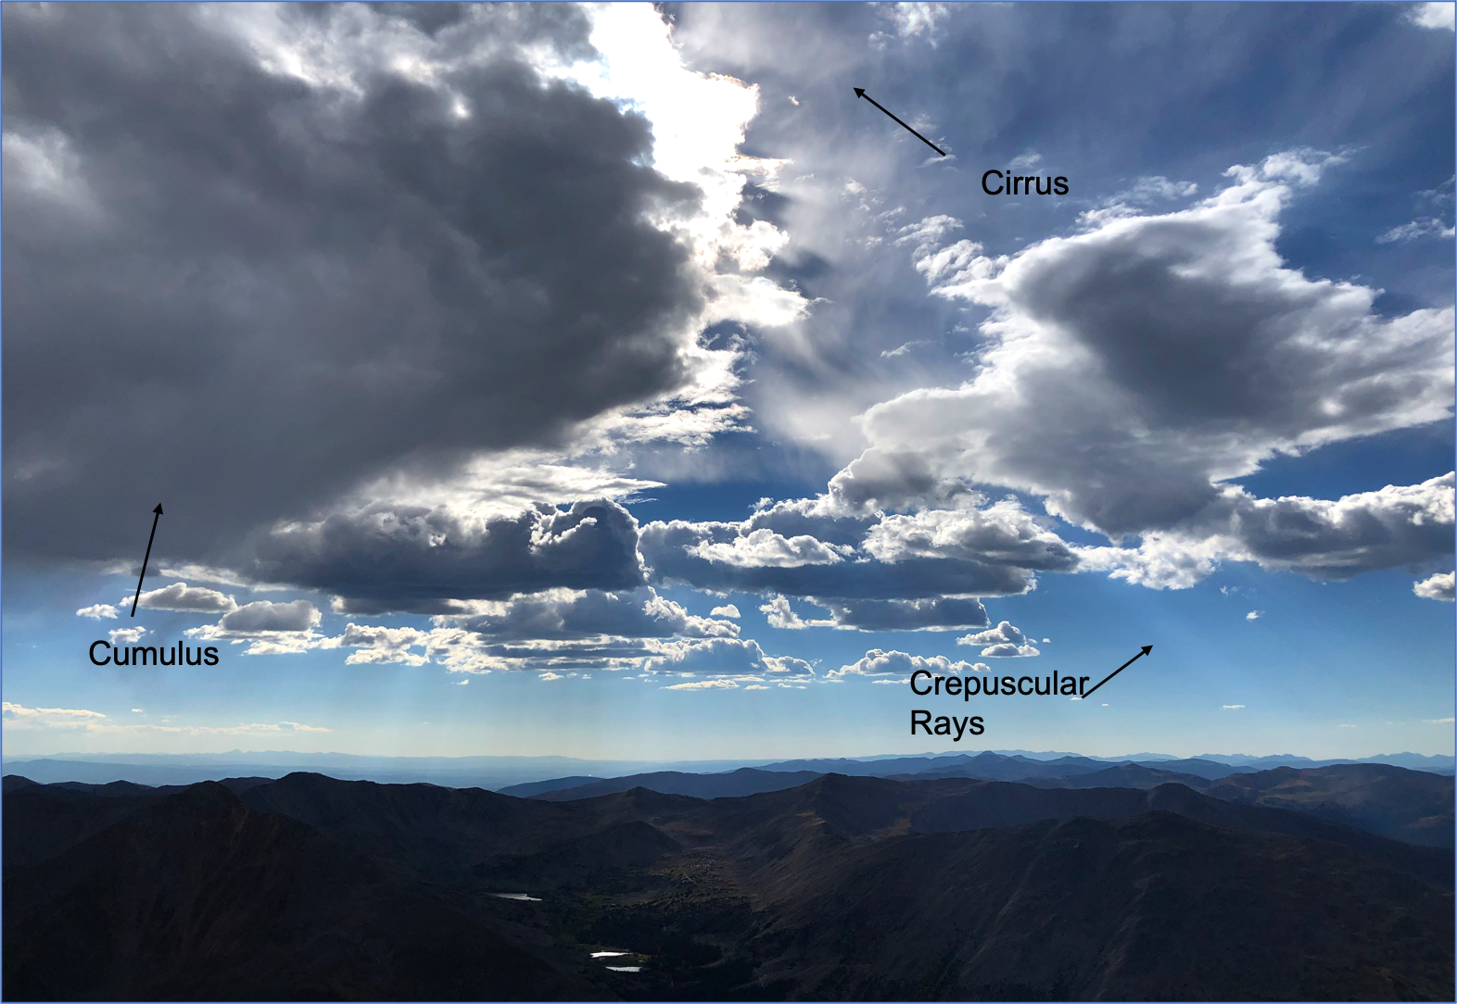
Image 1: Here cumulus and cirrus clouds can be seen along with crepuscular rays
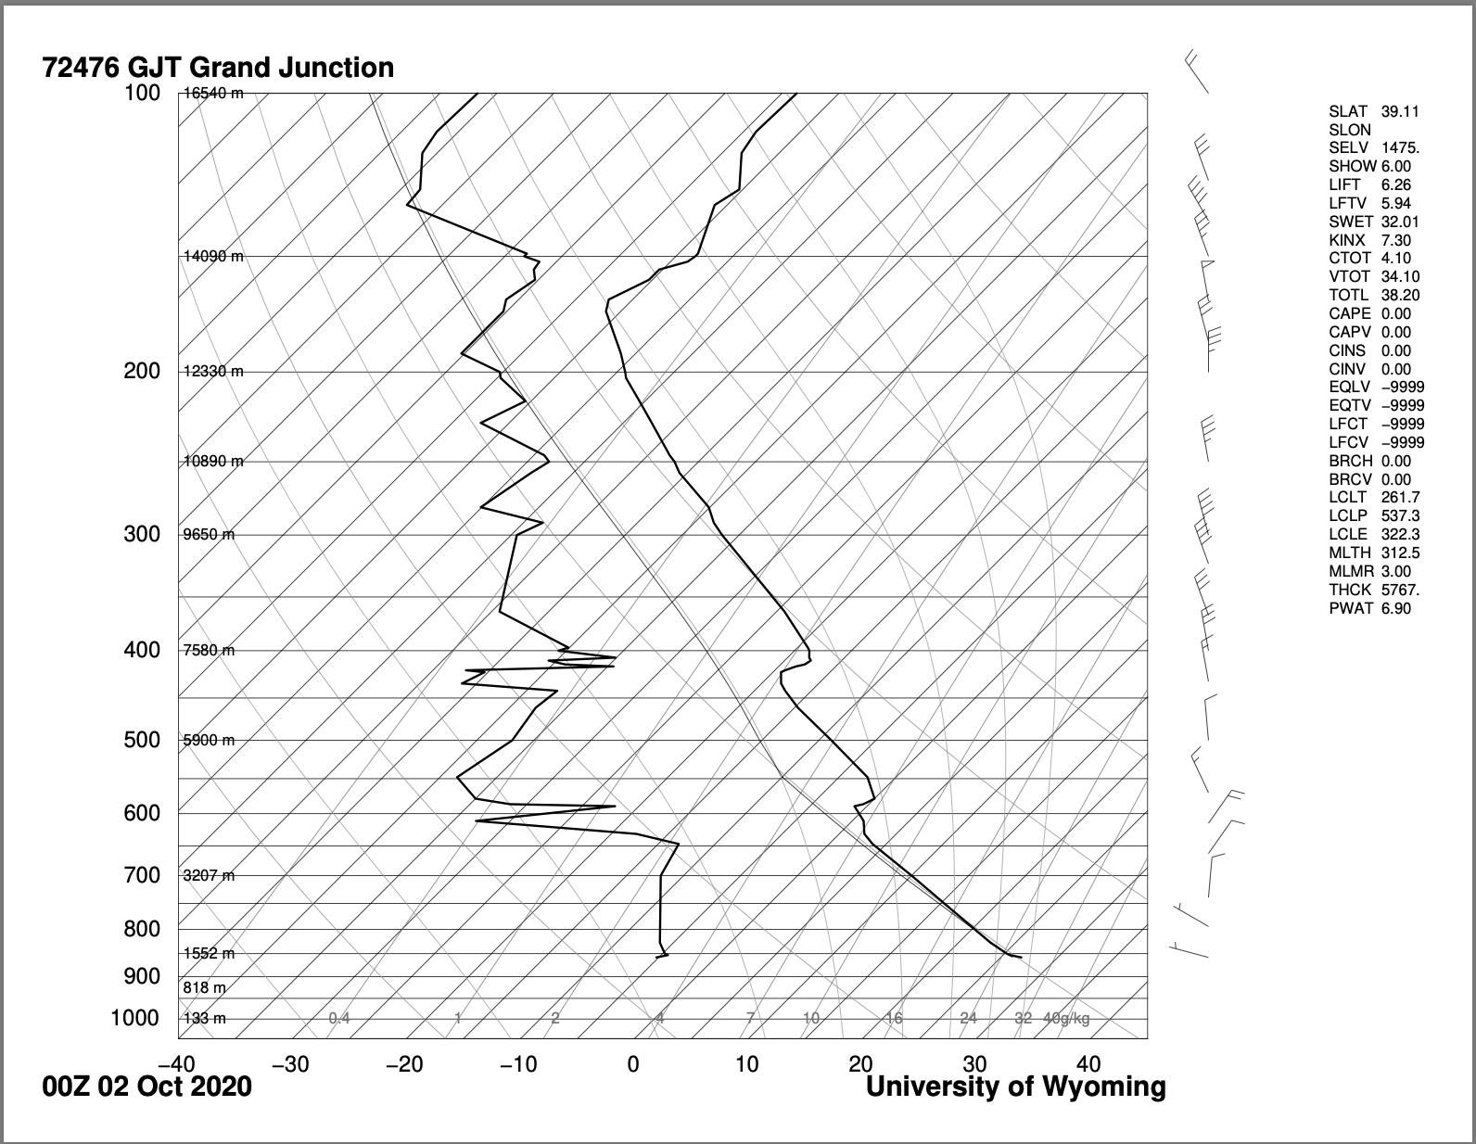
Image 2: A skew-T diagram from Grand Junction recorded at 6PM MST
For this visualization I quickly took this photo on my iPhone8 camera just for the sake of having it with no real focus on my choice specs with most of them being automated. With the camera on my iPhone8 the focal length was 3.99mm, with an F number of 1.8 and an exposure of 1/6,944 seconds, capturing the photo 4032x3024 pixels. I would estimate the distance to the cloud to the lens at over a mile for the cumulus clouds and possibly two for the cirrus. I was able to really bring out the clouds and crepuscular rays as can be seen in Image 3 where the original and the edited are next to each other. The I was able to make the mountains a little darker by adjusting the saturation while still capturing the sunlight breaking through the clouds to illuminate the mountain lakes in the foreground.

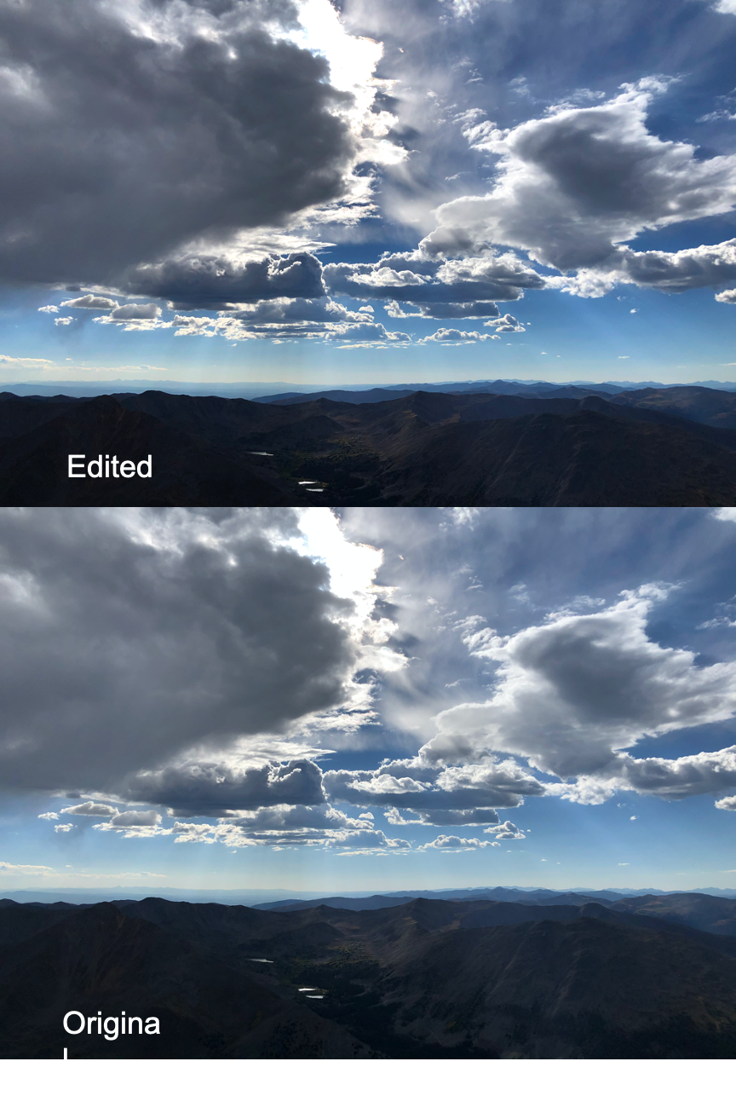
Image 3: A comparison of the edited and original photo

When I took this photo I was really just focused on capturing the initial beauty of the view from atop the mountain and capturing the clouds as they were moving towards us. I like that the photo came from very pure attempt of being something that was just for my personal photo album and through this assignment I was able to enhance it and make it stand out more while bringing out some of the lesser visible details in the clouds.

1. University of Wyoming, http://weather.uwyo.edu/upperair/sounding.html.

