John Shanley
Image-Video 2
MCEN 4151

In this photo my objective was to display the many flows that occur in a turbulent flow of Boulder Creek. In this photo laminar flows can be viewed, eddy currents, sub surface flows and capillary waves. In this photo the most easily viewed are the capillary waves. The photo was taken approximately 3’ off the ground. The exact recreation of this picture would prove to be challenging due to the ever-changing nature of the amount of runoff from day to day and the disturbance of rocks and other debris in the creek.

In this photo the phenomenon of capillary waves can be viewed in the labelled areas of Image 1. This photo was taken in late September under the bridge at 17th Street, where the average flow rate between Eben G Fine Park and The CU Green House was measured to be 24 cubic feet per second (cfs)¹. While many phenomenon are displayed in this photo I chose to focus on the capillary waves. Capillary waves are a result of a wave on a boundary layer of fluid who’s physics are determined by the surface tension and flow rate of the surrounding fluid². In Image 1 a previously laminar flow is intersecting a turbulent flow which is a result of a rapid being formed. This can be seen in the upper right corner, bottom left, and the bottom of the photo slightly right of center. Based upon the presence of air bubbles the Reynolds number in these areas would be assumed to be greater than 4000.

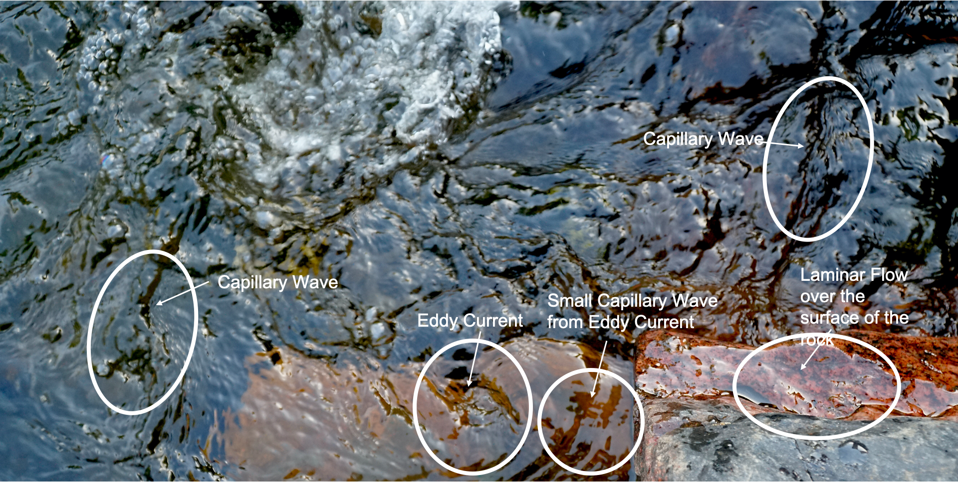
Image 1: Here multiple flows can be viewed in the Boulder Creek under the 17th Street Bridge

For this visualization the Boulder Creek underneath the 17th Street Bridge was photographed. Using the natural shade the bridge provided on a sunny day at 2PM on September 25th I was able to capture a depth within the water that normally would be lost to the glare. The photo was taken while kneeling on a the banks of the creek from a height of about 3’. The recorded flowrate on this day was 24cfs which was a low flow for month¹. I performed some minor enhancements on darktable as can be seen in Image 2, but overall the image is relatively natural.

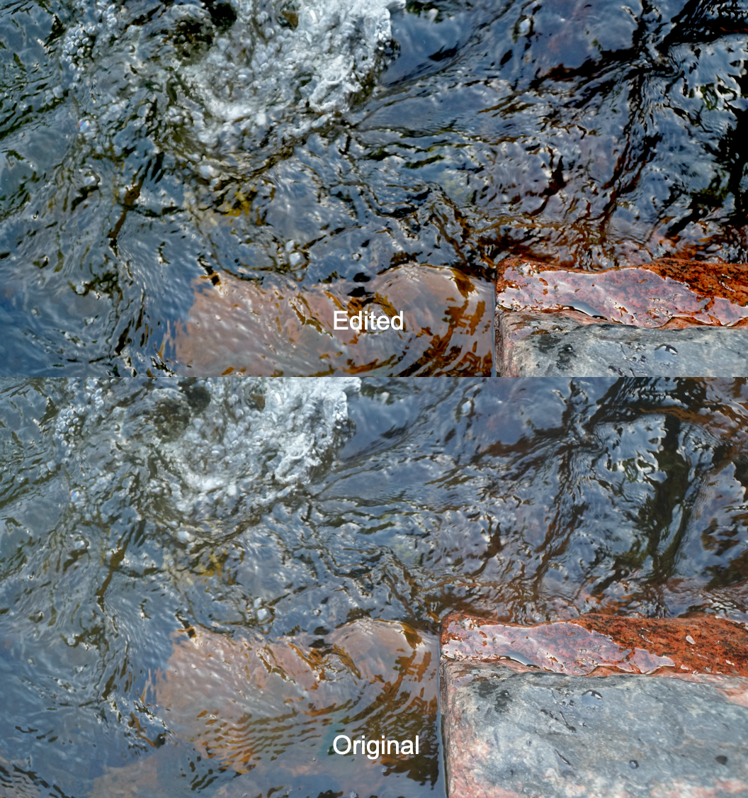
Image 2: A comparison of the edited and original photo

To capture this visualization I used a Sony ILCE-6300 with a focal length of 21mm with 1/320th sec exposure time on manual focus. I found that when attempting to capture flowing in auto focus that the whole photo tended to be very unfocused due to the high amount of movement from the fluid for this I found that a f/4 F type worked the best. The image was originally capture in a frame of 4000x6000 pixels. In darktable I increased the saturation, sharpness, and red color to enhance the background of the flow and the depth. This allowed the different flow types to become much more accented. Other than that I changed very little about this photo.

As a novice photographer I enjoyed capturing these flows for my second photo. I thought that the depth that I was able to bring out in the water was a beautiful byproduct of trying to make the flow phenomenon stand out more. I wasn’t sure about the rock in the bottom right that seems to steal some of the focus away from the flows, but I wasn’t able to find a way to edit the photo to make the flows stand out and give them without altering the red coloring which is what makes the rock pop out more.

1. American Whitewater, www.americanwhitewater.org/content/River/view.
2. The Editors of Encyclopaedia Britannica. “Capillary Wave.” Encyclopædia Britannica, Encyclopædia Britannica, Inc., 4 Jan. 2011, www.britannica.com/science/capillary-wave.

