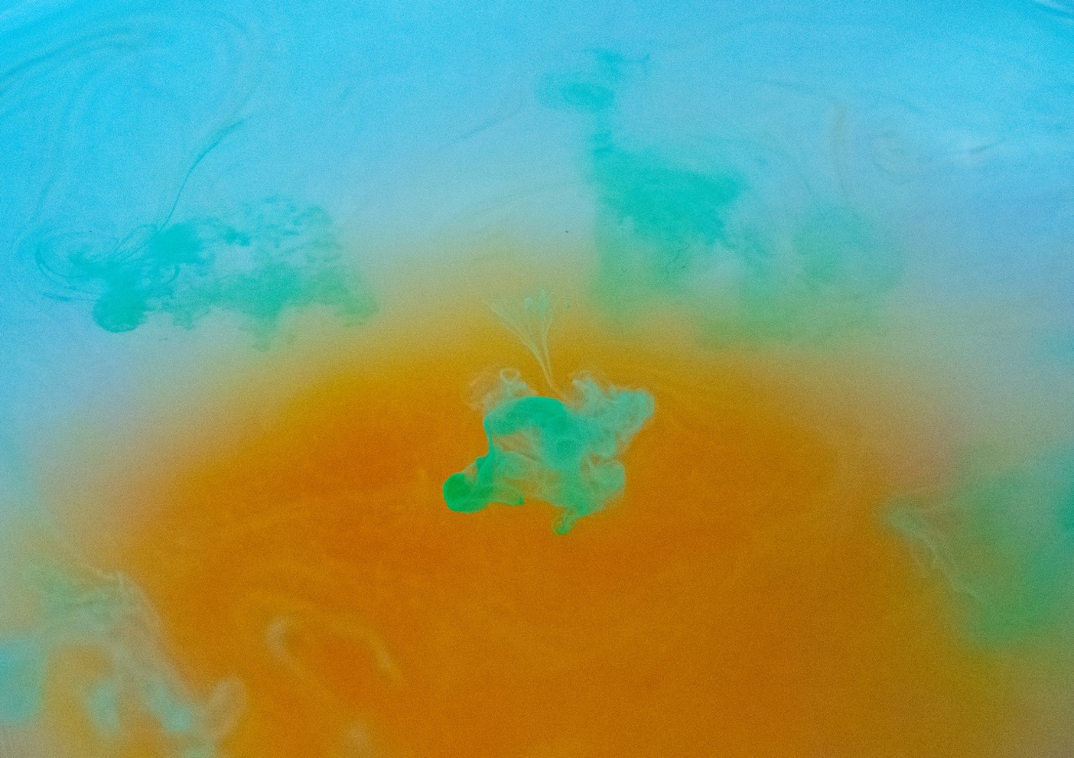

Victoria Rios
October 28, 2020
Image Video 2
This image was taken while trying to observe the flow phenomena of plumes and drops. In this image a drop of watercolor is dispersed into a bowl of water. The background is saturated watercolor that was dropped in prior to the shot. I used natural lighting and set the bowl on a blank white canvas.
This image was taken in my living room with natural lighting coming from behind and above. The camera was actually pointed downward towards the bowl at about -35 degrees. I first added the orange color with about 6-7 drops of watercolor, then I added 5 drops of the blue-green color. The drop itself is no more than a centimeter wide maybe even less. The drop of watercolor is being dispersed over time in the water particles. It has a plume/drop shape because some particles of the watercolor are dispersed through the water at different times and with different amounts of watercolor. The forces acting on these watercolors are gravity and the slight push down from the brush but that is so small its almost negligible.
The visualization technique used in this image was watercolor pigment in water. The watercolor is generic brand from Michael’s craft store. I dipped the brush in a separate cup of water once then dipped into the chosen color until I had a substantial amount of pigment. Then the color was dropped into the bowl of water while I was taking pictures. The image was taken using only natural lighting which illuminated the colors well.
The field of view was about 10 inches and the distance of the object to the lens was about 7 inches. The lens focal length was 50 and I used manual focus. The image was taken on a Nikon D3400 which is a DSLR. The exposure time was 1/100 with an exposure program of 0. The f-stop number was 5.6 with automatic shutter speed. The original image has dimensions of 6000 × 4000 pixels. The final image was produced after changing the white balance to a lower number and increasing the exposure, brightness, and saturation. The final image has dimensions of 4140 × 2921 pixels and was cropped to shift the focal point to the center droplet.
I’m very impressed with the final image because the first image was difficult to capture because I used manual focus. I am so happy that I was able to capture the shape of the drop so well because you can see how the water moves the pigment around as it diffuses into the water. I would have liked to focus the image even more and possibly try out different lighting techniques because that would have elevated the quality of the image. Overall, I am pleased with the result especially post production, and would like to explore the physic behind this even more, and possibly with different fluids.

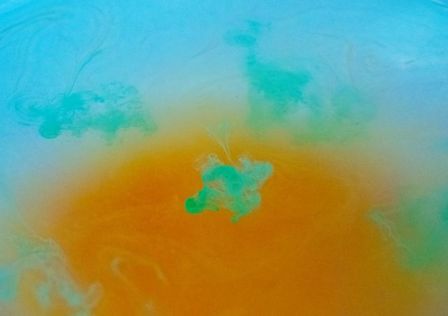

Citations
Chu, S., & Prosperetti, A. (2019, August 29). Multiphase buoyant plumes with soluble drops or bubbles. Retrieved November 02, 2020, from https://journals.aps.org/prfluids/abstract/10.1103/PhysRevFluids.4.084306

