John Shanley
Cloud 2
MCEN 4151
Date and Time of Photo: 1800 Sept 5, 2020
Cloud Type(s): Cirrus, Cumulus, Cumulonimbus
Location: Looking East on a saddle in San Isabel National Forest

This photo was taken 4 wheeling with my friend on a 4x4 trail in San Isabel National Forest the trail snaked through the mountains in the region near Buena Vista, CO. We were driving with the intention of camping later that night on the other side of the pass within tree line so we reached the pass around 1800 on the 5th. When we got to the top we took a moment to rest and admire the view. I took this photo on my iPhone 8 quickly because I didn’t feel comfortable bringing an expensive camera on this trip for fear of it breaking or falling out of the vehicle due to it not having doors or side walls. Since we were pressed for time this was one of a few pictures taken that were initially just for the sake of capturing the view to show friends and family later.

As stated this photo was taken in San Isabel National Forest near Buena Vista, CO. A rough estimation of the height would put us around 12,500-13,000ft since we were above tree line and the surrounding peaks were at 13,700ft. The photo was taken around 1800 facing east at 5º above the horizontal.

The temperature was beginning to cool off and in the early afternoon which allowed for the development of afternoon evening showers which can be seen in Image 1 on the left and right sides of the photo. We experienced common downslope evening winds that were no more than 5 miles per hour. The atmospheric conditions appeared to be stable which was confirmed by the Skew-T plot in Image 2. The cumulonimbus clouds were likely created by afternoon down sloping valley winds that are usually caused by latent heat from the ground condensing at cooler higher altitudes. The clouds were likely 2000ft above us which would put them at an altitude of 15,000ft. An additional phenomena that we witnessed was the presence of virga forming underneath the clouds.

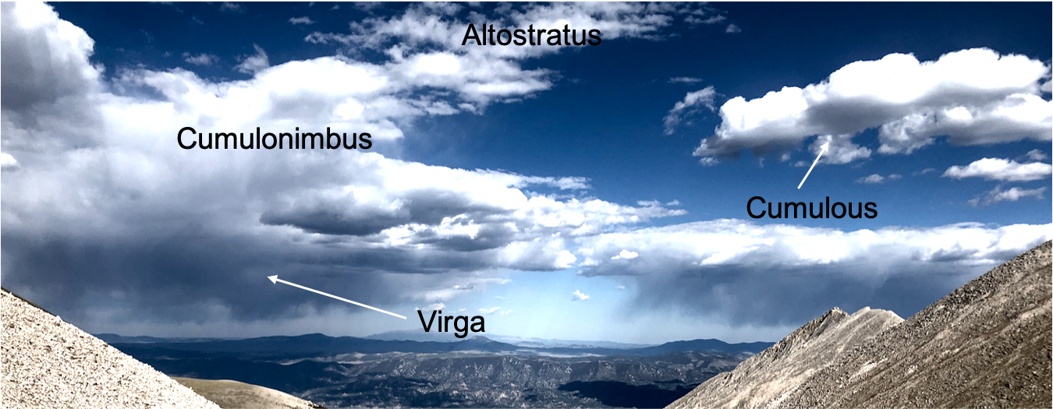
Image 1: The edited image displaying the multiple phenomena in the picture

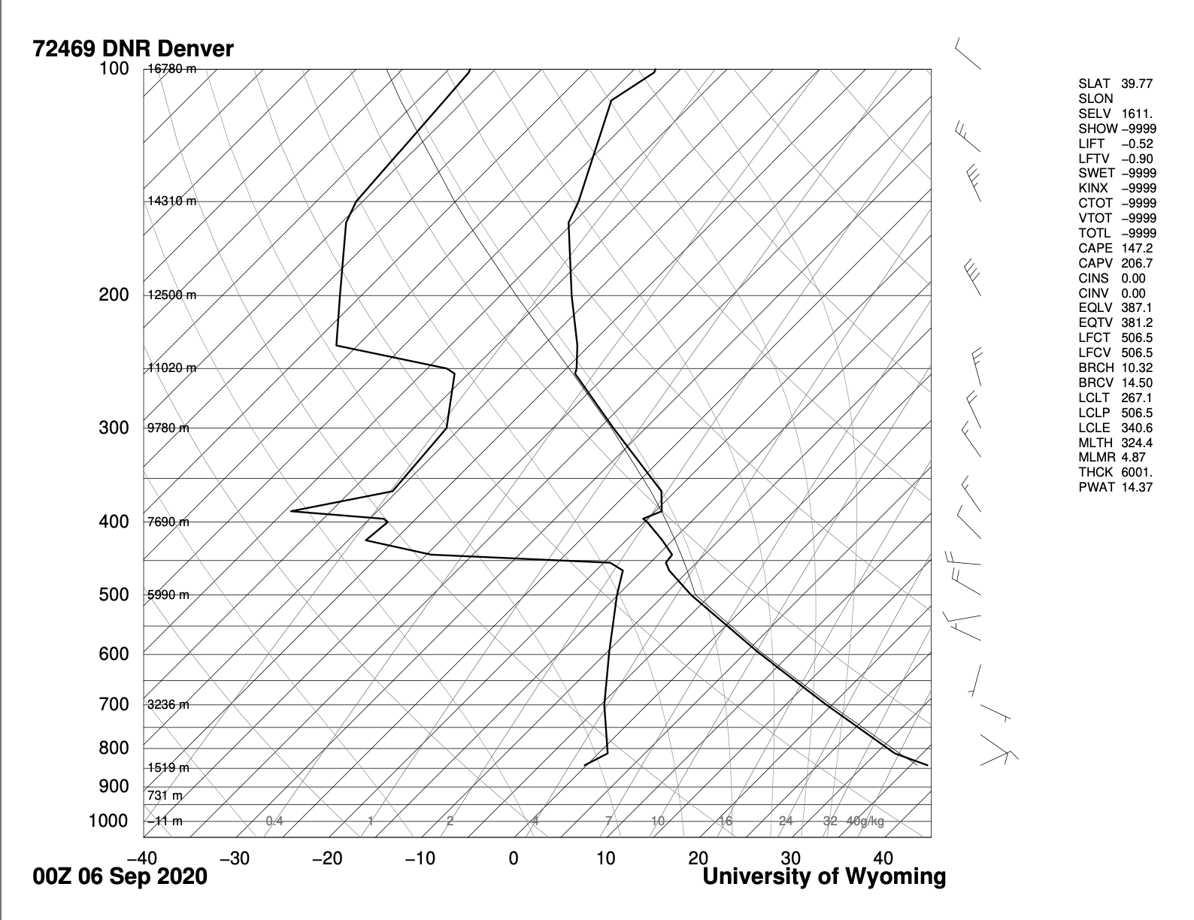
Image 2: Skew-T plot of the meteorological conditions in the region.

For this visualization I quickly took this photo on my iPhone8 camera just for the sake of having it with no real focus on my choice specs with most of them being automated. With the camera on my iPhone8 the focal length was 3.99mm, with an F number of 1.8 and an exposure of 1/6,944 seconds, capturing the photo 4032x3024 pixels. I would estimate the distance to the cloud to the lens at over a mile for the cumulonimbus clouds and possibly two for the altostratus. I chose to crop the photo pretty severely in order to make the clouds the center of the photo and to draw the viewers eye rather than the surrounding scree fields as seen in Image 3 where the original and the edited are next to each other. The I was able to make the bottom of the clouds where the virga is present a little darker by adjusting the saturation while still capturing the depth between each of the different clouds and emphasizing the shadows of the clouds in the valley.
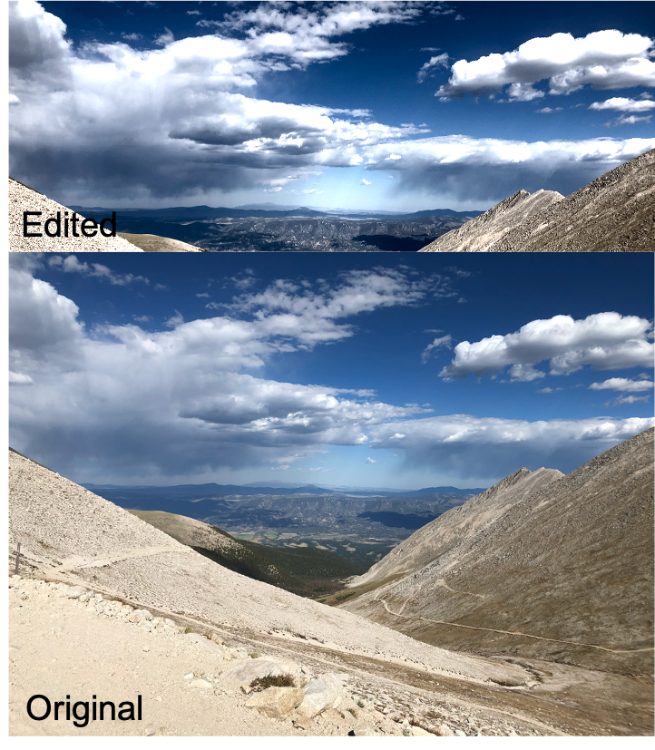
Image 3: A comparison of the edited and original photo
When I took this photo I was really just focused on capturing the initial beauty of the view from saddle and capturing the clouds as they were moving away from us. I like that the photo came from very pure attempt of being something that was just for my personal photo album and through this assignment I was able to enhance it and make it stand out more while enhancing the virga and the cloud shadow along the valley floor.
1. University of Wyoming, http://weather.uwyo.edu/upperair/sounding.html.

