Victoria Rios
Cumulus
September 7th 2020
4:14pm Great Falls, MT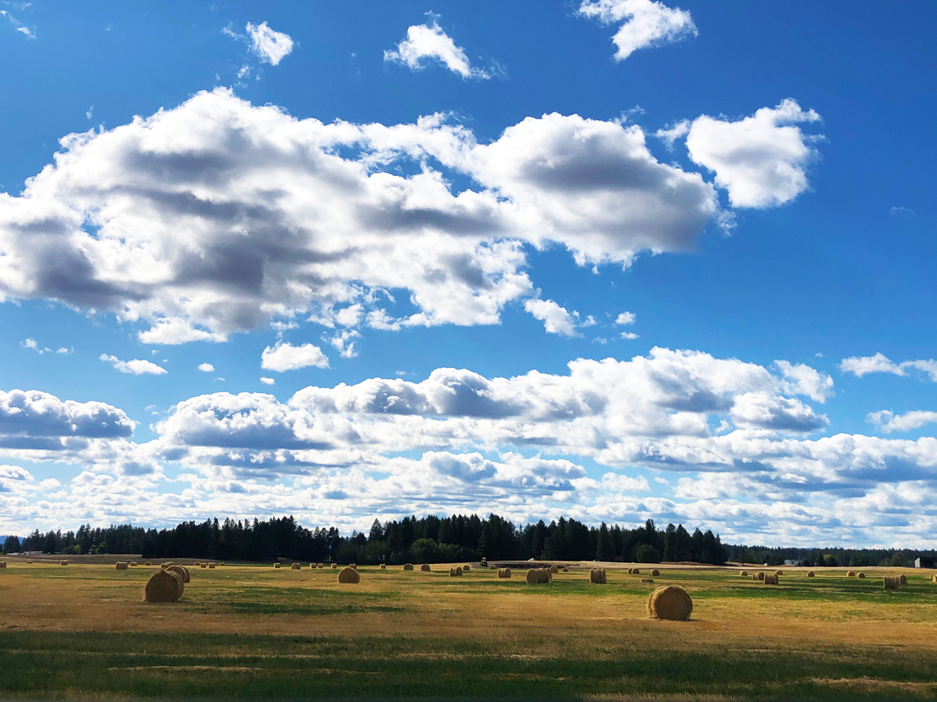

Clouds Second

This is an image taken in Great Falls Montana, at around 4:15 pm on September 7th , . This cloud formation is cumulus due to the multitude and shape. I took this picture because I thought this particular cloud formation very scenic and beautiful especially with the hay bales and trees. I wanted to capture the texture and contrast that can be observed in the clouds especially towards the bottom while still keeping the brightness. I also wanted to bring out more of the color in the image.
This image was taken in Montana, more specifically, Great Falls heading NE. This was taken on my phone while in the passenger seat so the angle of elevations is probably between 35-40 degrees. The camera was facing west as you can see the mountains in the far-off distance. It was about 4:14 pm when this image was taken, on September 7th with amazing weather and it was about an hour before the sun started to set.
The clouds in this image are cumulus clouds due to the shape of the puffs and the multitude of them observed. Another reason I believe they are cumulus is because of the CAPE value on the skew-t diagram; the value is 0 which means the atmosphere was pretty stable. Although these clouds do suggest rainy weather came through because of the way cumulus clouds form. Cumulus clouds usually form in mildly stable atmosphere (Weather Online). The entire sky was pretty much covered in these clouds which is further reason why I believe these are cumulus (Weather Online). It had rained earlier that day, so the clouds are left over from that weather. I estimate the cloud elevation to be around 650 to 800 meters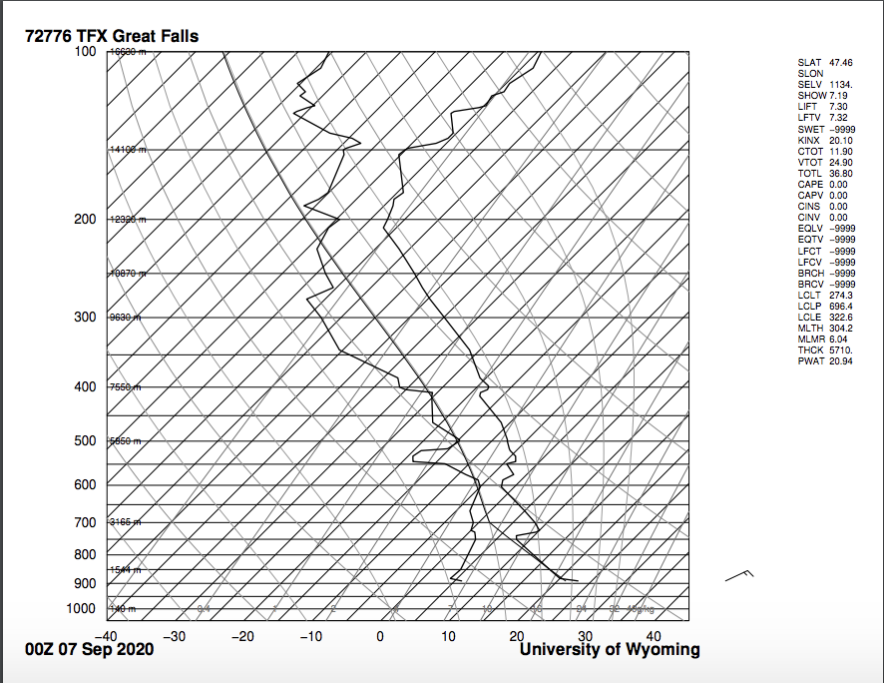
I took this photo on the way from Glacier National Park and I just thought it captured Montana’s scenic views so well. The field of view was very large and hard to estimate probably 9000 m. The distance of object to lens is the elevation of the clouds so about 7,000 m. This was shot on and iPhone8+ camera and according to the picture info the focal length was 3.99, and the f stop number was 1.8. The size of the original and edited image is the same: 4032x3024 pixels. The aperture, shutter speed and ISO are unlisted for this picture because it was taken on an iPhone. I edited the image using photoshop and I edited the color balance by upping the saturation, upping the contrast, and then upping the exposure while bringing down some of the highlights from being overexposed.
This images really capture the scale of the clouds, and the overall western plain aesthetic, which is what I was trying to capture. The fluid physics of cloud formation are shown really well; especially the shape and texture of the clouds. I really like my editing because I feel like I brought out the color without oversaturating the photo. This is one of my favorite cloud pictures taken to date!

