Victoria Rios
Image-Video 1
Flow Vis
9/28/20

Acrylic Flow
This project was my attempt at recreating the picture I chose for Best of Web. I loved how the different colors of the paint mixed together. I used acrylic paint because that’s what I had and a hair dryer. I placed 7 different colors in a row then blew air on the paint to move it down the canvas. I wanted to see how the paint’s pigments would mix with each other and if there would be distinct color mixing.
The flow apparatus I used was a blow dryer, which my guess would be a wind tunnel, and the flow of the air pushed the paint to flow down the canvas in the direction of the air. I tried to direct the flow of the paint to cover the entirety of the canvas but the paint was being pulled down the canvas due to the forces of gravity at the angle the canvas was held at. Upon that, the blow dryer air was causing a film to form on the surface of the paint because it was drying it out. This caused the paint to look chunky and textured in places. The flow phenomena that I ended up shooting for my IV-1 was non diffusive mixing where the particles don’t mix on a molecular level and you can still see remnants of the solutions you mixed together. This creates really cool lines and textures in the painting that are emphasized with the color contrast.
The visualization technique was the painting itself, which I would have done differently after this experiment. I lined the paint in circles along the top of the canvas when I should have just placed the paints in random places all around the canvas and used the blow dryer to move the paints all over the canvas. I used Craftsmart acrylic paint and a generic brand canvas. The lighting used was just natural indoor lighting because I used my Iphone camera to take the picture.
I only took a picture of a small part of the canvas that I thought showed non diffusive mixing the best. There was a very small field of view because my camera lens was right up close to the painting. I used my personal IPhone to take this picture because I was in the process of getting a DSLR camera. The lighting indoors is not great so cameras usually need a higher ISO when shooting indoors, and I didn’t need to worry about shutter speed or aperture. The original image was 3024x4032 pixels which is the same size as the final image. When it came to post production I decided to make the image sharper, higher contrast and more saturated with color in order to see the flow of the paint better. 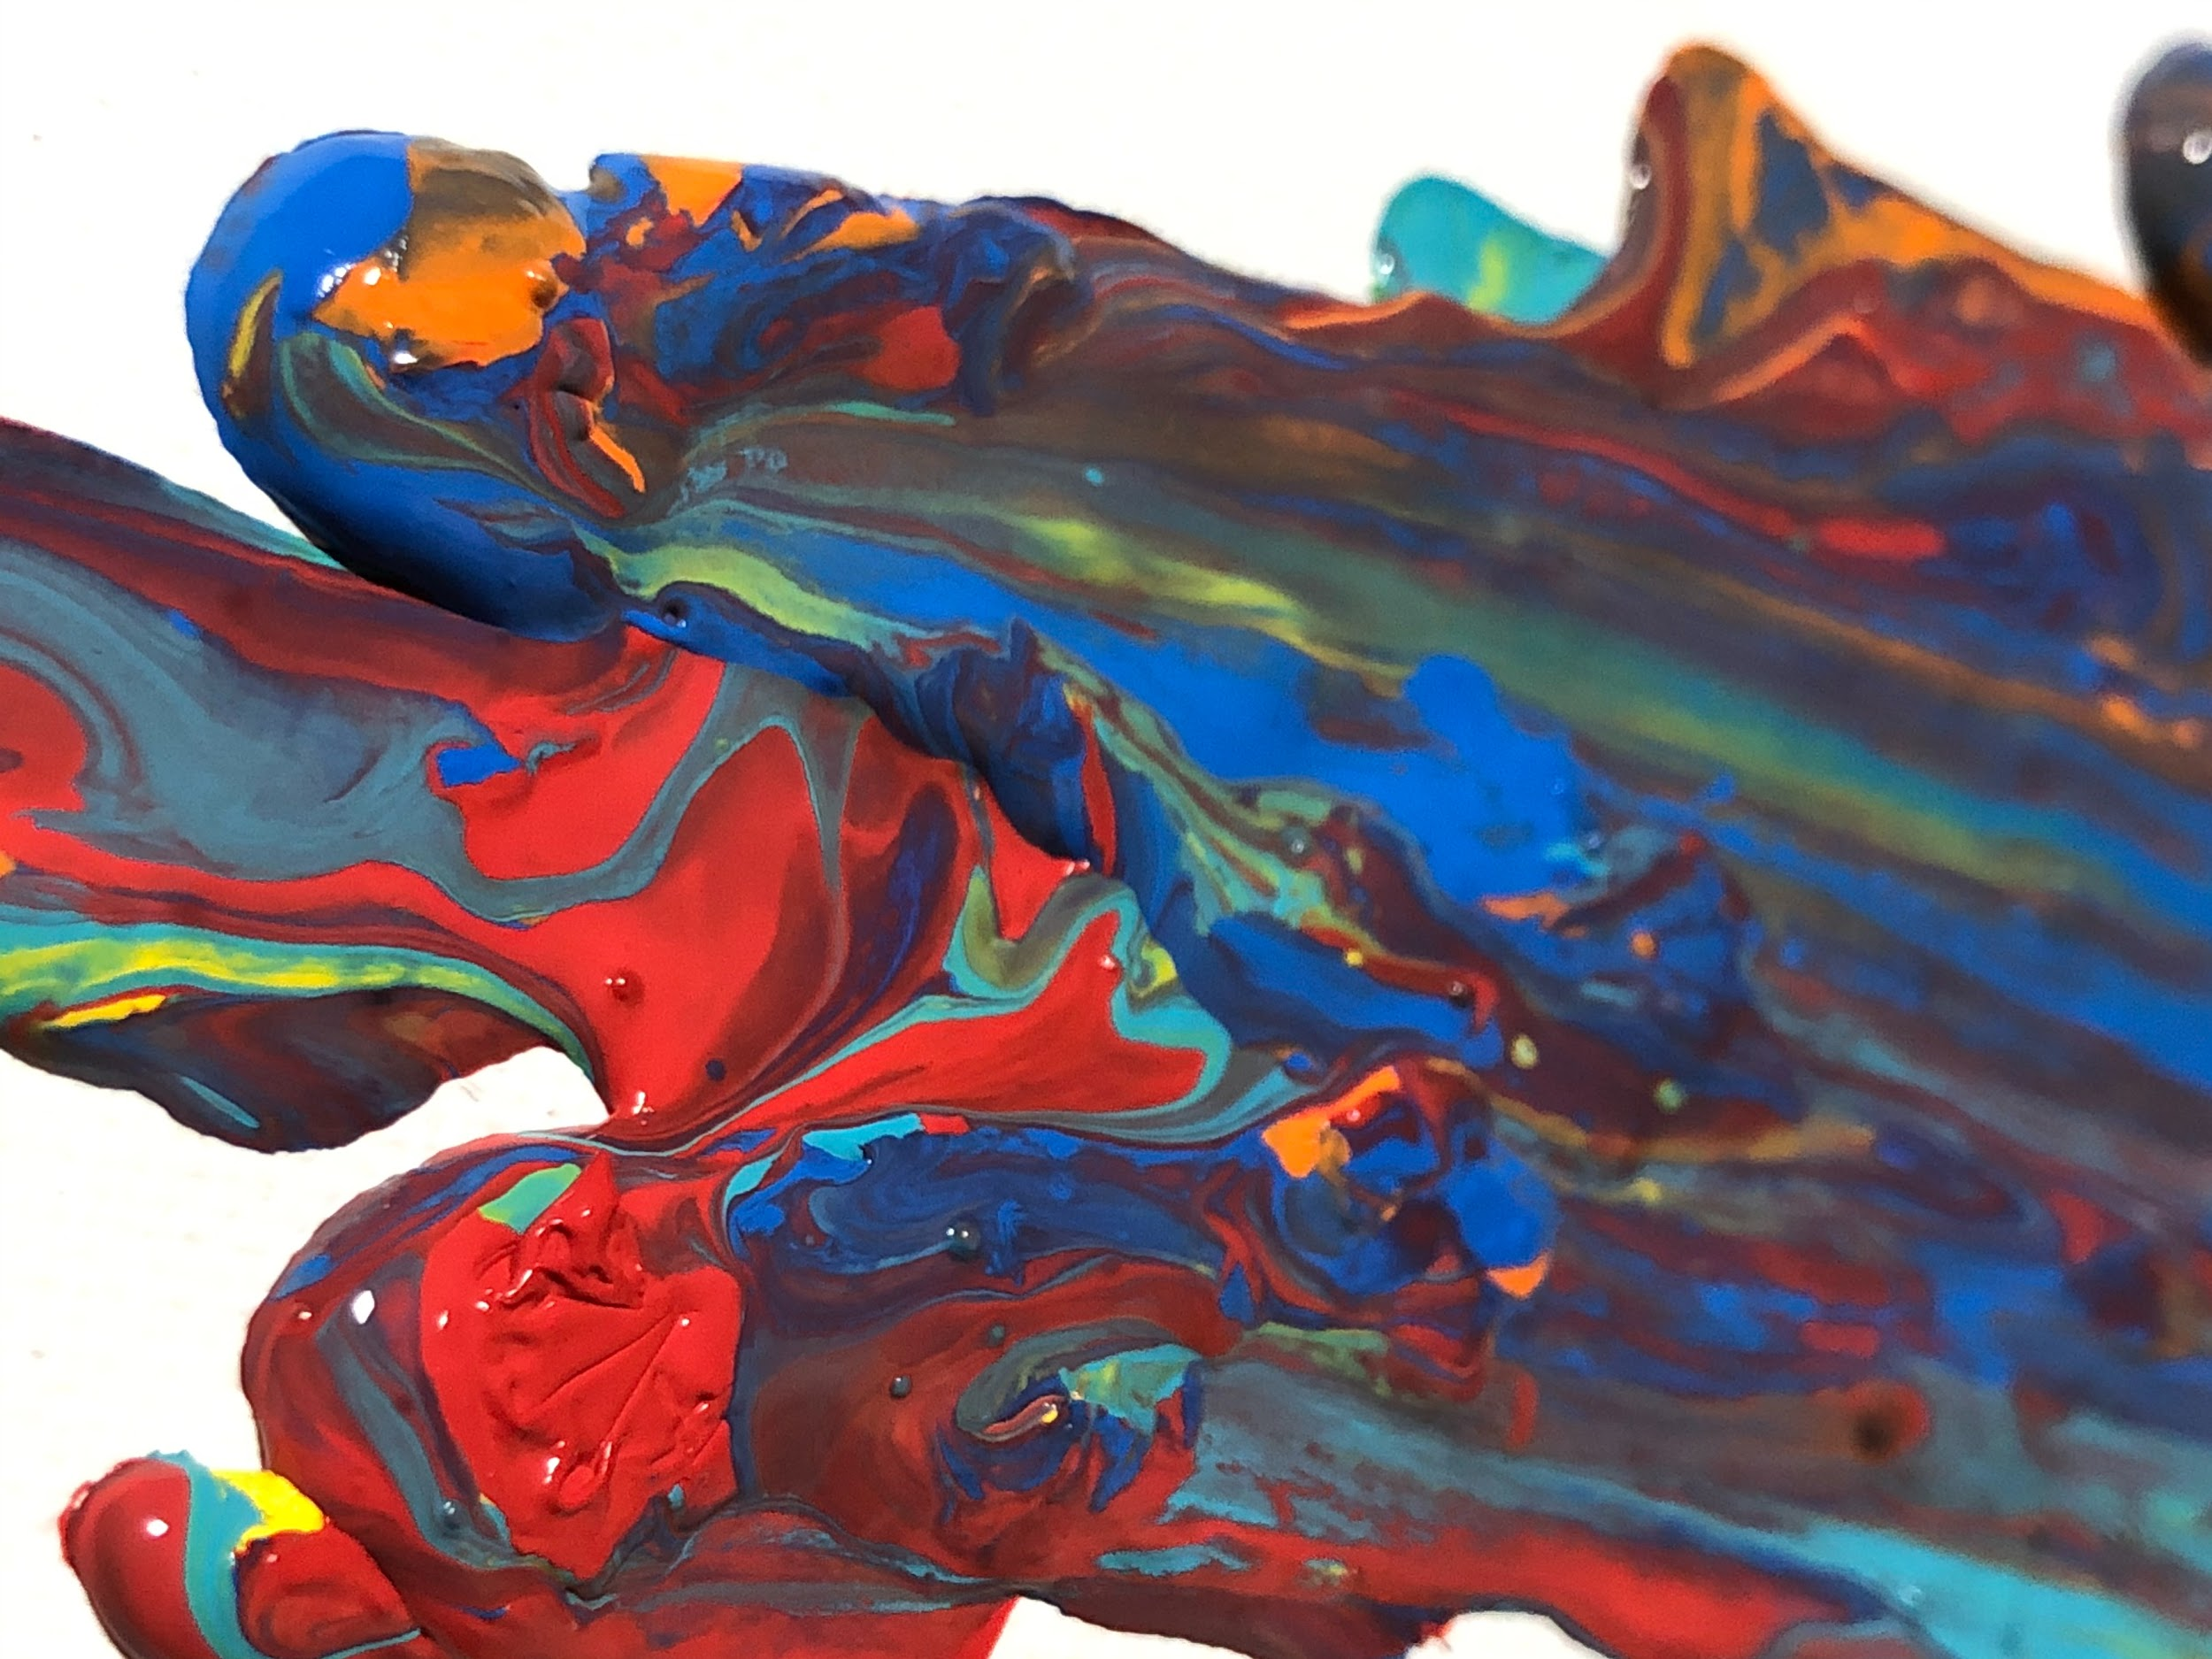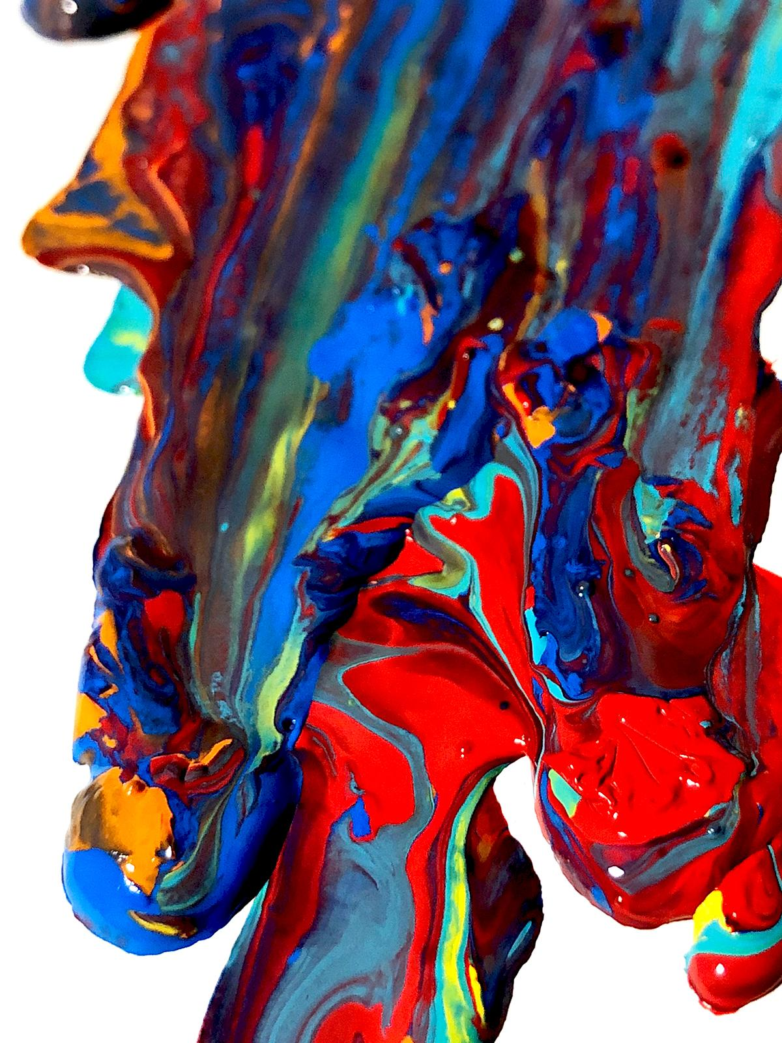
To me this image reveals that paint needs to be pushed with a bigger force and at a higher velocity in order to truly mix the paint pigments together. I think the non diffusive mixing flow phenomenon is shown well here although I do wish it were a higher quality image. I tried to edit it, which definitely makes it look better, but not exactly what I envisioned.

