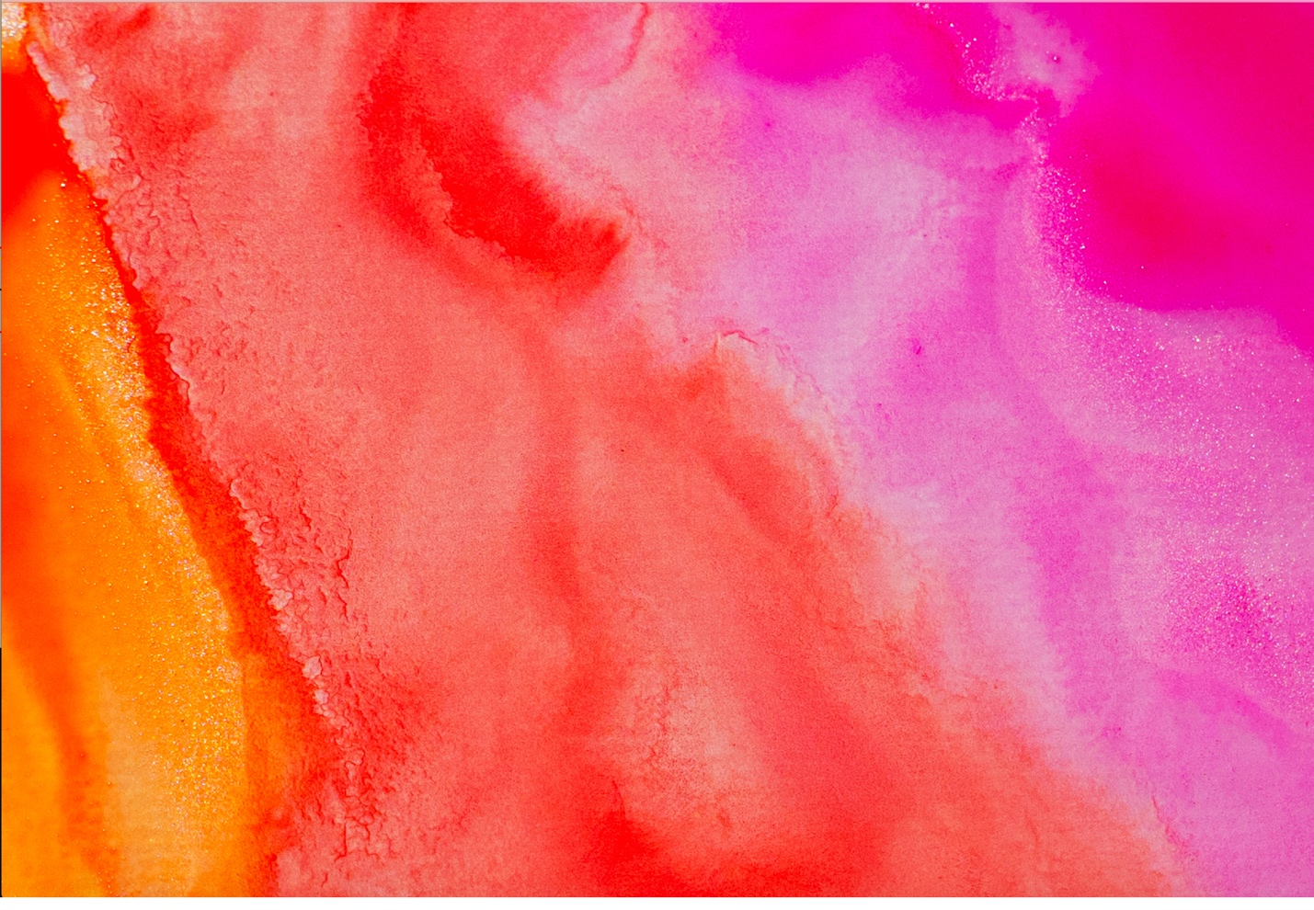
Victoria Rios
December 9th, 2020
Image Video 3
Pictured above is 3 different pigments of watercolor painted on top of a sheet of clear plastic layered on top of a white canvas. I was trying to observe the mixing of watercolor pigment on a surface the water molecules would adhere to, and hopefully I would create a gradient. The shine pictured in the original and edited image I think is a product or water surface tension and adhesion. This image was taken on a Nikon D3400 with a basic 18-55mm Lens on manual focus with direct sunlight.
This image was taken on my porch with natural lighting coming from a side angle. The camera was actually pointed downward towards the canvas at about -35 degrees. Using a thick watercolor brush I added the orange color, then I added the red color, and finally the magenta. The forces acting on these watercolors are gravity and the slight push down from the brush but that is so small it is almost negligible.
The visualization technique used in this image was watercolor pigment in water brushed onto the surface of smooth plastic. The watercolor is generic brand from Michael’s craft store. I dipped the brush in a separate cup of water once then dipped into the chosen color until I had a substantial amount of pigment. Then the color was brushed in random strokes on the surface of the plastic while I was taking pictures. I would brush the colors so the water molecules would adhere to each other and mix together, subsequently mixing the colors and creating a gradient effect. The image was taken using only natural lighting which illuminated the colors well. As you can see there also appears to be a shimmery/glitter substance along the gradient. I determined that those are just tiny air bubbles or water droplets reflecting the direct sunlight and creating a glittering effect.
The field of view was about 20 inches and the distance of the object to the lens was about 15 inches. The lens focal length was 50 and I used manual focus. The image was taken on a Nikon D3400 which is a DSLR. The exposure time was 1/200 with an exposure program of 0. The f-stop number was 5.3 with automatic shutter speed. The original image has dimensions of 4366 × 2962 pixels. The final image was produced after changing the white balance to a lower number and increasing the exposure, brightness, and saturation. The final image has dimensions of 2104 × 1458 pixels.
I am honestly very happy with the way my image came out especially because I was not even planning to do this really. I just sort of started mixing the colors and it ended up looking so good. I am pleased with the result especially post production, because I feel like I really brought out the vibrance of the colors and you can see shimmer of “glitter” which is just very aesthetically pleasing.
