Reid Pritchard
Flow Visualization, MCEN 5051 – 001
Clouds One Report

The goal of this timelapse was to capture altocumulus clouds forming, from a mountain wave. As well as how/if this changed over time. I captured images from my mirrorless camera once every 5 seconds in order to produce a long enough clip with a high framerate. The images were then stitched together to create a video.

For this composition I went out on my porch, on the third floor of my apartment building, and setup my camera directed at two clouds forming nearby. I tried to get both the start of the cloud as well as some of the cloud after it had formed, but as time went on the lenticular cloud moved more to the center of the frame, which wasn’t ideal. The first timelapse image was taken around 4:37 on October 12, 2020 and the final image was captured roughly two hours later. The reason for this approximation is that once the photos are merged for the video, the metadata is lost, and I don’t have a backup of the original set of images.
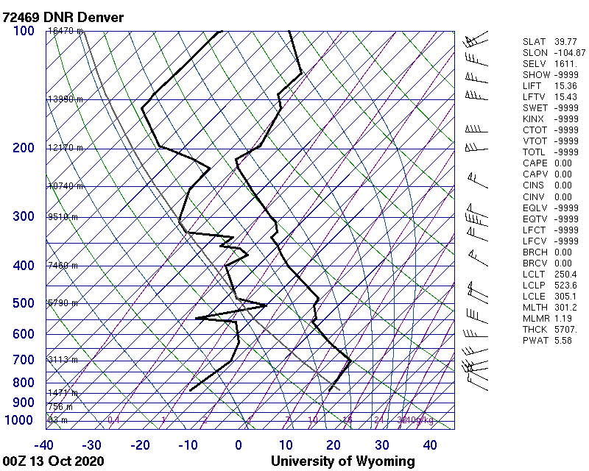
During this time the atmosphere was stable as the there is a cape value of zero on the skew-t diagram. This helps indicate that these are mountain wave clouds, though by viewing the video that is quite clear. Judging from the cloud form and the skew-t diagram, I believe these are altocumulus clouds. Behind them you can also see cirrus clouds forming though they are less prominent.

These images were captured using a Fujifilm XT-2 mirrorless camera with a focal length of 18mm. The aperture was prioritized at a wide f/22 in order to capture as much of the clouds as possible. The ISO was also locked at 3200, leaving just the shutter speed to change with the setting sun. The raw images were captured at 6000x4000 pixels which was kept nearly consistent in the final output. In post, the images were batch processed by Lightroom applying small adjustments to contrast, exposure, and vibrance. They were also converted to png’s for easier processing later. After the first adjustments the images were run through an open source deflickering Python program found on GitHub (. As previous experience showed me that without this the timelapse can flicker as the camera’s metering adjusts to changing lighting. To be frank I’m not convinced this made a noticeable difference. After this they images were stitched together in Premiere Pro where an image stabilization effect was applied to decrease movement in the timelapse. In hindsight this should had been left out as it lead to odd movement of the frame of the timelapse. Everything was exported and uploaded to Youtube.

Overall, I’m pretty happy with the timelapse. It captures a very cool phenomenon that I had yet to see captured, though I’m sure it is. While there are some things I could improve, such as a lower f-stop to increase the sharpness and more confidence in the composition could allow for much tighter framing of the clouds, and even better post processing choices, the timelapse is still somewhat visually appealing and is good as far as documentation goes.

