Reid Pritchard
Flow Visualization, MCEN 5051 – 001
Clouds Two Report

For this timelapse the goal was to capture the smoke plumes coming from the Calwood fires. The raw images were captured on a mirroless camera every fifteen seconds. After they were stitched together to create a video.

This composition was from my porch on the third floor of an apartment building. I tried capturing the source of the smoke as well as a significant portion of the plume. The timelapse was taken on October 17, 2020 starting around noon. The last image was taken at 6:16 that night. There are a few times throughout where the camera battery died and I didn’t notice for a bit, thus a few jumps in the timelapse.
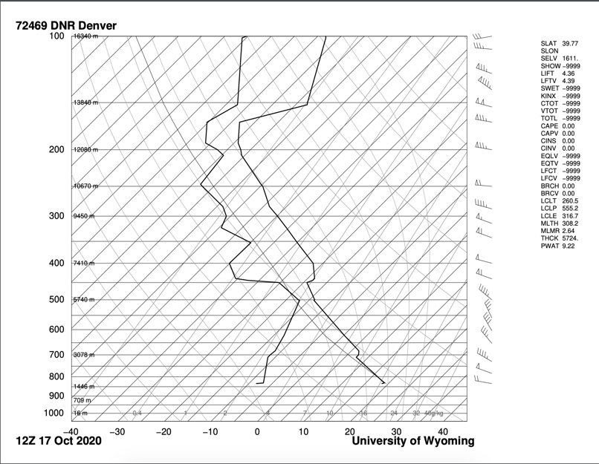
During the timelaspe the atmosphere was stable with a cape value of zero. Looking at the early part of the timelapse you can see the pyro cumulus clouds forming from the smoke plume as the darker, yellowish colored, smoke stays low while the top turns bright white. This most likely is happening near the pinch in the skew-t near the 500 line.

The images were taken using a Fujifilm XT-2 mirrorless camera with a focal length of 55mm. The f-stop was locked at f/20 to capture the greatest depth of field while slightly compromising on the sharpness. The ISO was also locked at a low 800 to minimize digital noise in the images. Locking both ISO and aperture was also to help the camera make consistent choices when metering the scene. Limiting which values can change can help reduce flickering in the final video. The raw images were captured at 6000x4000 pixels. The images were batch edited in Lightroom to slightly increase contrast, vibrance, and sharpness, these were minimal edits only to improve the details in the clouds. After exporting they were run through an open-source python deflickering program found on GitHub, created by the user maxnoe. The images were then stitched together in Premiere Pro and cropped to a 16:9 aspect ratio. The final video was then exported at the highest possible resolution and uploaded to YouTube.

I’m very pleased with the final product as it captures exactly what I hoped for. The image quality of the smoke plume is very nice and capturing the transition from smoke to pyro cumulus clouds is super interesting. While the angle is not very dramatic compared to the plume, at the time I couldn’t leave to find a better location and I’m happy with how it turned out. There are some small adjustments that could have made an even better timelapse, such as camera pan, it would have compromised the documentation benefit. Also as someone less experienced with the timelapse medium, it could have resulted in completely missing capturing this event. In all, I’m very pleased, but as with nearly anything there is always room for improvement.

