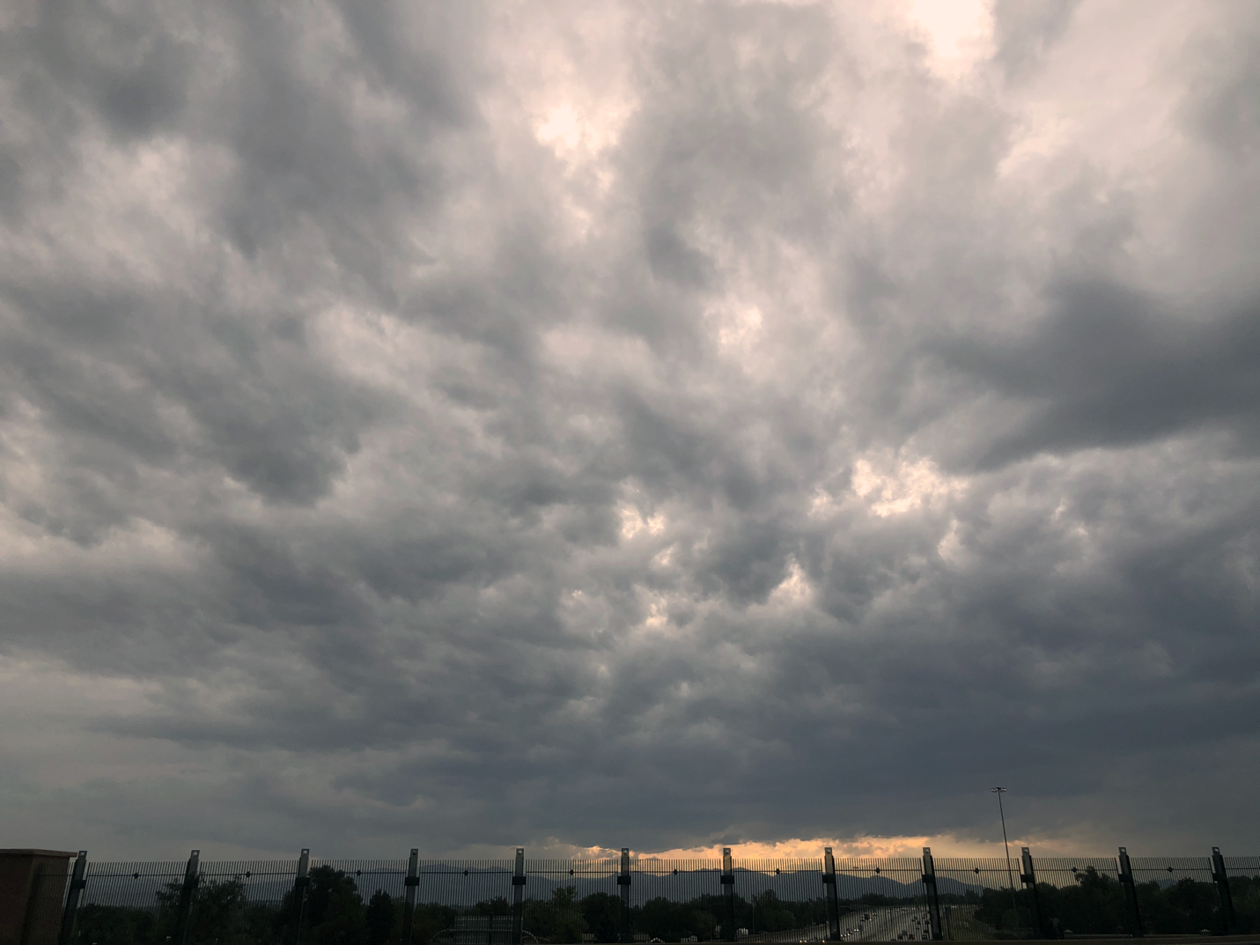

Victoria Rios
Stratocumulus
August 31st , 2020
6:48 PM Denver, CO
Clouds First
This is an image taken in Denver, CO at about 6:48 pm. This cloud formation is stratocumulus due to the flatness and shape. I took this picture because I thought this particular cloud formation was super unique and massive. I wanted to capture the texture and contrast that can be observed in the cloud because it’s very ominous and brooding like a storm was brewing in the atmosphere.
This image was taken in Denver, more specifically, west Denver on Federal Blvd. This was taken on my phone while walking so the angle of elevations is probably between 30-40 degrees. The camera was facing west as you can see the mountains in the far-off distance. It was about 6:48 pm when this image was taken, on August 31st which was just as the sun was starting to set.
The clouds in this image are stratocumulus clouds due to the shape of the puffs and the flatness observed by the sun poking through in parts. Another reason I believe they are stratocumulus is because of the CAPE value on the skew-t diagram; the value is 3.1 which is super close to zero which means the atmosphere is pretty stable. Stratocumulus clouds usually form in mildly stable atmosphere (Weather Online). The entire sky was pretty much covered in these clouds which is further reason why I believe these are stratocumulus (Weather Online). It had rained earlier that day, so the clouds are left over from that weather. I estimate the cloud elevation to be around 9750 to 10,500 meters. 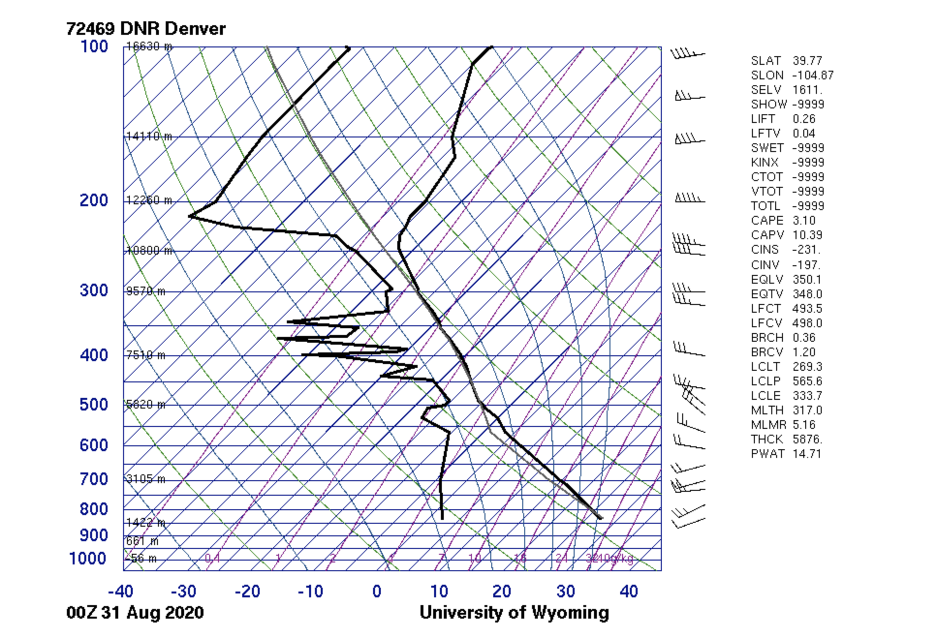
I took this photo rather impulsively while walking across a bridge because I was fascinated by the sheer size of the formation and how much it sprawled across the sky. The field of view was very large and hard to estimate probably 1000 m. The distance of object to lens is the elevation of the clouds so about 10,000 m. This was shot on and iPhone8+ camera and according to the picture info the focal length was 3.99. The size of the original and edited image is the same: 4032x3024 pixels. The aperture, shutter speed and ISO are unlisted for this picture because it was taken on an iPhone. I edited the image using photoshop and I increased the contrast and added more warmth which gives it an eerie and ominous aesthetic.
This images really capture the scale of the clouds which is what I was trying to capture so that gives me a sense of accomplishment, however I could have done better with the postproduction. The fluid physics of cloud formation are shown really well; especially the shape and texture of the clouds. I wish I had not edited the way I did because I think the cool tone is more fitting and aesthetic.

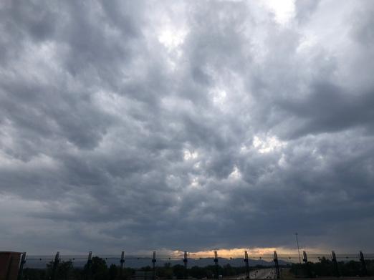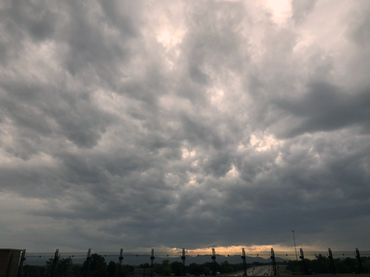
Original edited

Citations
Weatheronline.co.uk. (n.d.). Stratocumulus. Retrieved October 29, 2020, from https://www.weatheronline.co.uk/reports/wxfacts/Stratocumulus.htm

