Flow Visualization (CINE 4151): Clouds 1 Report
Gus Santaella
Prof. Scott Wieland
10/25/2021

Relevant stats:
Camera: Canon Rebel T7
Shutter speed: 1/200
Aperture: f.9
Lens focal length: 49 mm
ISO: 800
Size (final PNG file): 3.9 MB
Dimensions (final PNG file): 1300 x 595 pixels
Size (original RAW file): 27.2 MB
Dimensions (original RAW file): 6000 x 4000 pixels
Size-subject distance: about 3.5 to 4 miles (see setup and methodology section)
Brief description of the photo and introduction:
My photo for this first clouds assignment is a photo of a nimbus cloud traveling along the Front Range in Boulder, CO, where the clear skies and the nicely lit sections of the mountains depicted in the photo make up for a roundly composed photo. For more details, see the setup and methodology section.
Artistic and scientific intents
My ultimate artistic intent with this image was to come up with a nice photo of a cloud that could showcase flow visualization within a real-world environment, making up for a nice photo.
My scientific intent was to use the concepts learned about in class to be able to make sense of the cloud formation being captured in a theoretical way to put this newly acquired knowledge of clouds into practice.
Setup and methodology.
I took this photo at the commons room situated at the 11th floor of Gamow Tower in the
Physics Department at CU Boulder at 4:06 PM on Monday, September 20th, 2021. I looked around the environment, and then noticed the cloud formation due northwest above the Front Range and took many photos of it for a few minutes. The only lighting in the photo of course is natural and it comes from the sun, located at 1 AU away from the Earth. The setup can be described by the following diagram:
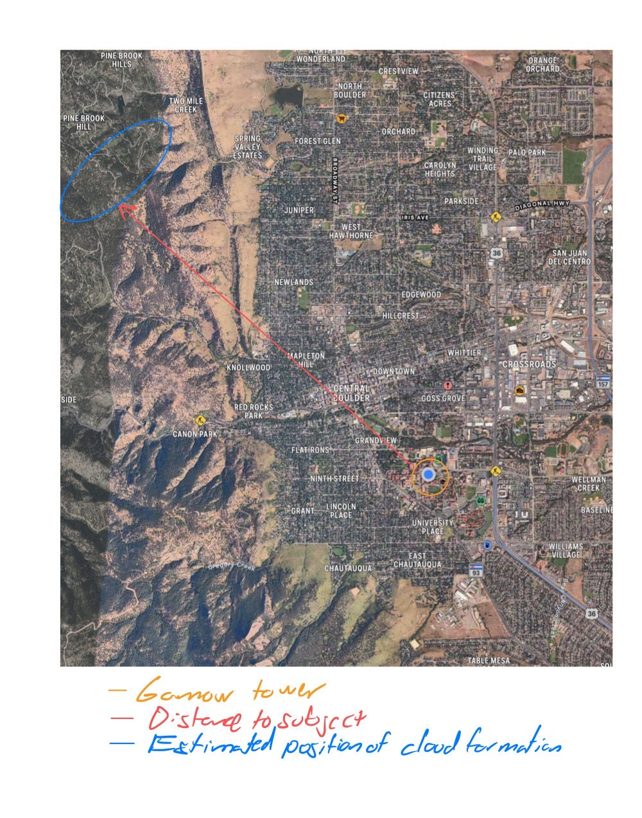
The horizontal distance to the subject is about 3.5 to 4 miles, with this being a loose estimate. The clouds, of a size of at least 1 km long, did not appear to be moving when they were captured (in other words, with a velocity equal to 0), which is of course minimal compared to the used 1/200 s = 0.005 s shutter speed. It must be noted that I tried working with different shutter speeds and aperture settings to get my desired lighting/color contrast until settling for the settings specified in the stats section.
SKEW-T diagram and explanation of effects based on a theoretical groundwork:
In general, cloud formations form as air closer to the ground is pushed up into the atmosphere right into areas of lower pressure, creating a shearing-like effect where microparticles of very light water droplets and ice stay in the atmosphere and saturate hence forming clouds. (NOAA, 2021). Hence, analyzing the atmospheric profile using a SKEW T diagram is often very useful to explain cloud effects. The SKEW T diagram for the day the photo of this cloud was taken is below.
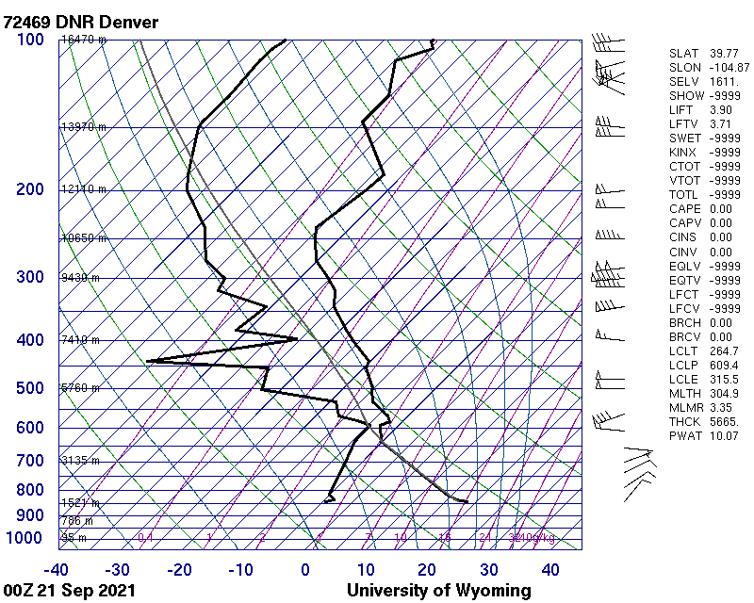
It must be noted that this is the diagram from the Denver station, given that this is the one that is closest to Boulder, and, as is the convention, this is the diagram from 00Z on 21st of September given that that is the one that corresponds to the afternoon/evening times of September 20th.
Right off the bat, we can see that the CAPE value is 0, meaning that our atmosphere is stable and that there was a very low chance of thunderstorms on that day and time. Analyzing the plot itself the dewpoint plot and the environmental sounding curves appear to almost briefly “meet” at about 4000 meters above sea level (or, equivalently, about 2400 meters above ground) possibly implying a cloud formation around this relatively low range. Given that the skies were visibly clear and the weather was stable the day the photos were taken, these aspects obtained from the SKEW-T diagram appear to make sense with our expectations.
With regards to the classification of the cloud formation as a nimbus cloud, I just empirically compared the cloud in my photo with photos of various types of clouds and concluded that it was a nimbus cloud, a claim most of my peers agreed with during the critique sessions. This makes sense looking at the skew T diagrams, given that cumulus clouds tend to form at relatively low heights (less than 6500 ft = 1981.2 meters, per NOAA, 2021) like the one being captured in the photo, which is loosely around the estimated height (within 500 m) for cloud formation cited above.
Description of changes done during post-processing
I used the GIMP editing software to do all my post-processing. Contrary to other assignments, I decided to shift the contrast and brightness curves heavily and significantly (sharpening the darks and brightening the lights by aiming for an “S” curve) to put the cloud in focus while removing focus from the mountains in the photo. I also cropped the image to remove minimal elements from the bottom of the photo (which shows bits of the city of Boulder) and some of the sky above the photo to put the cloud at the center of the final image

Original photo:
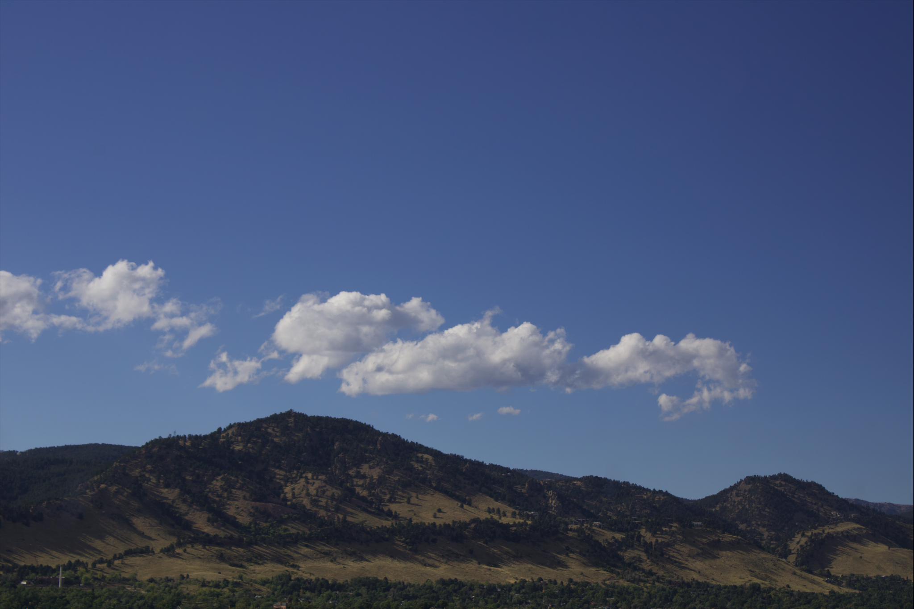

Post-processed photo:

Acknowledgments
I worked on taking the photo and the setup all by myself, but I would like to acknowledge professor Wieland for all his help in giving me advice while I was post-processing the image, as well as my peers for all the kind constructive feedback presented during the critique sessions.
References:
Atmospheric soundings. (2021). Retrieved October 26, 2021, from http://weather.uwyo.edu/upperair/sounding.html.
Cloud development. (2021). Retrieved October 26, 2021, from https://www.weather.gov/source/zhu/ZHU_Training_Page/clouds/cloud_development/clouds.htm.

