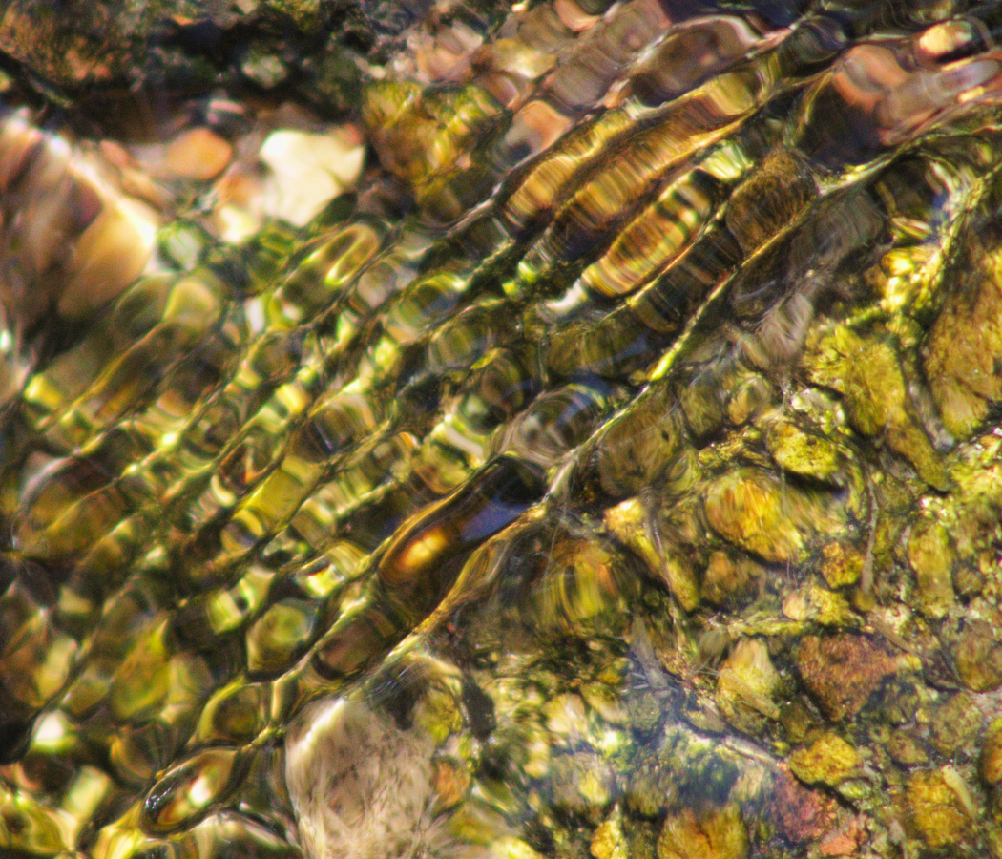

Flow Visualization (CINE 4151): IV Report 1
Gus Santaella
Prof. Scott Wieland
09/27/2021

Relevant stats:
Camera: Canon Rebel T7
Shutter speed: 1/640
Aperture: f 8.0
Lens focal length: 300 mm
ISO: 1600
Size (final PNG file): 6 MB
Dimensions (final PNG file): 1050 x 900 pixels
Size (original RAW file): 37.4 MB
Dimensions (original RAW file): 6000 x 4000 pixels
Size-subject distance: about 2.022 meters (see setup and methodology section)

Brief description of the photo and introduction:
In simple terms, my photo for this first assignment is a depiction of a natural flow occurring between the imperfect, right-triangle like junctions of the rectangular slabs of a mossy water canal, where the changing height causes the water to undergo an interesting rippling wave effect with a nice orthogonal geometry relative to the positions of the slabs. The image provides a nice contrast between the stillness of the water, where you can see the bottom of the canal and its stone and moss-based features, and the chaotic rippling water, where the light is so heavily distorted that one can only appreciate the visualization of the waves themselves.

Artistic and scientific intents
My ultimate artistic intent with this image was to come up with a nice representation of a natural flow in its medium with the right lighting and the right use of the means available to me to to take an impactful image.
Going along with my artistic purpose, my scientific intent was to be able to use natural phenomena to showcase an interesting physical effect in action within its environment, which is showcased by the diffraction effect in the rippling water and how it contrasts with the still water.
Setup and methodology.
I took this photo in the water canals located in the Norlin quad section of the CU Main Campus at 2:40 PM on a bright afternoon on Monday September 6th, 2021. I stood on the side of the walking path and used my macro lens to take the picture from a verical displacement of about 2 meters up and a horizontal displacement of 30 cm sideways, standing up and pointing towards the rippling water. My lighting solely relied on the light from the sun, located about a distance of 1 AU away from the Earth, striking the ground and the creek at an angle almost normal to the ground. Visually the setup can be described by the following diagram:

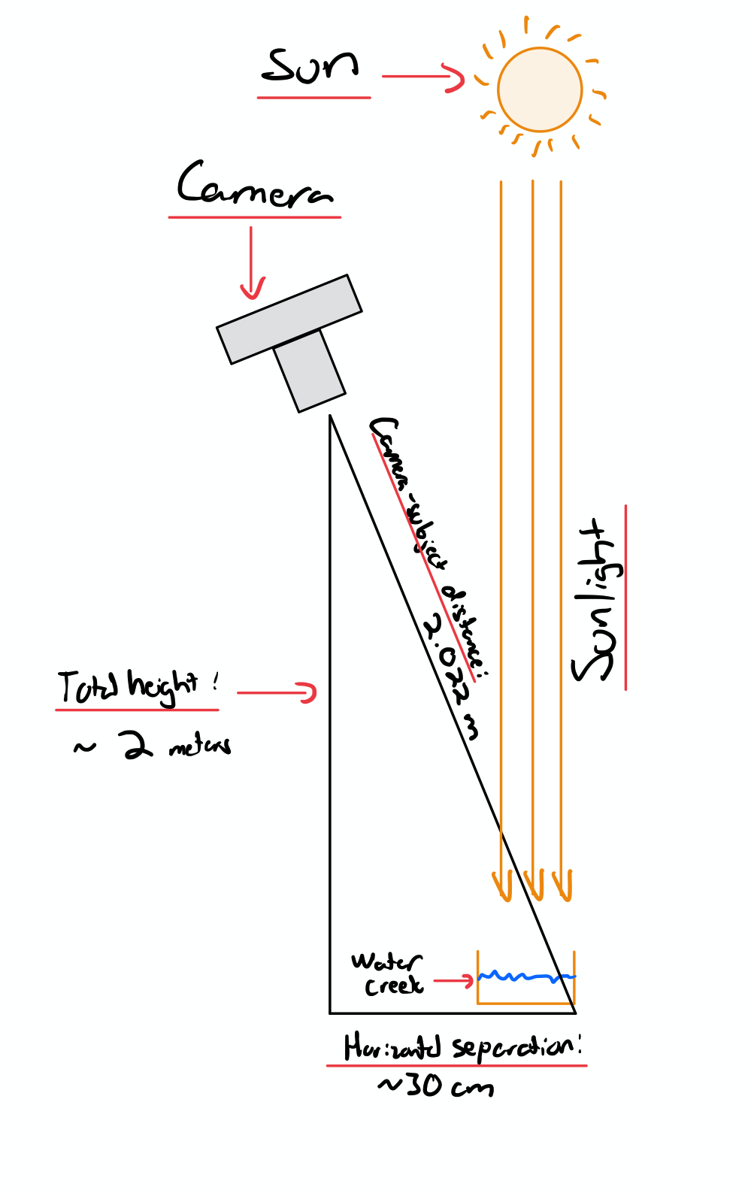
In addition, the net displacement of the flow depicted in the image (across the edge of the stone and along the time of exposure) was of about 3 cm moving at an estimated velocity of 10 cm/s, which is minimal compared to the used 1/640 s = 0.0016 s shutter speed and is definitely not a big distance or scale although the magnification of the macro lens makes it seem like one despite the fact that the photo was taken from about 2 meters away. A detail of the slab junction of the creek, along with the rippling/still water effect that it provoked, can be found below:
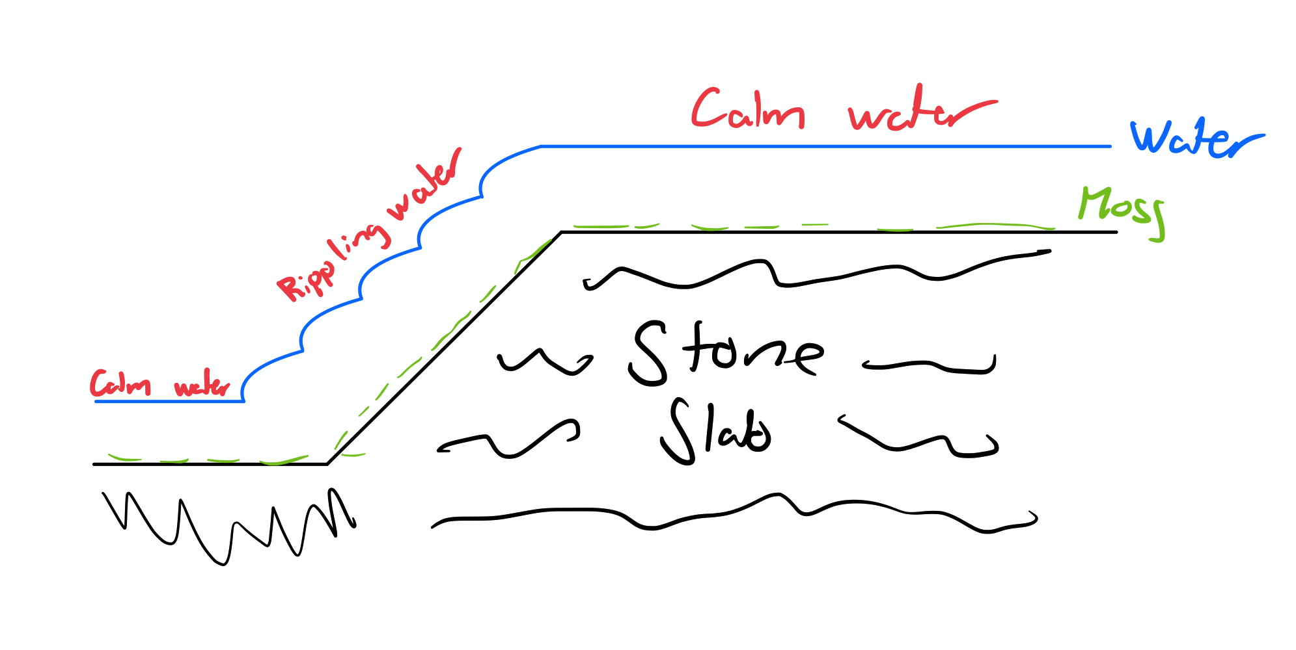

It must be noted that, while taking photos of the creek and the rippling effect described in my image, I tried working with different shutter speeds and aperture settings to get my desired lighting/color/shadow contrast until settling for the settings specified in the stats section.
Explanation of effects based on a theoretical groundwork:
I think that the distortion in the rippling water relative to the still water can be explained through Snell’s law of refraction. We know, through Snell’s law, that relative to the normal of a surface at which a ray of light is coming through:
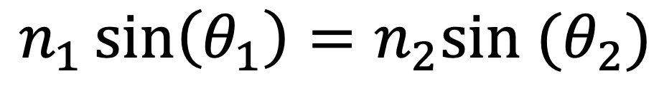
Where n1 and n2 are the indices of refraction of media 1 and 2 and theta 1 and theta 1 and theta 2 are the angles that the light makes relative to the normal of the surface separating the two media. This law can be better understood via this image from Wikipedia which depicts this type of refraction:
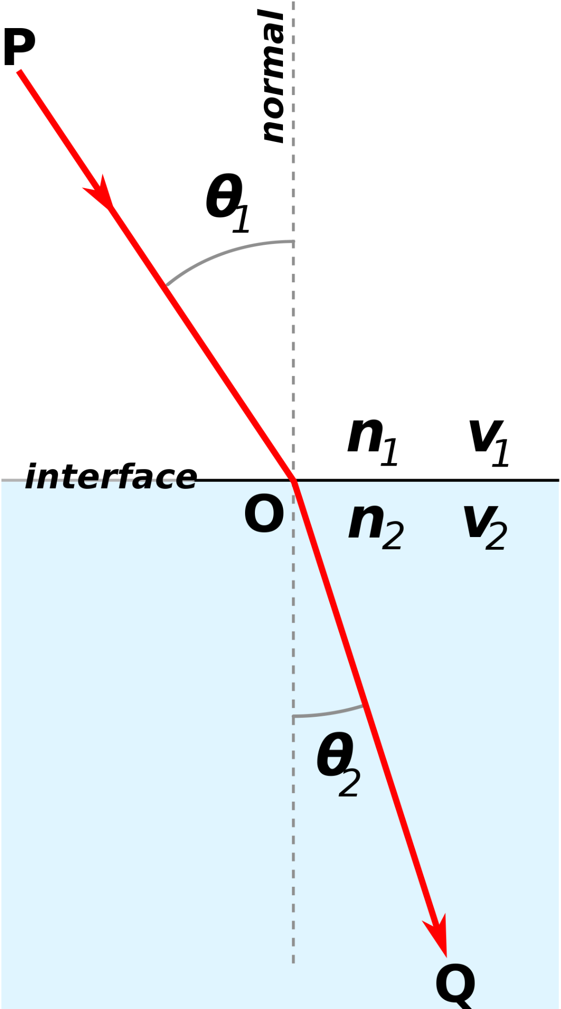

Long story short, if a light ray is coming from medium 1 across an interface at an angle relative to the normal, then it’s trajectory is going to change to one with a have a smaller angle relative to the normal if the index of refraction of medium 2 is larger than that of medium 1 (which is the case of water compared to air, with indices of refraction of 1.333 and 1.0 respectively). Hence, if the light is coming in at an angle of incidence close to 0 relative to the normal of the surface, then the light coming through is going to go through at an angle of transmission close to 0, but if its not close to 0 then the angle of transmission is going to vary. I am convinced that this is what happens with my setup, considering the diagram below (meant to be more of an artistic depiction rather than a serious scientific diagram)
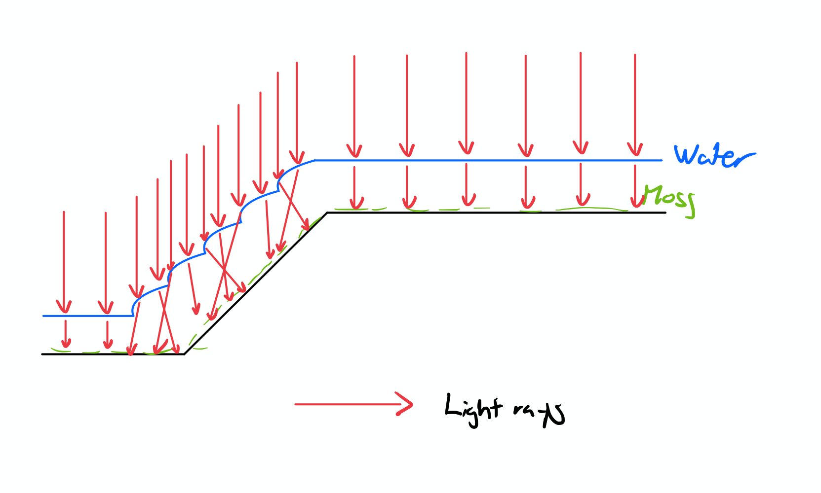
Considering that the rays of light of the sun (incident light) came in at an angle close to normal to the surface of the water at 2 PM on a clear cloud-less afternoon, one can expect that the transmitted light is going to be close to normal as well in the still sections of the water. However, the rippling sections of the water create a non ideal circumstance where the wave-like surface is no longer normal to the incoming light rays and viceversa. Hence, the transmitted light rays are ejected in many different directions within the water, creating interference patterns that create a distorted view. Because of the interference patterns these crossing light rays create, the light that is then reflected back to the viewer looks expectedly distorted, proving to be a rather feasible explanation of why the image in the rippling waves looks visibly distorted relative to the still water.
Description of changes done during post-processing
I used the GIMP editing software to do all my post-processing. For this, I decided to minimally shift the contrast and brightness curves (sharpening the darks and brightening the lights by aiming for a very subtle “S” like color curve, as was learned in class) to better emphasize the rippling effects and the waves while keeping the colors vibrant, being really careful of not ruining the otherwise naturally beautiful colors of the image. In addition, I decided to crop the image to center on the rippling effect and then rotate it 270 degrees clockwise so that the viewer better appreciated the flowing effect in the final photo.
Original photo:
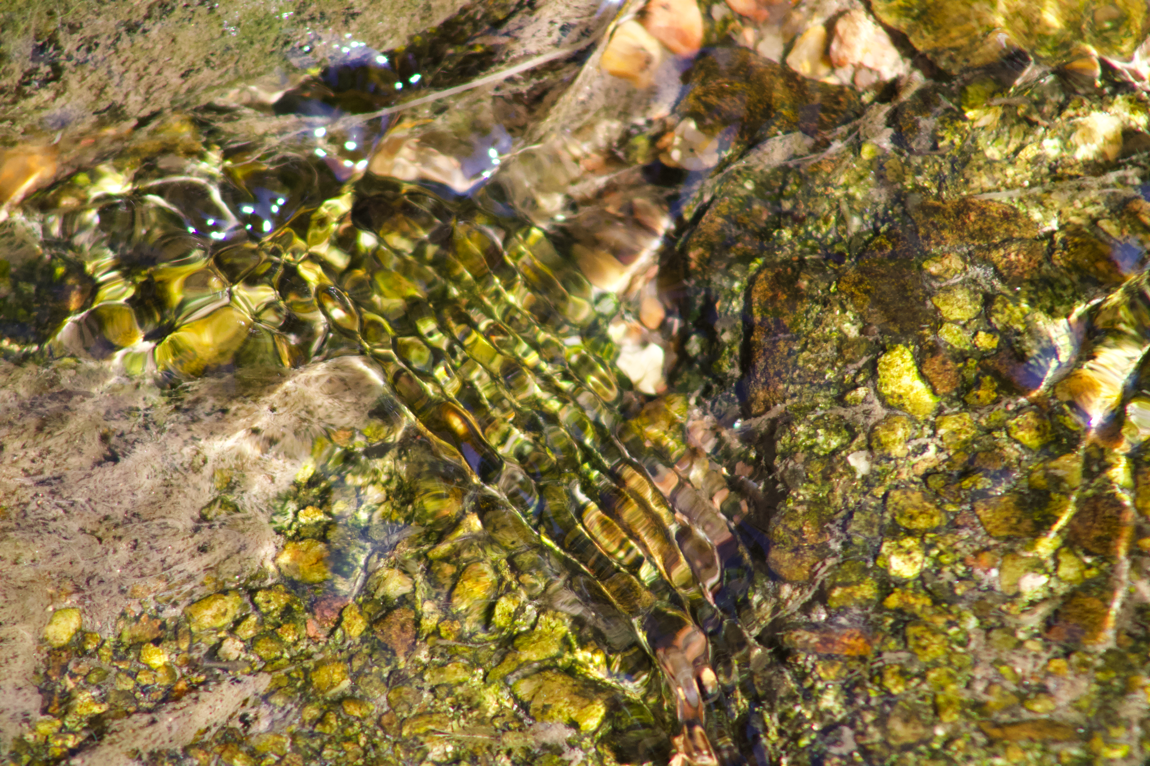
Post-processed photo:

Acknowledgements
I worked on taking the photo and the setup all by myself I would like to acknowledge professor Wieland for all his help in giving me advice while I was post processing the image, as well as my peers for all the kind constructive feedback presented during the critique sessions.

References:
Wikimedia Foundation. (2021, September 3). Snell's Law. Wikipedia. Retrieved September 27, 2021, from https://en.wikipedia.org/wiki/Snell%27s_law.

