Chris Taylor
MCEN 5152 - Flow Visualization
Image/Video #1
9/27/2021

____________________________________________________________________________

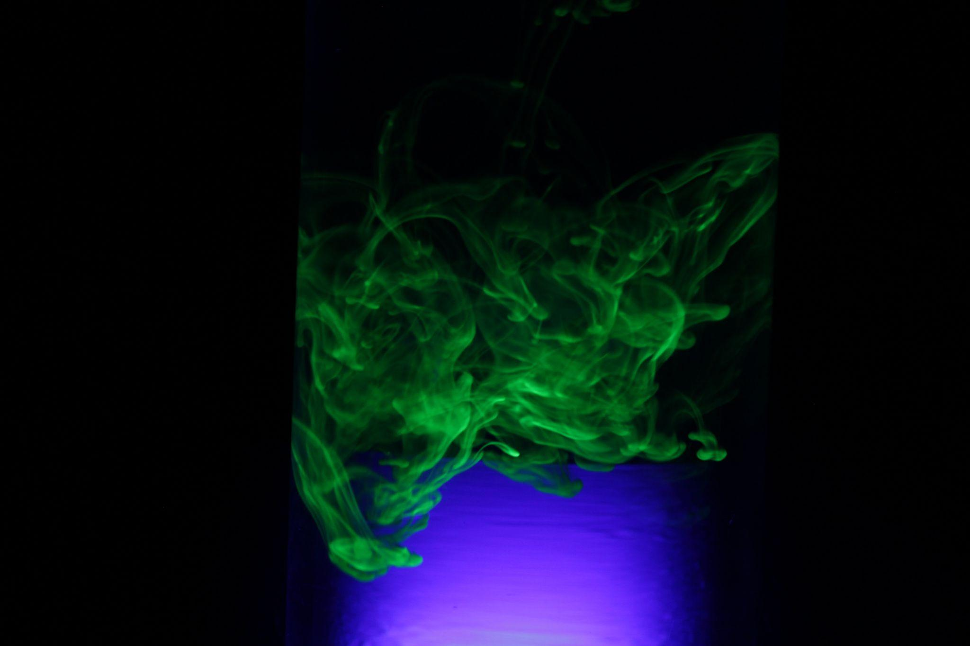

This image was captured for this first assignment in MCEN 5151 - Flow Visualization. The goal for this image was to test my skills at capturing fluid flows in the environment in a way that depicts both natural phenomena and creates a striking photograph. I wanted to capture the interaction of a higher density fluid moving through a less dense medium with only gravity as the driving force. This interaction is known as the Rayleigh Taylor Instability (RTI). The subject of this image is a drop of the fluid from a neon yellow highlighter falling through a vase filled with water.

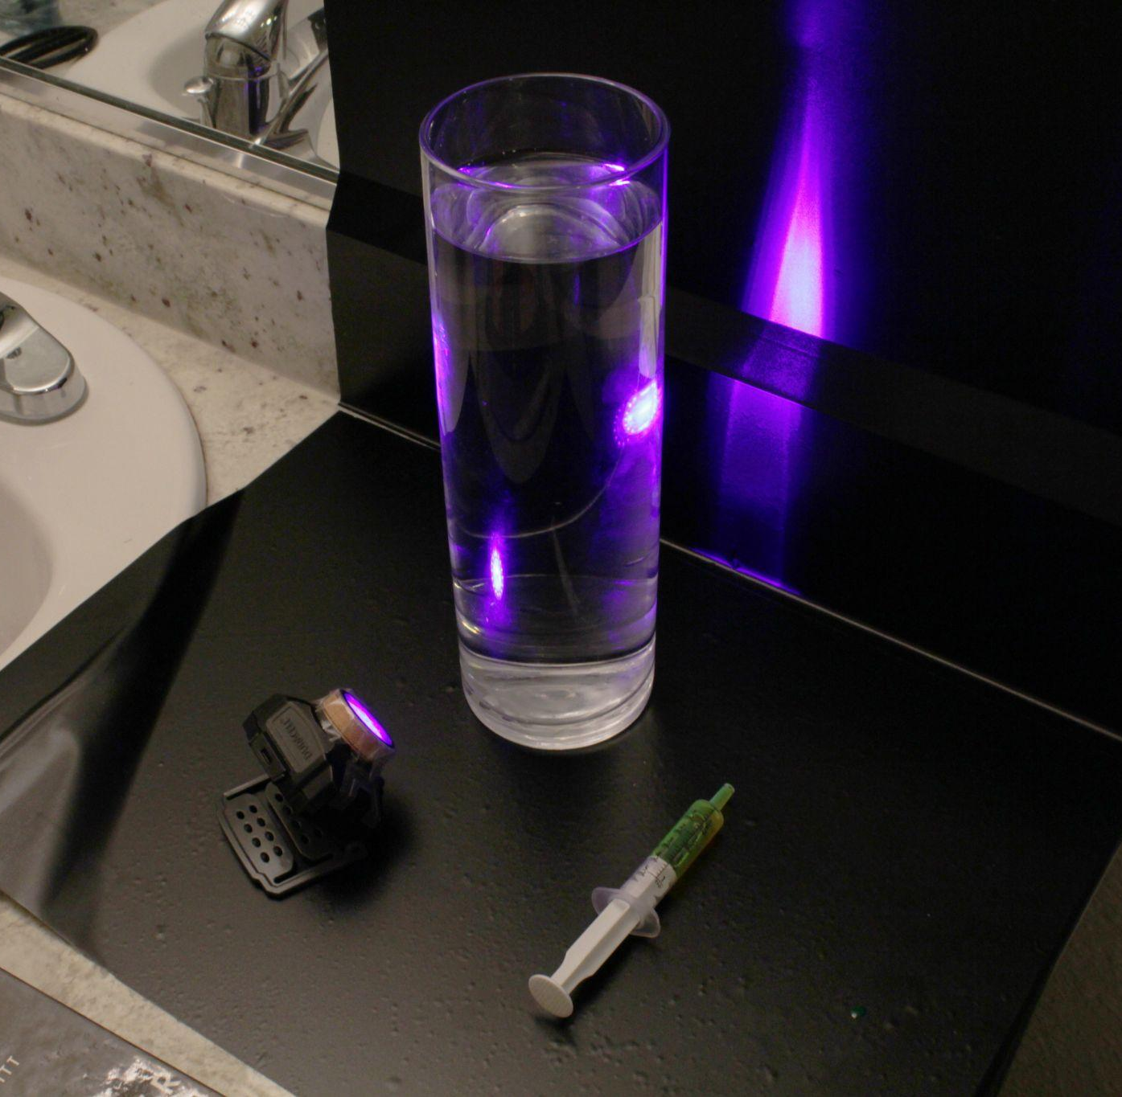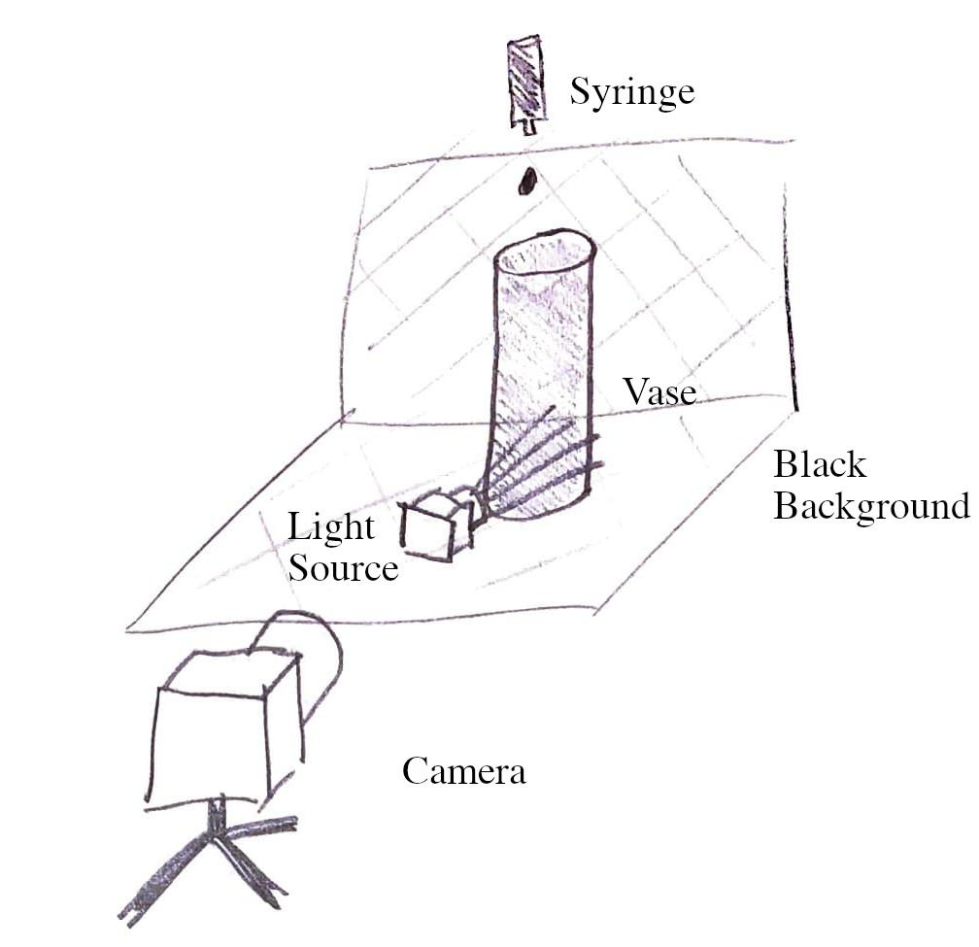
Figure 1: Picture Set up

Above in Figure 1 I have provided both a picture of the actual set up used and a sketch of my original design. The highlighter ink is contained in an oral syringe that I used to add a single drop of the ink to the water from 6” above the water’s surface. The droplet would then hit the surface and begin to fall through the water column before eventually reaching the bottom and diffusing into the water. The vase containing the water is 4” wide and 12” tall. This image was taken after the highlighter ink had sunk about 4” down through the water column. The speed of the highlighter fluid through the water changes with time: the fluid moves very rapidly through the first 2” of water before the stream begins to break apart and slow down. When this picture was taken I was able to estimate that the fluid horizon was sinking 1” every 4 seconds, or 0.005 m/s.
The predominant flow phenomena captured in this image is the Rayleigh Taylor Instability (RTI). This occurs when two fluids of different densities interact with only gravity acting on the system. In this case the instability is shown as the more dense highlighter ink moves through the less dense water in the vase. This instability initially generates “fingers” as the more dense fluid moves through its less dense surroundings. These “fingers” are characterized by a thin, downward flow of the heavier fluid which will begin to destabilize and generate “plumes” along the edges of the finger [1]. The frequency and size of the plumes will increase with time as the fluid’s motion becomes exponentially more unstable [2]. The RTI has four fundamental stages which commonly follow a linear timeline, however in this image we can observe flow characteristics from the last two stages simultaneously [1]. The first stage is focused on small amplitude perturbations in the fluid flow following the initial addition of the more dense fluid; this stage was exhibited at the beginning of the experiment but not captured in this image. In stage 2 fingers begin to form as the more dense fluid begins to move through the less dense medium, this also occurs prior to the picture being captured. The third stage is characterized by instabilities being generated at the edges of the fingers in the form of plumes, vortices and mushroom-like structures. The rate at which these instabilities generate is proportional to difference in the fluid densities, shown in the dimensionless parameter known as the Atwood Number. For larger Atwood numbers the system will destabilize more quickly as the more dense fluid will fall at greater velocities through the lighter fluid, which introduces more energy and increases turbulence [2]. I was able to estimate the Atwood number in this system knowing that the predominant ingredient of highlighter ink is glycerol with a density of 1260 kg/m^3 [3].

$A = \frac{p1 - p2}{p1 + p2 } = \frac{1260 - 997}{ 1260 + 997 } =0.117$

My system has a particularly low Atwood number as the density of glycerol and water are relatively close. This contributes to the lack of edge vortices around the highlighter fluid streams in the picture as well as the small mushroom structures at the horizon of the fluid as it falls. The fourth and final stage in a RTI is characterized by the general break up of the finger and the penetration of the lighter fluid into the more dense fluid as it falls. This stage is what is best exemplified by the image as the highlighter ink has completely destabilized and spread out across the vase. With the exception of the very bottom edge of the fluid as described above, the picture shows the chaotic mixing of two fluids best.
In order to visualize this phenomena in a striking way I decided to use the highlighter ink for the more dense fluid in the experiment. I utilized the phosphorescent properties of the ink to illuminate the fluid with a UV light as it moved through the water. The resulting irradiant wisps of fluid in conjunction with the deep violet background created a visual that I was extremely pleased with. To obtain the highlighter ink I cut open a neon yellow Sharpie and squeezed the foam ink vessel into a cup, where I then sucked it into the syringe shown in Figure 1. To create the UV light I used three layers of Scotch tape on top of an LED headlamp. On each layer of tape I used a Sharpie permanent marker to color the layer, effectively adding a color filter. I used two dark blue layers and one purple layer for the light in this experiment. This picture was taken in a completely dark environment with the exception of the DIY UV light.
I captured this image using a Canon Rebel t3i with an EFS 18 - 55mm 1:3.5-5.6 lens. The shutter speed was set at 1/4, with the aperture at f/10, and ISO 400. The focal length was 32mm while the distance from the subject was 12”. The original picture was 5184 × 3456 pixels in size. I chose to keep the camera close to the subject because I wanted the picture to be sufficiently bright to reveal the flow phenomena that were occurring. I had to keep the shutter speed slow in order to let in as much light as possible, luckily the highlighter ink was moving slow enough to limit the amount of motion blur present. I had the ISO lower when I took this picture as I did not want to introduce noise into the image. I did experiment with a higher ISO setting, however in the end I chose this picture because I felt it showed superior detail and had fantastic color. These colors are almost entirely as they appear raw in the original image. In post-processing I increased the saturation by 5% and the sharpness by 10%, but ultimately the final result was almost identical to the original. I purposefully left the image untampered with as I felt that what I was able to capture was fascinating enough to stand alone.
My favorite part of this image is the purple to green transition from bottom to top. The way that the UV light filled and reflected off the cylindrical vase created this amazing column of light that contrasts very well with the vibrant green of the highlighter ink. I also love the chaotic intersection of different strands of highlighter ink within the vase and the bright accents created as a result. I think this image shows the fluid physics in the later stages of the Rayleigh Taylor Instability very well as the different strings of color are distinct and exemplify the chaotic mixing of the two fluids in great detail. If I were to improve on this image I would want to try and retake the image with an ISO of 1600 or higher. I think that I was too conservative with the ISO as this was my first time using a digital camera and I was concerned that I would introduce noise. With this higher ISO setting I may also be able to increase the shutter speed to achieve a sharper image. I also learned the trick of using a pencil or similar object to allow the camera to set the focal length prior to running the experiment, which I will certainly use in the future. To take this idea a step further I would want to use a timed set up in order to capture the moment that the highlighter ink hits the water surface, to create an iridescent Worthington Jet. Overall I am proud of the image I managed to capture, particularly for my first time. The vivid color and energetic nature of the fluid against the black background allow the physics to pop off the screen in a way I did not think was possible.
References:

[1] Sharp, D.H. (1984). "An Overview of Rayleigh-Taylor Instability". Physica D. 12 (1): 3–18. Bibcode:1984PhyD...12....3S. doi:10.1016/0167-2789(84)90510-4.

[2] Journal of Computational Physics 169, 652–677 (2001) doi:10.1006/jcph.2000.6590, available online at http://www.idealibrary.com

[3] Christian, Schmid et al. INK COMPOSITIONS FOR USE IN HIGHLIGHTER MARKERS ASSOCIATED METHODS. 30 Aug. 2011, https://patentimages.storage.googleapis.com/e0/bc/f7/726830a361bb91/US8007096.pdf.

