Fall 2021 Image 1
  - Evan Hanson - 9/27/2021
  - MCEN 4151
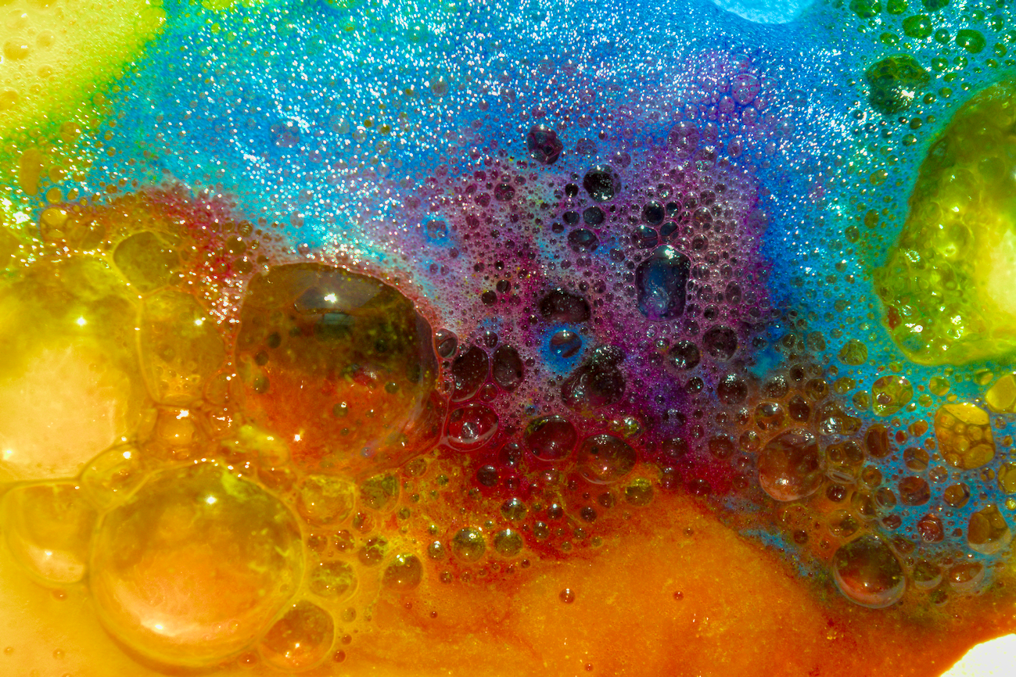

Introduction
For this flow visualization photograph, I aimed to capture a brilliant display of colors and textures. This was my initial dive into flow photography allowing me to learn more about flow visualization setups, photography details, and computer image editing. In this photograph, I intended to capture the chaotic release of gas of dyed baking soda and vinegar chemical reaction. I attempted many setup for this photograph including dumping the baking soda in a small white bowl and allowing the bubbles created in the chemical reaction to flow over the edges of the bowl. This created an interesting circle of bubbles but did not produce the quality of color that I was aiming for.

Set-up and Materials
To achieve a greater quality of color, I put the dyed baking soda onto a white plate, separated into thirds of a circle. I used yellow, cyan, and magenta powder dyes to create a final mixture of colors. I hoped that after I combined the vinegar into the baking soda, the colors would mix and produce secondary and tertiary colors as well. Figure 1 below shows the dyed baking soda divided into sections.
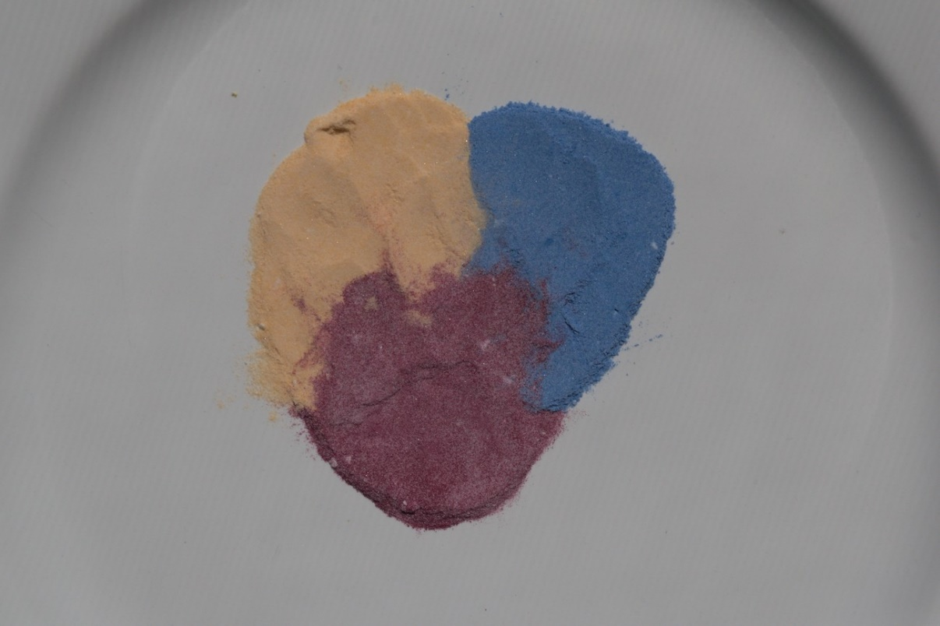
Figure 1. Baking soda and powder dye mixtures divided into sections.
After setting up the baking soda mixtures, I poured an approximately equal volume of white vinegar into the center of the baking soda. The two substances quickly began to react, and I was ready with the camera to capture the chemical reaction, creation of bubbles, and mixture of colors. Figure 2 below shows the experimental set up.
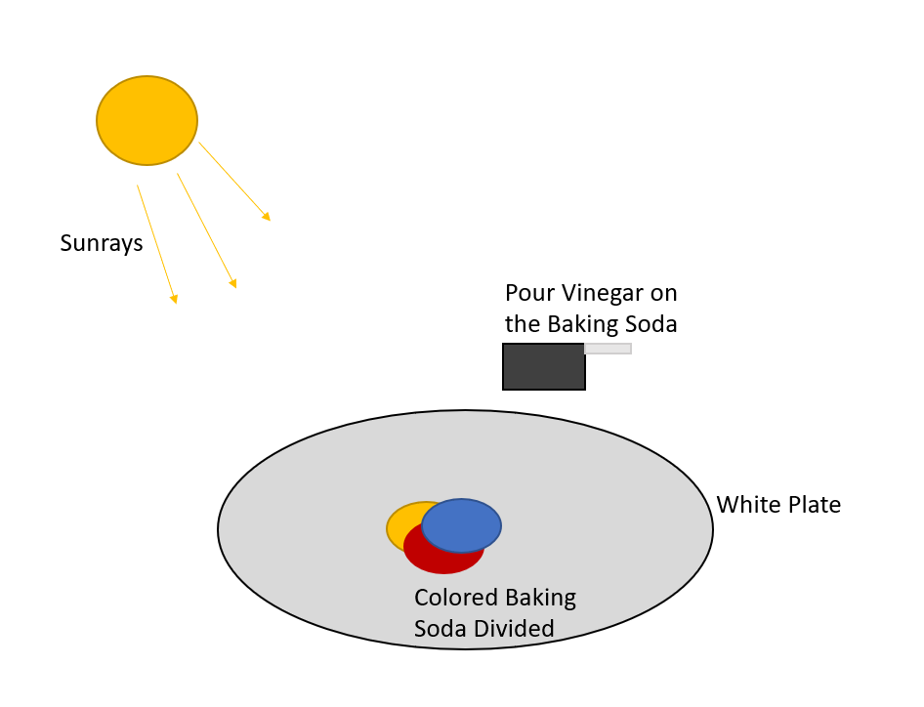
Figure 2. Experimental Setup

Flow Phenomenon

The fluid flow produced by the baking soda and vinegar reaction is better understood by looking at the chemistry of the reaction. Frist we must simplify the baking soda and vinegar into their active ingredients of the chemical reaction. Baking soda contain sodium bicarbonate which is a alkaline substance. White vinegar contains acetic acid which is an acidic substance. Combining sodium bicarbonate and acetic acid causes an exothermic neutralization reaction. This reaction will generate heat, carbon dioxide gas, water, and other aqueous molecules. Figure 2 below shows the chemical reaction of sodium bicarbonate ($NaHCO_{3}(s)$) and acetic acid ( CH₃COOH(l) ).
Figure 2. Chemical formula of the neutralization of sodium bicarbonate and acetic acid [1]
Seen in the chemical reaction formula, this reaction creates carbon dioxide gas that will expand to a greater volume than the 2 initial compounds. This quickly generates gas that the water and acetic acid solution will capture in bubbles due to the surface tension of the liquids.
As the gas is produced and bubbles form, the internal and external pressures of the bubble are equal and therefore the bubbles do not immediately collapse. While the reaction is occurring the gas produced created an internal pressure inside the bubbles that counters ambient pressure. Equation 1 below describes the forces acting on bubbles.
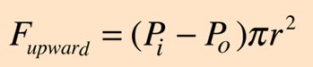[2] Eq. 1
When the internal pressure ($P_{i}$) and external pressure ($P_{o}$) from ambient pressure are equal, the resulting force on the bubble is zero. The bubbles expand when $P_{i} > P_{o}$ and they shrink when $P_{i} < P_{o}$.
Equation 2 below shows how the internal pressure and external pressure are related to the surface tension (T) of the liquid.
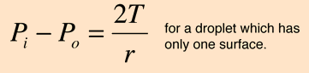[2] Eq. 2
We can see that when $P_{i} = P_{o}$ the tension in the bubble is zero thus it is stable. Also, when $P_{i} >> P_{o}$ or $P_{i}<< P_{o}$ then the tension in the bubble will get larger. If the tension resulting from the pressure differences is greater than the strength from cohesive forces of water, then the bubble will pop.

Photography Techniques
The camera used to take this photograph was a DSLR Nikon D3300 with a Nikon AF-s DX Nikkor 18-55mm f/3.5-5.6G VR II lens. The following table explains of the details of the camera setup.
Table 1. Camera Setup Details
Aperture | f/7.1
Exposure | 1/2000
Focal length | 55 mm
Focal Distance | 0.33 meters
ISO | 1600

I chose to photograph the flow by holding the camera in my hands. I needed to pour the vinegar onto the baking soda with one hand and take pictures with the other. This led me to use the automatic focus on the camera because I did could not hold onto the lens and change the focus real time manually. By holding the camera in one hand, I could get very close to the flow and take a full resolution photograph of the flow I wanted to capture. I did not crop the photo in post processing because I captured only the section of flow that I desired while shooting.
To illuminate the flow, I placed the plate of baking soda next to the window and had intense direct sunlight to use. The sunlight coming in the window was very bright and white which illuminated the colors even more. I hoped to be able to capture the vivid colors and the direct sunlight gave another depth of color to the flow.
To post process the photograph, I manipulated the color curves to accentuate the color contrasts and deepen the colors saturation. I had never used photo editing software before, so this process was trial and error to find what I liked.

Conclusion
Describe what the image reveals.
This photograph captures a variety of bubble sizes and colors from the three colors of dye mixing. I love the vivid colors captured in the photographs and contrasts of colors, bubbles, and focus. I dislike that I was not able to get the upper left portion of the photograph in focus. This is probably due to my shaky hands taking the photo as well as the different heights of the bubbles create different focus locations for the camera. If I were to retake the photo, I would manually set the aperture such that the upper portions of the flow are also in focus. The fluid physics of stable bubbles growing, decaying, and then popping due to a difference of pressure is captured well in this photo. We see many sizes of bubbles that have varying internal pressures due to the amount of gas produced in that area. I would like to develop this idea further by changing the setup so that more baking soda and vinegar reaction occurs and creates more bubbles.

Works Cited
- Anne Marie Helmenstine, Ph.D. “Know the Equation for the Baking Soda and VINEGAR REACTION.” ThoughtCo, Anne Marie Helmenstine, Ph.D., 31 Jan. 2020, https://www.thoughtco.com/equation-for-the-reaction-of-baking-soda-and-vinegar-604043.
- “Surface Tension and Bubbles.” Surface Tension, http://hyperphysics.phy-astr.gsu.edu/hbase/surten2.html.

