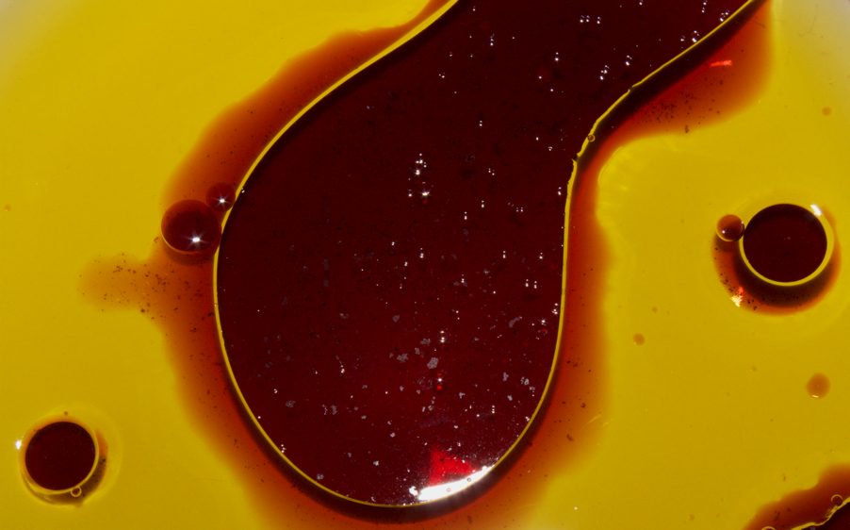

Flow Visualization (CINE 4151): IV Report 2
Gus Santaella
Prof. Scott Wieland
10/11/2021

Relevant stats:
Camera: Canon Rebel T7
Shutter speed: 1/60
Aperture: f. 22
Lens focal length: 55 mm
ISO: 800
Size (final PNG file): 5.3 MB
Dimensions (final PNG file): 1300 x 807 pi
Size (original RAW file): 29 MB
Dimensions (original RAW file): 6014 x 4003 pixels
Size-subject distance: about 20 centimeters (see setup and methodology section)

Brief description of the photo and introduction:
My photo for this second assignment is a depiction of wine dropped onto an oil base held in a white ceramic bowl, where the difference in viscosity of the wine and the oil (in addition to the flash of my camera) gives a nice combination of textures and sub-flows within the image, such as the wine “bubbling” within the oil, the wine “bleeding” onto the base of the ceramic bowl, and the little bubbles in the wine and the oil (possibly caused due to oxygenation during the dropping of the wine) reflecting some of the light of my flash bouncing back into the camera lens creating a glitter-like effect around the big bubble in the center and an interesting reflection pattern in both the side bubbles and the center bubble.

Artistic and scientific intents
My ultimate artistic intent with this image was to come up with an experimental representation of a flow solely using materials I could find in my apartment (in this case, olive oil and wine) while using the means available to me and working around the limitations in my apartment to create a nice image.
In addition to my artistic purpose, my scientific intent was to be able to use this artificially created flow to showcase the visually appreciable consequences of the mixing of two liquids with vastly different viscosities.
Setup and methodology.
I took this photo in my apartment, located just off the CU main campus at 10:12 AM on Wednesday, September 22nd, 2021. I placed a white ceramic bowl onto a table, poured an even layer of oil (of about 0.5 cm thickness) onto it, and then poured some wine droplets directly onto the oil. After waiting for a minute or two, the flow reached the steady-state appreciated in the final image, meaning it is not moving at the time the photo it was captured. I then stood directly above the flow and then started taking different photos of the flow from different angles. For the chosen image depicted in my submission, my camera lens was directly normal to the surface of the flow, standing about 20 cm away from the flow itself. My main source of lighting was my flash, located directly in the camera (thus, also 20 cm away from the flow), which allowed me to obtain even lighting throughout the flow. I must note that, despite the fact that there was an ambient light in my room, it is not appreciable in my picture. An overview of the entire flow can be appreciated in this image:
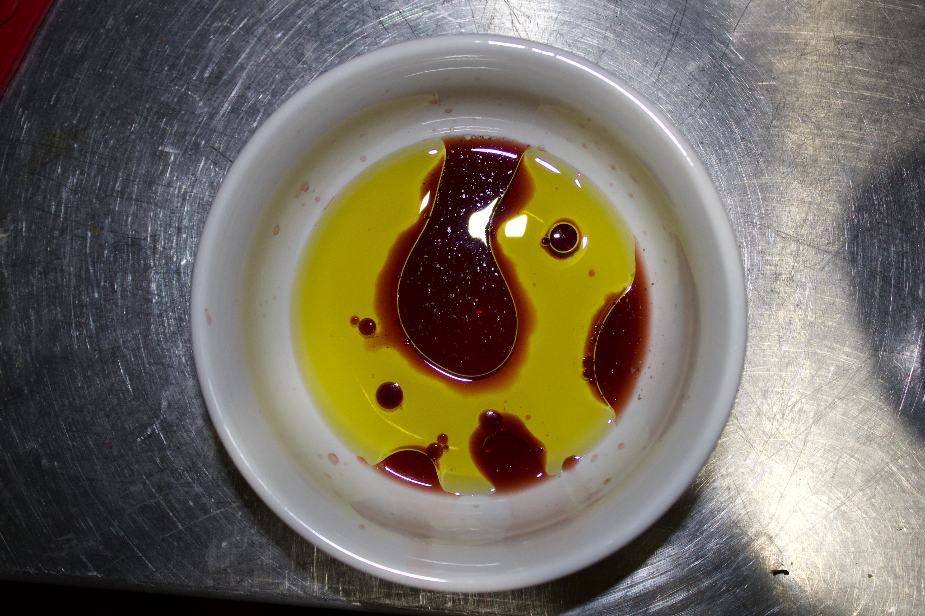

And this very setup setup can be described by the following diagram:

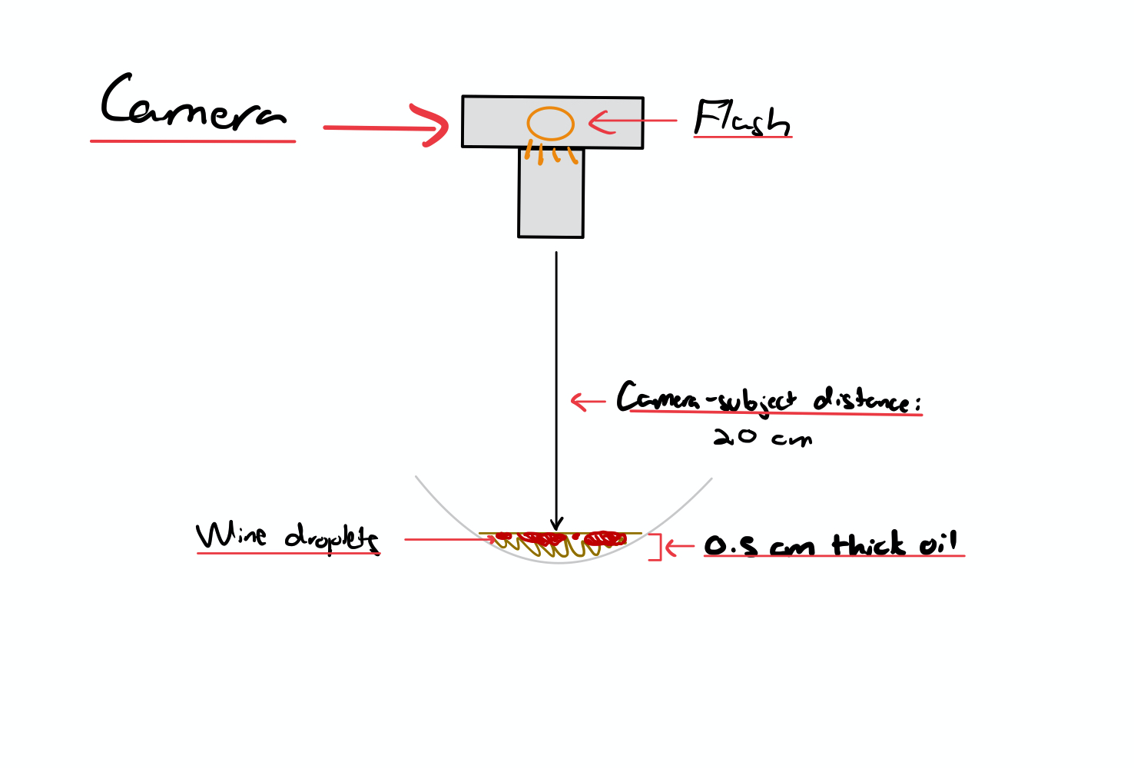
In addition, the net displacement of the flow depicted in the image was about 8 cm from side to sidewhich, at the steady-state position it was captured in, was at rest (in other words, with a velocity equal to 0), which is minimal compared to the used 1/60 s = 0.0166 s shutter speed. It must be noted that I tried working with different shutter speeds and aperture settings to get my desired lighting/color contrast until settling for the settings specified in the stats section.
Explanation of effects based on a theoretical groundwork:
The fluid depicted in the flow is in a steady state and is not moving, meaning it has no velocity. Thus, calculating a Reynolds number (which depends on the velocity of the fluids in a flow while an image is being captured), would be meaningless.
Instead, I think it is more interesting to make sense of the theoretical groundwork behind the difference in viscosity of the fluids to make us better understand the flow being captured, given that this is an explicitly heterogeneous mixture where the wine does not mix with the oil. We must note that the bleeding effect on the surface of the bowl took about a minute to reach its steady state position, so we can study it with viscosity and diffusion laws to better understand it. A detail of the effect can be found below, with a visible gradient in the change of concentration:
We know that particles of a certain substance will go from high to low concentration under a certain other substance, a phenomenon that can be described with Newton’s law of viscosity, defined to be:
$$τ=μ*\frac{Δv}{Δx}$$
In other words, the shear stress (called diffusion flux by some sources) is equal to the the viscosity coefficient times the chance in velocity of the fluid over its displacement. This defines “the relationship between the shear stress and the shear rate of a fluid subject to mechanical stress” (Springer, 2021).
We shall calculate what the shear stress is for the bleeding effect of the wine onto the oil between the 60 seconds between pouring and steady-state along the gradient where this effect occurs. To do this, we’ll have to make a few assumptions in order to consider the mixed properties of the wine and the oil. Considering that the viscosity ($μ$) of wine is of about$1.5*10^{-3} Pa*s$(Danner et al, 2019) and assuming that the net displacement of the bleeding effect ($δx$) is about 0.3 cm while assuming the initial velocity of wine to be $v{}_{0}=\frac{0.3 cm}{60 s}$and the final steady-state velocity to be $v{}_{f}=0$. Plugging in all of those values into the equation we get:
$τ = 1.5*10^{-3} Pa*s*\frac{-\frac{0.3 cm}{60 s} }{0.3 cm}$= -3.3$*10{}^{-5} Pa$

Description of changes done during post-processing
I used the GIMP editing software to do all my post-processing. As was the case with the last assignment, I decided to shift the contrast and brightness curves (sharpening the darks and brightening the lights by aiming for a very subtle “S” like color curve, as was learned in class) to better emphasize the bubbling effects while keeping the colors vibrant. I focused on making the colors of the flow more impactful relative to the original image with the color correction, minimizing any potential annoyances the flash may cause on the final image. In addition, I cropped the image to remove any undesired features, such as parts where the ceramic bowl appears in the image as well as to remove a single piece of undesired reflection of flash lighting located slightly below the main central wine bubble.
Original photo:
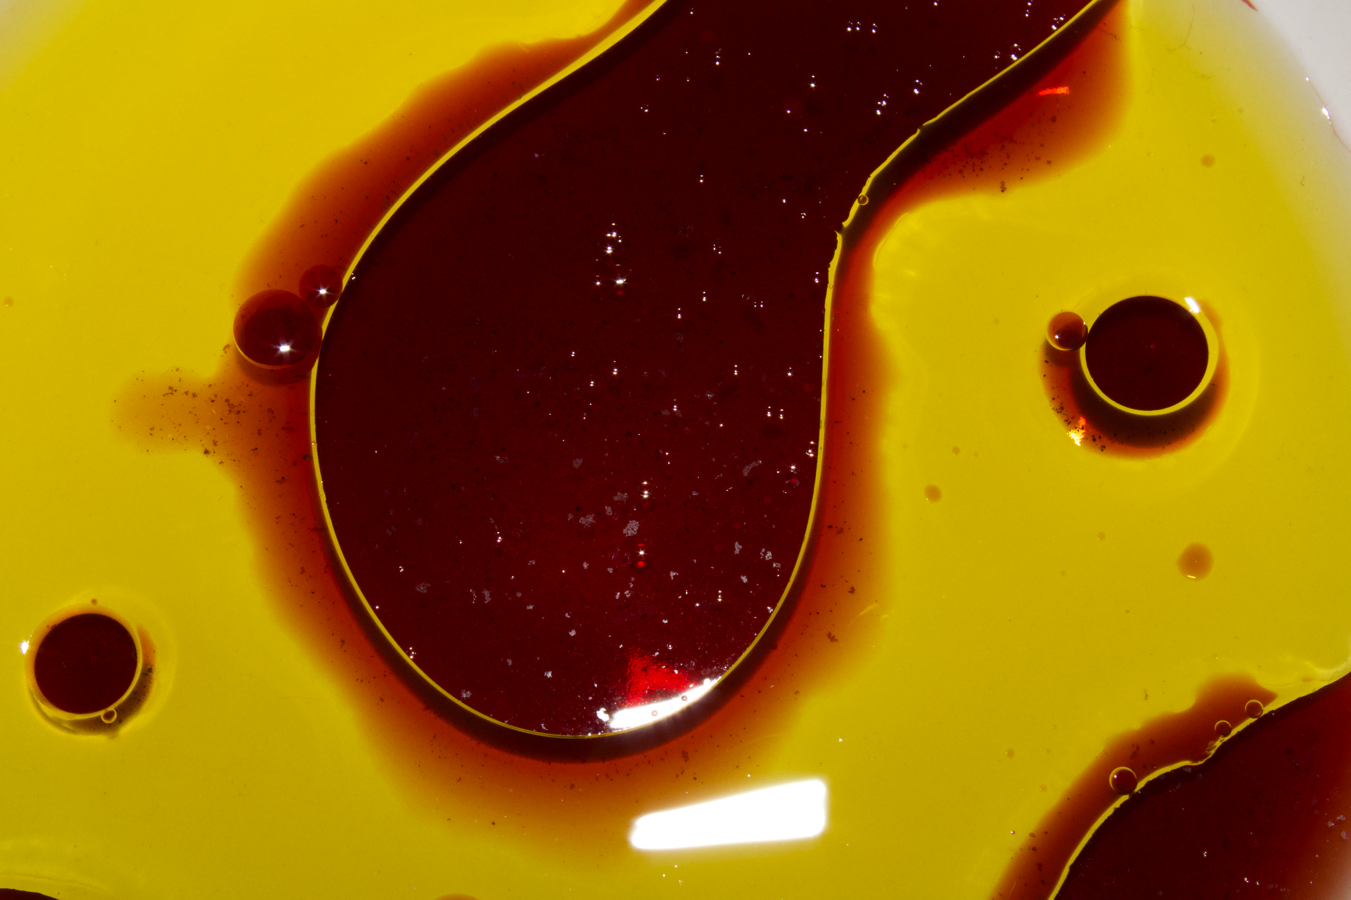
Post-processed photo:

Acknowledgments
I worked on taking the photo and the setup all by myself, but I would like to acknowledge professor Wieland for all his help in giving me advice while I was post-processing the image, as well as my peers for all the kind constructive feedback presented during the critique sessions.

References:
George, H. (2013). Newton’s Law of Viscosity, Newtonian and Non-Newtonian Fluids. Springer. Retrieved October 11, 2021, from https://link.springer.com/referenceworkentry/10.1007%2F978-0-387-92897-5_143.
Danner, L., Niimi, J., Wang, Y., Kustos, M., Muhlack, R. A., & Bastian, S. E. (2018). Dynamic viscosity levels of dry red and white wines and determination of perceived viscosity difference thresholds. American Journal of Enology and Viticulture, 70(2), 205–211. https://doi.org/10.5344/ajev.2018.18062

