Fall 2021 Cloud Image 1
  - Evan Hanson – 10/25/2021
  - MCEN 4151
Photograph of stratocumulus clouds taken on September 20th, 2021 at 6:05 pm in Boulder Colorado.
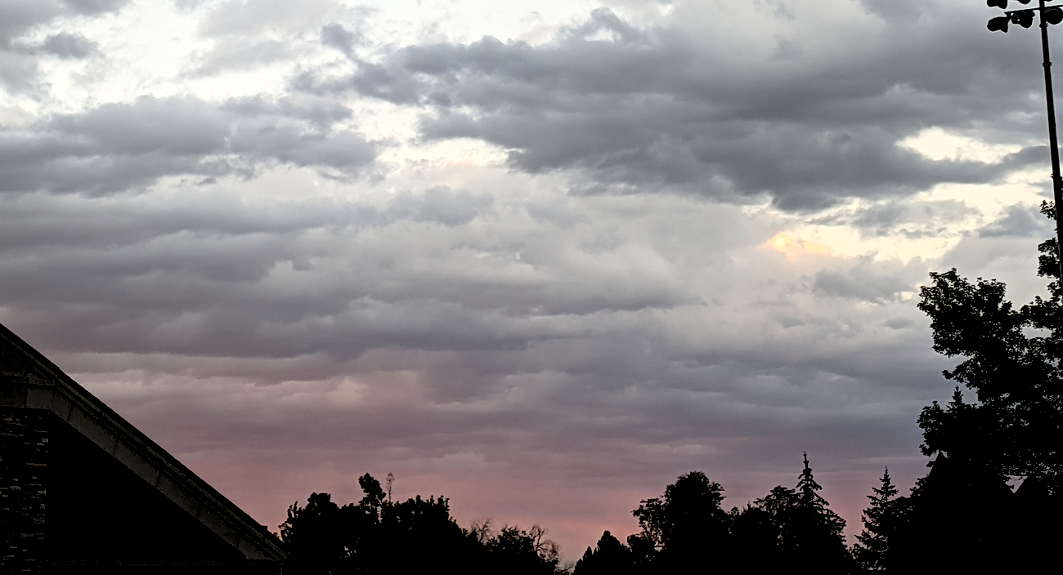

Introduction
For this cloud photograph, I aimed to capture a brilliant display of colors and blanket like texture of the stratocumulus clouds. This was my initial dive into cloud photography allowing me to learn more about cloud formation, types, and identification. In this photograph, I intended to capture how the sunset projected color over the unique texture of the stratocumulus clouds.

Photograph Setting
I took this photograph on September 20th, 2021 at 6:05 pm from Franklin Field on the CU Boulder campus. I oriented the camera northeast of Boulder at a very low angle relative to the horizon. In the photograph, I captured the tops of a building and trees that I later darkened in postediting to give them a silhouette look. The original photograph is shown below showing the trees and building roof top originally captured.
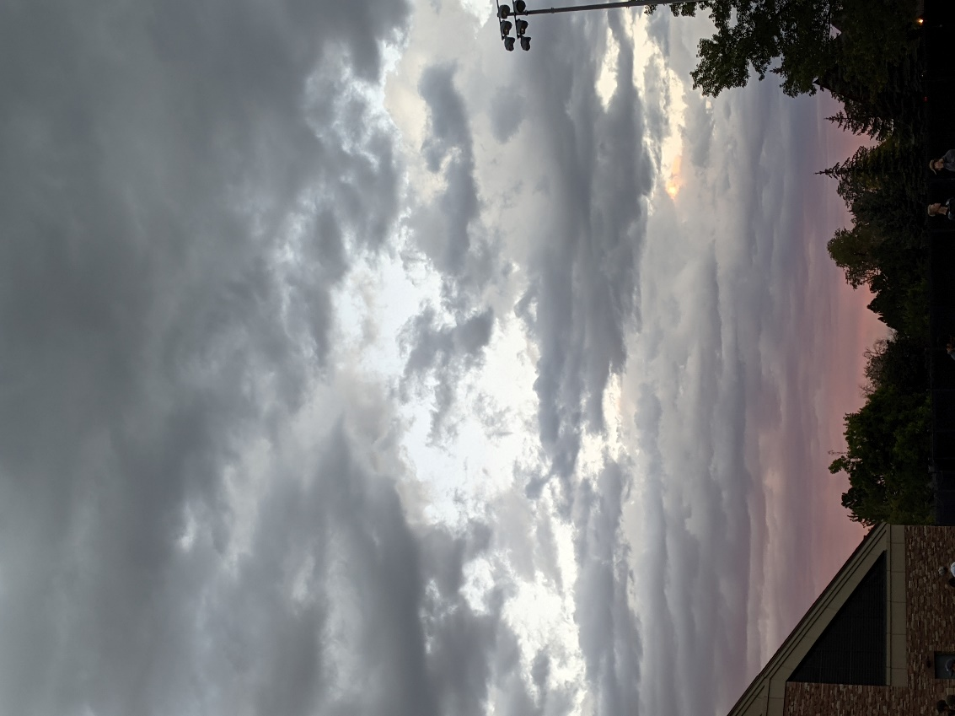
Figure 1. Original Photograph
The weather the day this photo was taken was very mild without much wind, temperature change, or precipitation. The high and low temperatures that day were 77®F and 52®F.

Cloud Phenomenon
In this photograph I can see clumps of darker, thicker clouds that cover the sky. From this I narrow the cloud type to stratocumulus clouds and a comparison to the descriptions to those from whatsthiscloud.com supports my conclusion. The following is an example of stratocumulus clouds from whatsthiscloud.com so that I can visually compare my photograph to a known cloud type.
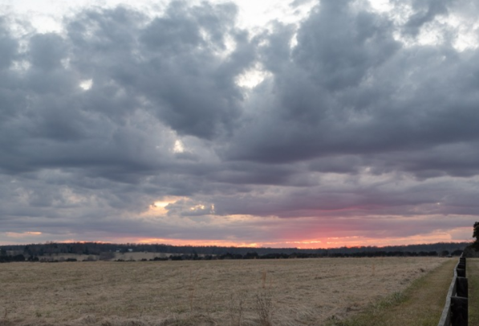
Figure 2. Example of a Stratocumulus cloud from whatsthiscloud.com [1]
On September 20th at 6:00 pm MST a weather balloon set of from Denver Colorado, only 30 miles away from where this photo was taken, generated the follow Skew-T diagram.
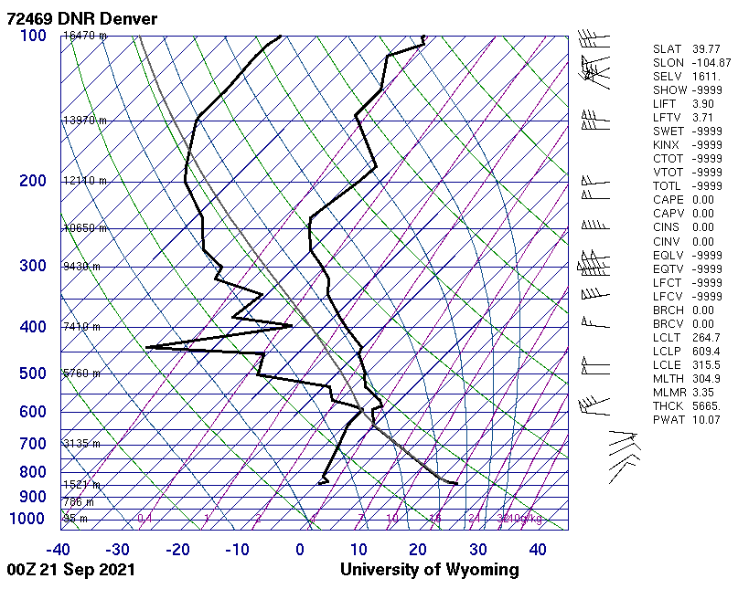
Figure 3. Skew-T diagram from Denver CO at 6:00 pm MST on 9/20/2021 [2]
This Skew-T diagram gives a lot of information about theses stratocumulus clouds. I am assuming that the same clouds were covering Denver. Looking at the Skew-T diagram, I see around the 4000 m above Denver mark, the dew point and temperature lines are very close. This suggests that the air around 4000 m is condensation into clouds. Also, at this altitude the parcel lapse rate is at a lower temperature than the dew point meaning that the temperature of a parcel of rising air would drop below the dew point and condensate into a cloud. This suggests that the stratocumulus clouds I photographed I on September 20th were at 5.6 km above sea level. The CAPE value is 0.00 suggesting that the atmosphere is in a stable spot. Another interesting note is on the Skew-T diagram, the wind direction flips at 4000 m and the speed of the wind below 4000 m is very low. This could create a shear layer at 4000 m and cause atmospheric instability by drawing upward through the shear layer.

Photography Techniques
The camera used to take this photograph was Pixel 3 cell phone camera. The following table explains the known details of the camera setup.
Table 1. Camera Setup Details
Resolution | 12.2 MP
Aperture | f/1.8
Focal length | 4.44 mm
ISO | 65
Exposure | 1/112

I photographed this cloud with my cell phone camera because that was the only camera I had access to at the time. If I had used a nicer DSLR camera I predict that I would have been able to capture a better resolution, focus, and better-quality photo.

Conclusion
This image captures a stable formation of stratocumulus clouds in the Colorado front range. I like the textures and colors captured. From the Skew-T diagram, this photograph illustrates cloud formation likely due to shear layer movement of fluid. The wind above and below the cloud layer is in opposite directions and dramatically different magnitudes that would cause shear layer turbulence. This will cause denser air to kick up into a higher location, which has a dew point causing cloud formation. I think that the clouds are from the shear layer and not atmospheric instability because the CAPE value is 0.00. I like that this photograph and Skew-T diagram shows explainable fluid physics. I could improve the quality of the image by using a better camera and spending time to hone in the camera settings to better capture the color and texture of the clouds. I would develop this idea further by changing the camera location to capture different angles of this cloud. If I could, I would like to get on top of a building to get a cleaner and better focused photograph of this cloud.

Works Cited

[1] “Learn about Stratocumulus Clouds: Low, Puffy Layer.” Whatsthiscloud, https://whatsthiscloud.com/cloud-types/stratocumulus/.
[2] University of Wyoming Department of Atmospheric Science. Atmospheric Soundings, http://weather.uwyo.edu/upperair/sounding.html.

