Fall 2021 Image 2
  - Evan Hanson – 10/11/2021
  - MCEN 4151
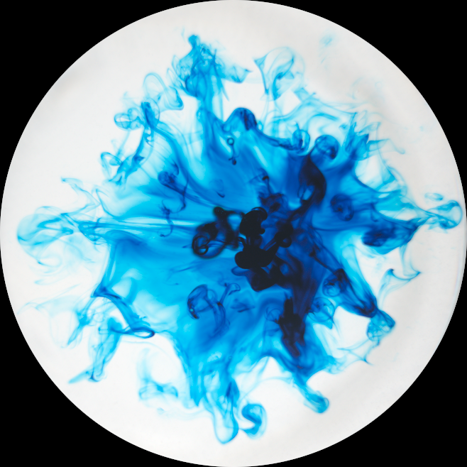

Introduction
For this flow visualization photograph, I aimed to capture a brilliant display of colors and textures. This was my second dive into flow photography allowing me to learn more about flow visualization setups, photography details, and computer image editing. In this photograph, I intended to capture a delicate moment of turbulence. In this flow visualization I worked with Luke Bieganek, who is a small business owner and professional photographer in Fort Collins. Luke and I tested out multiple flow visualizations but in the end we both liked the complexity of this photo. I set up and performed every experiment while Luke used his camera to photograph the flow phenomenon.

Set-up and Materials
To achieve a contrast of simplicity in color and complexity of texture, I dripped a single drop of dye into a clear glass of water and Luke captured the turbulence from above. I placed the glass of water on top of a LED panel light to create a homogeneous white background. On the camera, we used a macro lens with a polarized filter to focus precisely into the turbulent flow. Figure 1 below shows the original photo taken of the flow. Notice how the camera automatically dimmed the photo because of the backlighting in the setup. This was fixed in post processing by changing the maximum white position. Also, in this original photograph, the glass and backlight panel are visible.

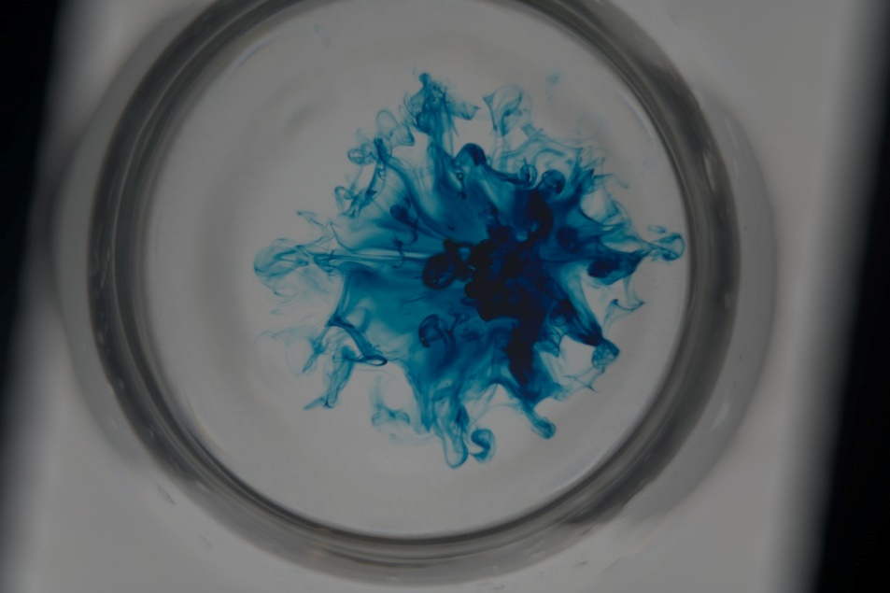
Figure 1. Original Photograph

Flow Phenomenon
The flow phenomenon was captured in this photograph by dripping dye into a clear glass of water that is on top of a LED light panel then photographing the dye from above. A diagram of the flow visualization setup is shown in Figure 2. This setup is very simple but allowed us to try the experiment over 20 times to capture the perfect turbulence.

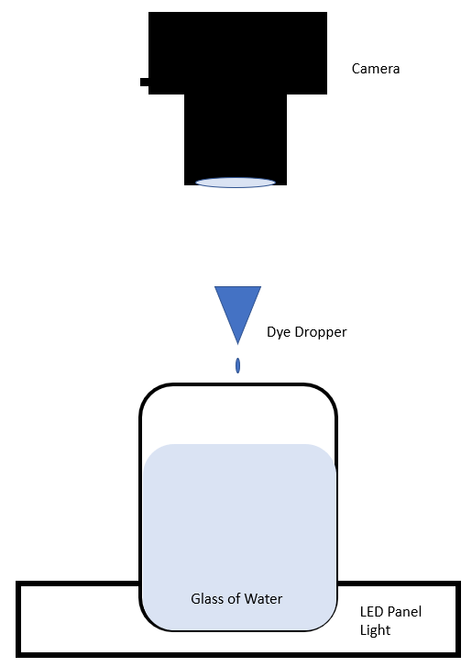
Figure 2. Experimental Setup
The turbulent flow in this photograph is governed by its Reynolds number, which gives information about if the flow is in turbulence or laminar. Equation 1 below explains how to calculate the Reynolds number of a flow. In this equation, ρ is the density of the fluid, μ is the dynamic viscosity of the fluid, L in the linear motion of the fluid, and u is the fluid velocity.
 | 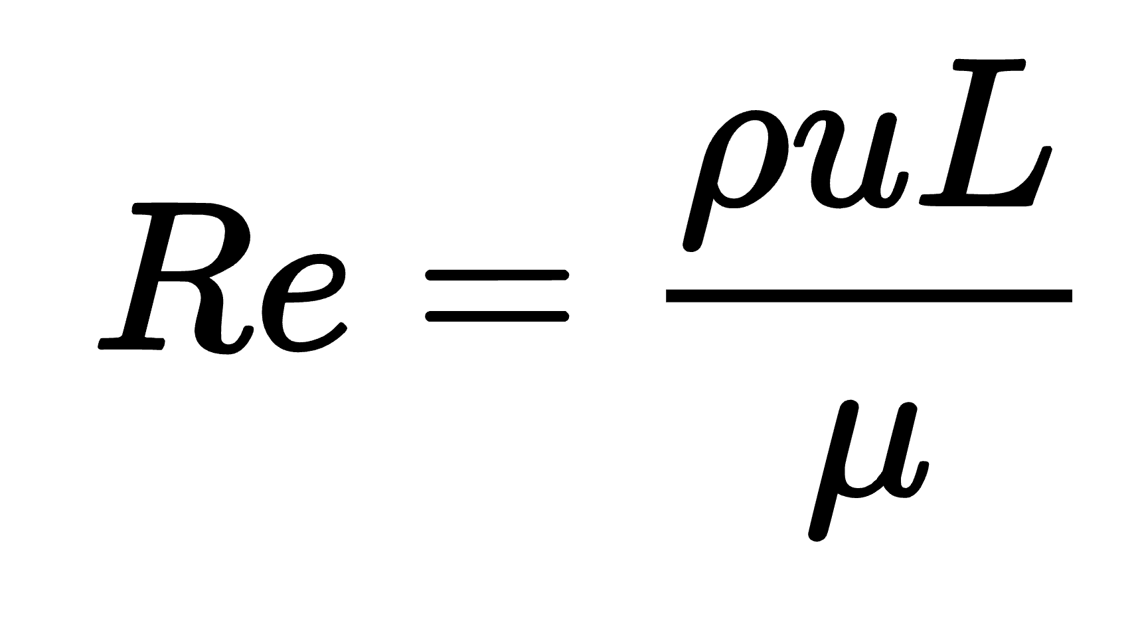 | Eq 1.

Looking at a different photograph taken three seconds after the chosen photo and following a section of flow allows me to approximate distance and velocity of the flow, shown in Figure 3. The dye is mostly falling away from the camera lens, so it is difficult to approximate the fluid movement distance. Because the water height was about 5 cm and between the two pictures a section of flow moves by about 1 cm, I will approximate the Linear motion of the fluid (L) as 3 cm.
I can approximate the velocity with a Δt of 3 seconds and Δx of 5cm as u = 1.66 cm/s.
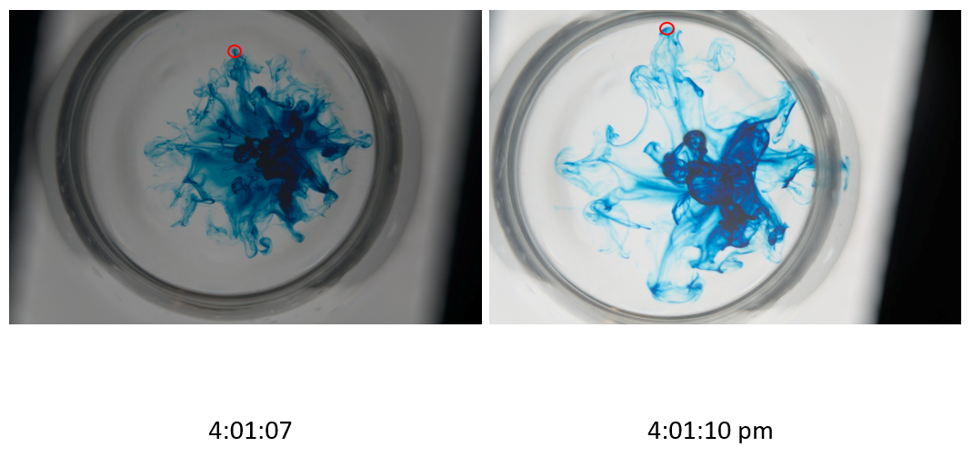
Figure 3. Comparing two photographs to estimate the velocity and distance of fluid flow
The density and viscosity of the dye are approximately the same as water and for this approximation I will assume similar densities and viscosity. [1]
Density (ρ) = | $1000 kg/m^{3}$
dynamic viscosity (μ) = | $$0.9 Ns/m^{2}$$

By combining all the approximated values to equation 1, I can approximate the Reynolds number to be about 3333.
Reynolds numbers less than about 2000 dictate the flow is laminar and Reynold number greater than about 3500 dictate the flow is in a turbulent state. [2] A Reynold number that lands in the middle of these values is in a transitional state between laminar and turbulent. This validates the flow in the photograph because there are vortexes around the flow but distinctly laminar wisps of dye as well.

Photography Techniques
The camera used to take this photograph was a DSLR Nikon D3300 with a Sony ILCE-7RM3 with a FE 85mm F1.4 GM lens. The following table explains of the details of the camera setup.
Table 1. Camera Setup Details
Aperture | f/1.8
Exposure | 1/800
Focal length | 85 mm
Focal Distance | 5.07 meters
ISO | 100

We chose to photograph the flow by setting the details of the camera up then and moving the camera up and down to get the flow into focus. The turbulent flow very quickly diffused into the water, so we needed to take the photos quickly and we were able to get them in focus easier by moving the camera instead of changing the focal distance of the camera.
I dripped the dye onto the water, moved the dye dripper quickly out of the way, then Luke took the picture. Because the dye diffused into the water very quickly, we only had a few seconds to capture a contrastive photograph. Therefore, I set the camera setting before dripping any dye and moved the camera up and down to get the turbulence in focus. Doing this, we captured an in focus and high-resolution photograph and the turbulent flow I set up to get.

Conclusion
This image captures a range of turbulent and laminar textures, dye shades, and a stunning neon blue color. I love the vivid color and contrast in this photograph. I chose to crop the image into a circle to isolate the flow from the surrounding setup. I think that this makes the flow pop out of the page. By looking into the Reynolds number of the flow is a transitional flow Reynolds number, I can better understand some of the physics within the photograph. I can see that there are turbulent patterns in the dye with swilling vortexes but as the dye spreads out, I see the laminar wisps of dye as well.

Works Cited
- Edge, Engineers. “Water - Density Viscosity Specific Weight.” Engineers Edge - Engineering, Design and Manufacturing Solutions, https://www.engineersedge.com/physics/water__density_viscosity_specific_weight_13146.htm.
- “Laminar and Turbulent Flow.” Laminar and Turbulent Flow | Engineering Library, https://engineeringlibrary.org/reference/laminar-and-turbulent-fluid-flow-doe-handbook.

