Cumulus Cloud

Isaac Lammers

MCEN5151: Flow Visualization

Aerospace Engineering

University of Colorado, Boulder
10/15/2021
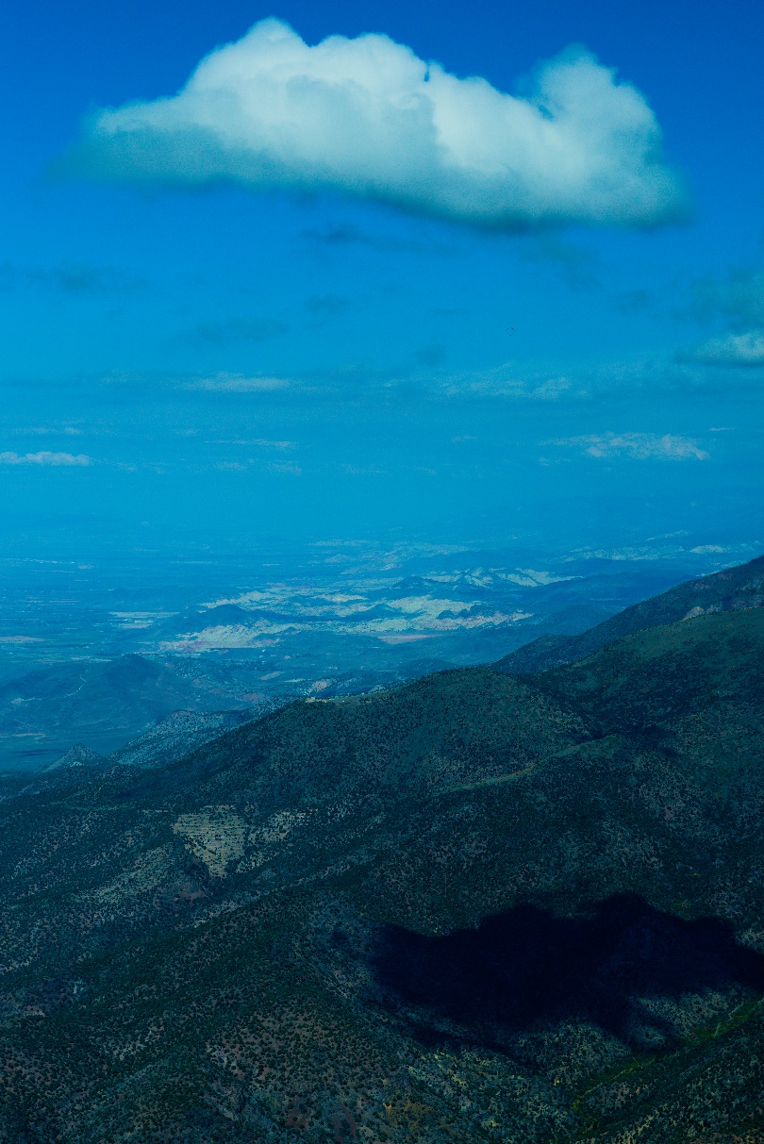

Introduction
The objective of the Cloud 1 project was to capture a photograph of clouds which are great visual indicators of air flow in the atmosphere. I set out to take a photo of a cumulus cloud which I am rather familiar with as it is something I look for when I go paragliding. In paragliding cumulus clouds are physical signatures of thermals and utilizing thermals in free flight is how a paraglider can stay aloft, flying, for hours. During a paragliding flight in Monroe, Utah I was able to capture an image of cumulus clouds and the intro picture is the result.

Explanation of Forces
To begin the explanation of cumulus clouds I am first going to talk about thermals. Thermals are areas of rising air that generally extend from the ground up to base of clouds. This rising air is being forced up by, cooler, sinking air surrounding it. This is indicative of an unstable layer in the atmosphere where there is warm air below cold air, and the warmer air wants to move from warm too cold to find equilibrium following the laws of thermodynamics. Thermals begin by the ground heating due to radiation from the sun. The ground warms and stores heat to some extent. Once the ground has absorbed enough heat to overcome the atmospheric differential in temperature required for the air mass to release, it generates a warm parcel of air that begins to rise from the atmosphere. Thermals can be visualized on paper as seen in Figure 1.
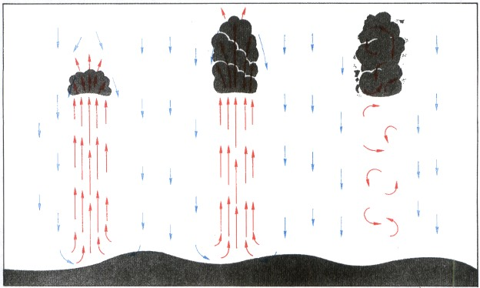
Figure 1 - Life of a Thermal (Federal Aviation Administration, 1965)
The picture on the right is the beginning of the thermal and the cumulus cloud. The second is fully developed and the third is as it is dissipating, and the cloud is beginning to break apart. As a paraglider, the interest is in the beginning and early stages of the fully formed cumulus cloud. This is also the focus of the cloud in the image. This cloud in the submitted image is in the early stages of fully formed and about to dissipate. It has some lift left to give but is likely to be done with the thermal cycle and will begin to break apart.
The thermal carries the moisture from the ground that has evaporated with radiative heating and is carried through this convective action to the altitude where the dew point and temperature are close enough to cause condensation and clouds are generated. This is also in part due to the reduced pressure the air parcel is subjected too at a higher altitude. As work is done on the parcel of air being lifted it prevents the air from holding moisture as easily as it did under pressure and is also aids in the condensation of the evaporated water and the formation of clouds (University Corporation for Atmospheric Research, 2021). This process does not only produce cumulus clouds but can also form the larger, more dangerous for paragliders, cumulonimbus clouds. These are the clouds that are typically associated with thunderstorms. In this image that I submitted there is also some forced ascent happening where air masses are pushed up against a mountain side and this forces the air to rise and generate clouds as well. All this combination of forced accent, thermal generation from radiative heating, and convective action of sinking air forcing the warmer air to rise higher in the atmosphere made for an excellent flying day.
The rate at which the air is rising can be calculated and is known as the lapse rate. This is found by looking at Skew-T chart. The Skew-T for this day can be seen in Figure 2.
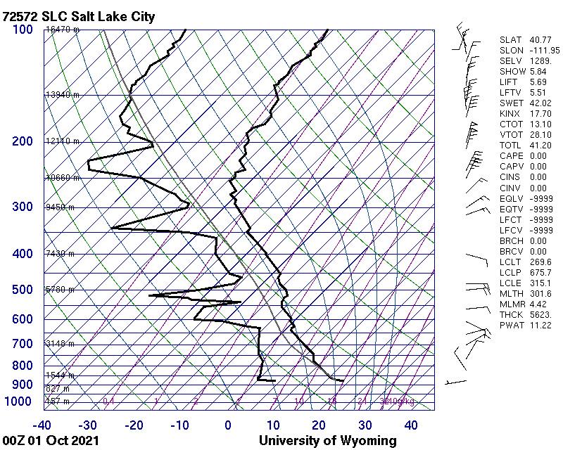
Figure 2: Skew-T Chart for 6pm Local Time, Salt Lake City, Utah.
The lapse rate is found by observing the temperature line which is the black line on the right. We can see down near the surface (where the line begins) the temperature profile is leaned far to the left which indicates an absolutely unstable surface air mass. Even though this Skew-T is for a location 150mi north of the location of the image, it is still a good representation of what was occurring on this day based on what I was experiencing in the air. We can see the dew point line (left black line) veer toward the temperature line at approximately the 625hPa line which can be translated into an approximation of altitude, and for this day it was about 11700ft. This is very close to the max altitude I achieved this day flying, which was 12,000ft. That is where the cumulus cloud bases were beginning. At this point that is where thermals end and clouds begin which is why that is as high as we could reach in our paragliders. If the air isn’t rising beyond a certain altitude that is as high as we are able to achieve. (Note: legally, paragliders are not allowed to exceed 17,999ft. and above 15,000ft. most pilots require the use of oxygen).
In this image we also see a stepped cloud base. The clouds further behind the subject cloud can be seen lower than the subject cloud. Earlier in the day we were flying closer to that area and the maximum altitude we were able to achieve in that area was about 11,000ft. This is because there was not as much heating in that area keeping the air mass cool and relatively more stable. In order to stay in the air I had to use the more ridge lift, which is air simply being forced up the face of a mountain, but not thermal release. It was tricky to stay up in that area. As we pushed south where there was more radiative heating and thermals it was much easier to stay in the air. We were also able to take the thermals higher to 12,000ft. which indicates this stepped cloud base.

Visualization Method
To capture this image, I used a Sony A6000 with a 50mm lens. I really like the way this lens shoots in portrait mode. The settings used were ISO 100, f5, and an exposure time of 1/2000s. I set the camera up in auto mode, because I was not going to be able to play with the settings and fly my wing at the same time. I find it generally produces decent images when using daylight, so I was not concerned. I was able to take a few photos so I could ensure I took one that was framed well. I really like the shadow in the image as I think it provides a really good indicator that this image is taken from the air. See the below diagram side view of where I am relative to the cloud in the image.

Figure 3:Side View of Taking Photo

Image Processing
I did some light image processing to attempt to reduce the haziness of the image and make the blue sky really pop. My peers pointed out to me that I inadvertently turned the cloud slightly blue as well when I did this however, I am unable to tell the difference. I attribute this to my red/green color blindness where I have some trouble decerning between colors that are very similar or slightly off. I have gone back and attempted to correct the blue color shift, but I struggle to see any differences when I play with the color curves. I darkened the image slightly to make the shadow darker and I adjusted the white balance. I also added some saturation to make the greens in the image stand out as well. Below are the original image and the edited image.

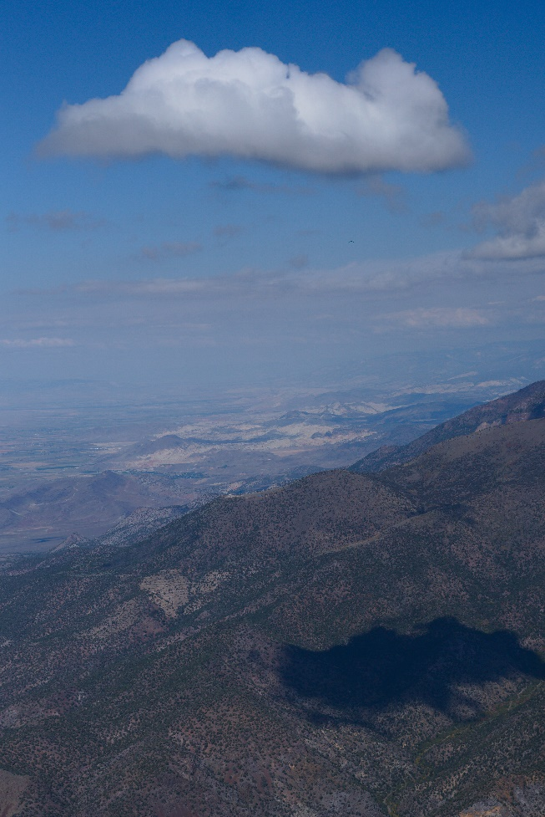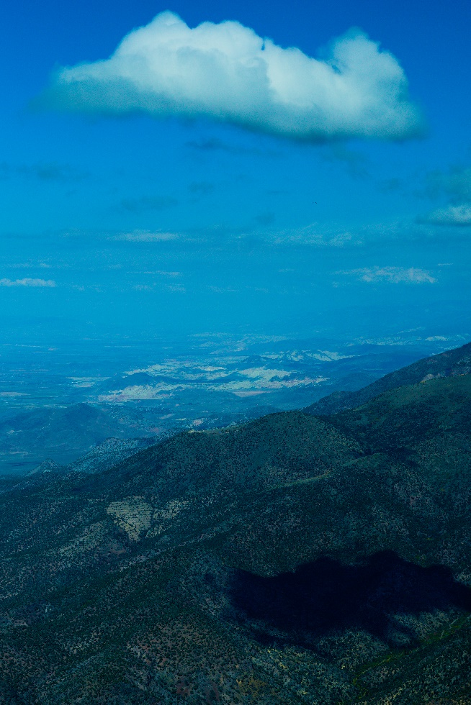
Figure 5:Original
Figure 6:Edited

Final Thoughts
I am excited that I was able to capture this image during a flight and share a cloud that means so much to me as a pilot. As a paragliding pilot I focus on reading the skew-t to identify days with good lapse rates and wind directions for flying. This is essentially the culmination of one of my favorite sports and science and it is such a cool feeling to take science and use it to fly around with out any motors. You are simply adrift in the wind and attempting to follow the flow as best as you can. A fuller and more wonderful picture of the atmosphere is achieved when you can physically experience what the air is doing. It creates such a great understanding of how the atmosphere functions, and I hope everyone can experience it one day as I do.

References
Federal Aviation Administration. (1965). Aviation Weather. Washington D.C.: ASA Publications.
University Corporation for Atmospheric Research. (2021). Clouds and How They Form. Retrieved from UCAR Center for Science Education: https://scied.ucar.edu/learning-zone/clouds/how-clouds-form

