Chris Taylor
MCEN 5152 - Flow Visualization
Image/Video #2
10/11/2021

_____________________________________________________________________________________

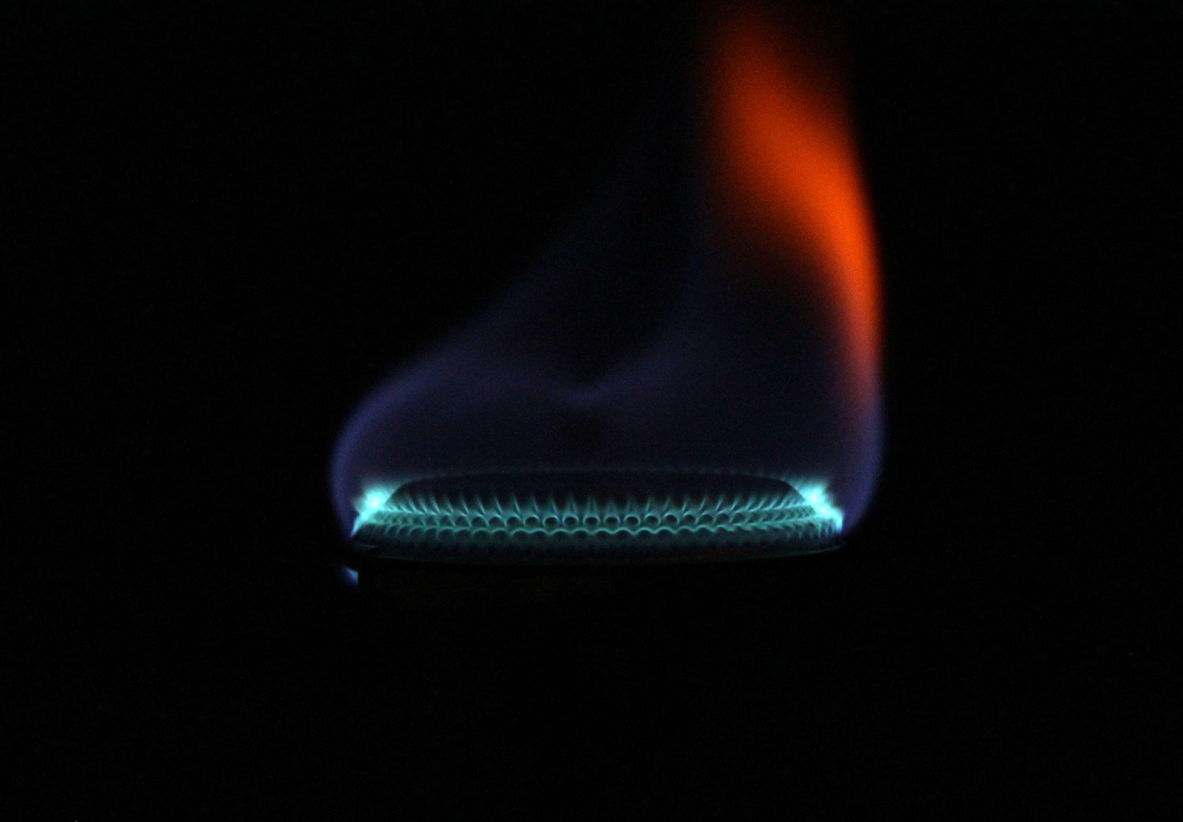

This image was captured for this second assignment in MCEN 5151 - Flow Visualization.
The goal of this image was to capture the network of cyan arches created as isopropyl alcohol is combusted in the burner of a camp stove. With this image I wanted to challenge myself to capture a dynamic subject with minimal motion blur, while also applying what I learned about low light photography from my first image. The resulting image showcases exactly what I intended to capture with a sharp focus on the nearest flame arch as well as a clean flame edge with striking color. The turbulent nature of flames makes them particularly difficult to get in focus and it took me well over a hundred of images at various settings to obtain what I had envisioned. Capturing the discontinuity in color was also particularly difficult as the flame travels so fast that any combustion irregularities will disappear before you click a button, so I simply captured as many images as I could in rapid succession until a red/orange lick appeared, like you see in this image.
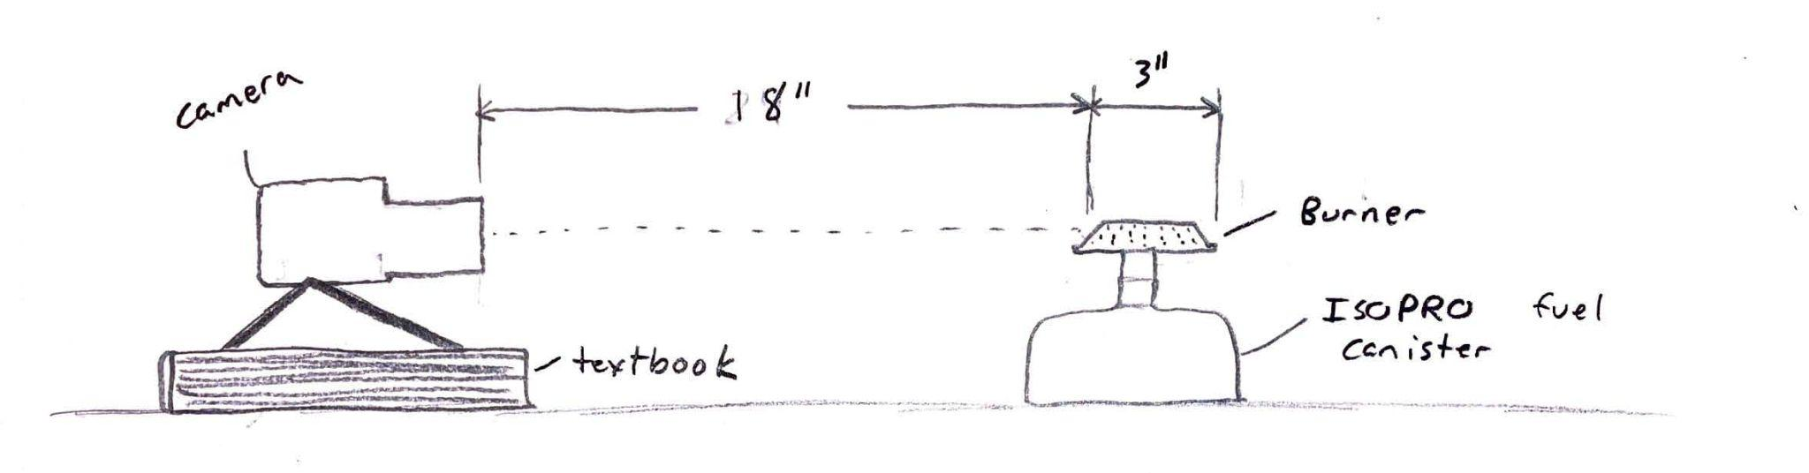
Figure 1: Set up sketch
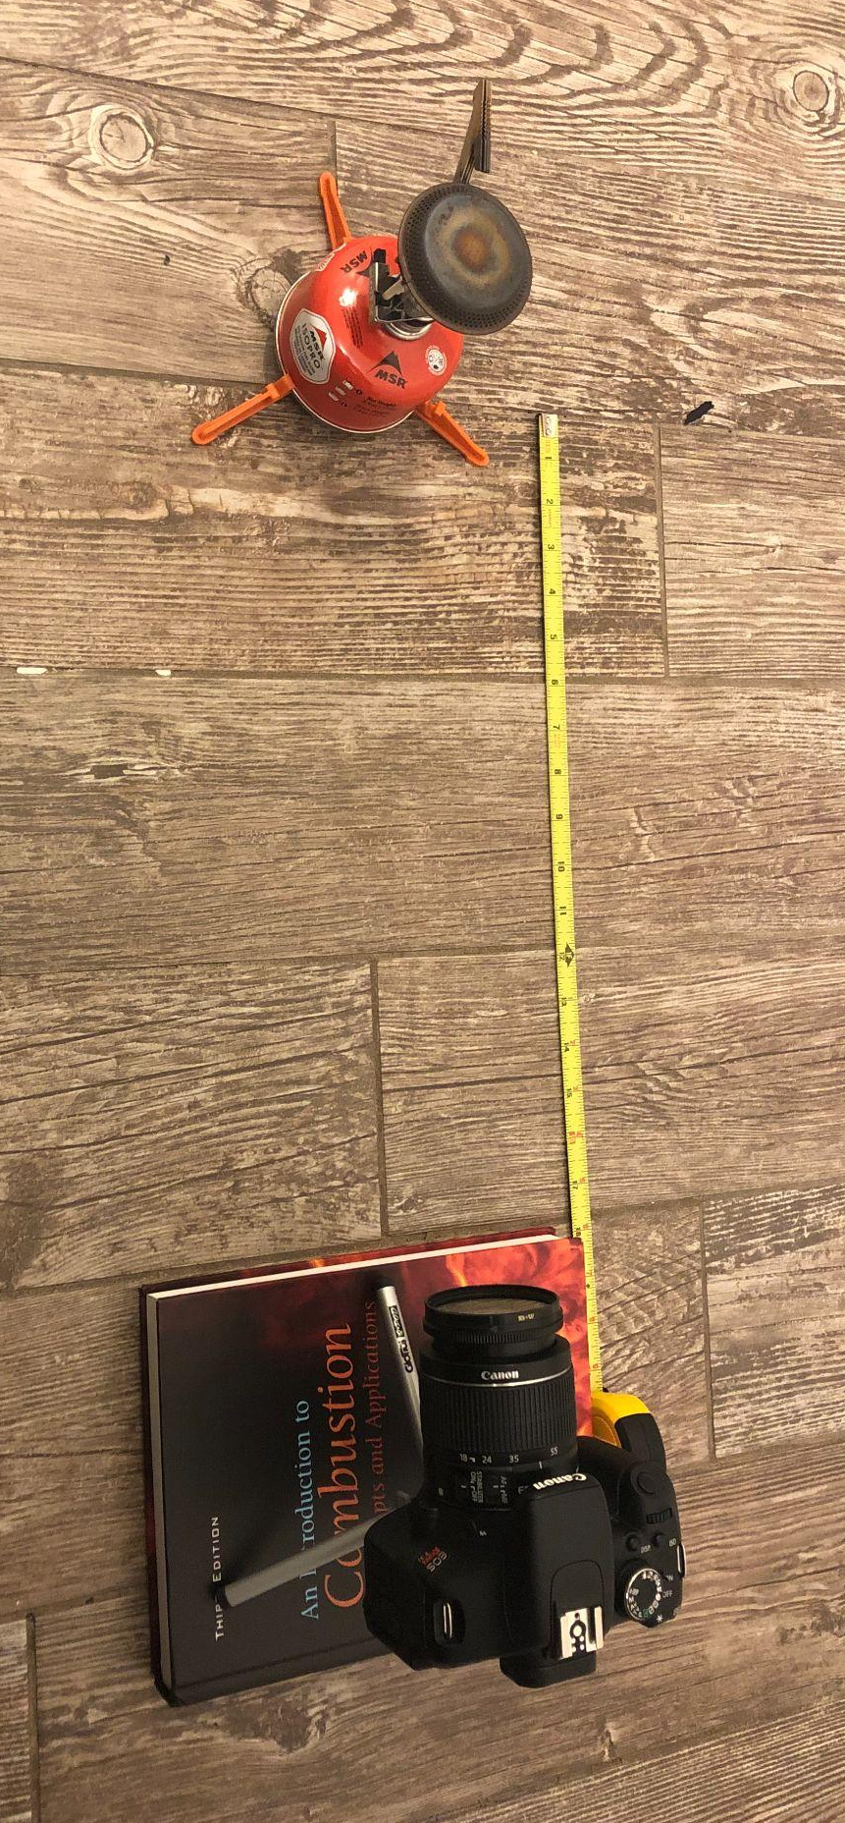
Figure 2: Picture Set up

Above in Figures 1 and 2 I have provided both a picture of the actual set up used and a sketch of my original design. I decided the camera distance from the burner through a course of trial and error, and ultimately determined that at 18” I could both have great detail and focus while still being a safe distance away from the open flame. The burner used was 3” in diameter with a series of holes through which the pressurized fuel flows. These holes allow the fuel and air to mix and create the cyan arch pattern seen in the image. I allowed the burner to operate continuously without disturbance at medium-high heat while taking pictures. Despite minimizing external forces on the flame by operating in a closed room with no air flow the flame still managed to have significant deviation from a symmetrical shape. The fluid captured in this image is a mixture of combusting fuel, unreactive nitrogen, excess oxygen, carbon dioxide, water vapor, and a number of trase gasses created in combustion.
Under these conditions the combustion gasses operate in a state of significant turbulence. Using a timer and my images as reference I was able to calculate the Reynolds number of the combustion gasses [1]. Since the flame is a consistent blue color it is difficult to estimate the velocity of the flame. I used images, such as this one where a change in the steady state creates an orange flame, to measure the total height of the flame. I then timed how long the orange flame existed in the system, as it traveled from the burner’s holes to the top of the flame. From this I determined that the average time for the flame to travel from burner to flame tip was 0.10 seconds and the average distance the flame traveled was 4.65 inches. I could then calcualte the average flame speed to be 46.5 ft/s or 14.17 m/s. Since this flame was combusted in air I assumed that the kinematic viscosity of the flame was equal to that of air at 122.01 * 10^-6 m^2/s. The resulting Reynolds number, calculated below, of 11,616.42 is significantly higher than the turbulent threshold of 4000 [3]. This shows that the flow of the exhaust gasses is turbulent as it rises rapidly away from the burner.

$Re = \frac{UD}{v} = \frac{(14.17)(0.10)}{(122.01*10^{-6})} = 11616.42$

The fuel burning in this reaction is pure isopropyl alcohol of the equation $C_{3}H_{8}O$. The combustion occurred under assumed standard conditions with air at 1 atmosphere of pressure and at room temperature (293K). Using this I was able to determine the stoichiometric equation for the combustion reaction, shown below.

2 $C_{3}H_{8}O +9 {(O}_{2}+3.76{ N}_{2}) ⇒ 3 CO_{2} +8 H_{2}O + 33.85 N_{2}$

This equation represents the combustion process of isopropyl alcohol under completely ideal conditions. Under ideal stoichiometric combustion every reactant is present in the exact amount needed, allowing for complete combustion as well as maximum heat output. This rarely occurs in nature, however it can be observed in this image. At the very base of the flame we can observe the bright cyan arches of flame at the very base of the burner. This flame occurs just as the air and fuel mix and is the most ideal conditions for complete combustion to occur. We can tell that the fuel is burning to completion in the area by the brighter flame color. The shorter wavelength of light emitted by the hot exhaust gasses as well as the light intensity indicates that this location has the highest temperature and consequently the largest rate of heat release [2]. Following the cyan flame the isopropyl alcohol begins to turn a darker shade of blue. This flame region is still burning quite efficiently but not as hot as the arch region below. This region is likely operating in a lean mixture, where excess air is present in the reaction, leading to a reduced rate of combustion and heat generation. The final flame region in the image is the bright red/orange region in the top right corner. This region is burning in a rich mixture, where there is more fuel available than there is oxygen to react with. This results in inefficient combustion, reduced energy release per reaction, and the lowest temperature region of the flame. We can determine this based on the longer wavelengths of light emitted in this region which gives the area its striking red/orange color [2].
To create this image I used a 50g ISOPRO pressurized fuel container for a Jetboil camping stove. The pressurized fuel is readily available at any camping supply store as well as the camping stove. For lighting I used a LED lamp placed two feet above the camera as the only light source in the room. I found that including this dim light source improved the definition of the image without providing enough light to have anything other than the flame appear on camera.
I captured this image using a Canon Rebel t3i with an EFS 18 - 55mm 1:3.5-5.6 lens. The shutter speed was set at 1/160, with the aperture at f/5.6, and ISO 1600. The focal length was 51mm while the distance from the subject was 18”. The original picture was 5184 × 3456 pixels in size. I chose to keep the camera close to the subject because I wanted the picture to be sufficiently bright to reveal the flow phenomena that were occurring. I used a medium shutter speed in order to let in as much light as possible, but it still needed to be fast enough to capture minimal motion blur from the fast moving flame. I used a high ISO in order to compensate for the fast shutter speed and ensure the image was bright enough to see. I did adjust the color curves of this image to a small extent in Gimp to improve brightness and saturation. My goal in post-processing was to brighten the image without taking away from the original clarity and to improve the contrast between the red and blue sections. Below, on the left, is the original image from the camera and the edited final image on the right. As you can see the processed image reveals far more definition and the colors are much more vibrant.
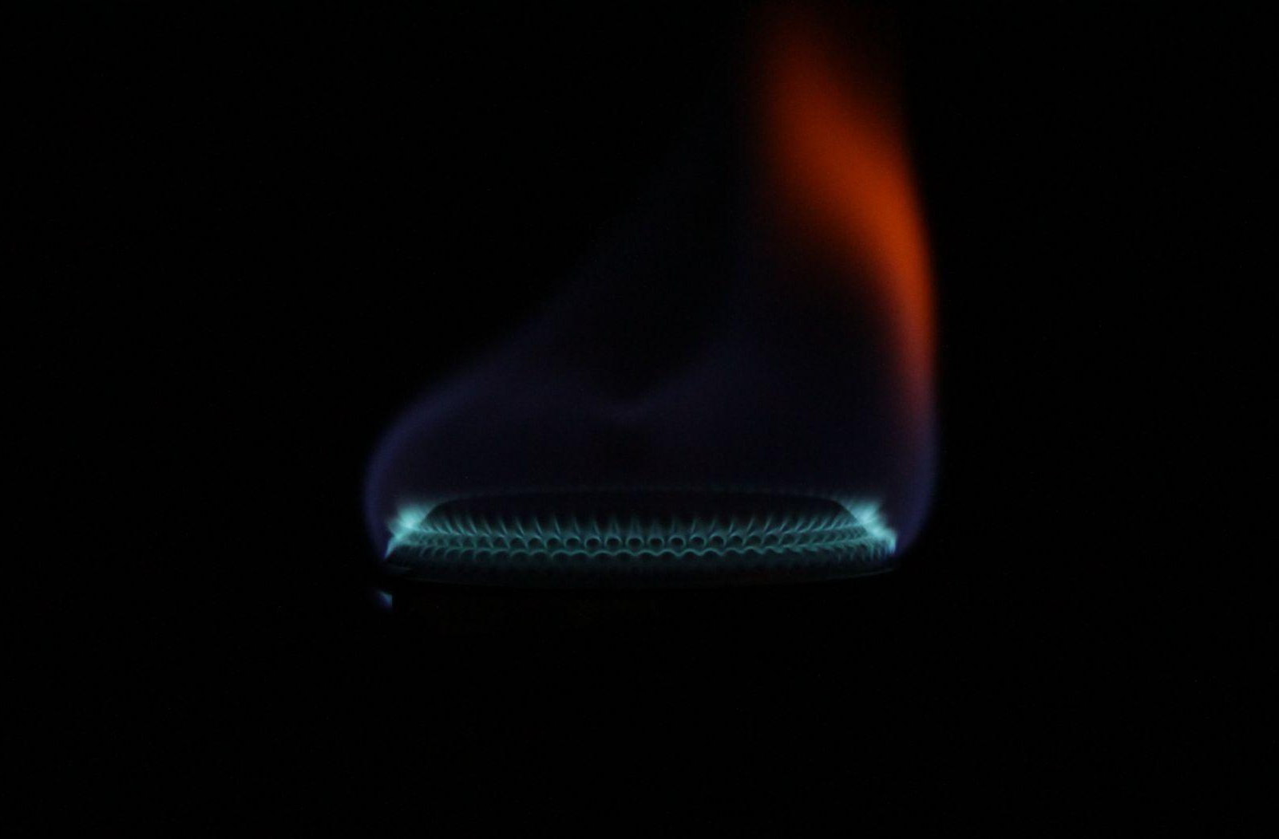
Figure 3: Prost-processing before (left) and after (right)

This image captures the process of fuel combustion in a perferatored burner in great detail. It reveals both the different chemical stages of combustion and the turbulent nature of the flame itself. My favorite part of this image is the cyan halo that rings the burner. The way that the burner is completely hidden in darkness while the cyan flame creates a circumference around the negative space is very fascinating to me. However, I am most proud of being able to capture the flame irregularity seen as the red/orange region in the picture. These color variations would last for less than a tenth of a second, so to capture one as large as the one I did was very lucky. My goal in this project was to use what I learned about shooting in the dark from my first image and apply it to a completely different subject. For an added challenge I decided to use a flame as it was both fast moving and emitted its own light. I think that I succeeded in these challenges and produced a superior image in both focus and degree of difficulty. This image was all my first attempt at post processing in a dedicated image processing software, which I think was very successful. I think the biggest improvement that this image would benefit from is lighting. I think that despite my use of secondary lighting, in addition to the light from the flame itself, it could be improved to produce a sharper, brighter image. Additional lense or camera hardware could also help to improve these aspects of the image. To develop this idea further I would want to add salts or chemicals to the flame to produce unnatural flame colors. For example adding copper sulfate to the flame would cause it to burn bright green. I think that the addition of color could only benefit this image and would not take away from the fluid physics capture. Overall, I am very proud of this project and look forward to building upon what I learned for the next one.

References:

[1] Wohl, Kurt, and Leon Shore. "Experiments with butane-air and methane-air flames." Industrial & Engineering Chemistry 47.4 (1955): 828-834.

[2] Najarnikoo, Mahdi, Mohammad Zabetian Targhi, and Hadi Pasdarshahri. "Experimental study on the flame stability and color characterization of cylindrical premixed perforated burner of condensing boiler by image processing method." Energy 189 (2019): 116130.

[3] Kouropoulos, George P. “THE EFFECT OF THE REYNOLDS NUMBER OF AIR FLOW TO THE PARTICLE COLLECTION EFFICIENCY OF A FIBROUS FILTER MEDIUM WITH CYLINDRICAL SECTION.” Journal of Urban and Environmental Engineering, vol. 8, no. 1, Celso Augusto Guimarães Santos, 2014, pp. 3–10, http://www.jstor.org/stable/26203405.

