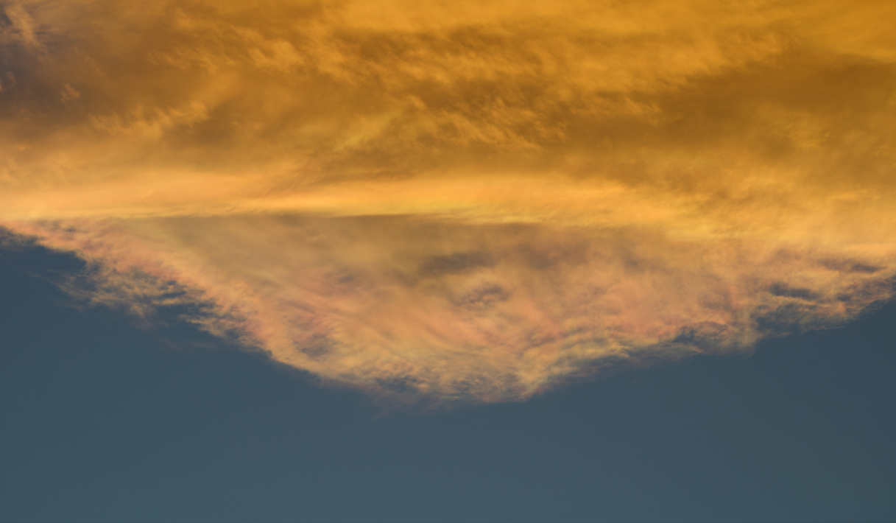

Flow Visualization (CINE 4151): Clouds 2 Report
Gus Santaella
Prof. Scott Wieland
12/10/2021

Relevant stats:
Camera: Canon Rebel T7
Shutter speed: 1/320
Aperture: f. 6.3
Lens focal length: 125 mm
ISO: 100
Size (final PNG file): 918 KB
Dimensions (final PNG file): 1217 x 710 pixels
Size (original RAW file): 26.8 MB
Dimensions (original RAW file): 6000 x 4000 pixels
Size-subject distance: More than 5 miles (see setup and methodology section)
Brief description of the photo and introduction:
My photo for this second clouds assignment is a photo of a detail of a cirrostratus cloud fragment (part of a larger cloud) traveling over the flat irons in Boulder, CO, where the dramatic sunset lights and apparent diffraction of the light within the cloud itself make up for a very aesthetically pleasing photo.
Artistic and scientific intents
My ultimate artistic intent with this image was to come up with a nice photo of a cloud that could showcase flow visualization within a real-world environment, but with a twist: instead of finding a whole cloud to capture, I would try to find small and interesting details within a cloud that could make up for a nice photo.

My scientific intent was to be able to elaborate on my knowledge of cloud-based phenomena (be it with diagrams, scientific analysis, or otherwise) and of flow visualizations in general as a nice conclusion to the semester.
Setup and methodology.
I took this photo outside my apartment complex, directly east of the CU main campus, at 6:12 PM on Wednesday, October 20th, 2021. I noticed a cloud formation facing westward, noticing that it had a fascinating rainbow-like effect, which could be clearly seen through my sunglasses, but in some brief periods also through the naked eye. The cloud, as a whole, looked as follows (photo taken earlier, at 5:44 PM. These photos were taken on my iPhone 12 Pro for convenience’s sake):
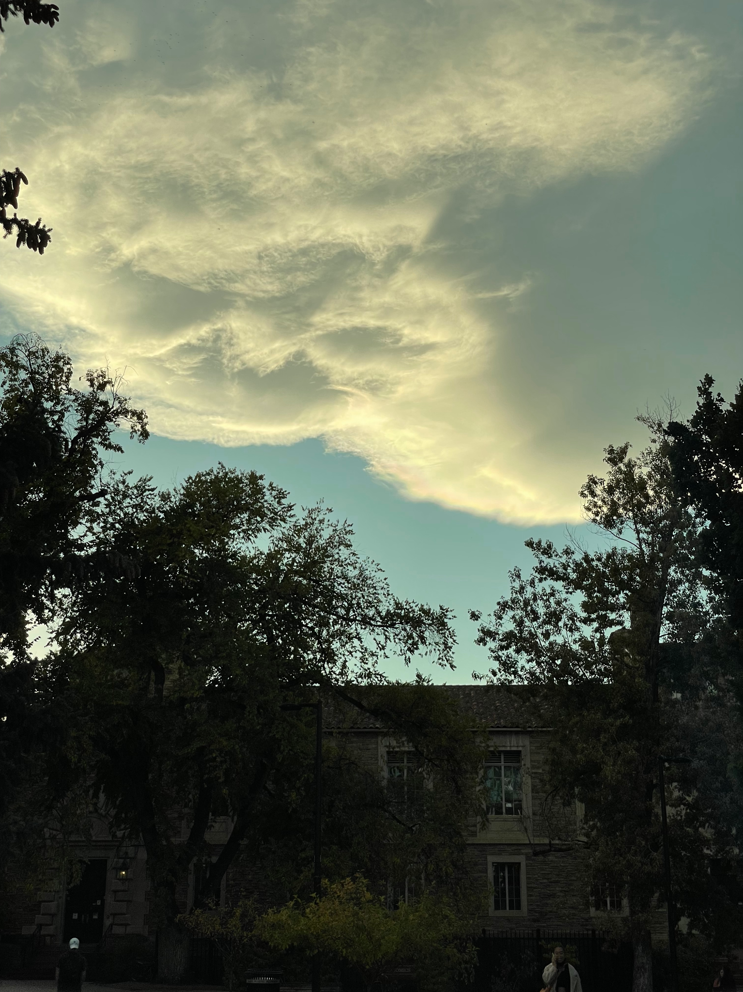
A detail of the rainbow effect can be also clearly seen here:
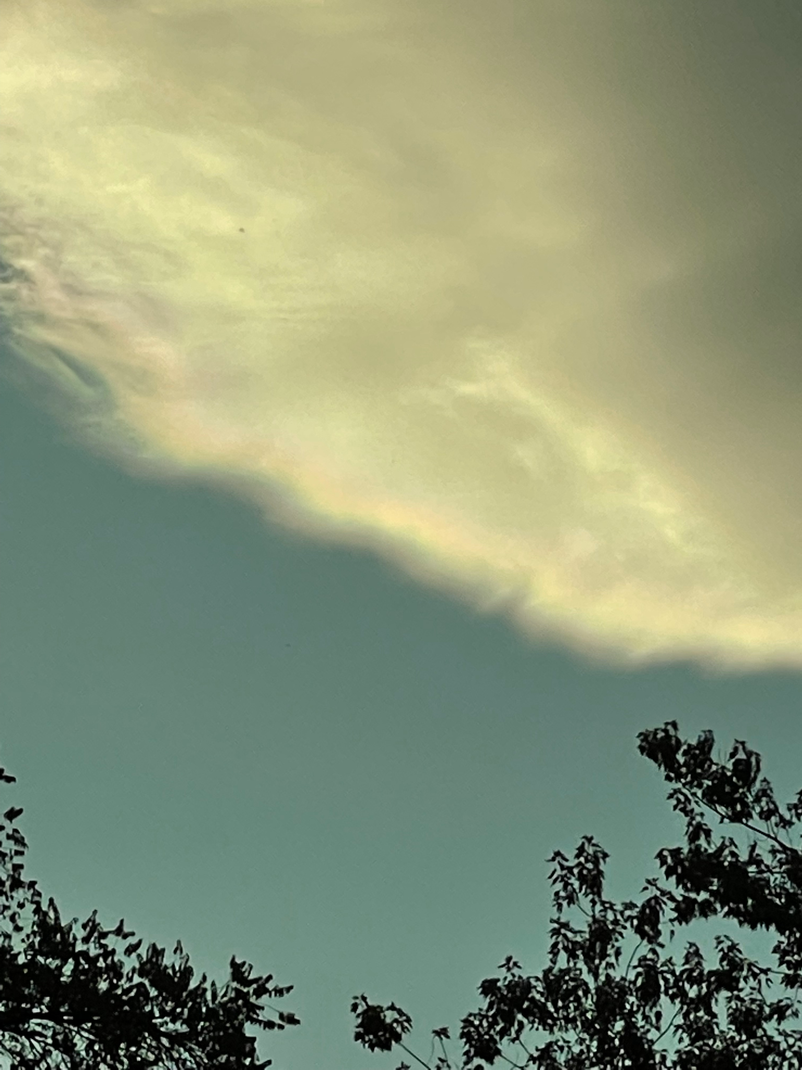
And finally, a photo of the cloud slightly before the final shot was taken (a few minutes before the sunset lights started giving the cloud its orange color):
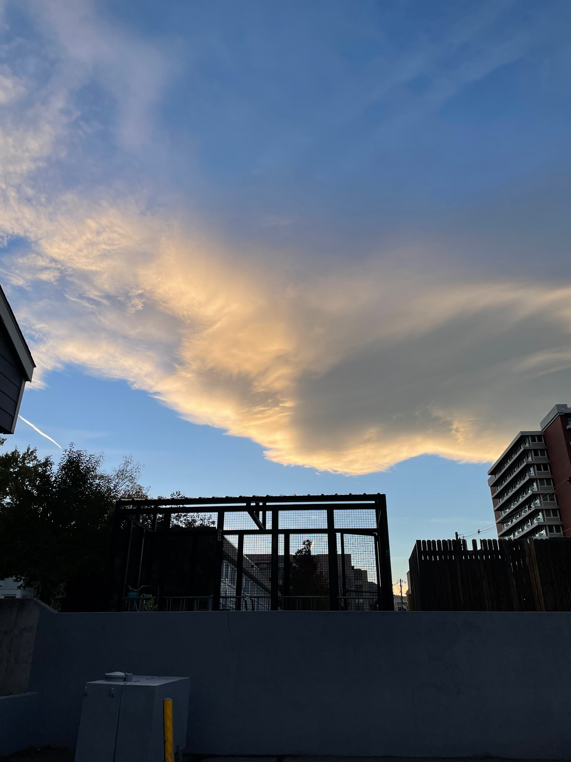
While I was not able to recapture the rainbow effect from the second photo with my camera, I am glad I was at least able to capture an interesting, visible gradient of color in the cloud.
The only lighting in the photo of course is natural and it comes from the sun, located at 1 AU away from the Earth. The setup can be described by the following diagram:
The distance to the subject is about 5 miles, with this being a loose estimate. The clouds, of a size of at least 2 or 3 km long, did not appear to be moving when they were captured (in other words, with a velocity equal to 0), which is of course minimal compared to the used 1/320 s = 0.003125 s shutter speed. It must be noted that I tried working with different shutter speeds and aperture settings to get my desired lighting/color contrast until settling for the settings specified in the stats section.
SKEW-T diagram and explanation of effects based on a theoretical groundwork:
In general, cloud formations form as air closer to the ground is pushed up into the atmosphere right into areas of lower pressure, creating a shearing-like effect where microparticles of very light water droplets and ice stay in the atmosphere and saturate hence forming clouds. (NOAA, 2021). Hence, analyzing and making sense of the atmospheric profile using a SKEW T diagram is often very useful to explain cloud effects like the one being captured. The SKEW T diagram for the day the photo of this cloud was taken is below.
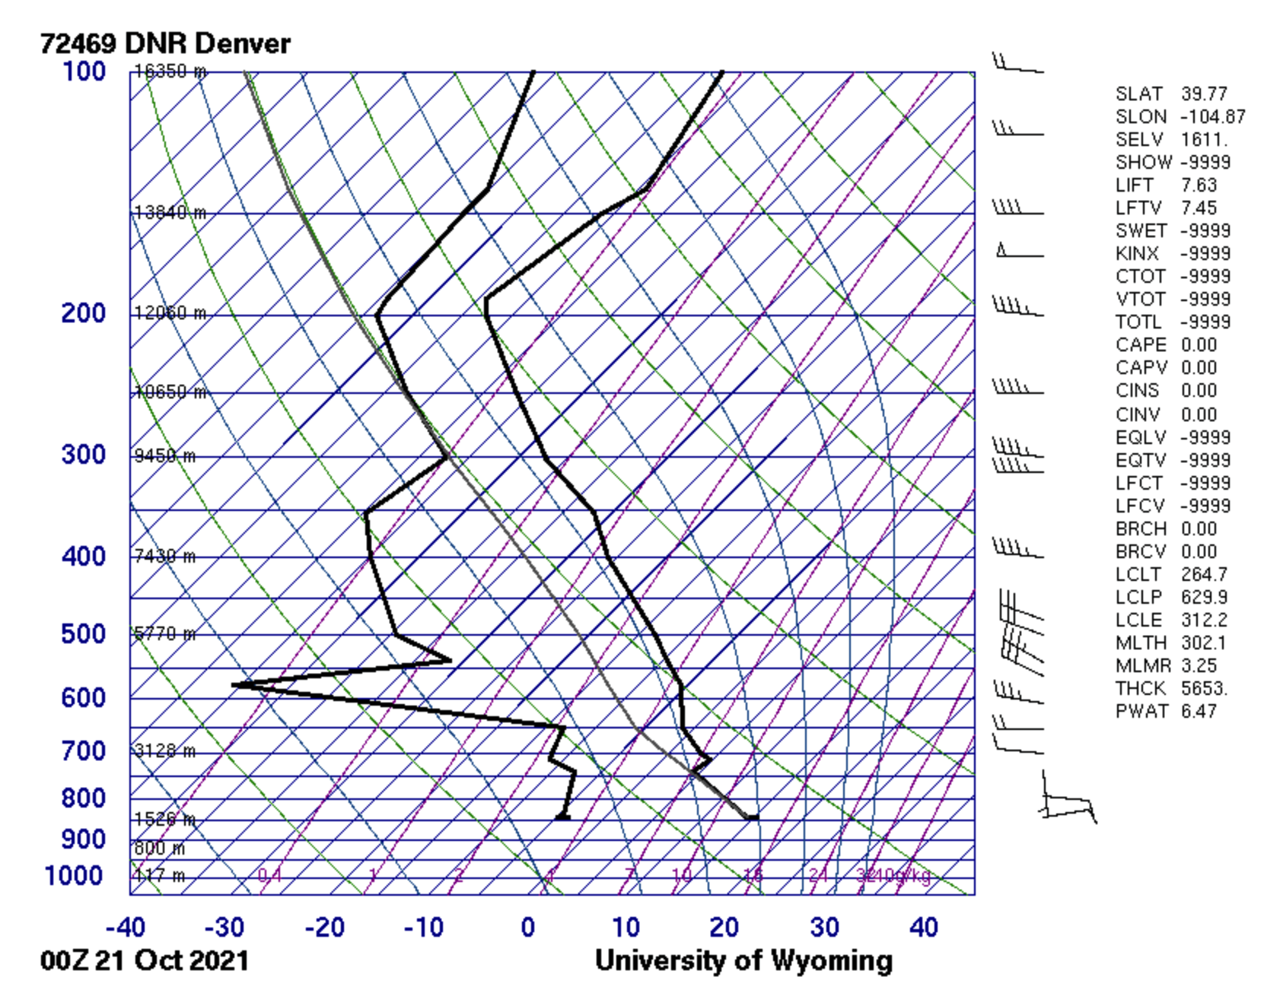
It must be noted that this is the diagram from the Denver station, given that this is the one that is closest to Boulder, and, as is the convention, this is the diagram from 00Z on the 21st of October given that that is the one that corresponds to the afternoon/evening times of October 20th, which is when the photo was taken.
We can see that the CAPE value is 0, meaning that our atmosphere is stable and that there was a very low chance of thunderstorms on that day and time. We can then see from the plot that the dewpoint plot and the environmental sounding curves are close to meeting at 9450 meters above sea level (or 7850 meters above the ground), telling us that there could potentially be a cloud formation at this point. (which would appear to confirm some of our expectations). This makes sense, given that if we use the plane trails as a reference, this would mean that the cloud is traveling around or under an estimated altitude of 30,000+ ft = ~ 9,000+ meters.
The classification of this cloud was quite a challenging process, even with the Skew-T diagram. This is because the cloud formation, as a whole, and the detail of the final photo did not match one “mold” of any single type of cloud found within these constraints. After a considerable amount of thorough analysis of the SKEW-T diagram, the photos themselves, and various conversations I had with professor Wieland, I concluded that this was a combination of not one type of cloud but two types of clouds. Afterward, the dilemma was whether the large cloud being captured was a single cloud or a combination of two or more layers of clouds creating the optical illusion that they could be one cloud (concluding that this was more likely to be a single cloud).
With all of this being said, and considering the skew T diagram and the shape of the cloud detail and the cloud as a whole, it was concluded that this was indeed a cirrostratus cloud, which makes sense given that these happen at relatively high altitudes of ~23,000 ft = ~ 7000 meters (NOAA, 2021), which would make sense given my expectations and analysis described above.
Description of changes done during post-processing
I used the GIMP editing software to do all my post-processing. I decided that the natural colors of the cloud were beautiful enough to remain as unchanged as possible, so I just decided to minimally shift the contrast (to highlight its colors as much as possible without ruining the image as a whole) and do minor cropping on the top to give the image a better geometry.
Original photo:
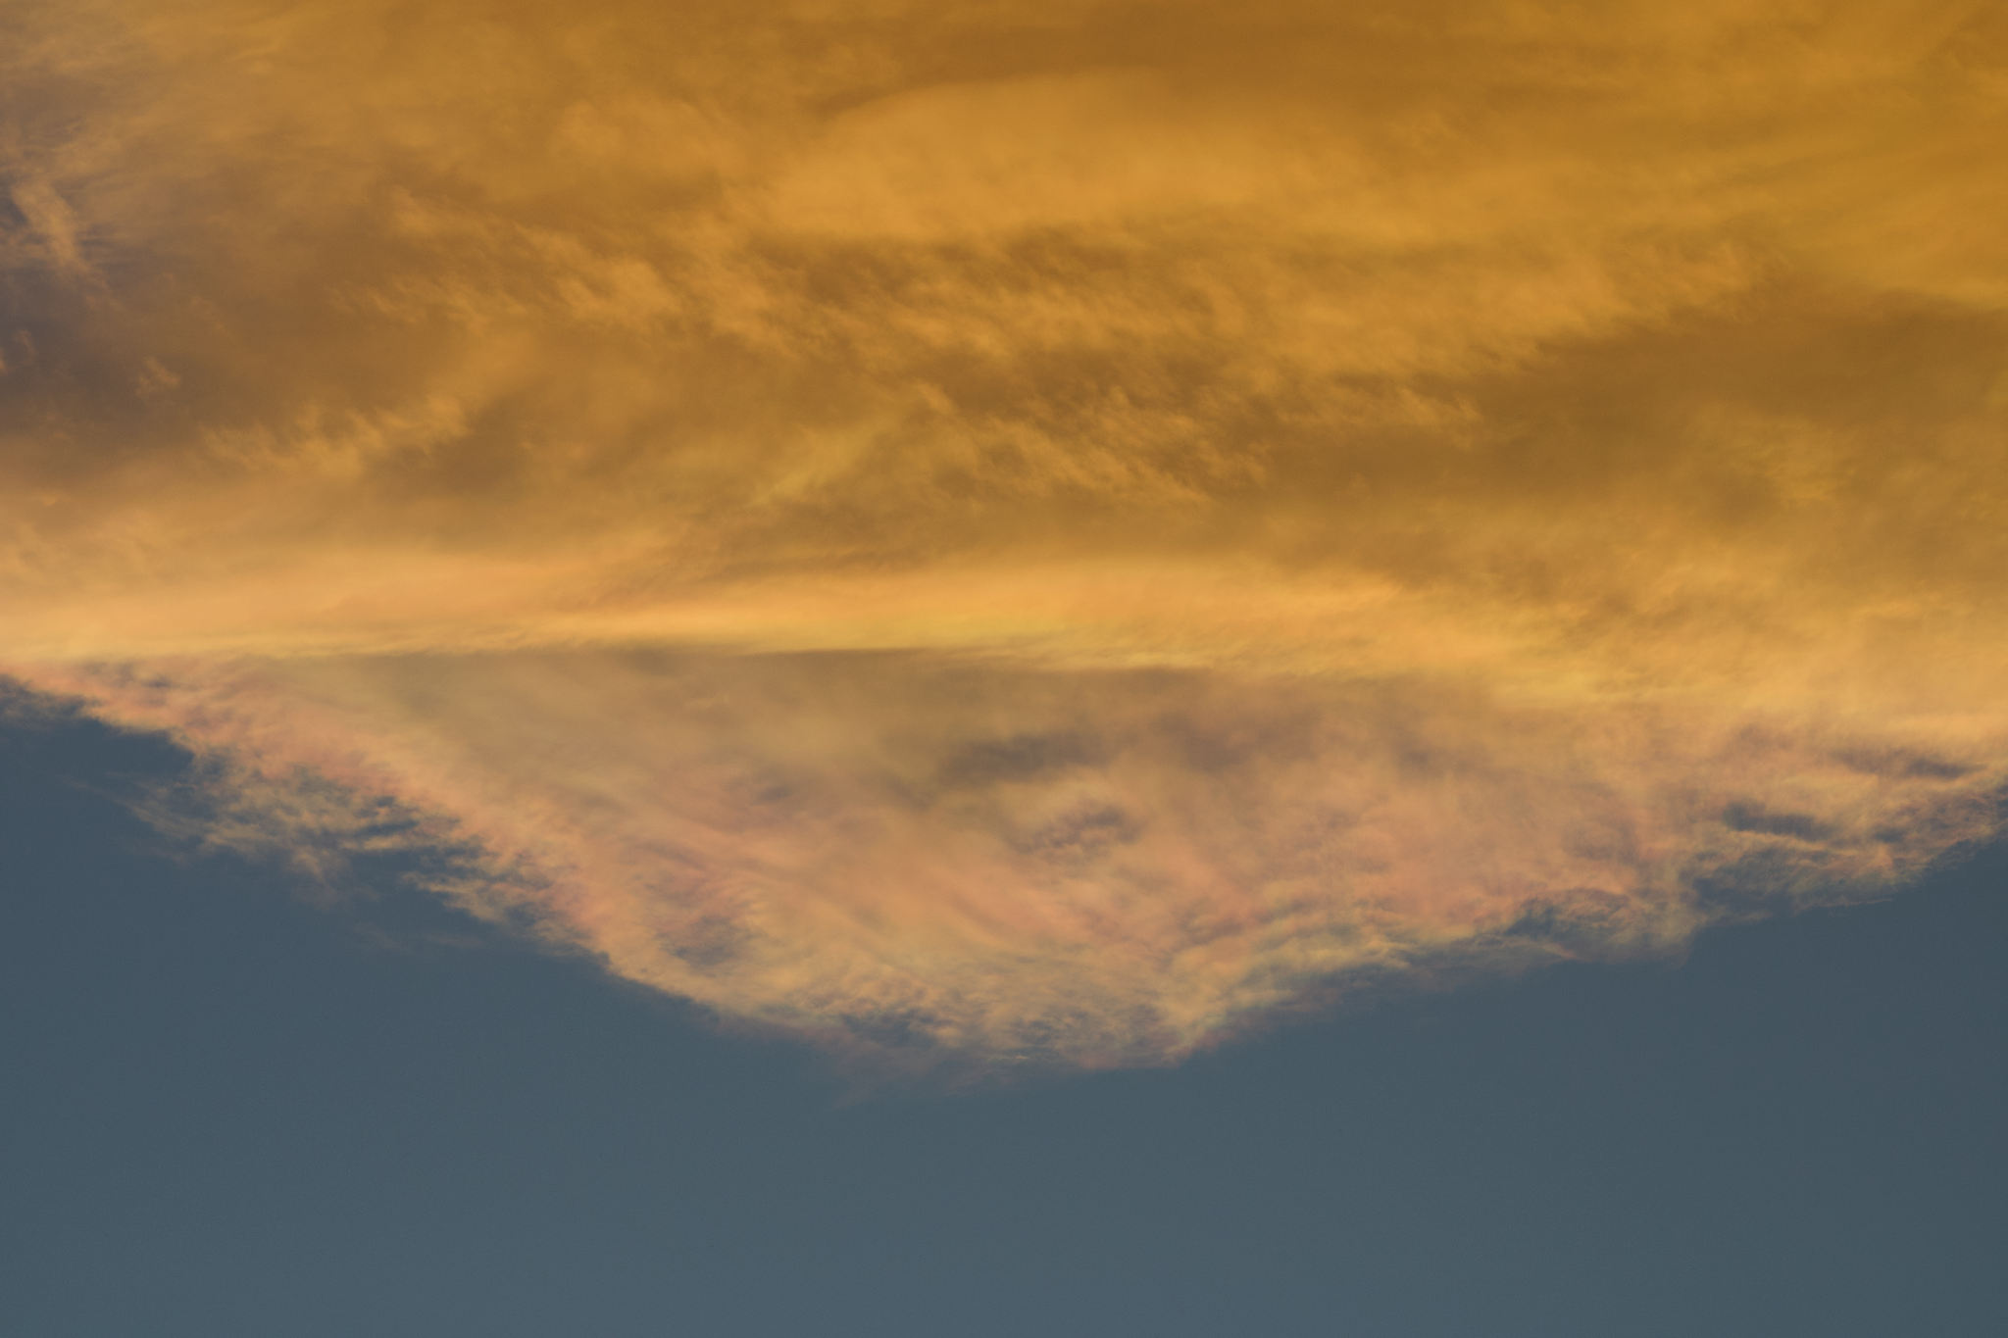
Post-processed photo:
Acknowledgments
I worked on taking the photo and the setup all by myself, but I would like to acknowledge professor Wieland for all his help in giving me advice while I was post-processing the image, as well as my peers for all the kind constructive feedback presented during the critique sessions. And also, I’d like to thank all of these parties for such a great semester!
References:
Atmospheric soundings. (2021). Retrieved October 26, 2021, from http://weather.uwyo.edu/upperair/sounding.html.
Cloud development. (2021). Retrieved October 26, 2021, from https://www.weather.gov/source/zhu/ZHU_Training_Page/clouds/cloud_development/clouds.htm.

