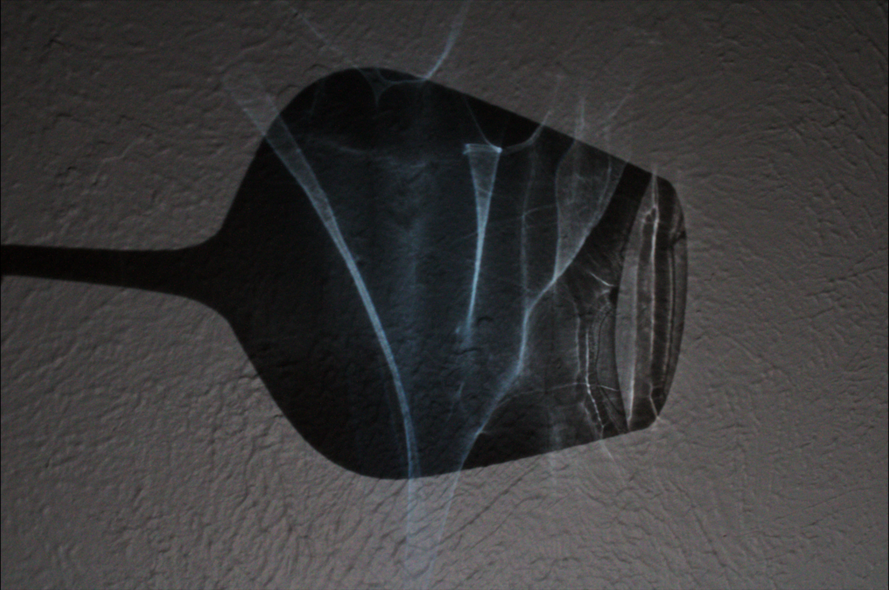

Flow Visualization (CINE 4151): IV Report 3
Gus Santaella
Prof. Scott Wieland
12/03/2021

Relevant stats:
Camera: Canon Rebel T7
Shutter speed: 1/25
Aperture: f. 9
Lens focal length: 36 mm
ISO: 3200
Size (final PNG file): 1014 x 675
Dimensions (final PNG file): 3.4 MB
Size (original RAW file): 34.7 MB
Dimensions (original RAW file): 6000 x 4000 pixels
Size-subject distance: about 50 centimeters (see setup and methodology section)

Brief description of the photo and introduction:
For this third image video assignment, and inspired by the lectures on shadowgraphy seen in class, I decided to depict a shadowgraphy experiment conducted in my apartment. I decided to put blue Tide laundry detergent into a wine glass (spreading it semi-evenly along the inner surface of the container before every shot), flashing a light source onto the object to create a shadow of it onto a white wall, and then take photos of the projection. The result of this is an interesting caustic pattern produced by the light refraction of the laundry detergent in the glass, creating a nice effect that can be appreciated in the attached photo.

Artistic and scientific intents
My ultimate artistic intent with this image was to provide a unique perspective on flow visualization which could be considerably different and far more experimental than my submissions for previous assignments, albeit still aesthetically pleasing.
In addition to my artistic purpose, my scientific intent was to be able to test (with my own style) the various flow visualization capturing techniques that we learned about in class, namely inspired by those based on shadowgraphy, and put them to the test.
Setup and methodology.
I took this photo in my apartment, located just off the CU main campus at 5:54 PM on Tuesday, November 9th, 2021. I took a wine glass and poured some laundry detergent on it, making sure it was enough to barely cover the inner walls on various rotations. Then I turned on my iPhone 12 Pro’s flashlight and placed it on a table about 1.5 meters away from a wall and had its light flash towards the wall itself in a normal orientation. I then grabbed my camera with one hand and held the wine glass with laundry detergent with the other, placing the latter in front of the light source (about 1 meter away from the light source, 0.5 meters away from the wall) in a way such that its projection could be seen onto the wall. I made sure to rotate the wine glass to make sure there was an even layer of detergent on the inner walls of the glass at all times. This had to be done fast, given that gravity could fully make the entirety of the liquid fall from the walls onto the bottom of the glass after a 15-second span or so (I estimate a net velocity of 10 cm/15 s = 0.66 cm/s for the flow). Regardless, while the detergent was viscous and sticky enough to stay on the inner walls of the wine glass for long enough for me to capture a few photos at a time before having to recoat the wine glass. After doing a few practice shots to get the focus, aperture, and shutter speed right (remember: I could only use one hand to both hold the camera and take the shot, which prevented me from changing any of these stats on the go) I captured many photos of the various caustic shadow patterns that the wine glass with detergent produced onto the wall, and it must be noted the camera was placed at an angle to make sure it did not interfere with the light projection. In the following photo, which I took as a sample, one can see the shadow projection with the glass in front of it (and the shadow of my hand holding the glass can also be appreciated in the photo):
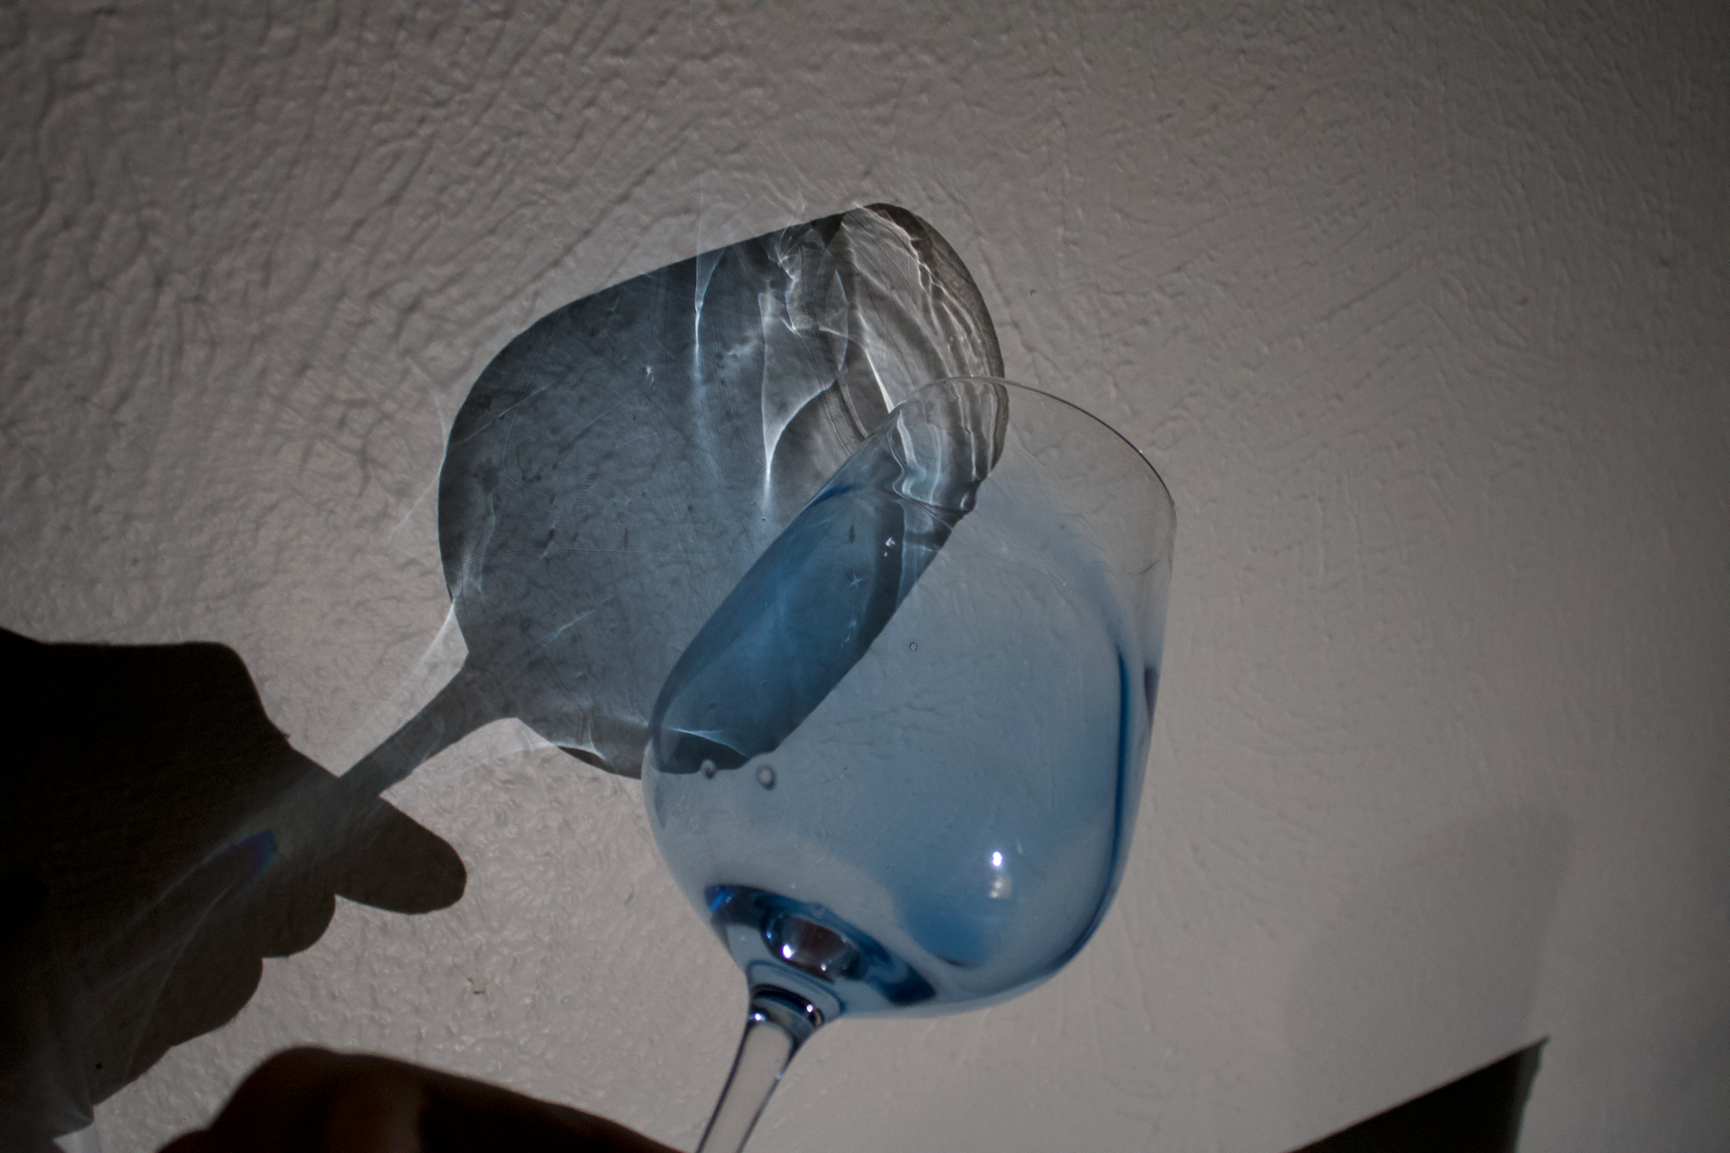

And this setup can be described by the following diagram:

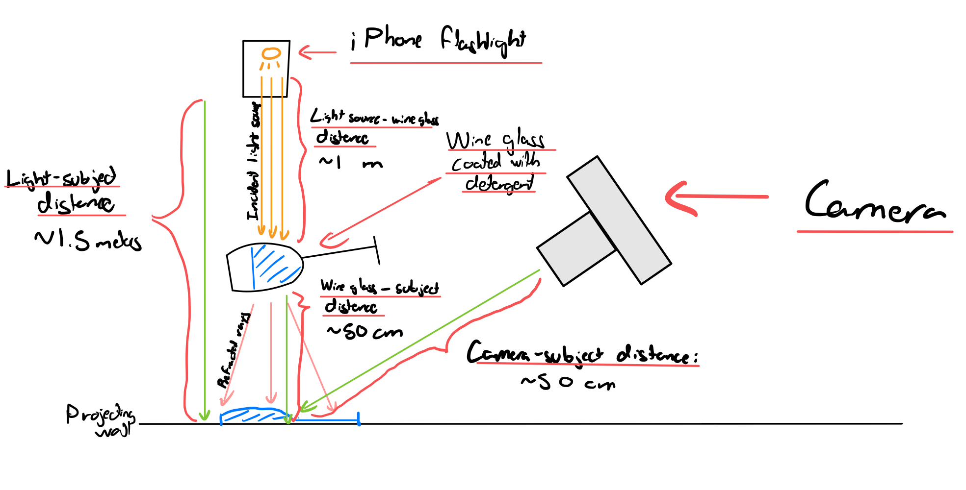
In addition, the net velocity of the flow depicted in the image was about 10 cm/15 s = 0.66 cm/s, which is minimal compared to the used 1/25 s = 0.04 s shutter speed.
Explanation of effects based on a theoretical groundwork:
The fluid depicted in the flow is slowly moving while it’s being captured, meaning we can calculate its Reynolds number to better understand it.
The Reynolds number is defined as:
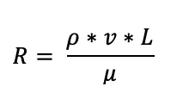
Where rho is the density of the fluid (1.058 kg/m^3 for Tide laundry detergent), v is its velocity (0.6 cm/s =$0.6 * 10^{-2}$m/s as estimated above), L is its approximate length (10 cm = $10 * 10^{-2}$ mas estimated above), and mu is its dynamic viscosity (about 375 Pa*s for Tide laundry detergent).
Plugging these numbers into the equation yields:
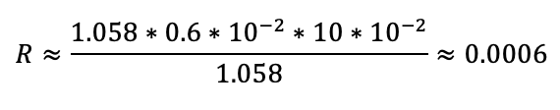
Hence, the Reynolds number of the flow visualization being depicted is 0.0006, which is very low. This means that our flow is not turbulent and rather behaves like a laminar/sheet flow (which makes sense, since it moves like a sheet along the inner walls of the wine glass).
Description of changes done during post-processing
As is tradition, I used GIMP to do all of my post-processing. I decided to take a risk this time and, as opposed to going for a very subtle “S” like color curve, I decided to heavily shift the contrast of the image to better highlight the shadows while making the blue color of the laundry detergent more pronounced. In addition, did some minor cropping on the image to bring the caustic effect to the center of the image and to better highlight it as the subject of it.
Original photo:
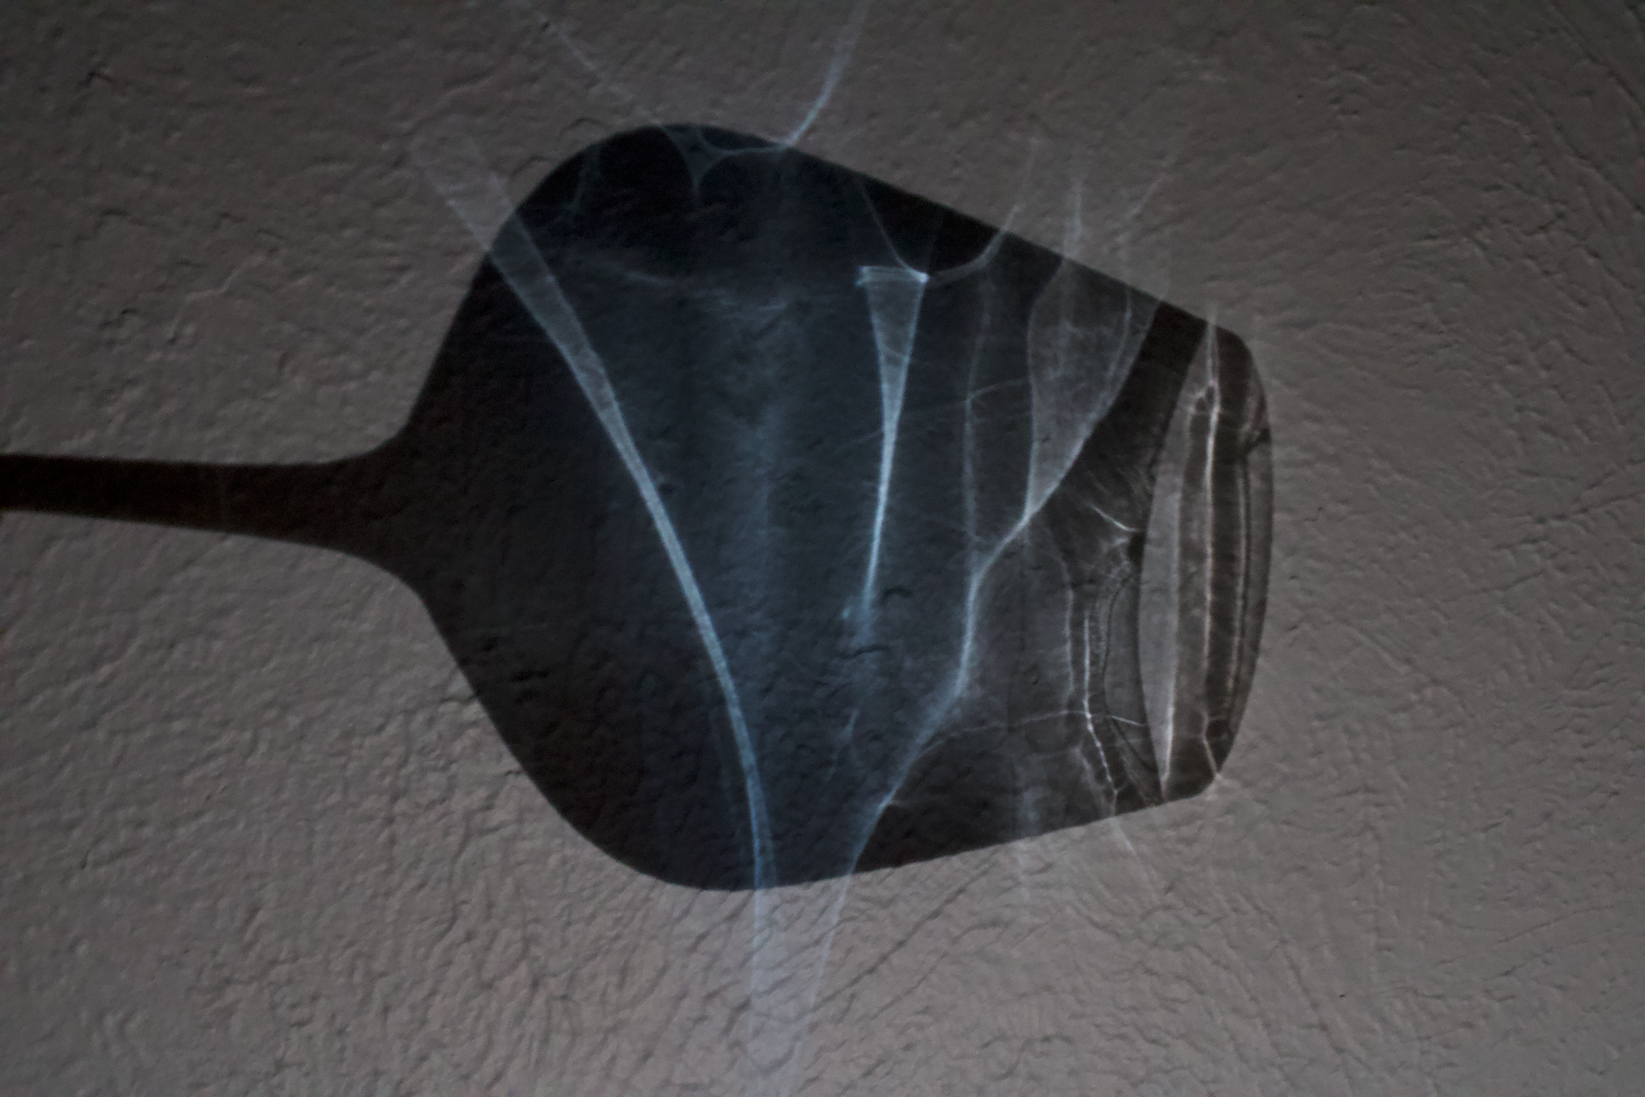
Post-processed photo:

Acknowledgments
I worked on taking the photo and the setup all by myself, but I would like to acknowledge professor Wieland for all his help in giving me advice while I was post-processing the image, as well as my peers for all the kind constructive feedback presented during the critique sessions.

References:
NASA. (2021). Reynolds number. NASA. Retrieved December 4, 2021, from https://www.grc.nasa.gov/www/BGH/reynolds.html.
P&G (2018) Tide safety information. P&G. Retrieved December 4, 2021, from https://www.kandelandson.com/msds/Tide%20Liquid%20Laundry%20Detergent.pdf

