Fall 2021 Cloud Image 2
Evan Hanson – 12/13/2021
MCEN 4151
Photograph of rotor clouds taken on November 11th, 2021, at 4:00 pm in Boulder Colorado.
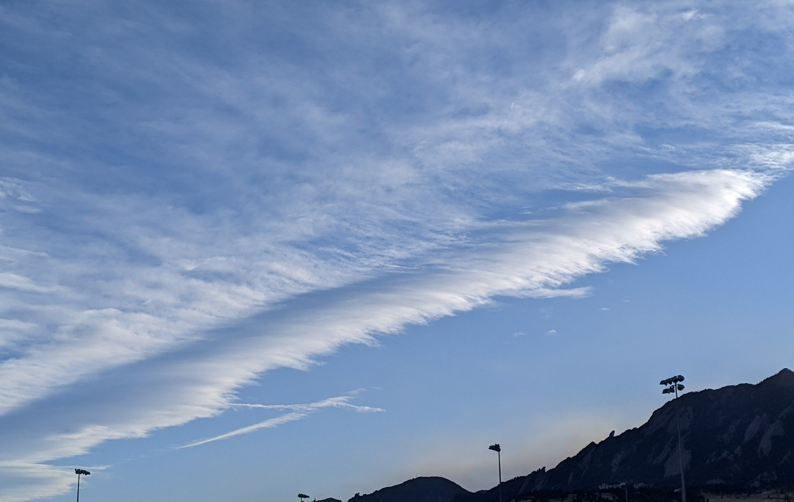

Introduction
For this cloud photograph, I aimed to capture a unique cloud formed from wind blowing over the flatirons. I aimed to capture the unique texture displayed by orographic cloud formation. This was my second dive into cloud photography allowing me to learn more about cloud formation, types, and identification.

Photograph Setting
I took this photograph on November 11th, 2021, at 4:00 pm from Kittridge Field on the CU Boulder campus. I oriented the camera southwest of Boulder toward the flat irons. I attempted to remove most of the distractions from the photograph including the field lights by climbing on top of a rooftop to take this photo. This allowed me to separate myself from the ground and cut out many distractions. Even with my best efforts I captured some of the field lights the building leading up to the flatirons. In post processing I cropped out the some of these distractions. The original photograph is shown below showing the lights, trees and building roof top originally captured.
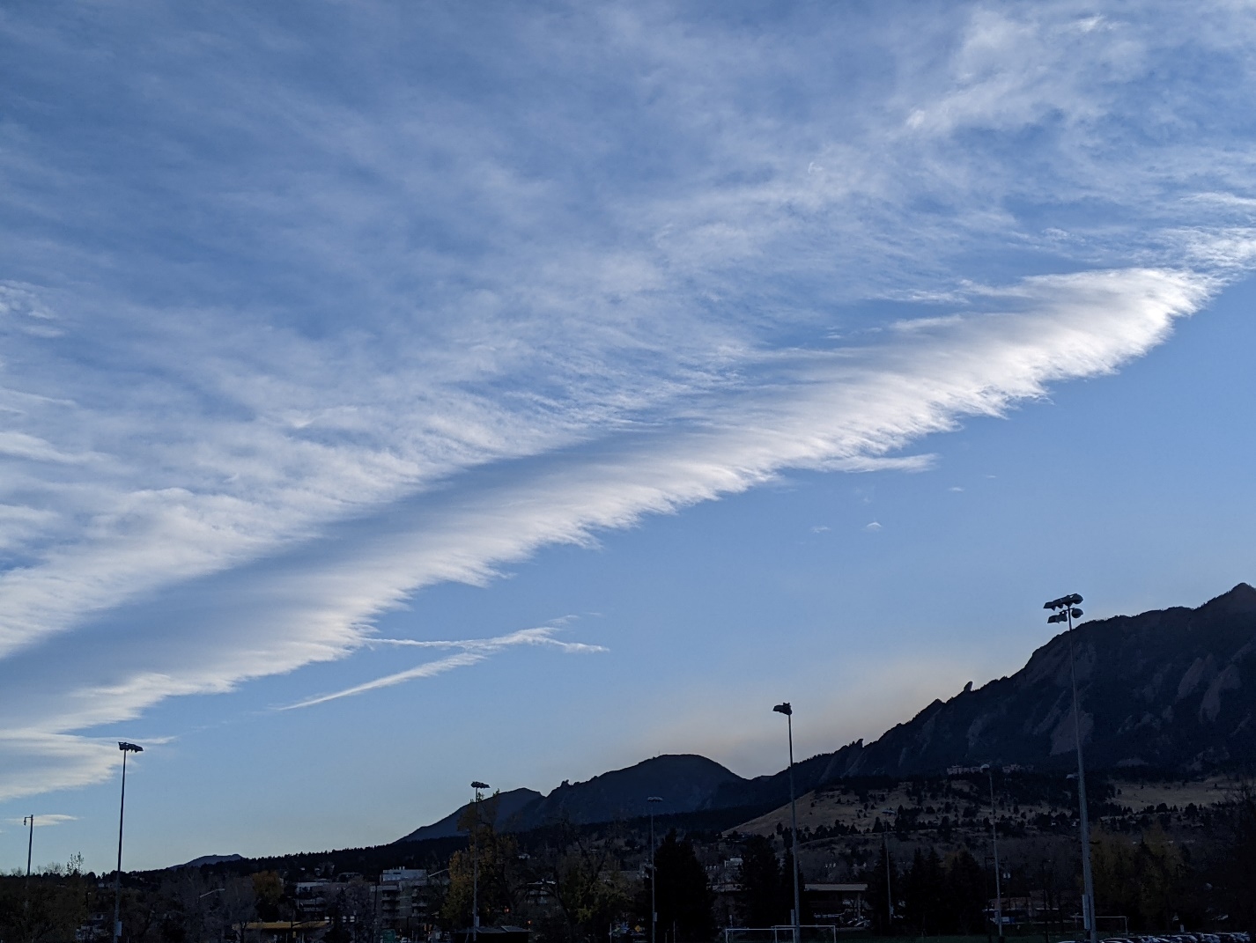
Figure 1. Original Photograph
The weather on November 11th, 2021, at 4:00 pm was very windy in Boulder and clouds accumulating east of Boulder over Denver. The high and low temperatures that day were 55 F and 32 F and the approximate temperature at 4:00 pm was 48 F.

Cloud Phenomenon

In this photograph I can see a line of clouds parallel to the mountains that seem to slightly curve. Also notice that when the cloud is slightly further from the mountains, the cloud seems to disappear and reappear in waves. Also, over the hour that I was watching this cloud, it did not move with the wind but seemed to stay in place. From this I predict that this cloud was formed from an orographic effect from the flatirons. I predict that these clouds are rotor clouds formed from wind blowing over the mountains.
On November 11th at 6:00 pm MST a weather balloon set of from Denver Colorado, only 30 miles away from where this photo was taken, generated the follow Skew-T diagram.
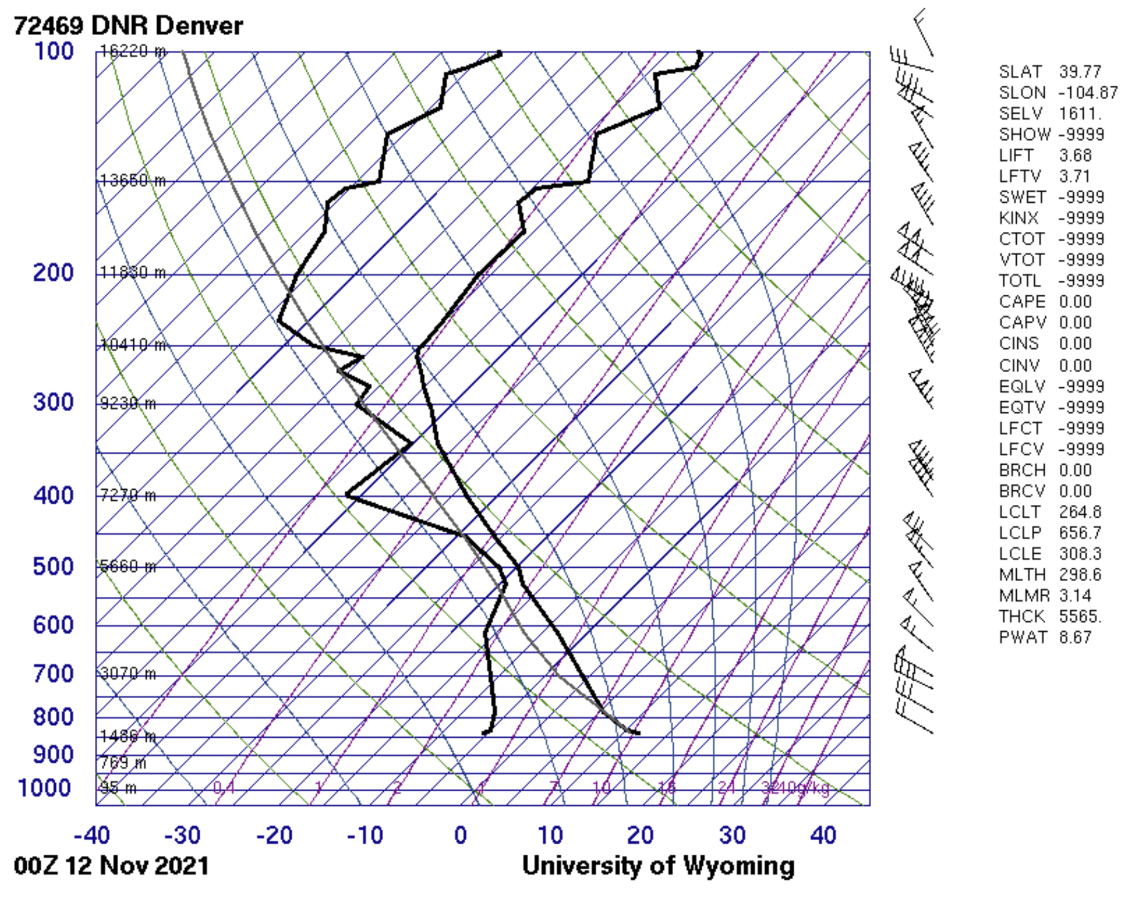
Figure 3. Skew-T diagram from Denver CO at 6:00 pm MST on 11/11/2021 [1]
I do not think that this Skew-T diagram gives much information about this cloud. I think that this cloud was formed due to orographic effects from the flatirons thus a weather balloon 30 miles away in Denver would not capture the information about this cloud. Other photos I took that day show that there was a large cloud cluster forming southeast of Boulder which the Skew-T diagram shows around 5660 m where the dew point (left bold black) and the temperature (right bold black) line are very close. Also note that the Skew-T diagram has a 0.00 CAPE value indicating that the atmosphere was stable at that time therefore this cloud captured in my photograph was likely formed by other means than instability. The rotor clouds captured in the photograph are likely around the same elevation as the tops of the flat irons. The flat irons only reach up 2 km above sea level therefore I predict that these rotor clouds are around 2 km above sea level or about 0.5 km above Boulder.

Photography Techniques
The camera used to take this photograph was Pixel 3 cell phone camera. The following table explains the known details of the camera setup.
Table 1. Camera Setup Details
Resolution | 12.2 MP
Aperture | f/1.8
Focal length | 4.44 mm
ISO | 65
Exposure | 1/112

I photographed this cloud with my cell phone camera because that was the only camera, I had access to at the time. If I had used a nicer DSLR camera I predict that I would have been able to capture a better resolution, focus, and better-quality photo.

Conclusion
This image captures a unique orographic cloud formation of rotor clouds in the Colorado front range. I like the textures captured. From the observations this photograph illustrates cloud formation likely due to wind blowing over the flatirons and creating low pressure pockets which the humidity in the air will condense into a cloud in that pocket. When the condensed air flows out of these low-pressure pockets, it re-evaporates, and the cloud disappears. More air will flow into these pockets and create more clouds. This looks to an observer that the clouds are not moving. I like that this photograph and shows explainable fluid physics. It shows how the pressure effects condensation and the dew points in the air. I could improve the quality of the image by using a better camera and spending time to improve the camera settings to better capture the color and texture of the clouds. I would develop this idea further by changing the camera location to capture different angles of this cloud. If I could, I would like to get on top of a building to get a cleaner and better focused photograph of this cloud.

Works Cited

[1] University of Wyoming Department of Atmospheric Science. Atmospheric Soundings, http://weather.uwyo.edu/upperair/sounding.html.

