Fall 2021 Image 2
  - Evan Hanson – 10/11/2021
  - MCEN 4151

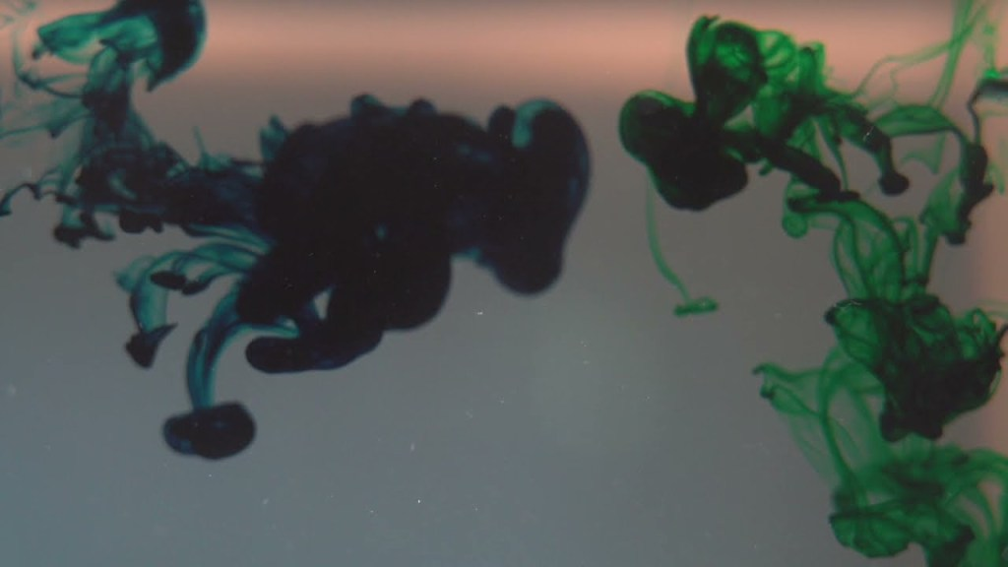

Introduction
For this flow visualization video, I aimed to capture a mixture of colors, texture, and movement of dye flowing through water. This was my first dive into flow videography allowing me to learn more about flow visualization setups, videography details, and computer video editing. In this video, I intended to capture a delicate moment of turbulence. In this flow visualization I worked with Luke Bieganek, who is a small business owner and professional photographer in Fort Collins. Luke and I tested out multiple flow visualizations with a variety of set ups. This video demonstrated three of our best shots. I set up and performed every experiment while Luke used his camera to film the flow phenomenon. The music used in the video is Modular Ambient 04 by sscheidl and is royalty free music I found online.

Set-up and Materials
In this video, I used a fish tank to capture the first and second clips and a glass of water sitting on a LED panel light for the third clip. In the fish tank setup, I used a syringe and medical tube setup to inject blue and green dye into the still water. The difference of velocity and viscosity of the fluids create a unique turbulent flow. To achieve a contrast of color and demonstrate the complexity of texture, I positioned a LED Panel light below the fish tank, placed two desk lamps on either side of the fish tank, and shined flashlights into the fluid from the bottom. Behind the fish tank I placed a white piece of cardboard to isolate the flow in the video from any background images of my living room. The tank setup took about 15 minutes to reset therefore we only had a few changed to capture the perfect turbulence. Below is a diagram of the fish tank set up.

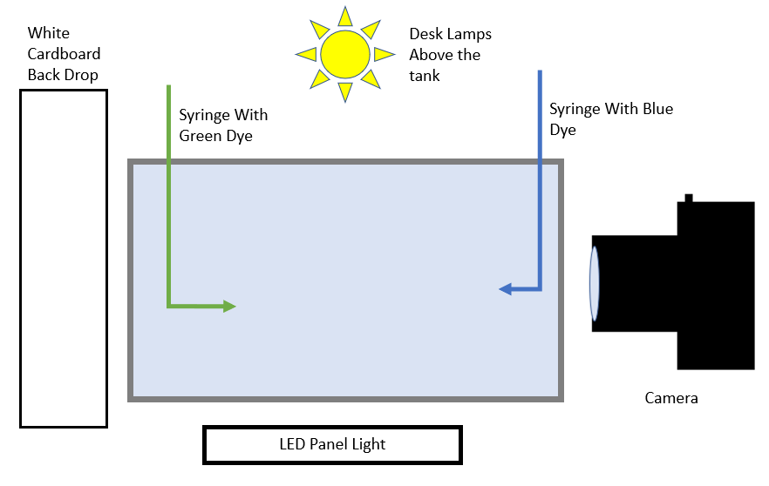
Figure 1. Diagram of the Fish Tank Setup
For the glass of water setup, I placed a clear glass of water on a LED panel light and adjusted the focus and aperture of the camera so that the pixels of the panel light were unfocused to create a pure white background without textures. I used the same syringe and medical tube fixture to inject blue dye into the still water of the glass. This produced very stark turbulent flow with noticeable vortices. On the camera, I used a macro lens with a polarized filter to focus precisely into the turbulent flow. Figure 2 below shows the setup for the glass of water.
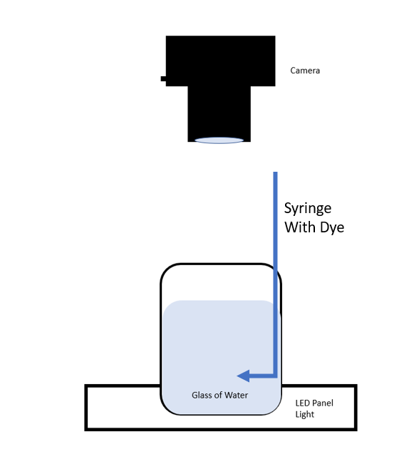
Figure 2. Diagram of the Glass of Water Setup

Flow Phenomenon
The turbulent flow in this video is governed by its Reynolds number, which gives information about if the flow is in turbulence or laminar. Equation 1 below explains how to calculate the Reynolds number of a flow. In this equation, ρ is the density of the fluid, μ is the dynamic viscosity of the fluid, L in the linear motion of the fluid, and u is the fluid velocity.
 | 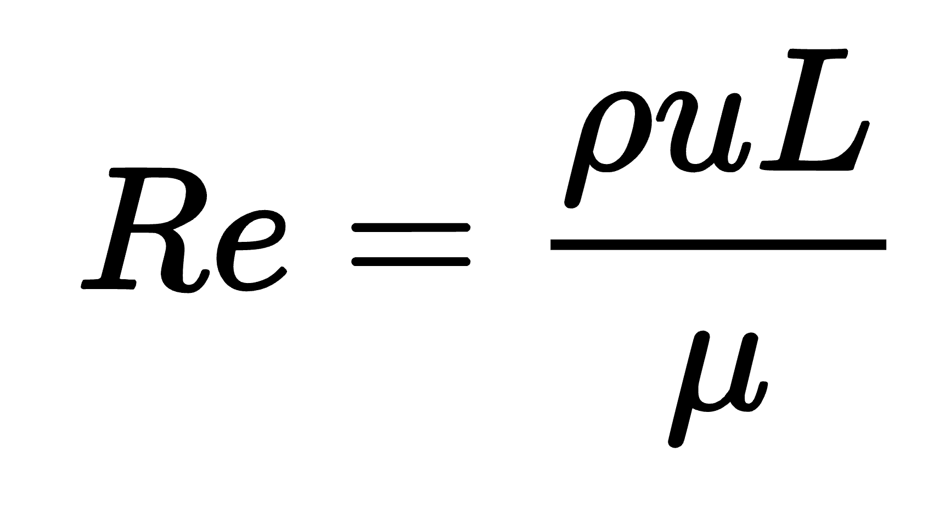 | Eq 1.

Looking specifically at the first flow visualization in the tank, I followed a portion of the flow over 1 second of un-slowed time. This allows me to approximate distance and velocity of the flow. The dye is moving horizontally across the shot so can estimate the fluid movement distance (L) to be about 2 cm based on the tank dimensions observed while filming. Then I can approximate the velocity with a Δt of 1 seconds and Δx of 3cm as u = 2 cm/s.
The density and viscosity of the dye are approximately the same as water and for this approximation I will assume similar densities and viscosity. [1]
Density (ρ) = | $1000 kg/m^{3}$
dynamic viscosity (μ) = | $$0.9 Ns/m^{2}$$

By combining all the approximated values to equation 1, I can approximate the Reynolds number to be about 6700.
Reynolds numbers less than about 2000 dictate the flow is laminar and Reynold number greater than about 3500 dictate the flow is in a turbulent state. [2] A Reynold number of about 6700 is in the turbulent region .This validates the visual clues of turbulent flow in the tank set up because there are vortexes around the flow but distinctly laminar wisps of dye as well.

Photography Techniques
The camera used to take this video was a DSLR Nikon D3300 with a Sony ILCE-7RM3 with a FE 85mm F1.4 GM lens. The following table explains of the details of the camera setup. The aperture and focal length changed throughout the experiment to keep the flow in focus.
Table 1. Camera Setup Details
Frame Rate | 180 frames/sec
ISO | 800

The turbulent flow very quickly diffused into the water, so we needed to take the video in a high frame rate so that I could slow down the video in post. Most of the video is ½ speed with a portion around 1 minute in at ¼ speed. Filming at 180 frames per second allows the video to be ¼ speed but still look smooth. On the day of filming, we forgot to get a tripod to shoot with so there are improvements to the focus and shaking camera that could make this flow visualization even better.
Because the dye diffused into the water very quickly, we only had a few seconds to capture a contrastive video. Slowing down the flow also allows the viewer to appreciate the flow in a longer time instead of the few seconds that the flow occurred. By making theses photographic decisions, we captured an in focus and high-resolution video of turbulent flow I set up to get.

Conclusion
This video captures a range of turbulent and laminar textures, dye shades, and a stunning neon blue and green color. I love the vivid color and contrast in this video. I chose to merge the three flows visualizations together under ambient music to create an experience for viewers. I think that this makes the flow more dramatic and visually pleasing. By looking into the Reynolds number of the flow is a turbulent flow Reynolds number, I can better understand some of the physics within the video. I can see that there are turbulent patterns in the dye with swilling vortexes but as the dye spreads out, I see the laminar wisps of dye as well.

Works Cited
- Edge, Engineers. “Water - Density Viscosity Specific Weight.” Engineers Edge - Engineering, Design and Manufacturing Solutions, https://www.engineersedge.com/physics/water__density_viscosity_specific_weight_13146.htm.
- “Laminar and Turbulent Flow.” Laminar and Turbulent Flow | Engineering Library, https://engineeringlibrary.org/reference/laminar-and-turbulent-fluid-flow-doe-handbook.

