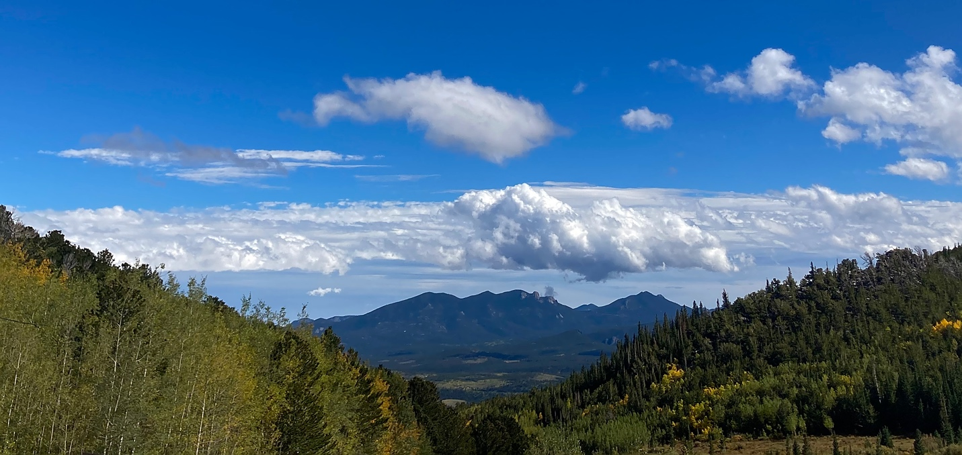
Cumulus and Stratocumulus
Ella McQuaid
Clouds First
MCEN 4151

Overview:
This image was taken for the first clouds assignment for the Flow Visualization course at CU Boulder. The intent of the image was to capture the layer of clouds framed between two mountains. The horizontal angle of the shot shows the relative altitudes of the various clouds.

Circumstances:
This image was taken at about 3:00 P.M. on September 22, 2022 on Caribou Road at GPS coordinates 39.98, -105.58. The elevation angle of the image was close to 0°, and the elevation of the location was around 3,000 meters.

Cloud Analysis:

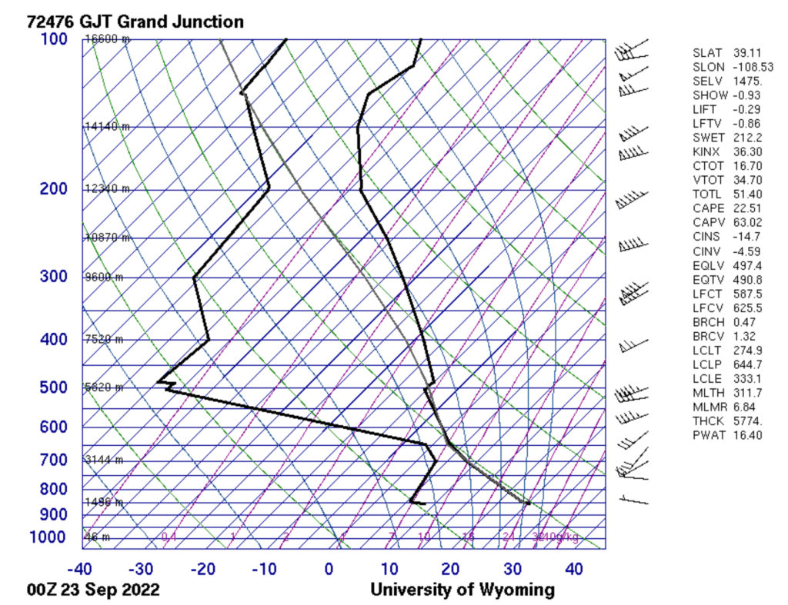
Figure 1: Skew-T diagram for 6pm September 22, 2022 in Grand Junction, CO

Figure 1 shows that clouds are most likely to form at about 4,000 meters, and because the CAPE value is 22.51, the atmosphere is very weakly unstable. These conditions, in addition to the shape of the clouds, confirm that this image shows cumulus and stratocumulus clouds.

Photographic Technique:
This photo was taken on iPhone SE second generation, with automatic settings of f-stop = 1.8, focal length = 3.99 mm, ISO = 20, and shutter speed = 1/2558s. The far mountains in the image are about 20 miles from the camera, and the field of view is about 0.1 mile across. Because the image was taken at about 3pm and the camera was pointing west, the sun lights the scene from the front. The original image (Figure 2) was 4032 X 3024 pixels and the final image is 2946 X 1396 pixels. During post-processing, the image was cropped to draw focus to the clouds and the sharpness and saturation were increased.

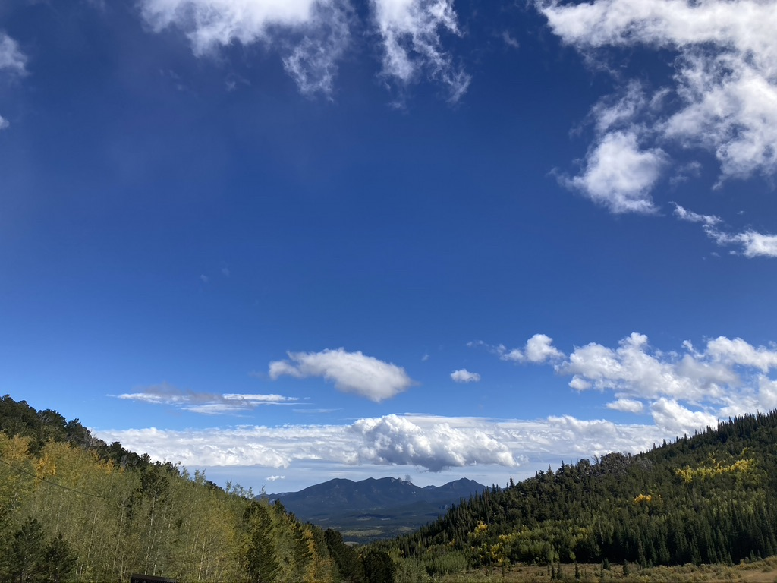
Figure 2: Unedited Image

Conclusion:
I think this image is effective both in showing how different cloud types exist in the same area and in creating a grand landscape scene using the clouds as a focal point. Shooting with an iPhone camera somewhat limited my control while shooting, but I am still satisfied with my final image.

