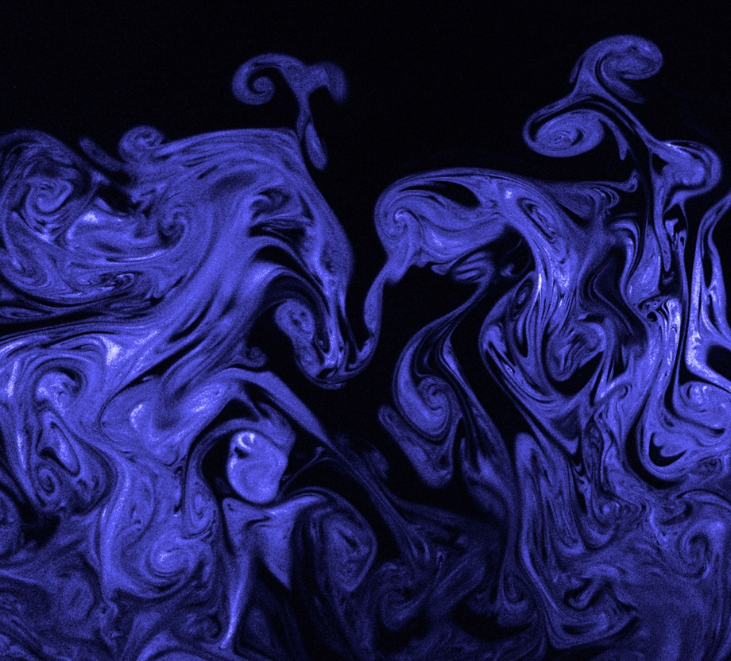

Ella McQuaid
With Alessandro Villain, Marina McCann, and Max Patwardhan
IV2: Team First
October 10, 2022
MCEN 4151

Overview:
This image was created for the first team visualization assignment of the Flow Visualization course. The intent of the image was to use a planar laser to show the mixing of stage fog in air as it was expelled from a fog machine. The laser and fog machine used were provided by Professor Hertzberg.

Fluid Dynamics:
Based on the varied sizes of the curls within the fog, the flow in this image appears to be turbulent. This assumption can be supported by calculating an approximate Reynold’s number for the fog as it is expelled from the fog machine. Using similar fog machines as a reference, the volumetric flow rate as the fog leaves the machine can be estimated as 2000 CFM or 0.94 m³/s, and the diameter of the opening can be estimated as 0.005 m[1]. At 20°C, air has a kinematic viscosity of 15.06*10⁻⁶ [m²/s][2].

$Re= \frac{QD}{Aν}=\frac{0.94\left[\frac{m^{3}}{s}\right]*0.005\left[m\right]}{π*{\left(\frac{0.005\left[m\right]}{2}\right)}^{2}*15.06*{10}^{-6} \left[\frac{m^{2}}{s}\right]}=15,894,358.2$ (1)

This is most likely an overestimation for the fog shown in the image because the fog lost velocity rapidly after being propelled out of the machine. Additionally, the fog juice is a mixture of water and glycerin, which has a higher viscosity than air alone. Even so, Equation 1 clearly shows that the flow is turbulent. Throughout the fog cloud, but most prominently at the top center and right of the image, the laser has sliced through vortex rings and captured mushroom-shaped cross sections such as the one shown in Figure 2.

Figure 2: Vortex ring cross-section
Visualization Method:
The visualization method for this setup was the reflection of the laser light off the aerosol of the stage fog and into the camera lens. The images were taken in a windowless room with one door around 8 feet diagonally from the laser open to a lit hallway and no other light sources, and Figure 2 shows an approximate recreation of the setup used. The laser was positioned to project a vertical plane in front of a camera on a tripod, with the fog machine blowing fog into the laser perpendicularly so that it would rise into the camera’s field of view.

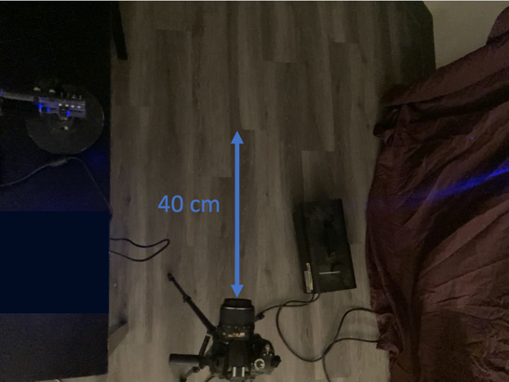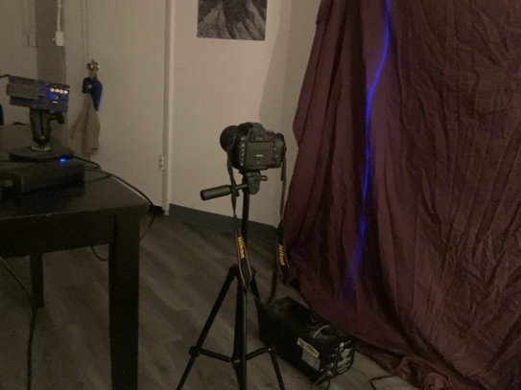
Figure 3: Photographic setup recreation
Photographic Method:
The camera used for this image was a Canon EOS 250D with a 50 mm focal length. The f-stop and ISO were set at f/1.4 and 6400, respectively to let as much light into the sensor as possible. The shutter speed was set at 1/1250 in order to capture the quickly changing patterns of fog. The original image size was 6288 x 4056. The distance between the laser plane and the end of the camera lens was around 40 cm. Except when actively shooting, the laser was kept off or at a low enough power level for the plane to be seen without lasing. In order to focus on the laser, one person held up a cardboard box in the plane of the laser while another person manually focused the camera on the box. The field of view of the camera was around 3 ft x 2 ft. Once the laser power was turned up to around 40%, one person held the fog machine below the laser and released puffs of fog while another person took photographs. Because focusing and capturing the laser was so difficult, all group members took turns using one camera that remained set up in the same position with very similar settings. In post-processing, the green and red was removed from the image to eliminate noise, the sharpness was increased, the tone curve was set to a transfer function to darken the black background, contrast, brightness, and saturation were adjusted to shift the de-noised image from blue to purple, and the soften tool was used to bring out highlights.

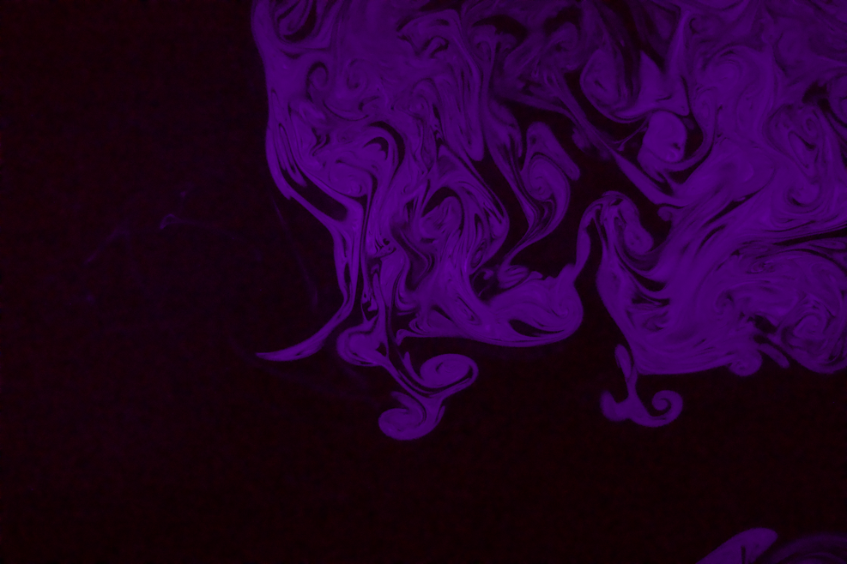
Figure 4: Unedited image
Final Thoughts:
I am very glad to have gotten to see this visualization in person, as it was very difficult to fully capture. I was initially disappointed with my final image, but after critique I was able to make edits to my post-processing that led to an image that better displays the flows present. Getting to work with a more powerful camera than my own was also exciting and very interesting. Overall, I feel proud of the work we did to get our setup as perfect as we could at the time, and the images that resulted from our work.

References:
[1] “Fog Machine - 500 Watt Mini Fog Machine with Remote and Fog Juice”.
http://www.cheapdjgear.us/Fog_Machine_500_Watt_Mini_Fog_Machine_with_Remote_p/MINI-FOG-500-Juice.htm?gclid=EAIaIQobChMI6NCRiu_82QIVgZFCh0s6guBEAQYAiABEgKdQ_D_BwEm
[2] “Air – Dynamic and Kinematic Viscosity”, The Engineering Toolbox, (2003). https://www.engineeringtoolbox.com/air-absolute-kinematic-viscosity-d_601.html

