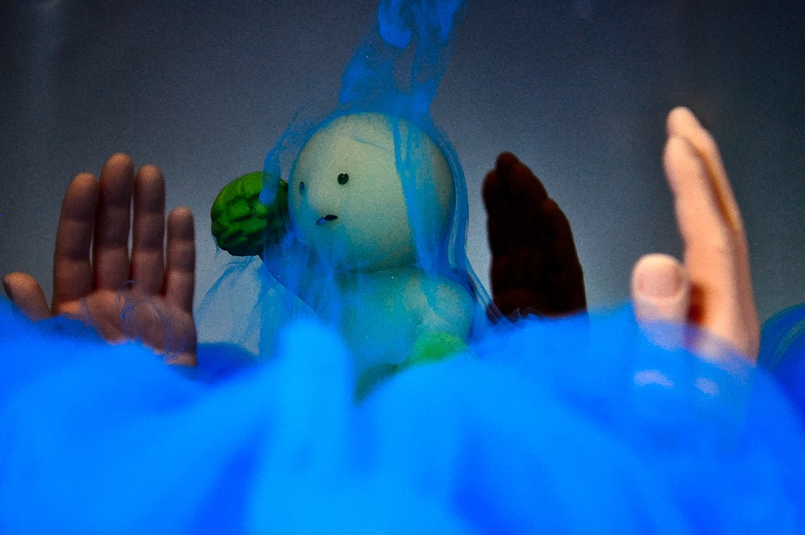

Ella McQuaid
with Alessandro Villain, Marina McCann, and Max Patwardhan
IV3: Team Second
November 7, 2022
MCEN 4151

Overview:
This image was created for the second team visualization assignment of the Flow Visualization course. The intent of the image was to observe flows created by injecting paint into water and how they interacted with submerged objects, a concept inspired by the video “Ink in Motion” from the YouTube channel Macro Room[1]. It was determined that food dye dissolved too quickly into water while pure paint did not dissolve enough for an engaging visualization, so the final image used a mixture of paint and water. The hands were intended to appear to reach up through the blue “fog” sitting at the bottom of the tank, and the figurine was included as a central subject.

Fluid Dynamics:
The chosen image was taken after the initial injection at a time when the pigment was settling through the water due to the density difference in the two fluids rather than the propulsion of the syringe. According to its safety data sheet, the paint has a specific gravity of 1.1 relative to water[2] or a density of 1100 kg/m³. The streamlines visible to the right of the figurine show that the flow is laminar. Based photos taken over 2 seconds following another injection, shown in figure 1, the velocity of the paint can be estimated at 0.2 inches per second or 0.0051 meters per second. The characteristic length for the streamlines around the figurine’s head is the diameter of the head, 1 inch or 0.025 meters. The dynamic viscosity of the paint can be estimated as slightly lower than that of glycerin at 1.25 N*s/m² [3]. Equation 1 solves for the Reynolds Number using these values, resulting in a value below 1, which confirms that the flow is very laminar.

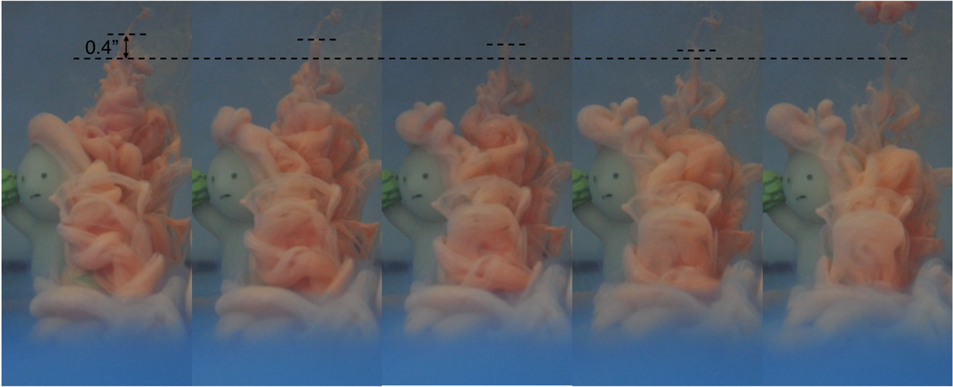
Figure 1: non-propelled paint movement over 2 seconds

$Re= \frac{ρvL}{μ}=\frac{1100\left[\frac{kg}{m^{3}}\right]*0.0051\left[\frac{m}{s}\right]*0.025m}{1.25[\frac{N*s}{m^{2}}]}=0.1122$ (1)

Visualization Method:
The pigment used in this visualization was a mixture of about 1 part water to 3 parts Tulip Soft Matte Fabric Paint. This mixture was injected into the tank using a syringe with a very narrow opening, which created a suddenly started flow. The paint that left the syringe last was not propelled downward but stayed suspended in place briefly before sinking. The streamlines were created when the paint moved around the figurine’s head. It then settled to the bottom of the tank but remained fog-like due to the small density differences between the fluids and the miscibility of the paint in water. When the flow of a new injection disturbed the fog, it would billow outward as can be seen in the foreground of the image. This particular image was taken through the narrower face of the tank, shown on the right side of figure 2, with lights positioned about 24 inches above the objects and 16 inches diagonally to the left.

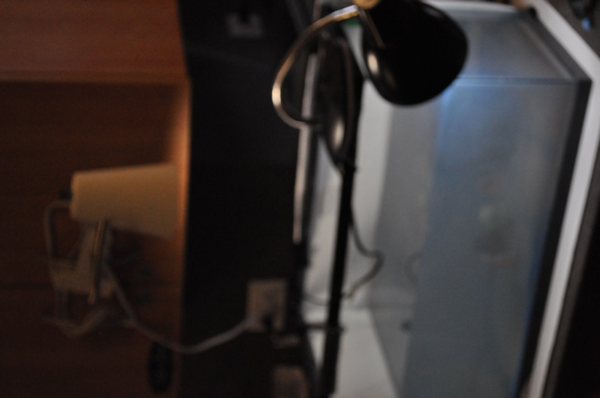
Figure 2: Photographic setup

Photographic Method:
The camera used for this image was a Nikon D5000 with the settings listed in table 1.

Table 1: Camera settings
Focal Length | 48 mm
f-stop | f/5.6
ISO | 2000
Shutter speed | 1/640

The end of the camera lens was around 1 inch away from the glass, and therefore around 10 inches from the green figurine, 9 inches from the closest (rightmost) hand, and 11 inches from the two further hands. The field of view of the camera was around 6 x 4 inches. The image size is 4288 x 2848 pixels.
In post-processing, the seam at the right corner of the tank was retouched, as was a reflection in the top left corner. The high end of the RGB curve was brought to a horizontal slope to utilize the full color range. The brightness was reduced and the saturation was increased. The image was sharpened and denoised, and the tone curve was changed to a transfer function. Figure 3 shows the unedited image for comparison.
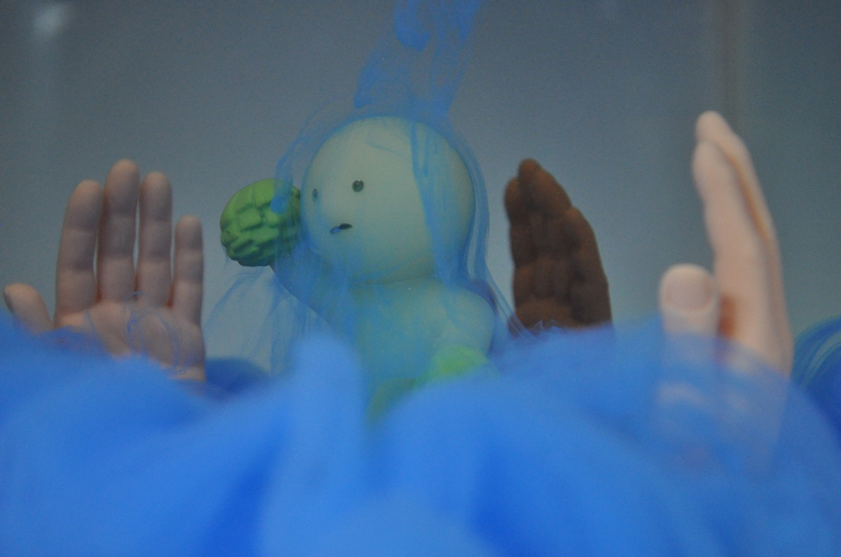
Figure 3: Unedited image
The range of scales in this image goes from about 3 pixels to about 4000 pixels, which is around 3 decades. The range in the flow goes from about 10 microns at the particle level of the paint pigment to about 0.25 meters at the level of the fog cloud diameter. This range is about 5 decades. The image is not resolved down to the level of the pigment particles.
The values used to calculate time resolution can be found in table 2. Equations 2 through 4 indicate that the image is highly time resolved.

Table 2: Time resolution values
Fluid velocity | 0.0051 m/s
Field of view | 0.1 m
Sensor size | 2848 pixels
Shutter speed | 1/640

Streak Length:$0.0051 \left[\frac{m}{s}\right]*\frac{1}{640}\left[s\right]=7.97*{10}^{-6}[m]$ (2)
Object:$\frac{0.1 \left[m\right]}{2848 pixels}=3.5*{10}^{-5}\left[\frac{m}{pixel}\right]$ (3)
Fraction of image affected: $\frac{7.97*{10}^{-6}[m]}{3.5*{10}^{-5}\left[\frac{m}{pixel}\right]*2848 pixels}= \frac{8}{100000}$ (4)

Final Thoughts:
I am very happy with how this image turned out, our team had a lot of fun creating the scene and trying out different injection methods. The setup, angle, and editing of the final image combine to create a dramatic and spooky atmosphere out of what was a basically silly idea. The figure looks like it is shrouded in a veil and surrounded by a council of hands that will decide its fate. In the future, it would be interesting to combine additional colors or take high speed video of the flow. Incorporating different objects that would create varied shapes in the flow or moving an object through a stationary cloud of paint could also be interesting.

References:
[1] “Ink in motion”, Macro Room, YouTube, (2018). https://www.youtube.com/watch?v=ICxC5ekWnUc&t=32s.
[2] Safety Data Sheet, Tulip Soft Fabric Paint, Duncan Enterprises. https://ehslegacy.unr.edu/msdsfiles/31160.pdf.
[3] Gerhart, P. M., Gerhart, A. L., & Hochstein, J. I. (2016). Table 1.6. In Munson, Young, and Okiishi's Fundamentals of Fluid Mechanics (Eighth Edition). essay, Wiley.

