Clouds 2 Report
Lucas Fesmire

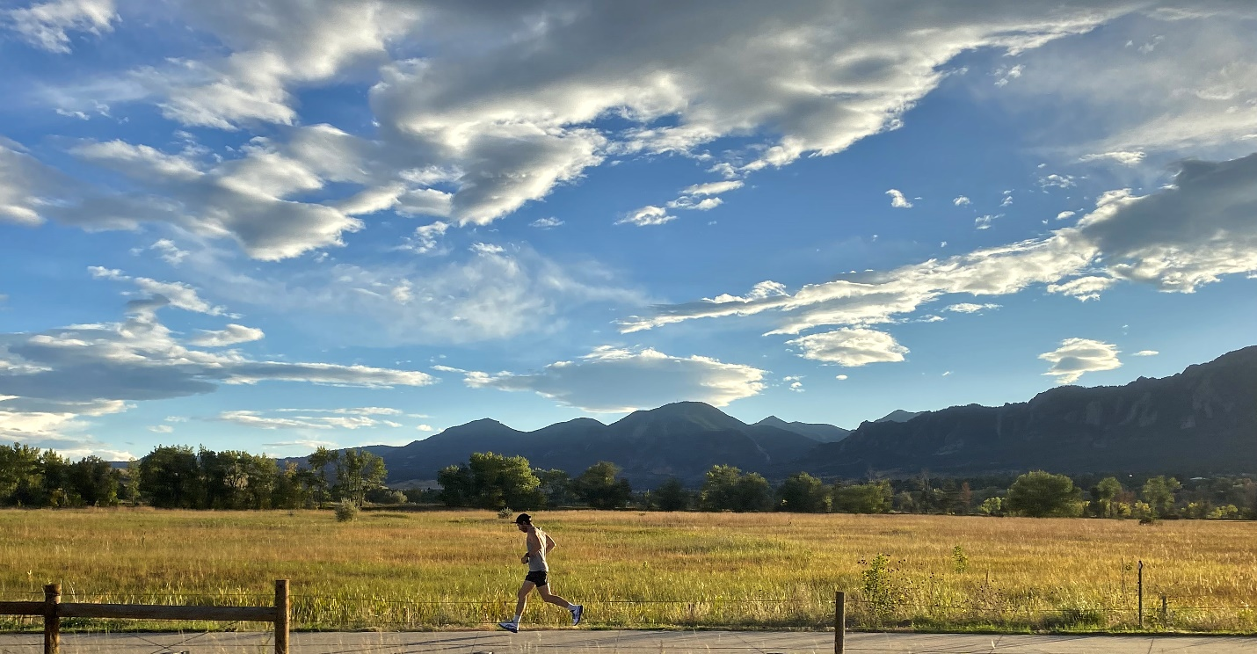

MCEN 4151-001: Flow Visualization
Date: 12/9/2022

This report will detail the process I followed to capture this image for Clouds Assignment 2. Early in the year, Professor Hertzberg mentioned that Colorado is one of the best locations for cloud spotting because of the geography and atmospheric conditions. Although I’ve been in Colorado for almost 4 years now, I had always been focused on the land and have only recently noticed the beauty present in the clouds. For this assignment, I wanted to showcase the beautiful vastness of Colorado’s land as well as it’s sky. To achieve this, it was clear I would need to capture a wide variety of clouds but also a large section of land.
This image was taken while leaving Boulder, driving East on Route 36. As I was sitting in the passenger seat, I turned to the window and was excited to see abundance of unique characters floating in the sky. I quickly got out my phone and pointed it out into the field, parallel with the horizon, before snapping the photo. At this moment, I was at an elevation of about 5,300 feet above sea level.
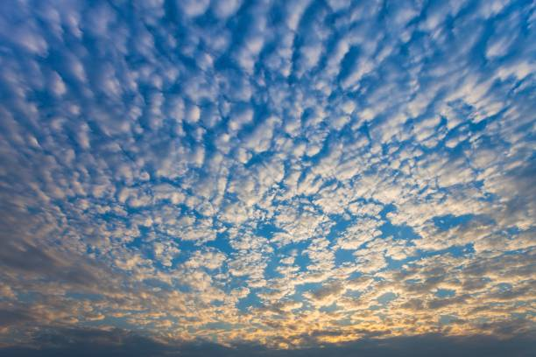
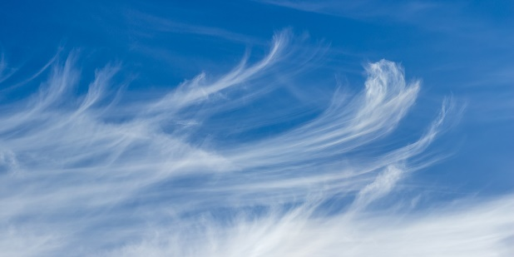
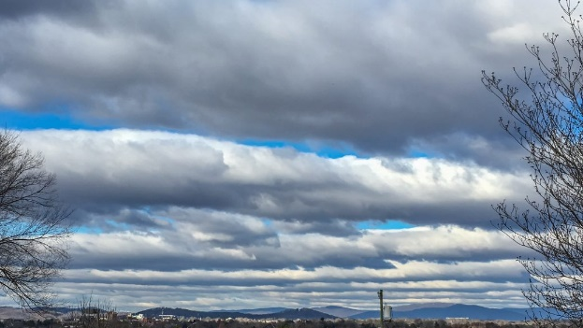
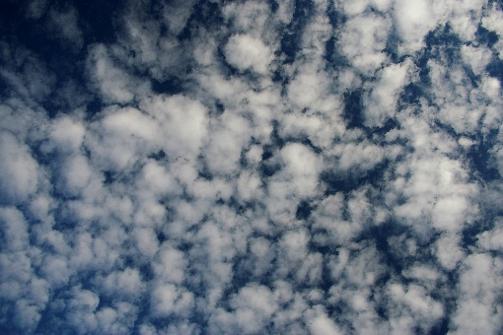
On the day of the photo, the weather was spectacular. The temperature was in the 70s and the sun was shining most of the day; only being blocked by the occasional cloud passing by. This photo contains several clouds, however, the most apparent at first glance are certainly the stratocumulus clouds. They can be identified by the appearance of cumulus clouds merged in thick, continuous distribution. Stratocumulus clouds form between 1,000 feet and 4,000 feet and consequently the lowest clouds in this photo. Almost directly, in the center lies the cirrus cloud. Cirrus clouds are defined by their wispy, feathery form and are composed entirely of ice crystals. Cirrus clouds form between 15,000 feet and 30,000 feet. Along with the stars of the show, is the supporting cast: several groupings composed of altocumulus and cirrocumulus clouds. Both alto and cirrocumulus clouds exhibit many of the same characteristics as the cumulus cloud such as it’s fluffy, cotton-like appearance, as well as a flat bottom and a vertical growing direction. The cumulus is larger than the altocumulus and the altocumulus is larger than the cirrocumulus. In terms of formation height, altocumulus form between 6,500 feet and 20,000 feet while cirrocumulus clouds form between 16,000 feet and 39,000 feet. Looking at the Skew-T diagram from Grand Junction, it’s apparent that the atmosphere was stable and there was a large range of space where cloud formation was possible.
Figure 1: Stratocumulus (top left), cirrus (bottom left), altocumulus (top right), and cirrocumulus clouds (bottom right)

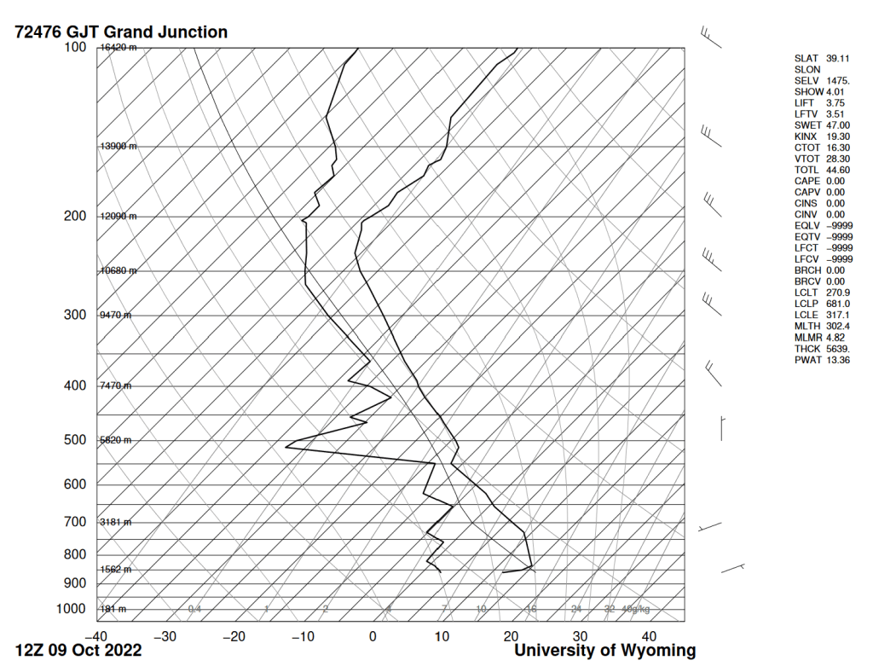
Figure 2: The Skew-T diagram taken from the Grand Junction/Walker station on the day of the photo.
I used an iPhone 11 to take this photo. I used the 4.25mm lens with the shutter speed at 1/2000 seconds and the aperture at f/1.8. Additionally, the ISO was set to 32. The original image size was 3997 x 2080 pixels while the cropped image was 4032 x 3024 pixels. I had cropped out the road and the right side of the image. I used the split RGB curve to deepen the blues and the greens in the image. I thought this helped to make the sky and the field pop more. I also turned the shadows up a bit to try and bring a little more detail out of the backlit mountains.
I was very proud of how this image turned out. I think that it does a good job of highlighting Colorado’s landscape and sky. It also showcases a wide variety of clouds which was another one of my goals. The runner in the photo was a bonus too as I did not intend on having him in the frame, but we drove by at the perfect time. I would have preferred to have taken this with my camera as I feel I would have gotten a more clear image with a lot more details. Overall, I’m happy with how the image turned out.

References
Atmospheric soundings. (n.d.). Retrieved October 22, 2022, from https://weather.uwyo.edu/upperair/sounding.html
Pretor-Pinney, G. (2012). The cloudspotter's guide. Sceptre.

