Clouds Second Report
Sander Leondaridis
Flow Visualization Fall 2022

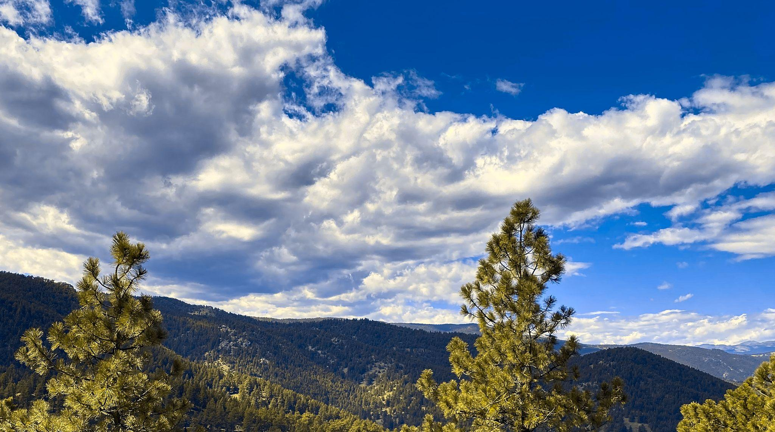
Cumulus clouds, 9/17/22, 11:38 AM, Flagstaff Boulder, CO

Context and Purpose
This image was produced for the second cloud assignment of the semester. I chose this image as it had a nice balance of color with the mountains and trees present. This image was taken facing west at the top of a hiking trail at Flagstaff on September 17, 2022 with fair weather and a stable atmosphere.

Cloud Information
This image contains formations of good old cumulus clouds, characterized by the puffy shape and lower altitude. There is a possibility that these are in fact stratocumulus clouds, but those typically have a flat surface and are more closely clumped together. The fair weather would also suggest that these were just cumulus clouds.
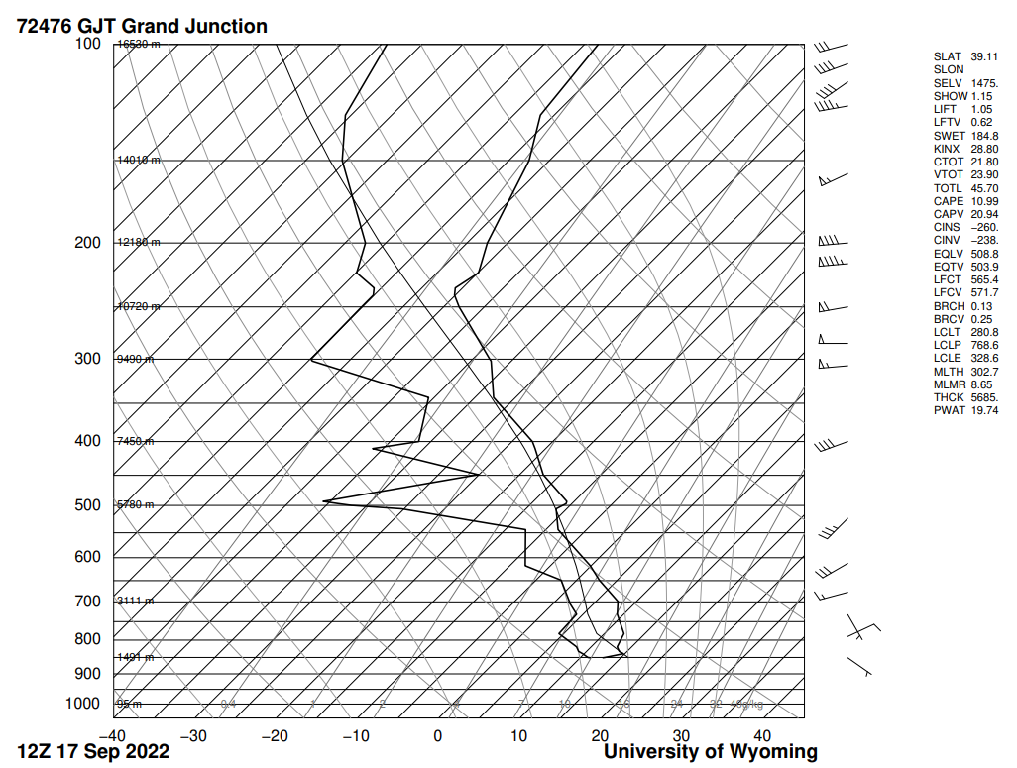
Figure 1. Skew-T diagram for September 17, 2022 ~11 AM

The skew-T diagram reveals that there were cloud formations at roughly 1,500 m. The Convective Available Energy (CAPE) is low enough to be a stable atmosphere. It should be noted that this skew-T diagram was taken at Grand Junction, and should not be treated as completely accurate. Assuming that the clouds agree with the skew-T plot, the elevation fits in the typical range for the formation of cumulus clouds. I remember the weather being beautiful, with low winds and a comfortable temperature of 70 degrees Fahrenheit.

Photographic Techniques
~3000 ft
~5 degrees

Camera

I will be assuming that the cumulus cloud is at its upper elevation range of 3,000 ft, and that the angle of the camera was 5 degrees.

$d_{object} = \frac{3000 ft}{sin(5∘)}≈34,000 ft$

This puts the cloud at a distance of 34,000 ft from the camera. I used my iPhone 11 camera to capture this photo, which has a focal length of 4.25 mm, and a sensor size of 1/2.55 in.

$FOV = d_{object}*tan^{-1}(sensor size/2*focal length)$

Using the above equation, the calculated FOV is 128,974 ft. Information about aperture, shutter speed, and ISO were not available from my iPhone camera on Darktable software, and thus are not included in this report.
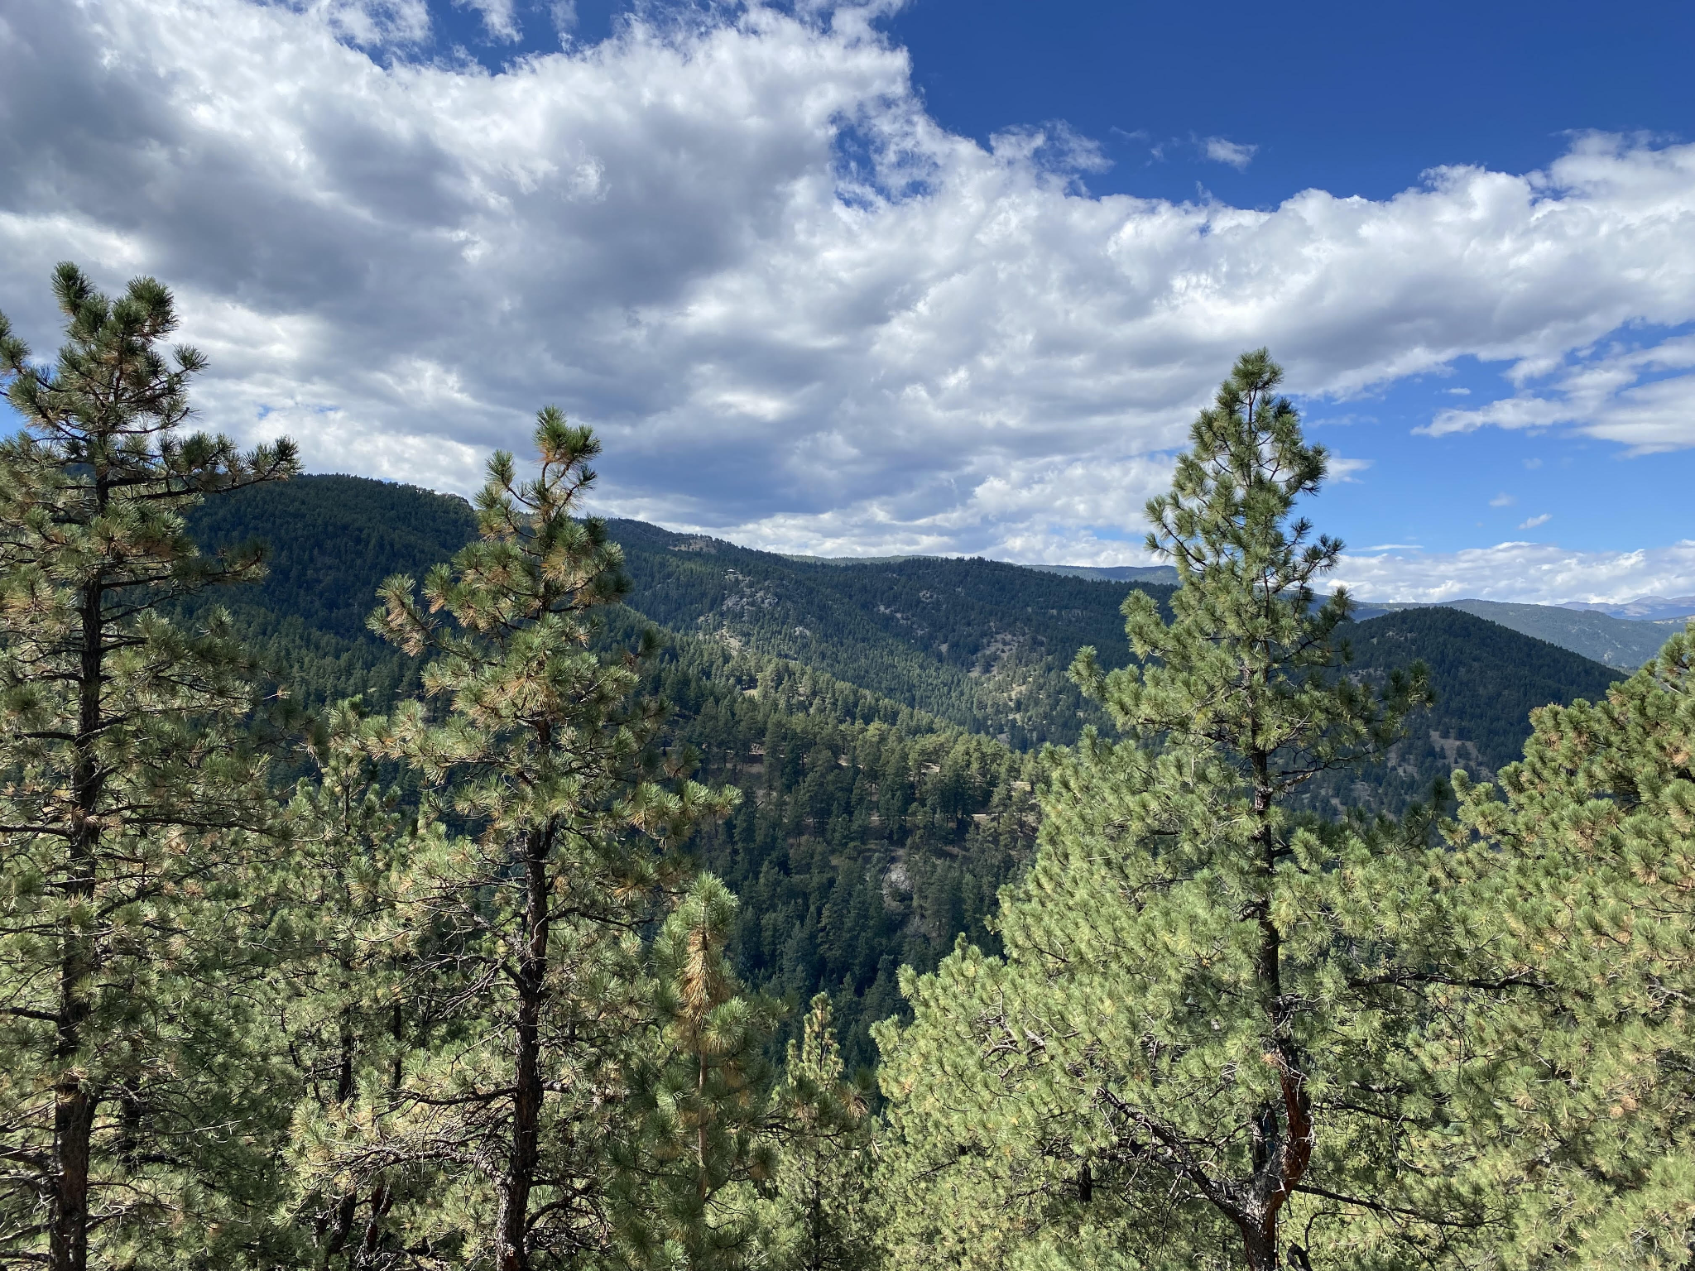
Figure 2. Original unedited photo.

I cropped much of the foreground in order to put more emphasis on the clouds themselves. I also wanted to brighten the colors of the image, and upped the contrast and saturation in order to achieve this.

Conclusion
This image was taken when my father visited Boulder for the first time in a few years, so it was a special moment for me that also happened to make for a great cloud photo. I love how the colors of my final image turned out, but wish I was able to remove the trees from the foreground. This was a fun way to end the semester, and now I am always looking to the skies to see more amazing cloud formations.

Appendix

University of Wyoming College of Engineering (2022) http://weather.uwyo.edu/upperair/sounding.html

Smith Falls Flying Club https://smithsfallsflyingclub.com/pilot-resources/cloud-tops-skew-t/

Weather Underground (2022) https://www.wunderground.com/history/daily/us/co/loveland/KFNL/date/2022-9-29

Edmund Optics (2010) https://www.edmundoptics.com/knowledge-center/application-notes/

