IV1 Report
Lucas Fesmire

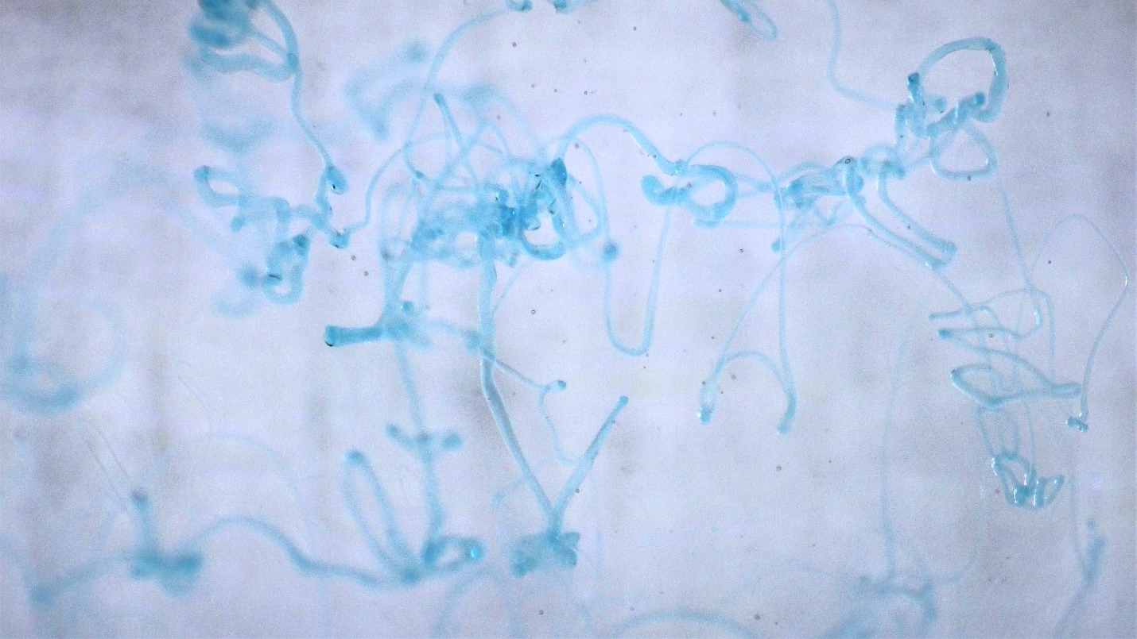

MCEN 4151-001: Flow Visualization
Date: 9/26/2022

This report will detail the setup, governing physics, and capture of a flow phenomenon for Image-Video Assignment 1. I hoped to capture a Non-Newtonian fluid as it came into contact with water. I hoped to show that the form and shape of the Non-Newtonian fluid are preserved as it moved through the water.

This experiment was carried out inside of a 3-gallon aquarium. Initially, I made sure to thoroughly clean the interior and exterior of the aquarium glass so that no stains or marks were present. After, the tank was filled to the top with water from the tap. A bottle of blue Dawn dish soap was held 6 inches above the surface of the water and was lightly squeezed and moved in an oscillatory motion. As the dish soap comes into contact with the water, rather than dispersing and dissolving, it maintains its shape. This is largely because dish soap is a Non-Newtonian fluid. A Non-Newtonian fluid is defined as a fluid whose viscosity is dependent upon the instantaneous shear rate of the fluid. In other words, the fluid’s resistance to deformation depends upon how fast that deformation is taking place. In the case of the dish soap, it begins deforming the second it hits the water, and the pressure forces acting on it increase its viscosity thus preserving its shape. Using some measurements and approximations, we can find the Reynolds number for the flow of the dish soap and subsequently classify the flow. The equation below can be used to calculate the Reynolds number for flow in an open channel where $ρ$ is the density of the fluid, V is the velocity of the flow, $L$ is the characteristic length of the fluid, and $μ$ is the dynamic viscosity.
$$Re=\frac{ρVL}{μ}$$
It took 420 milliseconds for the dish soap to reach the water from 6 inches above the surface. Using this information, we can determine the velocity of the flow $V$ was 0.363 $m/s$. The density $ρ$ of dawn dish soap is stated to be 932 ${kg}/{m^{3}}$ (Home, 2020) while the dynamic viscosity $μ$ is 0.085 ${kg}/{m∙s}$ (Flux, unknown). The characteristic length $L$ was measured to be $\frac{1}{16} in$ or $0.0015875 m$.
Using these values, the Reynolds number comes out to be 6.319, which classifies the flow as laminar. This low Reynolds number can be attributed to the limitations on accuracy for the measurement equipment.

In order to obtain a clear image, lots of thought went into how this phenomenon would be visualized White printer paper served as the backdrop to more clearly highlight the shape and the color of the soap. I had both blue and green dish soap but decided that the blue provided more contrast against the bright white background. The subject was illuminated with two LED lanterns placed on either side of the lens.

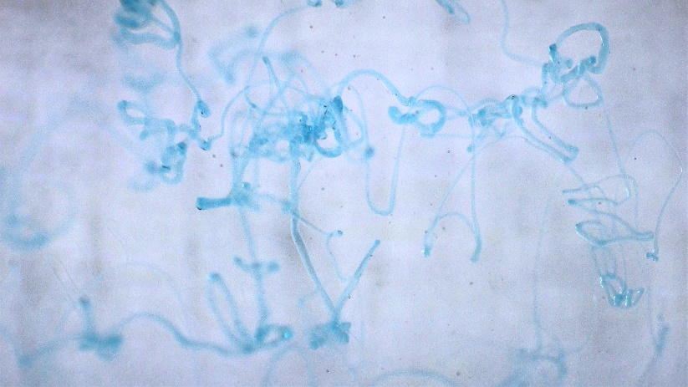
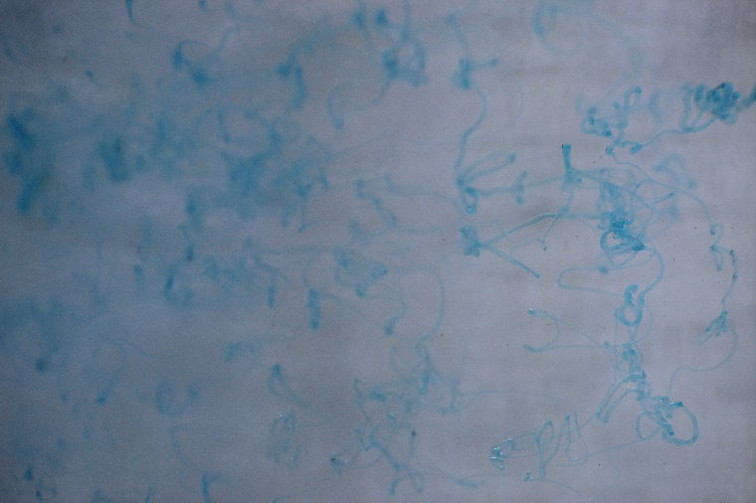
I chose to place the camera two feet from the front of the aquarium with the focal plane located directly in the center of the tank. The decision for focal plane location was made with the hopes that the image would display a clear plane of the dish soap in the middle while some strings toward the back or front would be out of focus, adding depth to the composition. I used a Canon EOS Rebel T5 with a Canon 18-55mm 1:3.5-5.6 lens. The camera I used was a digital camera and the original image size was 5184 x 3456 pixels while the cropped image was 1942 x 3452 pixels. My shutter speed was 1/400s, my aperture was f5.6 and my ISO was 500. In regards to post processing, I cropped the image quite drastically to better showcase the good examples of the flow phenomenon I was after. I also modified the RGB curve to brighten the image a bit and increase the depth of the blue dish soap. Lastly, I bumped up the contrast to make the distinction between the background and the soap clearer.
Figure 1: The image before (left) and after (right) post processing.

I believe the image reveals how a Non-Newtonian fluid interacts with water. The distinct shapes and swirls of the soap show that it does not dissolve after coming into contact with water. If I were to repeat this experiment again I think I would position the camera much closer to try and get a clearer photo of fewer strands of soap. I would also use a thicker background like cardstock or cardboard to prevent any light from entering through the rear of the tank. Artistically, I would use the green dish soap in addition to the blue soap to add more color to the photo.

References
(2020, May 29). Home. Profound. Retrieved September 25, 2022, from https://profound-answers.com/what-is-the-density-of-dishwashing-soap/
Flux. (n.d.). Viscosity chart - weebly. Viscosity Chart. Retrieved September 26, 2022, from https://thesuccesstechnic.weebly.com/uploads/7/2/1/3/7213446/flux-high-viscosity-b0000-visc-chart-1.pdf

