IV2 Report
Lucas Fesmire
Martin Allsbrook
Issac Martinez
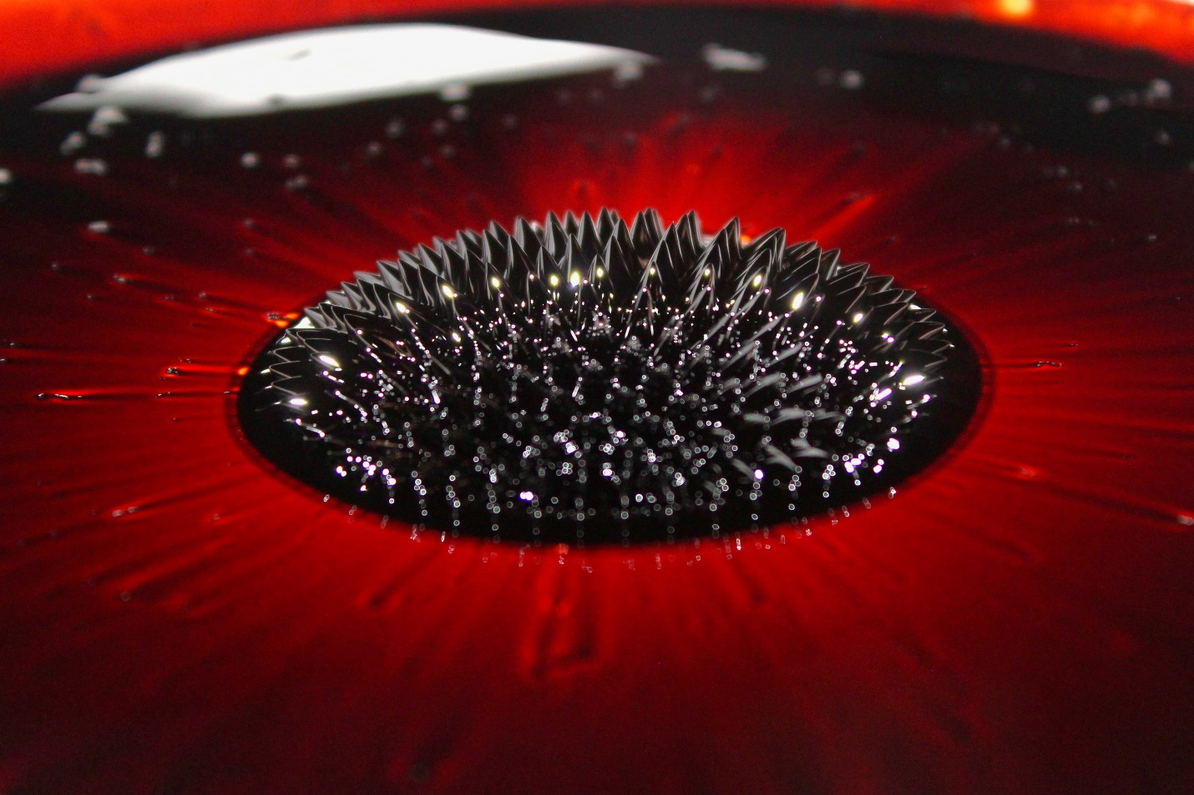

MCEN 4151-001: Flow Visualization
Date: 10/9/2022
This report will detail the setup, governing physics, and capture of a flow phenomenon for Image-Video Assignment 2. What began as a quick meeting with my group to take a picture for this assignment, evolved into a three-hour long session of experiments, where we found ourselves being amazed over and over by the strange properties of ferrofluid. I preformed these experiments with Martin Allsbrook and Issac Martinez, pursuing a goal of capturing the unique shape ferrofluid takes when in the presence of a magnetic field.

This experiment was carried by pouring the ferrofluid onto a large white porcelain plate. A strong magnet was placed underneath the center of the plate to generate a magnetic field which would extend through the ferrofluid above. The magnet was oriented with it’s poles on the top and bottom to ensure the magnetic field would extend through the fluid. The plate was slightly concave and about a foot in diameter. The ferrofluid had been dragged around the plate using the magnet to produce a very thin film of liquid. After, the magnet was placed back in the center and caused the ferrofluid form a 3-inch diameter blob in the center.
Figure 1: A sketch of the experimental set up.

Ferrofluid is composed of many very small ferromagnetic particles suspended in a carrier liquid(1). These ferromagnetic particles are attracted to the poles of a magnet and are responsible for the unique properties of the fluid. When a magnet is brought near ferrofluid, spikes rise out of the liquid. This phenomenon is known as the normal-field instability. The formation of the spikes is due to the balance of several forces including the magnetic field, surface tension, and gravity. These spikes rise out of the liquid along the path of the magnetic field lines.
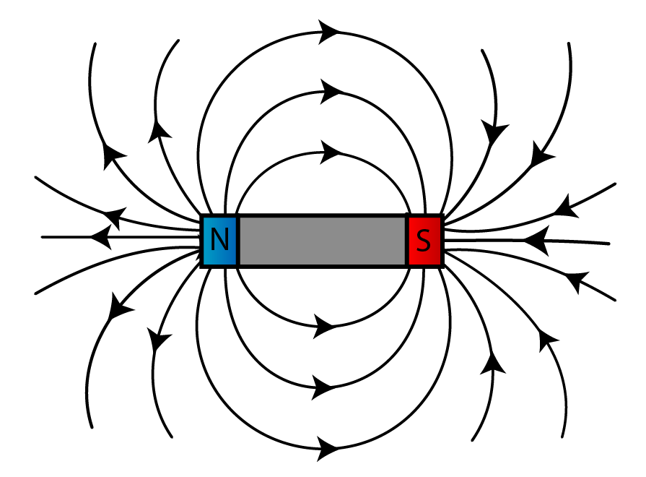
Figure 2: A diagram showing the direction of magnetic field lines extending out of a magnet’s poles.(2)

The height of the spike is determined when the force of gravity on the fluid is equal to the force from the magnetic field (1). Thus, spike height is directly related to the distance between the magnet and the ferrofluid.

Lighting was a critical factor in the process of capturing the normal-field instability. The thinner the layer of ferrofluid, the lighter it appears. Since the magnet causes ferrofluid to pool up, the fluid becomes very dark and reflections of light are only way the shape can be visualized. Taking this into consideration, we placed a large construction floodlight a foot away from the plate. This light helped to fill in the edges, and sides of the peaks. Additionally, two purple LED strips lined the edge of the ceiling of the room we were in and yielded several smaller point reflections towards the front of the ferrofluid. I used the flash on my camera as one last source of light. The reflection of this light is visible at the beginning of the focus plane and appears to have a slight yellow tint.

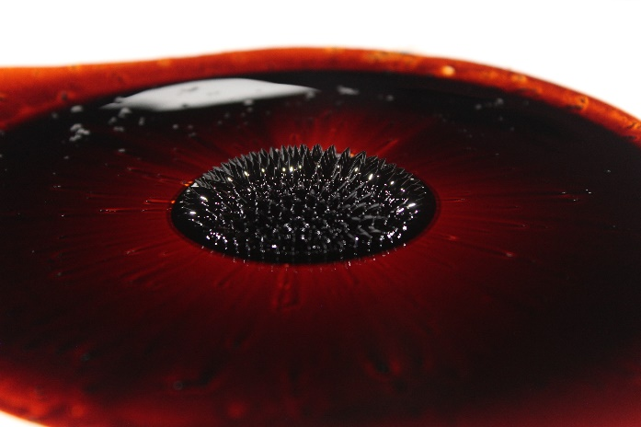
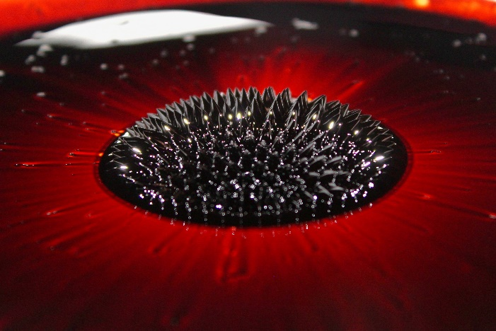
I used a Canon EOS Rebel T5 with a Canon 18-55mm 1:3.5-5.6 lens. The camera I used was a digital camera and the original image size was 5184 x 3456 pixels while the cropped image was 3439 x 2293 pixels. The clump of ferrofluid was 8 inches from the surface of the lens and the field of view is 4 inches wide and 8 inches deep. My shutter speed was 1/60s, my aperture was f5.6 and my ISO was 800. In regards to post processing, I cropped the image quite drastically to better showcase normal-field stability. I also modified the RGB curve to brighten the image a bit and display more of the detail present in the film. I also changed the RGB curve to make the red film more vibrant. Lastly, I bumped up the contrast to make the distinction between the ferrofluid film and the normal-field instability clearer.
Figure 3: The unedited, raw image (left) and the image after post processing (right).
I was quite pleased with how the image came out. I love the deep red caused by the thin film and the crispness of the spikes. I chose to keep my focal plan toward the back of the pool of ferrofluid because I thought it made it easier to see the spikes against the red background rather than against the black pool of fluid. I think the combination of the color, and the texture of the spikes makes it look like this could be a computer animated graphic. If I were to repeat this experiment, it could be beneficial to use a larger f stop value to increase the depth of the focal plane. I would also play around with the location of the lights to remove the large white reflection in the back of the photograph. It would be interesting to use a much larger magnet or a much smaller one to produce different sized spikes.

References
(1)Ferrofluid - Description - Normal-field Instability. LiquiSearch. (n.d.). Retrieved October 9, 2022, from https://www.liquisearch.com/ferrofluid/description/normal-field_instability
(2)Introduction to magnetism (revision). SPM Physics Form 4/Form 5 Revision Notes. (2014). Retrieved October 9, 2022, from http://spmphysics.onlinetuition.com.my/2008/06/introduction-to-magnetism-revision.html

