IV3 Report
Lucas Fesmire
Martin Allsbrook

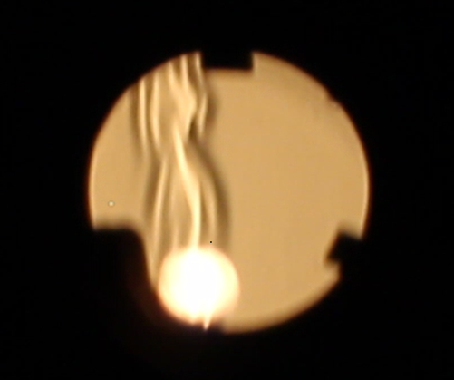

MCEN 4151-001: Flow Visualization
Date: 11/6/2022

This report will detail the setup, governing physics, and capture of a flow phenomenon for Image-Video Assignment 3. This video was created using Schlieren imaging to capture the air currents emitted from a handheld lighter. I wanted to capture not only the illumination of the flame, but also, the heated air rising from the flame which would otherwise be invisible to the naked eye.

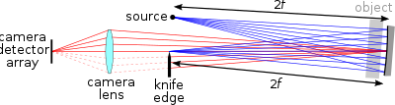
This experiment was conducted using a Schlieren set up. Schlieren imaging is a process for photographing fluid flow. The technique was invented in 1864 by German physicist August Toepler to study supersonic motion (Schlieren Photography, 2022). Today, one of the largest applications for Schlieren imaging is to capture the flow of air around an object, such as a aircraft in mid-flight. These hidden currents are revealed due to their varying refractive indices caused by density gradients present across the fluid (Schlieren Photography, 2022). To properly view this refracted light, a Schlieren setup must be constructed. Our Schlieren setup involved an LED, a slotted hole to convert the LED into an idealized point light source, a 6-inch concave mirror to reflect the light, and a sharp blade to cut the reflected light at its focal point.

Figure 1: A sketch of the Schlieren setup with the reflected light rays included.
As shown in figure 1, the knife edge is placed at the point where the reflected light rays converge. Placing the camera behind the edge of the knife allows for some of the reflected light to be passed into the lens while the rest of it is blocked by the knife. This filtering is what allows us to see different levels of light intensity. During the ignition of the lighter in the video, a jet can be seen propelling vertically from the lighter. After this, the hot air floating away from the flame can be seen wisping and waving as it rises. This video was taken for a duration of 4.5 seconds.
Getting the correct lighting for this experiment was certainly a challenge. To clearly capture the light reflecting off the mirror, we needed the room to be extremely dark. This required covering all the windows to prevent any outside light from creeping in, killing all the light in the room and even putting tape over small LED lights such as the clock on the microwave and the oven. The only source of light present was the single LED bulb which was surrounded by a carboard box, where the only exit for the light was the miniscule slot which would transform this into a point light source.

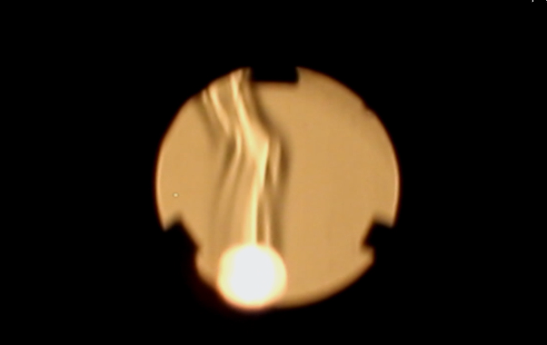
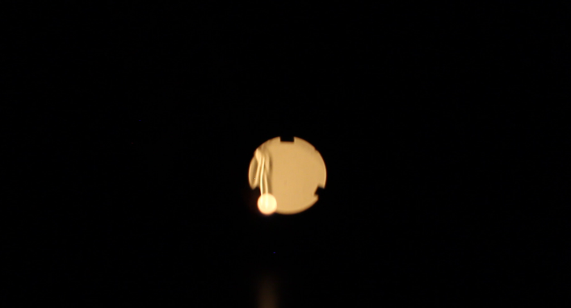
This video was taken on a Canon EOS Rebel T5 with a Canon 18-55mm 1:3.5-5.6 lens. This camera is a digital camera and recorded the video in 1920 x 1088 resolution at a frames rate of 30 frames per second. Later, in post processing. The video was slowed down to playback at 9.64 frames per second. I felt that this gave the viewer more time to see and appreciate the fluid flow. I cropped the image quite a bit to zoom in on the mirror in the center of the frame. I also slightly increased the brightness and the contrast. The mirror was about 6 feet from the lens and the field of view after cropping was around 20 inches wide and 10 inches tall.
Figure 2: Screenshots of the video before (left) and after (right) post processing.
I love that this image reveals something that is so hidden. We can feel wind, heat, and the absence of heat, but we can’t see them and because of this, it’s pretty uncommon to associate temperature differences with your sense of sight. When setting this experiment up, I leaned in close to the knife blade and was able to see the air currents with my naked eye. I felt like I was looking into a rift into another universe where temperatures and air currents were visible. It was truly amazing and eerie at the same time. I think this video helps to display this phenomenon and the privilege it is to see it. If I were to go back and do this experiment again, I would try and use many other heat sources or heat sinks. I would also try using a high-speed camera to get some really smooth videos.
References
Wikimedia Foundation. (2022, July 12). Schlieren photography. Wikipedia. Retrieved November 6, 2022, from https://en.wikipedia.org/wiki/Schlieren_photography

