IV4 Report
Lucas Fesmire

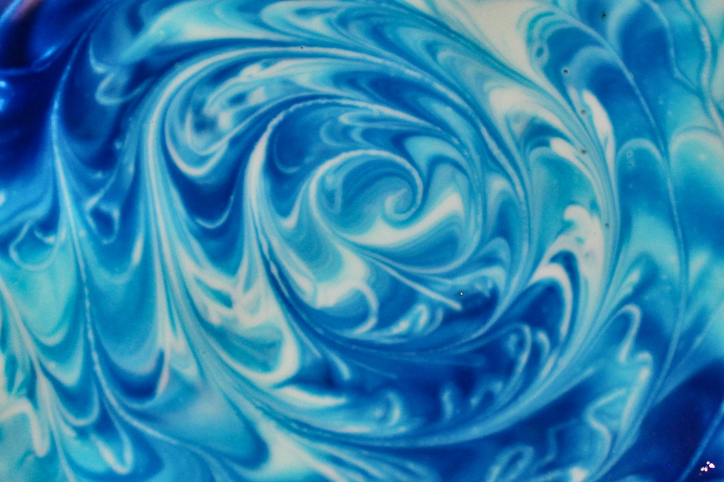

MCEN 4151-001: Flow Visualization
Date: 11/16/2022
This report will detail the setup, governing physics, and capture of a flow phenomenon for Image-Video Assignment 4. This image is taken over top of a vessel containing oobleck with food dye being mixed in. Initially, I hoped to capture a glob of oobleck interacting with a rigid object. However, upon adding the food dye, I noticed that mixing the mixture produced beautiful swirls of color suspended in time. I wanted to highlight the range of colors and shapes on the surface of the oobleck. Additionally, I decided the dye would be a good visualization of the wake of the stirrer.
Named by Dr. Seuss, oobleck is the nickname for this non-Newtonian fluid which is based off a simple mixture of water and cornstarch. A Non-Newtonian fluid is defined as a fluid whose viscosity is dependent upon the instantaneous shear rate of the fluid [1]. This means that the oobleck acts more like a solid than a liquid when there is a force applied to it. However, without the force, the oobleck is very similar to a viscous liquid. This substance has even been proposed as a temporary solution to potholes. This would require a bag of oobleck to be placed into the hole. The oobleck’s ability to change from a liquid to a solid would allow it to form to the pothole and support heavy loads as cars drive over it [2].
To create the oobleck I mixed 1 cup of water and 2 cups of corn starch in a large measuring cup. While swirling the dye around, there was not a lot of flow happening in the cup. When the force of the stirring needle was applied to the surface of the oobleck, a small portion of the mixture would harden, preventing any disturbances in the fluid to be transmitted across the surface. This allowed for a surprising amount of control when tracing lines of dye onto the oobleck. Shortly after the string needle passed and the oobleck returned to its liquid state, the dye began to very slowly diffuse. This caused a softening of the boundaries over a long period of time.
To create the swirl pattern in the image, three drops of die were placed in in the cup and a stirring needle was used to gently swipe and stir the surface of the oobleck, making sure to maintain a wide range of color. Then, the stirring needle was used to stir a spiral into the fluid. This photo was taken in the kitchen under an overhead tungsten light bulb which was 5 feet above the table.
I used a Canon EOS Rebel T5 with a Canon 18-55mm 1:3.5-5.6 lens. The camera I used was a digital camera and the original image size was 5184 x 3456 pixels while the cropped image was 2,356 x 1,570 pixels. The surface of the oobleck was about 1.5 feet away from the lens and the field of view is around 5 inches wide and 4 inches tall. My shutter speed was 1/40s, my aperture was f4.5 and my ISO was 800. Regarding post processing, I cropped the image quite drastically to better showcase color and surface of the oobleck. I also turned down the highlights a bit and turned up the contrast.
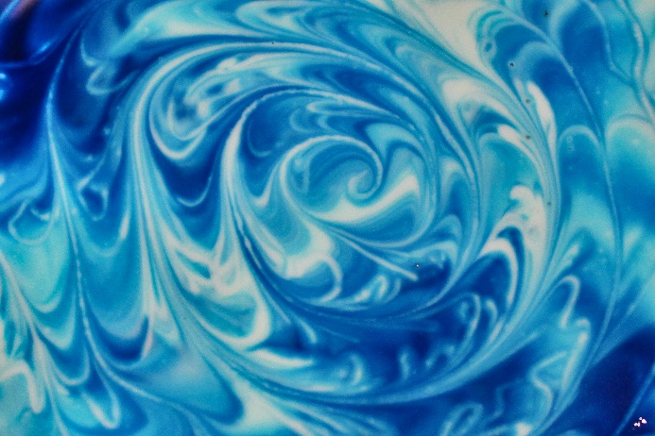
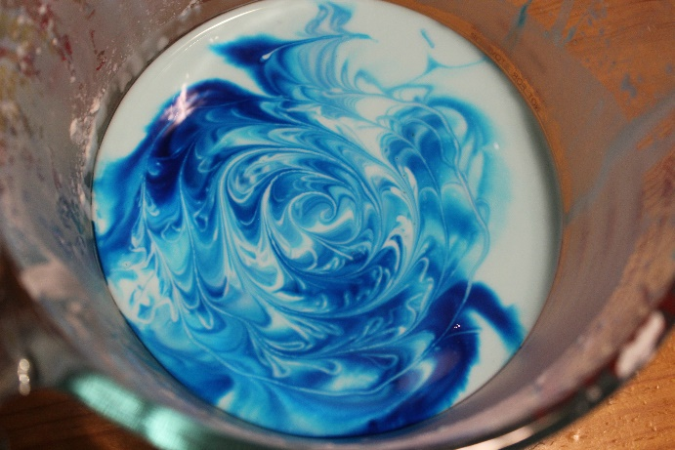
Figure 1: The image before (left) and after (right) post processing.
I’m happy with how the image turned out. I think that the range of color makes the image both aesthetically pleasing and helps to shed light on the wakes created from stirring. I was surprised at the amount of control I had in shaping the color and direction of the oobleck. I think it would be interesting to experiment with drawing more complex shapes in the oobleck or using localized vibrations to mix the dye.

References
[1] Wikimedia Foundation. (2022, October 30). Non-newtonian fluid. Wikipedia. Retrieved November 13, 2022, from https://en.wikipedia.org/wiki/Non-Newtonian_fluid
[2] Pappas, S. (2019, October 8). Oobleck's weird properties demystified. LiveScience. Retrieved November 13, 2022, from https://www.livescience.com/oobleck-mysteries-solved.html

