Get Wet Report – MCEN 5151 Flow Visualization

Jessica Holmes, 9/25/23

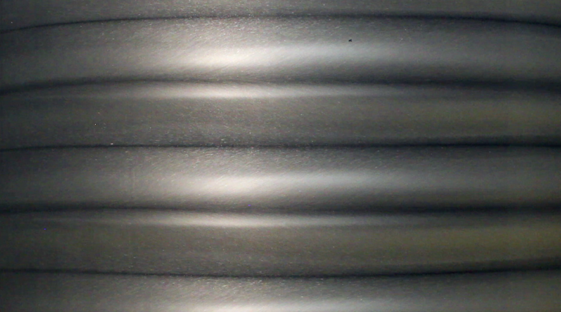
The phenomenon of Taylor-Couette Flow is physically well understood but visuals demonstrating the various possible regimes of the system are sparce. The intent of my visualization is to provide a closer look at the transitional dynamics within a Taylor-Couette system which help to illustrate how steady flow systematically deforms into chaos.

Special thank you to Scott Kittleman, a Professional Research Assistant in the
Department of Atmospheric and Oceanic
Sciences at CU Boulder, for assembling and operating the flow apparatus which made this visualization possible.
Figure 1: Screen shot of my visualization video illustrating wavey vortical flow behavior within a rotating Couette apparatus.

A Taylor-Couette flow apparatus consists of two concentric cylinders, i.e. one cylinder is evenly nested within the other, leaving an empty gap between both cylinders to be filled with a viscous fluid. In this experiment the gap is filled with silicon oil and aluminum flakes producing a rheoscopic fluid. The aluminum flakes tend to align parallel to the shear stress which illuminates dynamics within the flow that would otherwise be invisible.
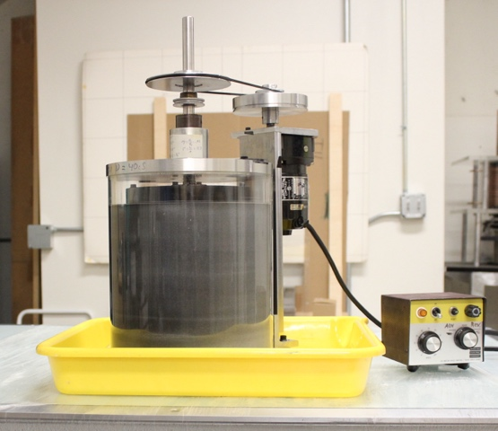
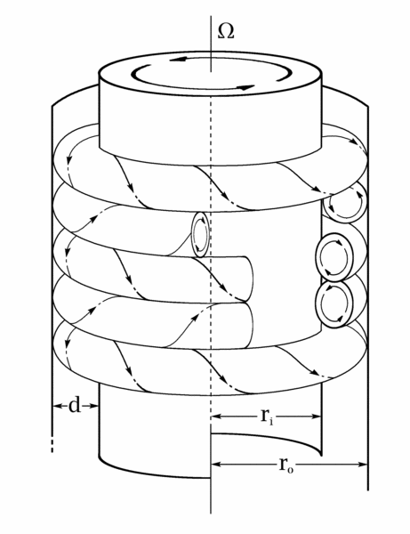
b.
a.

Figure 2: a. Picture of apparatus configuration

b. “Schematic of counter-rotating axisymmetric vortices of Taylor-Couette flow (Mike Minbiole and Richard M. Lueptow, © 2000)”

The interior cylinder is hooked up to a motor which allows us to control the rotation speed. As we begin to rotate the inner cylinder, the fluid begins to move, driven by the shear force from the interior boundary. When the angular velocity of the inner cylinder is slow enough, we see a steady, exclusively azimuthal flow, which is called rotating Couette Flow (Lueptow 2009). As the inner cylinder rotates faster, the system undergoes a progression of instabilities, each more spatially complex than the last. Our visualization depicts wavy vortex flow, characterized by paired toroidal vortices with wavey outflow and inflow boundaries (Taylor 1922).

We can calculate the Reynolds number at the interior boundary by

$$R_{i}=a(b-a)Ω_{i}/ν$$

where a and b are the inner and outer cylinder radii, Ω_{i} is the angular velocity of the inner cylinder, and ν is the kinematic viscosity. In our experiment, we have a = 3.5 inches = 88.9 mm, b = 4.25 inches = 107.95 mm, with the inner cylinder spinning at 45 RPM which yields an angular velocity of Ω_{i} $≈$ 4.7 rad/s, and a kinematic viscosity of 40 iS $≈12.5$ $mm^{2}/s$. This yields a Reynolds number of $R_{i }= 88.9 ∙ 19.05 ∙ 4.7 / 12.5 ≈ 636.77$. This is a transitional Reynolds number, and as we see in the visualization, the flow is closer to laminar than it is to turbulence due to its ordered nature and lack of small-scale dynamics.

In their famous publication, “Flow Regimes in a Circular Couette System with Independently Rotating Cylinders,” D. Andereck, S. Liu, and H. Swinney culminate their observations of this system into a regime transition diagram which plots possible flow regimes achieved for different combinations of inner and outer cylinder Reynolds numbers. For an inner cylinder Reynolds number of $636.77$ and an outer cylinder Reynolds number of 0 (stationary exterior boundary), the diagram would classify our flow as wavey vortex flow with the imminence of modulated waves. This is indeed how I would classify the flow behavior within the visualization.

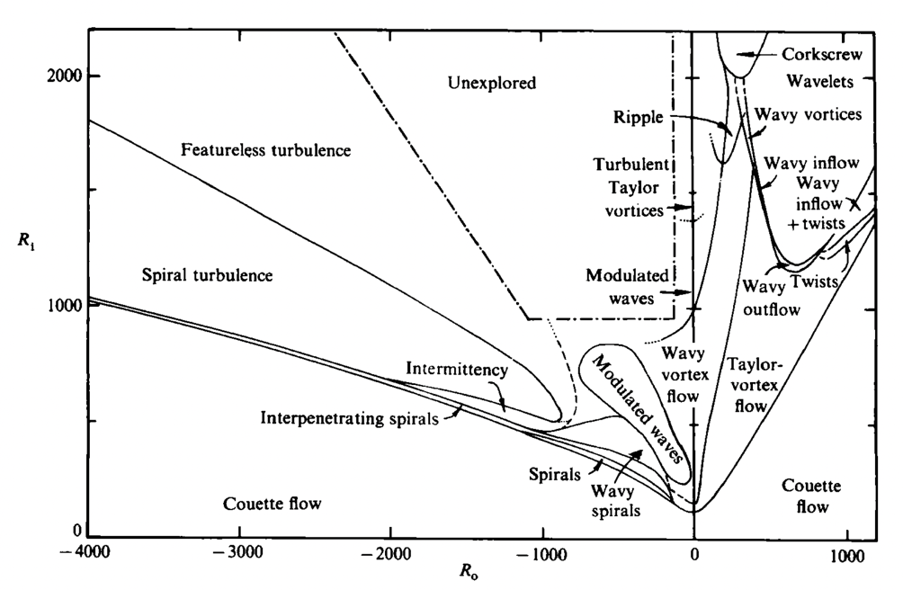
Visualization

Figure 3: “Regimes observed in flow between independently rotating concentric cylinders. Dashed
lines indicate the transition boundaries that are difficult to establish from visual observation alone since there is no abrupt change in the appearance. Dotted lines indicate the expected, but not yet observed, continuation of several boundaries” (Andereck et al. 1985).

Capturing this phenomenon is harder than it may seem given the nature of the curved reflective surface of the apparatus. To alleviate some of the glare I corralled the apparatus with black poster board to eliminate reflections from both the room and the presence of the camara (of which white poster board was unable to do). The temperature was around 20$°C$ which is noted considering the behavior of the silicon oil can change under various temperatures. A single bulb lamp was used to indirectly light the apparatus by reflecting the light off the poster board.

The photographic technique is where I had the most creative leeway. I chose to video tape this phenomenon because I felt the time dependency of the wavey vortices was important to capture. I wanted a close-up view of the dynamics, thus the flied of view is only approximately 4in x 5in. The lens of the camera was placed a foot and a half away from the apparatus on a tripod to stabilize the view. The video was shot on a Canon T3i at with 1920 × 1080 resolution at 30 fps with a circular polarizing lens attached to counteract glare from the glass fixture. For post processing I used iMovie to add a title card and subtly increase the brightness of the video for better clarity.

The image indeed captures one of the regimes the system transitions through before turning turbulent. As the aluminum flakes turn inward, they are perpendicular to the light source and reflect light the least, while the opposite happens as they pass along the outer faces of the vortices. This captures the dynamics perfectly by showing us the exact behavior of the flow. I am, however, unsatisfied with the left-over glare as my technique for mitigating reflection did not fully eliminate the objects in the room resulting in two immobile lines that distract from the flow itself. To avoid this, I should’ve corralled the full apparatus instead of just half, as the cylindrical nature of the apparatus allows for a larger range of reflection. In the future, I intend to work to perfect the lighting and reflection mitigation techniques I use to minimize any distracting elements. I also feel like the video would be more visually pleasing if I used a different color of fluid.

References

Andereck C. David, Liu S.S, Swinney Harry L. (1986) Flow Regimes in a Circular Couette System with Independently Rotating Cylinders. Journal of Fluid Mechanics 164:155-183

Lueptow R (2009) Taylor-Couette flow. Scholarpedia, 4(11):6389. http://www.scholarpedia.org/article/Taylor-Couette_flow

Taylor G.I. (1922) Stability of a Viscous Liquid contained between Two Rotating Cylinders. Royal Society Publishing VIII:289

