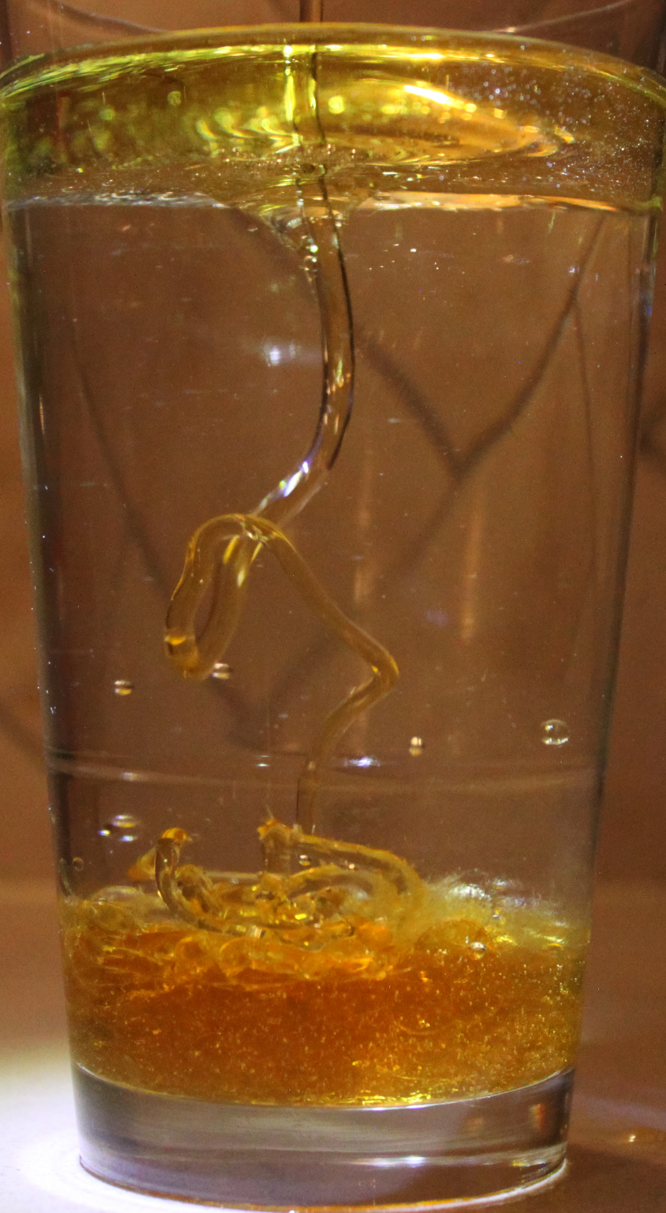
The image was taken for the first team assignment for the fall semester of Flow Visualization. This assignment focused on collaborating with your team, whether that’s doing similar projects or consulting them for advice on how to execute an idea. The intent of the image was to depict the density differences between water, olive oil, and honey. This photo took a few different iterations, as different containers were used as well as various different lighting combinations.

The image was created by filling up a glass with water and olive oil. Once the olive oil had settled on the top of the water, a stream of honey was pictured as it passed through the olive oil layer and into the bottom of the water. The glass used had a volume of 20 ounces and is 6 inches tall. This cup was filled with 16 ounces of water and 2 ounces of olive oil. The photo was taken approximately, 8 inches away from the glass.
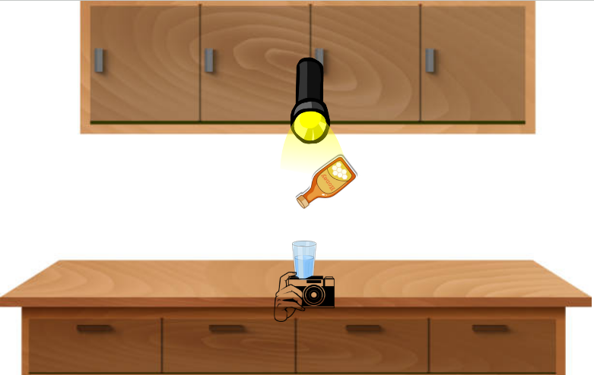
Diagram of how the photo was taken

There were a number of different forces that contributed to the flow that is pictured. The primary force being gravity. This is what caused the honey to pass through each layer and create the stream. However, adhesion also played a role. When testing out the setup, I tried putting the honey straight in the water and found that the stream was a much more thin, stringy flow. It was once the honey had to pass through the olive oil layer that this more pronounced thick flow was seen. I believe this is due to the adhesive properties of the honey causing the stream to be coated in olive oil on the way to the bottom of the glass. This allowed the stream of honey to be preserved as the olive oil protected it from the water. This theory would also make sense as after the honey had reached the bottom, bubbles of oil could be seen rising back to the top.

Since there is a stream depicted in the picture, there is a Reynolds number associated with it. As mentioned previously, the glass is 6 inches tall. The honey traveled to the bottom in 1.23 seconds. Converting inches to meters, we get a height of 0.152 m. From this we can get a velocity of $\frac{.152}{1.23} = .124 m/s$. This value can then be used in the equation for the Reynolds number, $Re=\frac{ρvL}{μ}$along with the viscosity of honey 10 $Pa*s$ (RheoSense 2017), the density of honey at 20℃ ρ = 1420 $\frac{kg}{m^{3}}$ (Tomasik 2003) , and the flow diameter $L=.00343 m$.

$Re=\frac{1420*.124*.00343}{10}= .0604$

A Reynolds number this much smaller than 2000 indicates a laminar flow (Engineering Library). This result makes a lot of sense as the flow pictured is very smooth.

The materials used in this experiment were not altered in any way since the honey and olive oil could be differentiated from the water quite easily. The honey and olive oil was Kroger brand and was purchased from King Soopers. In order to provide lighting, I hung a 120 lumen LED flashlight above the glass. In addition, lights from under the cabinets above the glass and in the kitchen I was in were on.

The camera used to capture this image was a Canon Rebel T1i with a focal length of 32 mm. The camera was set about 8 inches away from the glass. When taking this photo, the shutter speed was set to 1/400, aperture to f/4.5, and ISO to 3200. The original image was 4752 X 3168 and was cropped down to 1696 X 3084. The only edit I made was cropping as the colors were already quite vibrant.

I think this image turned out much better than I expected. I do not have much experience with cameras so I was excited to see that the setting I chose created a decent image. In addition, I think the image depicts the physics quite clearly as the flow can be seen nicely. However, if I were to redo this image I would use a white background to make the colors pop a bit more. I would also change the lighting a bit as the shadows can be a bit distracting towards the bottom of the image.

Citations:

American Chemical Society
https://www.acs.org/education/outreach/celebrating-chemistry-editions/2020-ncw.html

Tomasik P (2003), Chemical and Functional Properties of Food Saccharides, Page 74.

Engineering Library
https://engineeringlibrary.org/reference/laminar-and-turbulent-fluid-flow-doe-handbook

RheoSense (2017)
https://blog.rheosense.com/what-is-the-viscosity-of

