**Team First Report**

**MCEN 4151: Flow Visualization**

Riley Menke

10/6/23

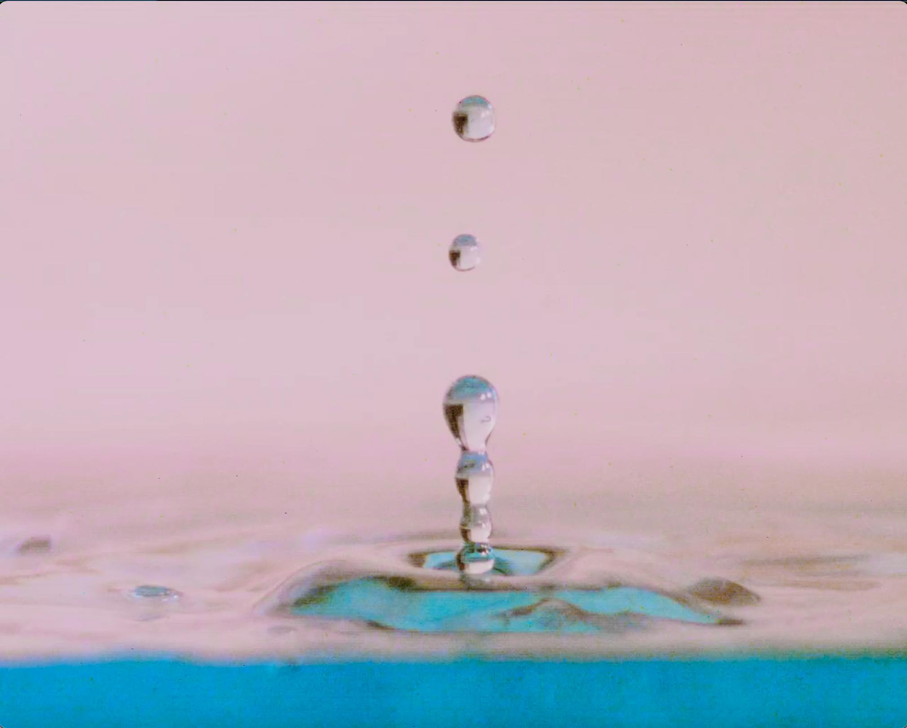

**Figure 1:** Separation and pinch off of water after a Worthington jet sequence from a droplet impacting still, visually seeded, water. Photographic assistance by Rachel Marbaker and Tandralee Chetia.

**Introduction**

For this assignment in MCEN 4151 at the University of Colorado Boulder, my team and I focused on capturing common phenomena using a high speed camera and macro lens. In this photo, as seen above in figure 1, I decided to shoot the ‘recoil’ of a water droplet, professionally known as a worthington jet. Inside of this topic, there are a multitude of other fluid dynamics at play that make this picture visually interesting.

**Flow Phenomena**

In Figure 1, there are two main flow phenomena visible. The first interesting piece of physics, what's known as a Worthington Jet, is actually causation for the second phenomena, the satellite droplets.

To form the jet feature, there must be a massive body that makes impact with the surface of the water. In this experimental case, the impact is from a water droplet released at a considerable height relative to the tank. To break the physics softly, the water droplet opens up a pocket of air beneath the general water line as it first makes an impact. As the water in the tank rushes back in to fill this air cavity, which can be described as a collapsing pressure differential, it smacks into itself causing the jet upwards.

Qualitatively, the size of the cavity and thus the size of the Worthington Jet is dependent on *A,* the cross section of the object, 𝜌 the density of the impact object, and *L,* the length of the object1,4. Whereas again in this experiment, and perhaps the most common daily observation of this phenomena, the impact object is a water droplet with the same material properties as the water it is falling into.

Looking back at Figure 1, the jet appears to be on its way back to the surface. The indications given are the formations of this second effect, satellite droplets. To be simple and frank, the vibrations that occur in jets cause round drop-like features to form in the pattern of the vibrational frequency2. As water retreats, the necking part of the jet shrinks until it is fully detached from the satellite droplet.

**Experimental Setup** The set up to get the desired results, as seen, required a few common items. The materials to perform this experimental procedure are listed below.

**Materials**

* Kroger® Assorted Food Coloring Kit
* Clear 10cm x 10cm x 25cm food storage container
* A 2ft x 2ft white board
* Tap water
* Incandescent lights
* Common Ruler

**Procedure**

As a team, we fixed the camera set up in place for multiple views of interest. The Phantom C110 high speed camera was paired with the Micro-NIKON 105mm macro lens that used the N-AF Zeikos Digital AF macro extension tube. The positioning of the camera was fixed using a tripod and its relativity to the set up is shown in figure 2.

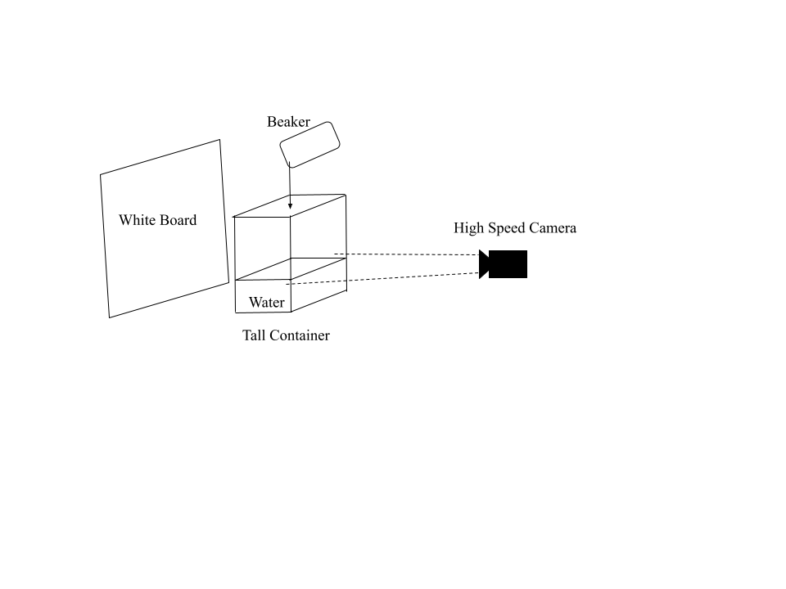\

**Figure 2:** Representation of the photography setup that results in the submitted photo.

For my photo, I chose to use the footage from when the camera was just above the waterline of the tank. We focused the camera on the ruler dipped into the tank so that when the subject of interest would be in focus despite its inconsistency. Beginning to drip water out of the beaker, above the camera's view at about a foot, we hit the recording button on the high speed camera's user interface.

**Photographic Decisions**

In editing, I cropped the focus closer into the interesting fluid physics. Although before this submission was a picture, it was an mp4 file taken from the high speed camera. Using video rather than stills, I was able to catch the exact frame I wanted. After pausing and saving my desired frame, I began to edit it as a still photograph.

I thought it was aesthetically pleasing to skew the aspect ratio such that the framing follows the length of the flow. In the editing software DarkTable, I manipulated the colors. IN an effort to make anything pop more, I tried to saturate the blue in the water. I do feel as though this picture does not have the best contrast balance. It was a struggle to get vibrant eye-catching colors while trying to maintain true darks in my image. In the future, I would have adjusted my lighting in the photography stage to not be so harsh and bright. Both the raw and unedited photos are shown in Figure 3.

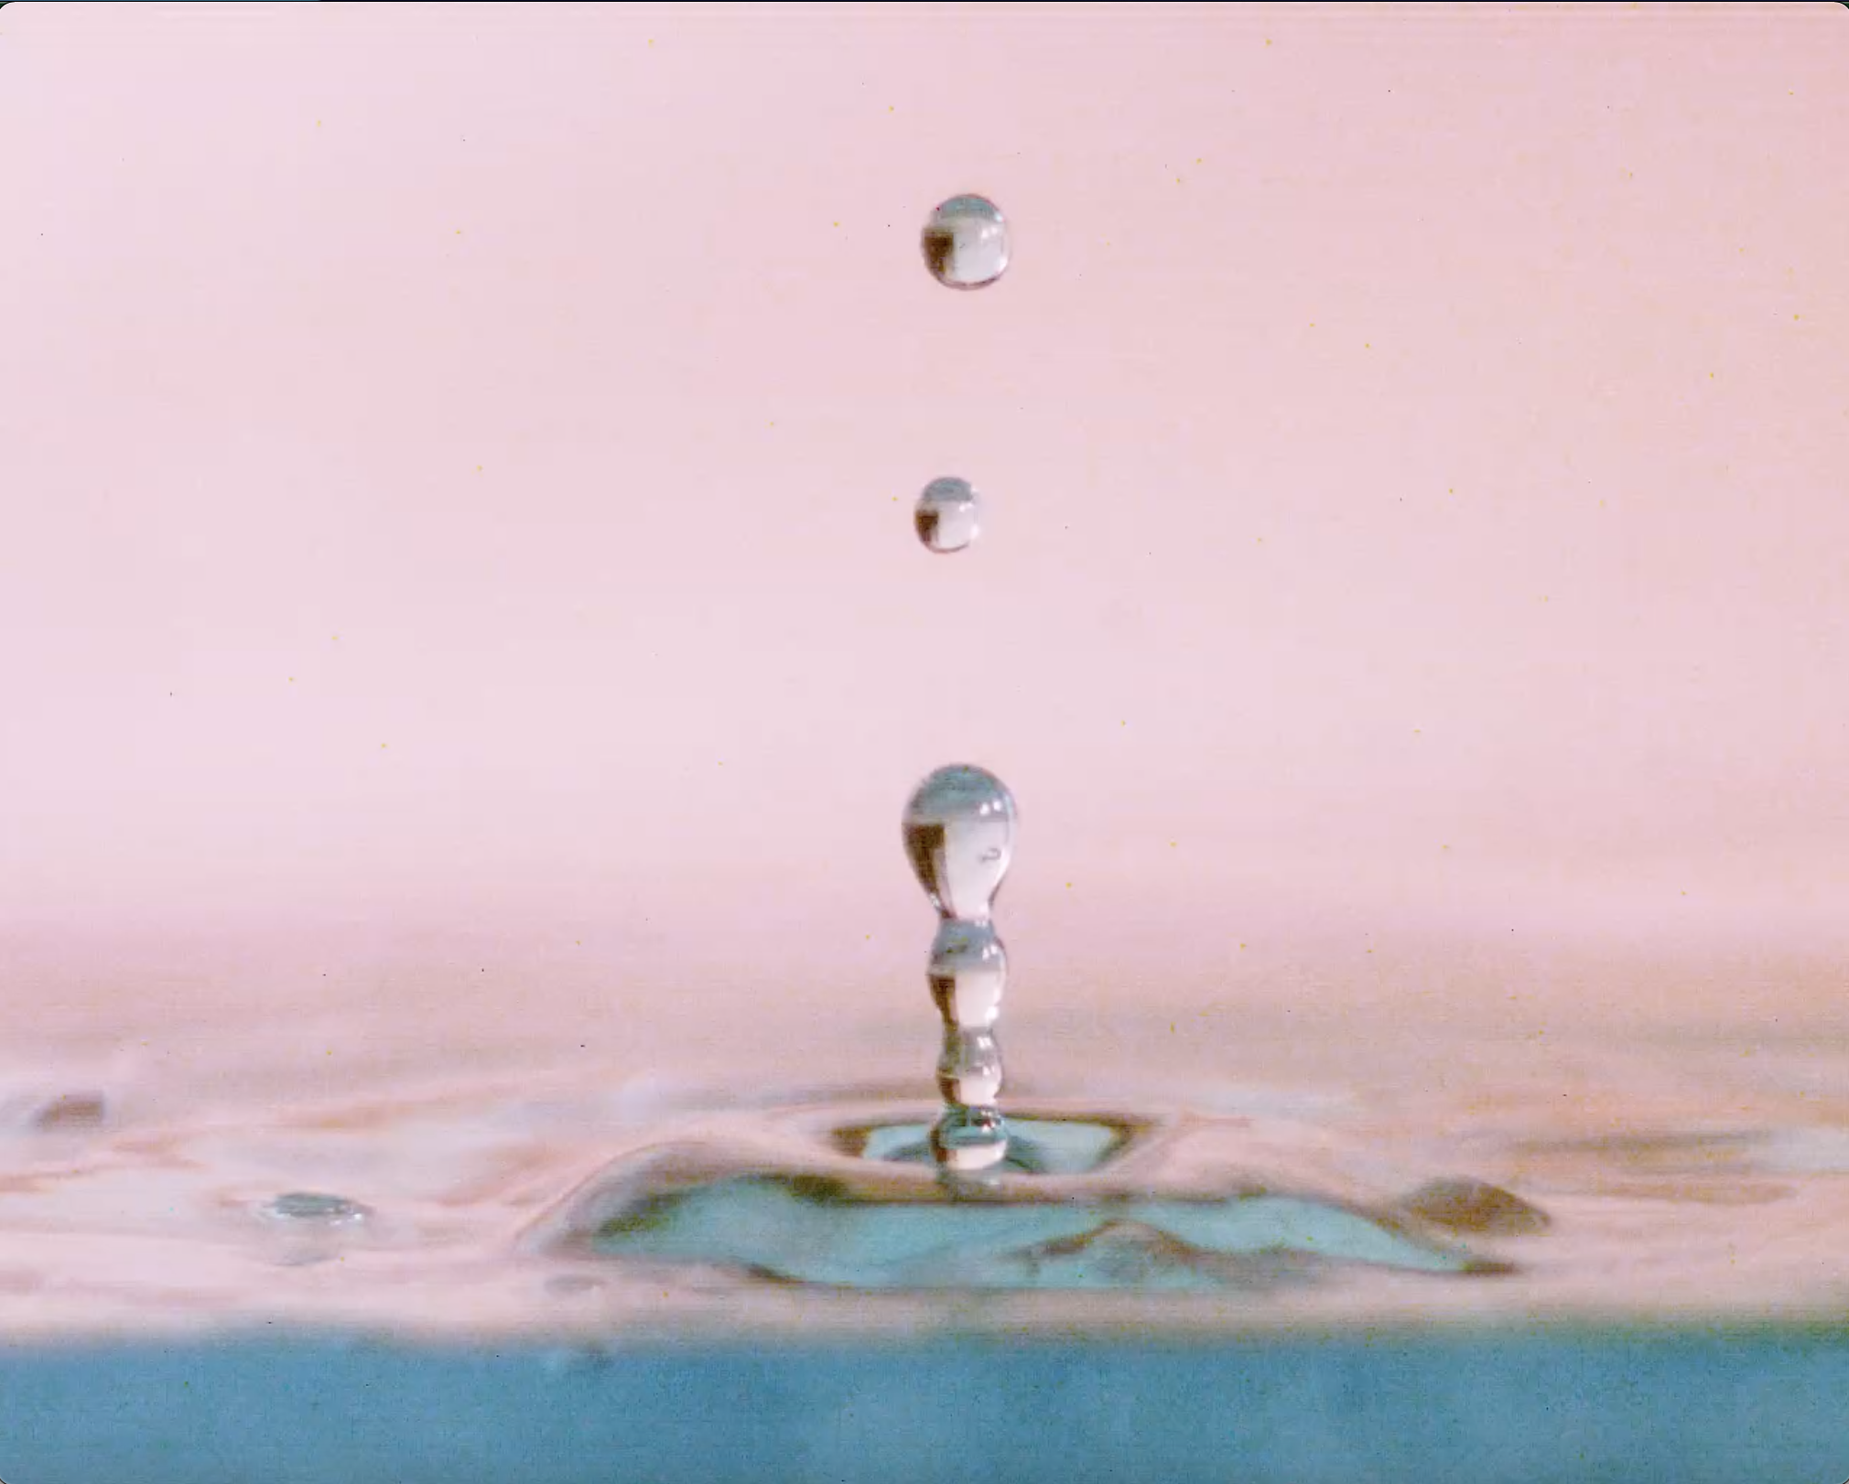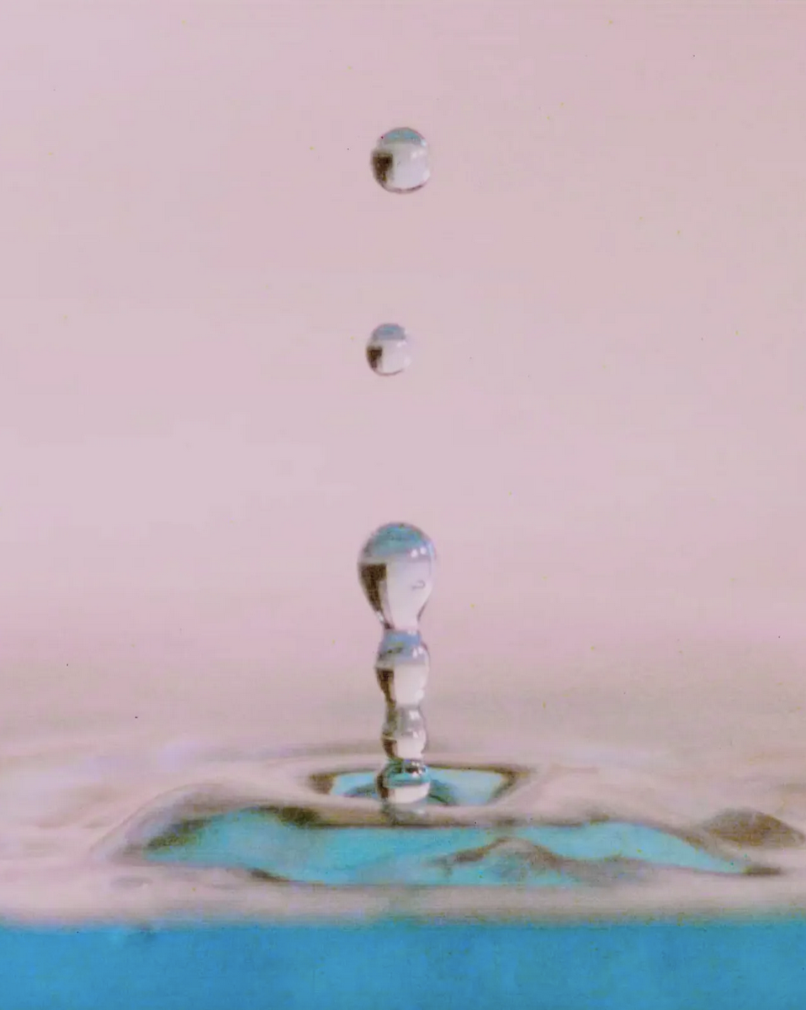

**Figure 3:** Shows how editing choices create differences in the original and submitted image. The left is the unedited frame from the video file, and the right is the image that has been edited and submitted.

**Conclusion**

For this assignment, I decided to give my take on a very common branch of fluid dynamics. Although there is no short supply in photographing Worthington Jets, they are still very aesthetically pleasing. To get the collapse of the air cavity which causes the jet, my team and I had to use the Phantom C110 high speed camera with the Micro-NIKON 105mm macro lens attached using the N-AF Zeikos Digital AF macro extension tube. With these photographic specifications I was able to visualize a Worthington Jet, complete with two satellite droplets.

*References*

1GEKLE, STEPHAN, and J. M. GORDILLO. “Generation and Breakup of Worthington Jets after Cavity Collapse. Part 1. Jet Formation.” *Journal of Fluid Mechanics*, vol. 663, 15 Oct. 2010, pp. 293–330, https://doi.org/10.1017/s0022112010003526. Accessed 29 Aug. 2020.

2Pimbley, W. T., and H. C. Lee. “Satellite Droplet Formation in a Liquid Jet.” *IBM Journal of Research and Development*, vol. 21, no. 1, Jan. 1977, pp. 21–30, https://doi.org/10.1147/rd.211.0021. Accessed 28 Oct. 2019.

3“Poop Splash Elimination - Smarter Every Day 22.” *Www.youtube.com*, www.youtube.com/watch?v=-XNDM4eAn1U.

4“V. Impact with a Liquid Surface, Studied by the Aid of Instantaneous Photography.” *Philosophical Transactions of the Royal Society of London. Series A, Containing Papers of a Mathematical or Physical Character*, vol. 189, 31 Dec. 1897, pp. 137–148, https://doi.org/10.1098/rsta.1897.0005. Accessed 20 Oct. 2022.