**Clouds First Report**

[Riley Menke](mailto:rime7982@colorado.edu)

MCEN4151: Flow Visualization

10/30/23

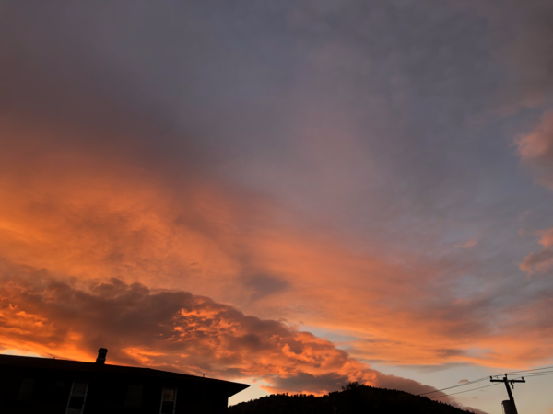

**Figure 1:** Photo taken facing West of the cloud formations above the Sanitas Mountain range on the evening of October 14th, 2023 taken by Riley Menke using an IPhone X camera.

**Background**

The purpose of photographing clouds, particularly in the photo shown above, is to showcase the continuous fluid flow that is happening many layers deep in the Earth’s atmosphere. The concentration of ice or water in the atmosphere, what we know commonly as clouds, serves as a wonderful seeding of the flow in air. I took the picture shown above in north boulder, looking west, about a mile or so east from the footing of the Sanitas peaks. When the picture was taken it was the evening of October 14th, around 6:30pm, just when the sun was setting which gave the clouds that dramatic coloring.

I chose this picture as my submission for ‘Clouds First’ because I particularly like the range of textures that are visible in this one frame. In the sky, I believe that the viewer is seeing Altostratus clouds, seen more in the right side of the frame, possibly transitioning into Altocumulus near the top of the picture. There also seems to be clouds lower to the horizon on the left, most likely cumulus or Stratocumulus clouds. The bottom of the picture is framed by the silhouette of a roof and a mountain peak.

**Cloud Classification**

As briefly discussed, it could be argued that there are multiple cloud formations visible in this photo. I believe that this picture contains at least two different kinds of clouds while calling into question possible transitions in cloud altitude and density that might categorize other formations. Below, in figure 2, the location and name of each formation has been labeled.

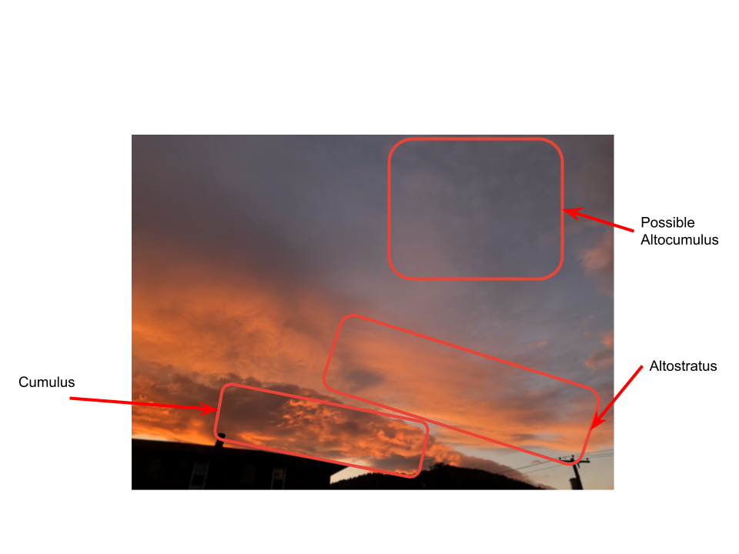

**Figure 2:** Identifying and outlining the different cloud formations visible in the frame.

**Skew-T**

To further analyze these formations in the Boulder sky at 6:30pm on the 14th of October, I used the Skew-T graphs seen in figures 3 and 4. These were taken from the Salt Lake city weather station from the morning and evening readings on the 14th.

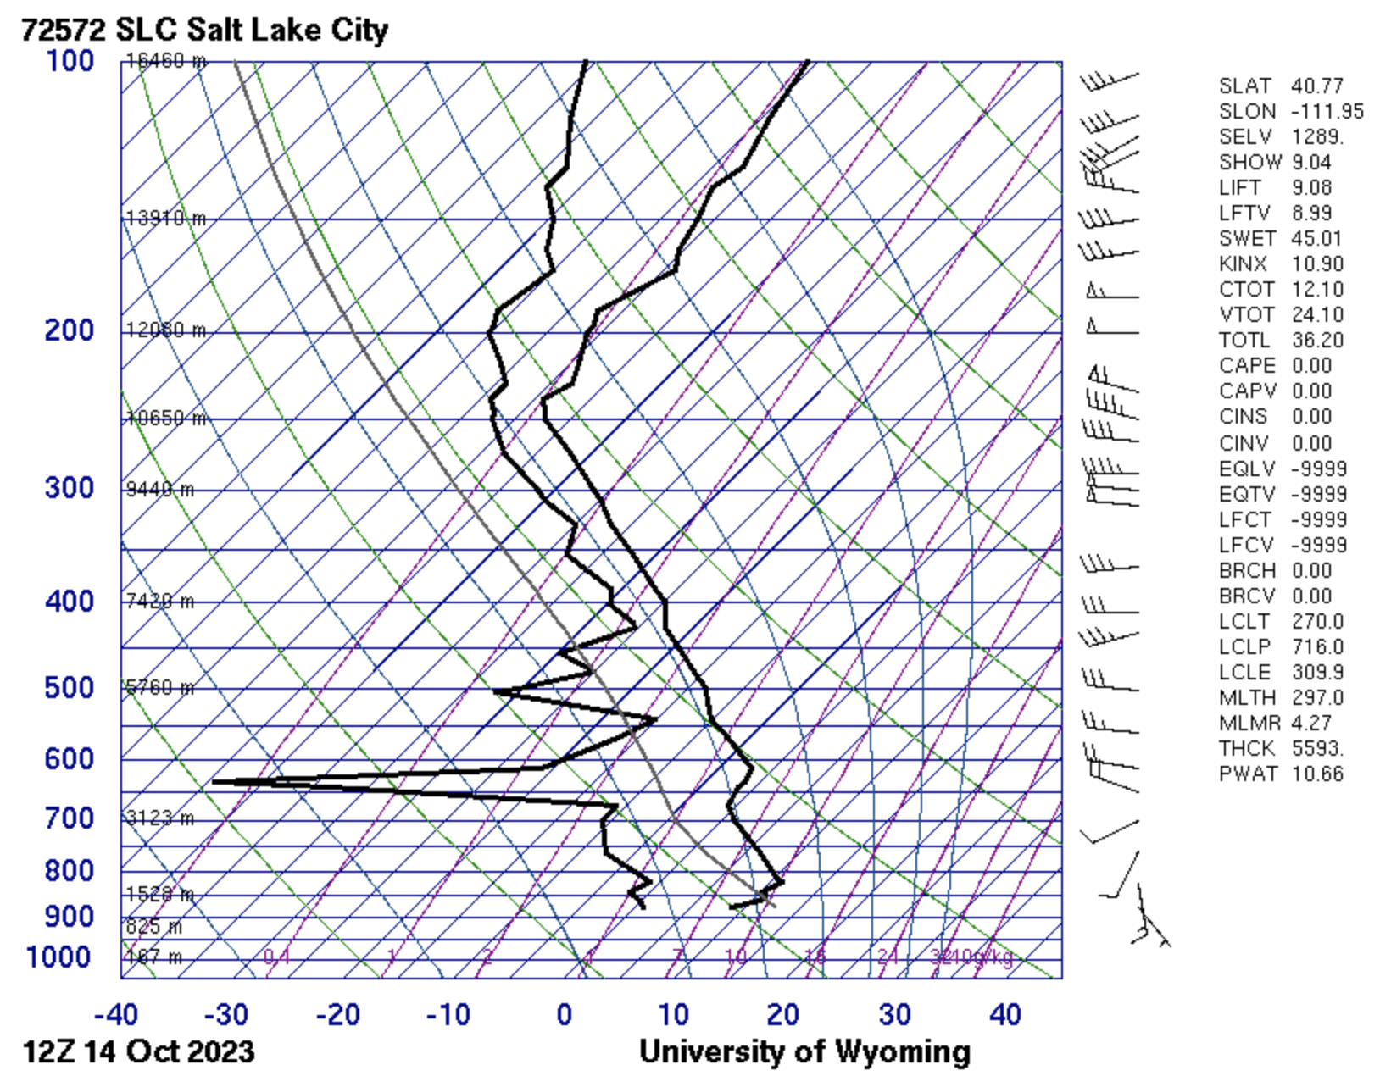

**Figure 3:** Skew-T graph taken from the SLC station at 7am on October 14th, 2023.

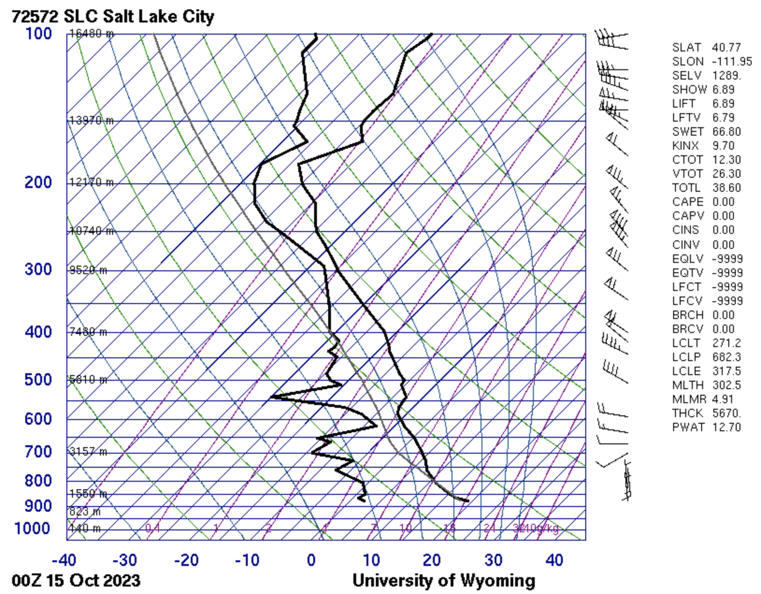

**Figure 4:** The Skew-T graph from 7pm on October 14th, 2023.

From the Skew-T data, it can be further deciphered if clouds in this picture are as annotated in Figure 2. The first graph, Figure 3, taken from that morning depicts an atmosphere that has greater instability than the one taken later that day. This is because the moist adiabatic cooling line is nearly parallel with that of the temperature as the line ascends into the atmosphere.

As for the instability that morning, this could give reason to the cumulus clouds types that are abundant in Figure 1. In Figure 4 however, the depoint and temperature lines get very close at two points of pressure; One being around a shallow 3,123 meter mark, and the other closer to the 9,528 meter index. Clouds are likely to form in this unstable atmosphere here because a parcel of air will have to travel only a short temperature gradient to become saturated, and thus cloudy. The varying proximity of these two lines in Figure 4 gives an explanation as to why the clouds appear to be layered in the photograph. Closer to the ground the large cotton like fluffs indicate that cumulus shape as annotated, and further in the atmosphere the air has again cooled to form stratus clouds.

**Historical Weather**

To get a better picture of the flow movement in the atmosphere during the formation of these clouds, it is important to look at the historical weather data surrounding the time of observation.

Figure 5 below contains the historical weather data for Boulder, Colorado during the day the clouds in this picture were taken and the next.

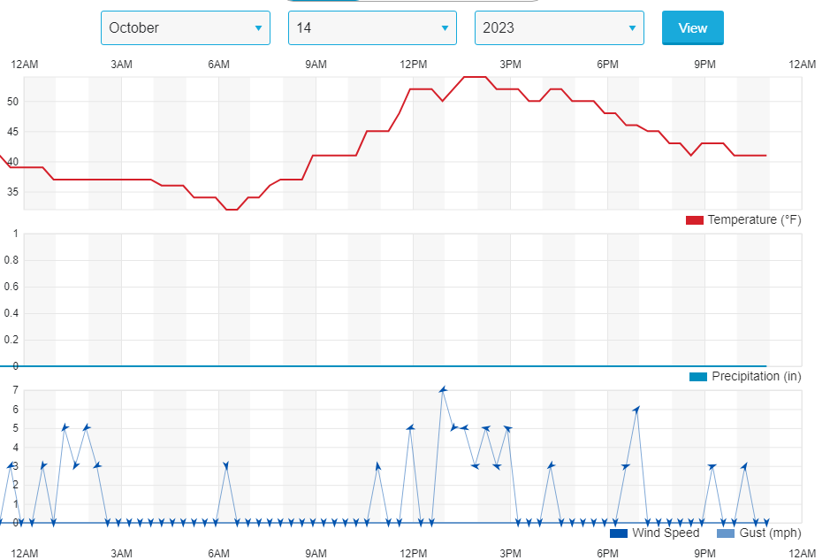

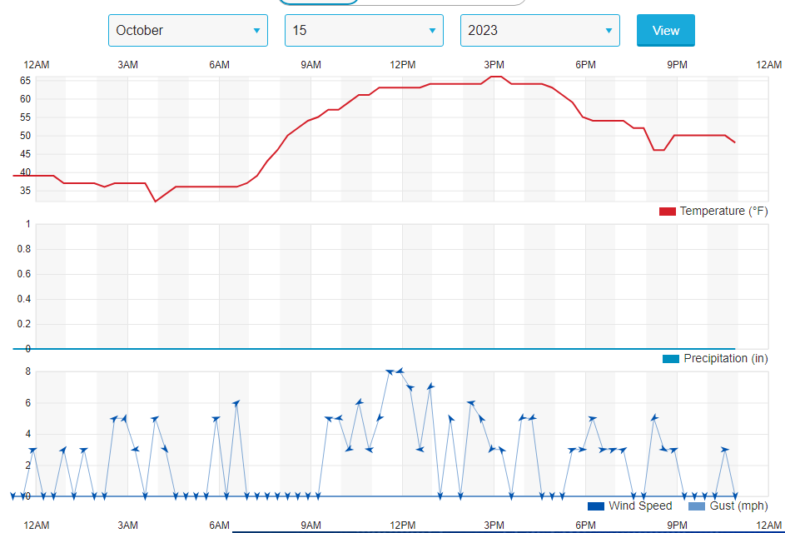

**Figure 5:** Historical weather data in Boulder, Colorado on the 14th and 15th of October, 2023.

Seeing from this figure that the peak temperature of the day increases from 54℉ on the 14th, to 66℉ on the 15th, it can be assumed that there was a warm air mass moving into the town of Boulder. This 10℉ difference is cause for an unstable atmosphere, thus further explaining the cumulus clouds that were captured in the submitted photo. In addition, altostratus clouds are said to be the indication of an oncoming warm front1. All signifiers indicate that the clouds observed in the atmosphere on this day are a result of low, warm, unstable air masses.

**Photographic Choices**

Although the picture in Figure1 has vivid sunset colors, I made no editorial changes to the original file. This choice of abstinence was very much aesthetically influenced. Without cropping the black shadows of buildings and mountains out of the frame, I liked the natural scale it provided to the atmosphere. IN addition, the pastels in the sky were so nuanced that to change them would have been to detract from the natural art that is within this flow phenomena. To me, the sun added the color gradient that would've been needed, and so I left the picture's color curve untouched. Being photographed on the IPhone X camera, focusing the picture was easy. To get this lighting, I tapped on the left hand side of the picture. I am personal;ly pleased with the resulting aesthetic.

**Conclusion**

In this assignment, Clouds First, I submitted to the Flow Visualization archive what I found to be interesting layered formations of moisture in the sky. The photograph that I submitted was taken on the 14th of October with my IPhone X while facing West toward the mountain range. After analyzing the atmosphere on this day, it was easier to deduce the cloud formations seen in this frame. It can be concluded that the warm front moving into town caused atmospheric instability, which gave the conditions for the cumulus and altostratus clouds that were seen at varying heights in this photograph.

*References*

1“Altostratus Clouds.” *Met Office*, www.metoffice.gov.uk/weather/learn-about/weather/types-of-weather/clouds/mid-level-clouds/altostratus#:~:text=Altostratus%20are%20large%20mid%2Dlevel.

2“Boulder, CO Weather History | Weather Underground.” *Www.wunderground.com*, www.wunderground.com/history/daily/us/co/boulder/KBDU/date/2023-10-14. Accessed 13 Dec. 2023.

3University of Wyoming. “Atmospheric Soundings.” *Uwyo.edu*, 2022, weather.uwyo.edu/upperair/sounding.html.