Team Second Report 2023 – MCEN 5151 Flow Visualization Jessica Holmes
Shishito: Cameron Sprenger, Maddie O’Brien, Nicole Nageli Dec. 1, 2023

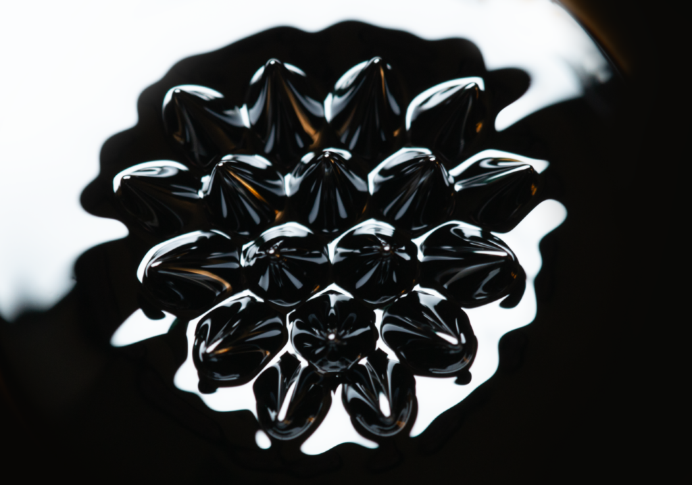

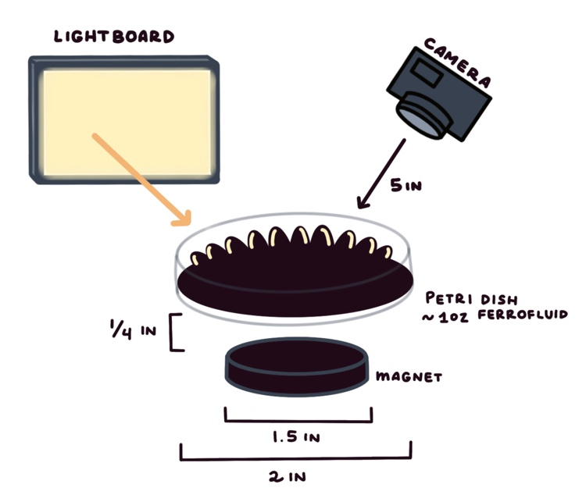
While the previous projects I have worked on have been intriguing, they have arguably lacked artistic direction. I took this project as an opportunity to focus on the beauty of a static flow with an unfamiliar medium to create an esthetically pleasing photo that speaks for itself. This photo depicts ferrofluid exhibiting the normal field instability when introduced to a magnetic field. Thank you to my teammates (all listed above) for aiding in the execution of this experiment, with a special thanks to Cameron Sprenger for providing us a macro lens which pushed the boundary of the detail we were able to capture.

The image captures ferrofluid responding to a magnetic field induced by a nearby magnet. The ferrofluid is held in a small petri dish that is elevated slightly and placed over a large magnet. The ferrofluid itself is comprised of a ferromagnetic material, a carrier liquid (usually oil), and a surfactant. The surfactant prevents the magnetic particles agglomeration, while the “carrier liquid suspends the particles” (Oehlsen, et al. 2022). The nanometer sized particles allow for increased stability and suspension time (Oehlsen, et al. 2022).

When introduced to a magnetic field, the ferrofluid form peaks which persist under static conditions. “The critical magnetization $M_{c}$, is specified in dimensionless form by,
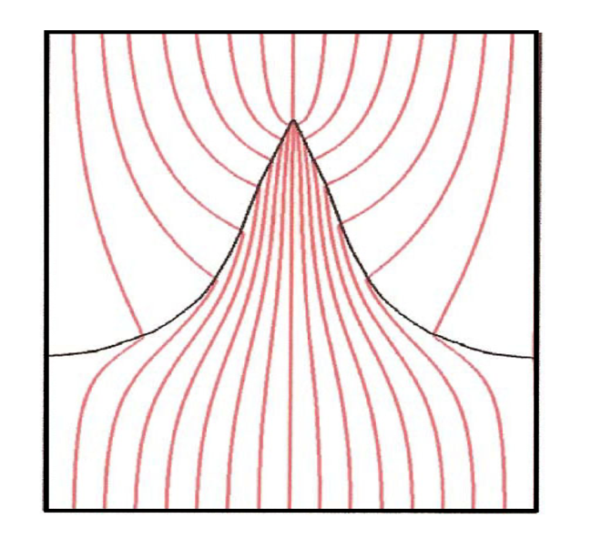
Finite element computation of ferrofluid peak shape for single parameterization (Andelman and Rosensweig, 2009).
$$\frac{μ_{0}M_{c}^{2}}{\sqrt{gΔp_{m}σ}}=2\left(1+\frac{1}{r_{p}}\right),$$
where $μ_{0}$ denotes the permeability of vacuum, g the gravitational constant, $Δρ_{m}$ the difference in mass densities of fluids across the interface, $σ$ the interfacial tension, and $r_{p}$ the dimensionless permeability ratio” (Andelman and Rosensweig, 2009),

$$r_{p}=\sqrt{ \frac{μ_{c}μ_{t}}{μ_{o}^{2}} } .$$
Thus, the intensity of the magnetization must overcome the effects of surface tension and gravity before forming (and I regrettably cannot calculate these values for I do not know how to calculate permeability).

To light the ferrofluid we used a lightboard (usually for handy for hand drawn animations) held directly behind the small apparatus. The ferrofluid itself was supplied by CMS MAGNETICS (an Amazon affiliate), where they unfortunately do not detail the specific carrier fluid or surfactant used. The orange reflection in the spikes in the final photo are a reflection from a poster hanging on the wall behind our apparatus, which adds character to the photo.

The photographic technique used in this image is what allowed for such a crisp depiction of this phenomenon. The size of the field of view is approximately 2 inches, where the lens was approximately 5 inches from the apparatus. The focal length was set to 200 and was shot with an AF Micro-Nikkor 200mm f/4D IF-ED lens for up-close clarity. The photo was shot on a Nikon D800 in manual focus mode.

Edited Image 4803×3366
Original Image 7360 × 4912

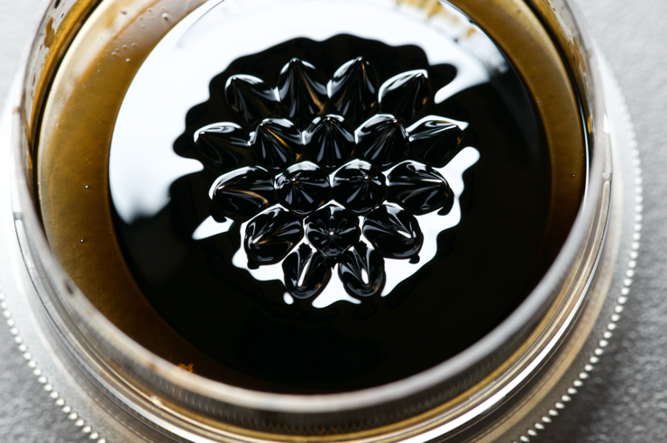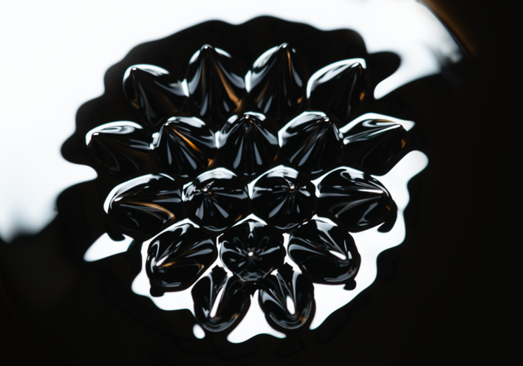

The F number was set to 11, the exposure time to 5/8, with an ISO of 1250. You can see from the comparison of the original to the edited photo, that there were no alterations of color, contrast, sharpness, etc., but rather the photo was digitally cropped, and the top left and right corners were filled with white and black, respectively, as to not distract from the focal point.

The photo highlights how intensely reflective this magnetic medium is. The reflected light amplifies the structure of the instability, revealing the shape, size, and direction of the resulting peaks. Notice the peaks are not normal to the surface of the petri dish but rather, they point in the direction normal to the magnetic field creating a curvature. The distinct triangular pattern is a result of the suspension height of the dish over the magnet. We observed that the closer the magnet is to the base of the petri dish, the less spikes form, but move the magnet too far away and the spikes disappear. Thus, there seems to be a particular distance that maximizes the number of resulting spikes, which lies in the middle of both. This is a static flow which constitutes a fully time and space resolved photo.

In the future I would like to experiment with either heated ferrofluid or ferrofluid in motion. Both have interesting properties that are unlike what is pictured above. Thus, experimentation would allow me to deepen my understanding of this magnetic medium within different regimes.

References

Andelman, David, and Ronald Rosensweig. “Chapter 1 The Phenomenology of Modulated Phases: From Magnetic Solids and Fluids to Organic Films and Polymers,” February 1, 2009. https://doi.org/10.1142/9789814271691_0001.
(David and Rosensweig, 2009)

Oehlsen, Oscar, Sussy I. Cervantes-Ramírez, Pabel Cervantes-Avilés, and Illya A. Medina-Velo. “Approaches on Ferrofluid Synthesis and Applications: Current Status and Future Perspectives.” ACS Omega 7, no. 4 (January 21, 2022): 3134–50. https://doi.org/10.1021/acsomega.1c05631.

