Blue Moo: Color Changing Milk
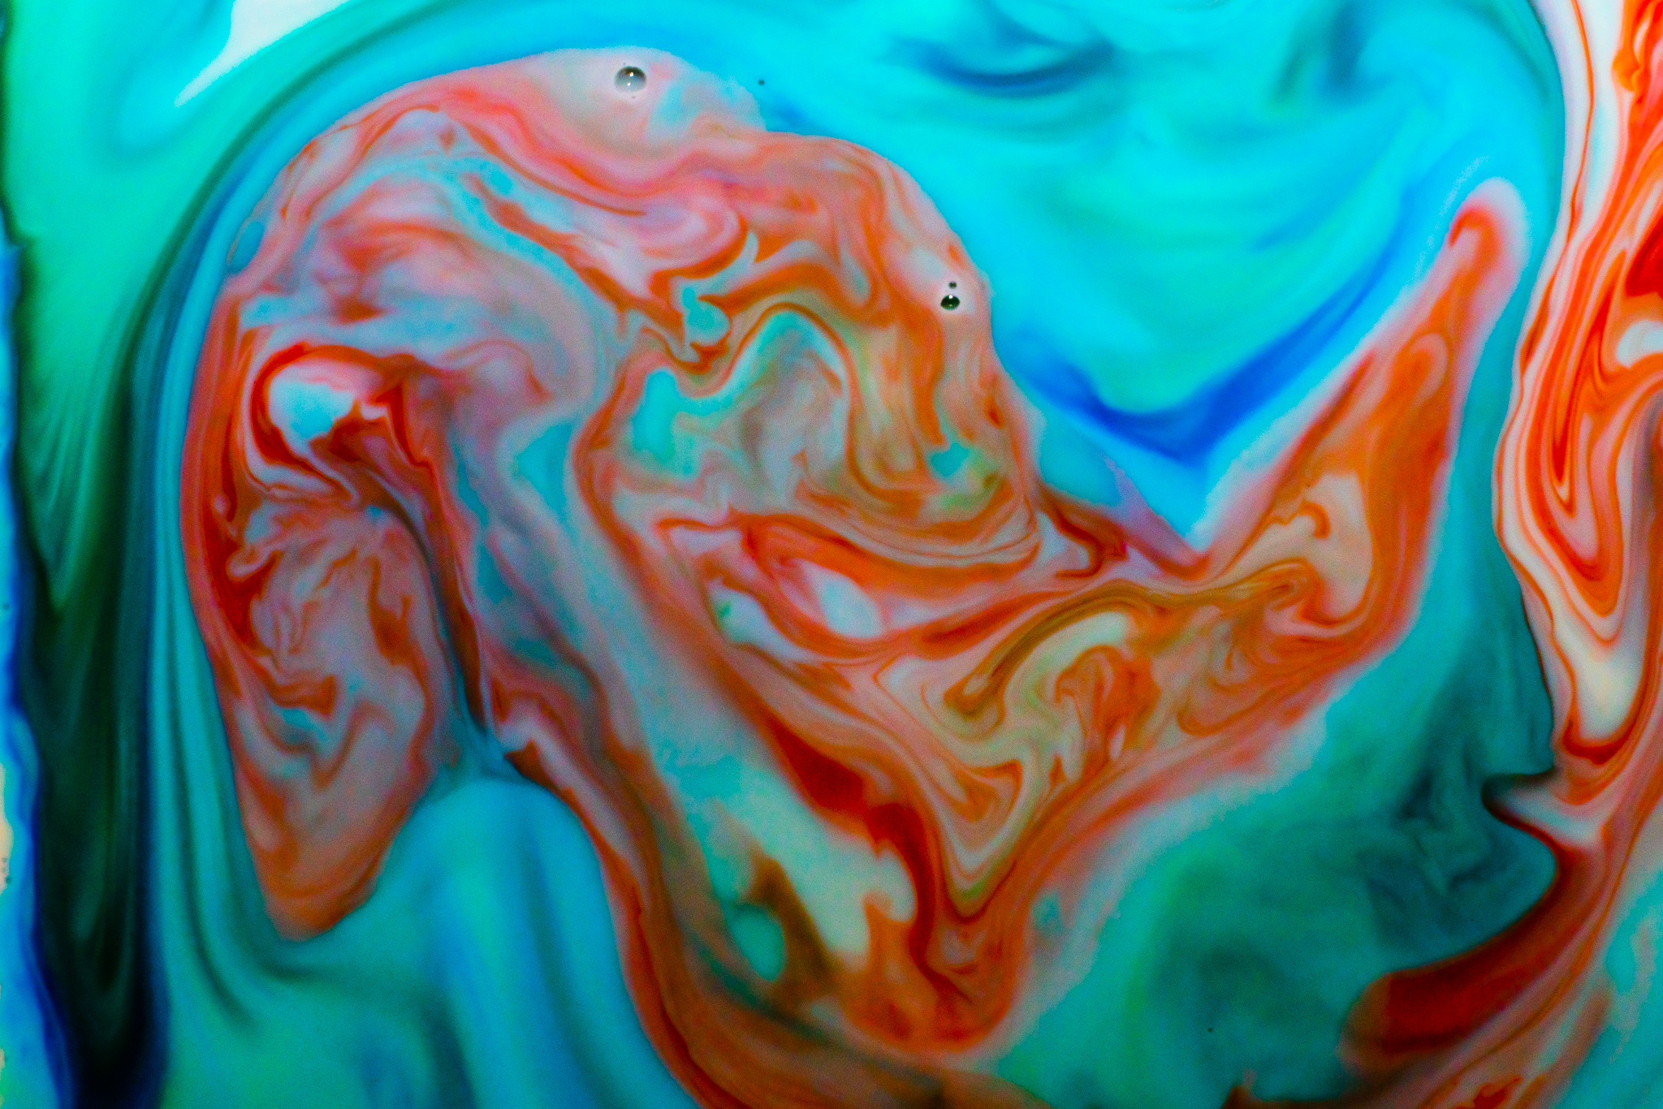Austin Emfield
Get Wet
ATLAS 4151-002: Flow Visualization
Sep 10, 2024

The purpose of this lab is to begin exploring flowing flows and practice photographing or filming the effect. In this lab, I studied the interaction between food dye and milk when adding dish soap. The phenomenon I was trying to see was the Marangoni Effect. When dish soap is added to a milk and food dye mixture, the dye disperses, creating prominent flows. In my first few attempts, I used small amounts of dye. This still created detailed flows. However, I was looking to make a very colorful image. For my final image, I ended up using three times the amount of dye I used in my initial attempt, resulting in all the whiteness of the milk disappearing and a rainbow of flows appearing.

The effect at play is the Marangoni Effect, which occurs when a surfactant, a compound that reduces surface tension, is added to a liquid, causing variations in the mixture's surface tension. In this experiment, the dish soap acts as the surfactant, reducing the surface tension of the milk. The soap molecules' hydrophobic tails attach to the water molecules' hydrophilic heads in the milk, causing the cohesive forces of the fats to break up. As a result, the surface tension of the milk decreases in area when the soap is present. This causes the food dye to flow from regions of low surface tension to areas of high tension since the areas of high tension pull more intensely on the dye than the lower regions.

The flow apparatus used to capture the image is photographed below. I attached my mirrorless camera to a tripod and aimed it straight down onto a square white ceramic plate. I then added 1.5 cups of milk onto the plate and manually focused the camera on the bubbles formed in the milk. Next, I added three drops each of blue, green, and red dye to the middle. I then dipped a Q-Tip lightly covered in dish soap into the mixture and let the colors spread to the edges. After the color had reached the edges, I added three more drops of red four inches from the center. Using the same soap-covered Q-Tip, I stirred the red dye clockwise. Using a remote shutter, I captured images as I stirred.

To mathematically describe the flow of the experiment, we can calculate the Marangoni number using the equation below:
$Ma=\frac{Δσ⋅L}{μ⋅α}$
In this equation:
- $Δa=$ Change in surface tension, which is 0.02 N/m for soap
- L = characteristic length, which is 0.1778m (7 inches)
- $μ=$ which is dynamic viscosity, which for mild is $0.003 Pa⋅s$
- $α=$which is mass diffusivity which for liquid milk is $10^{-9}m^{2}/s$
Plugging these values into the equations gives:
$Ma=\frac{(0.02N ⋅ m⋅0.1778m)}{(0.003Pa⋅s ⋅ 10^{-9}m^{2}/s)}= 1.19x10^{9}$

A large Marangoni number, such as the one calculated here, tells us that the surface tension forces are far greater than the viscous forces. This means that soap will cause very strong surface tension gradients, resulting in fast and extreme flows, as seen by the wild patterns created by the food coloring.

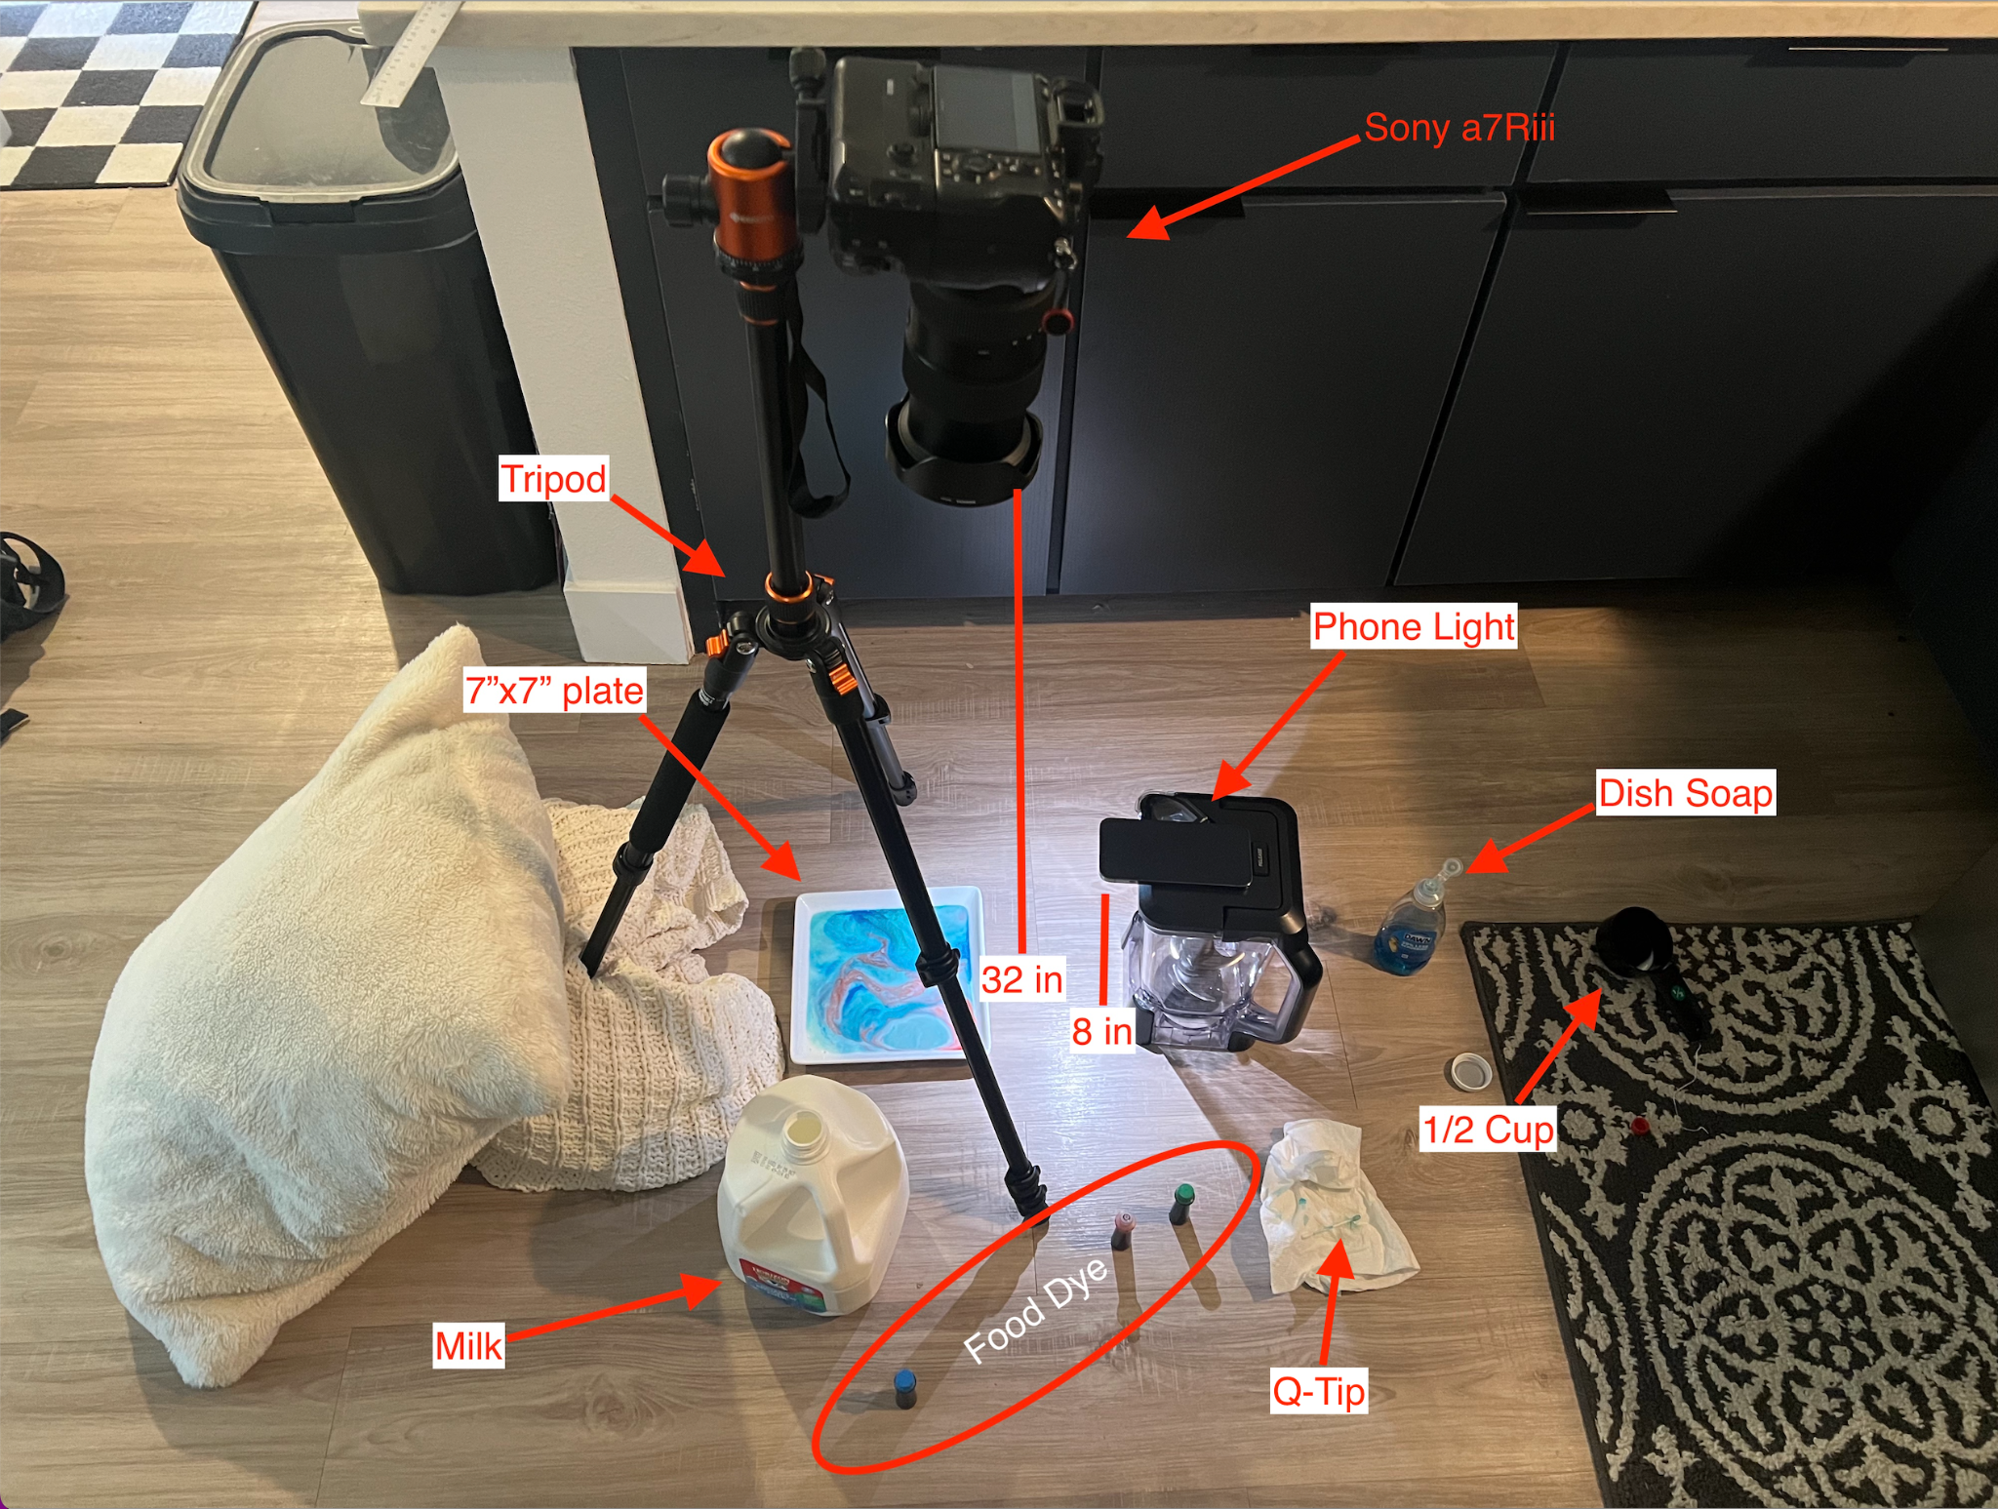
(Setup for the experiment)
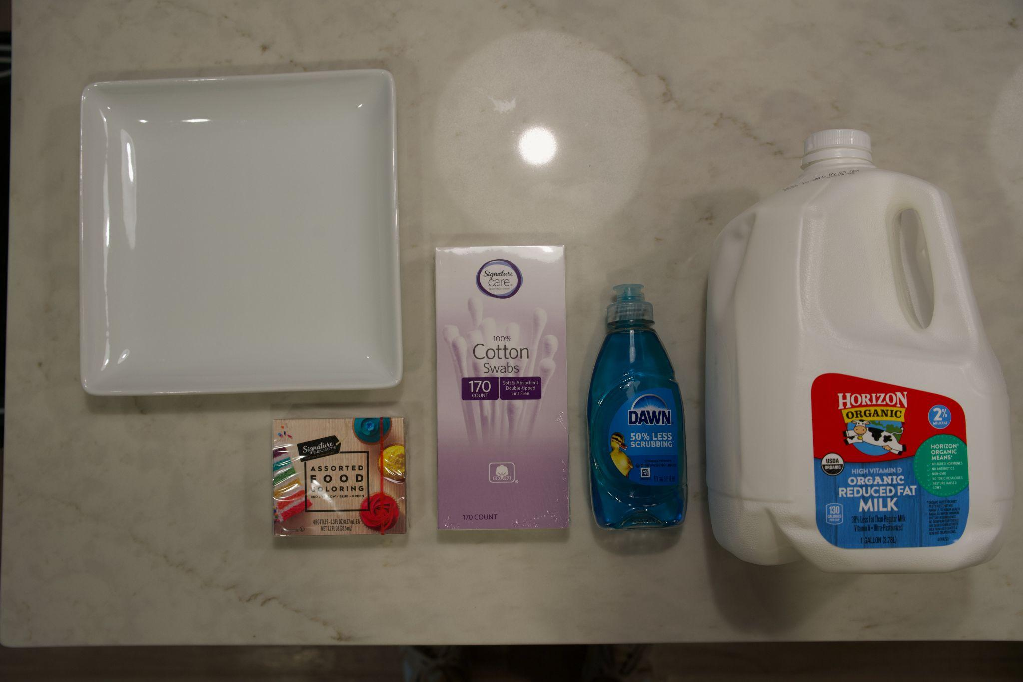
(Materials used in experiment)
Shown above is a photograph of the exact materials used in this experiment. Food dye was employed to visualize the interaction between milk and soap and enhance the flow patterns' visibility. The dye used was from Safeway’s Signature Selects brand. It was added in small, concentrated drops to the surface of the milk, specifically in the center of the dish, and carefully applied to avoid splashing. Three drops of blue, green, and red dye were used for the final image. After the initial mixing with a Signature Care cotton swab covered in Dawn dish soap, three additional drops of red dye were introduced, followed by further mixing with the same cotton swab. The milk used was organic reduced-fat milk from Horizon Organic, with a volume of 1.5 cups, filling the dish to a depth of 0.75 cm.
To capture the image, a mirrorless Sony A7R3 with a Tamron 35-150mm lens was used, mounted on a tripod with a remote shutter to ensure stability and precision. The lighting setup consisted of two overhead lights to provide even illumination and an iPhone flashlight used as a key light to minimize shadows created by the overhead lights. This combination of lighting ensured a clear and well-lit image of the flow patterns.
I positioned the camera 32 inches above the ground and focused it manually on the mixture. The camera's settings were as follows: focal length of 150 mm, aperture of 2.8f, shutter speed of 1/320s, and an ISO of 3200. With these settings, the image had a field of view of 6 inches by 4 inches and a resolution of 5168x3448 in RAW format. Using Adobe Lightroom Classic, I made several adjustments to the image: increased saturation by +61, created an S curve for the exposure, reduced noise, smoothed the colors, brought out the highlights, and increased the vibrance to 31. These adjustments enhanced the colors and reduced the grain caused by the higher ISO.
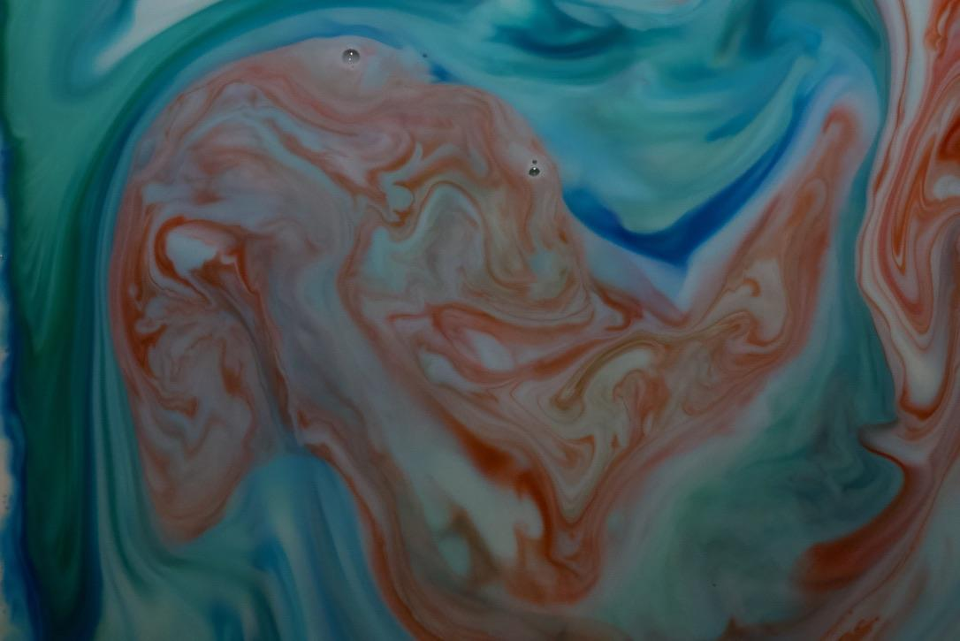
(Left shows before post processing and right shows after post processing)

My favorite aspect of the image is how vibrant the colors are. I find it really cool how distinct each trail of dye is. Adding two rounds of dye was very successful as the first round turned the milk blueish green, creating a captivating background for the second round of red dye to interact with. It is also visually compelling how each color creates a strong border between each other. It’s fascinating to see how each dye moves through the mixture and claims its own territory within the image. It’s as if each color is contending with the others for space.

The unique and intricate patterns the dye flows create effectively demonstrate the Marangoni Effect. The dye vividly illustrates the variations in surface tension caused by the surfactant, showcasing the complex interactions at play. The distinct borders and the random, dynamic patterns highlight how the soap disrupts the surface tension of the milk, resulting in a visually stunning representation of fluid dynamics. If I could change one thing, I would like to use a proper macro lens to get a real up close image of the flows. Right now, I have a good image of what the plate looked like, but it would be cool to get a len capable of focusing on a very small section of the flow to get an even closer and more detailed view.

Works Cited
Surface tension, http://labman.phys.utk.edu/phys221core/modules/m7/surface_tension.html. Accessed 22 September 2024.
“Food Products - Viscosities.” The Engineering ToolBox, https://www.engineeringtoolbox.com/absolute-viscosity-foods-d_1827.html. Accessed 22 September 2024.
“L. Malafronte, L. Ahrné, E. Kaunisto, F. Innings, A. Rasmuson, Estimation of the effective diffusion coefficient of water in skim milk during single-drop drying, Journal of Food Engineering, Volume 147, 2015, Pages 111-119, ISSN 0260-8774, https://doi.org/.”
“Marangoni effect.” Wikipedia, https://en.wikipedia.org/wiki/Marangoni_effect. Accessed 22 September 2024.

http://labman.phys.utk.edu/phys221core/modules/m7/surface_tension.html
https://www.engineeringtoolbox.com/absolute-viscosity-foods-d_1827.html
https://www.sciencedirect.com/science/article/abs/pii/S0260877414004002#:~:text=NMR%20is%20used%20to%20determine,0.70%20on%20total%20weight%20basis)
https://en.wikipedia.org/wiki/Marangoni_effect

