Clouds First Report
Andrew Mord
MCEN 5151-001
Oct 20, 2025
Cumulus Congestus and Cumulus Humilis
Photographed August 27, 2025 at 4:07pm MT
NCAR Mesa Lab, Boulder, Colorado
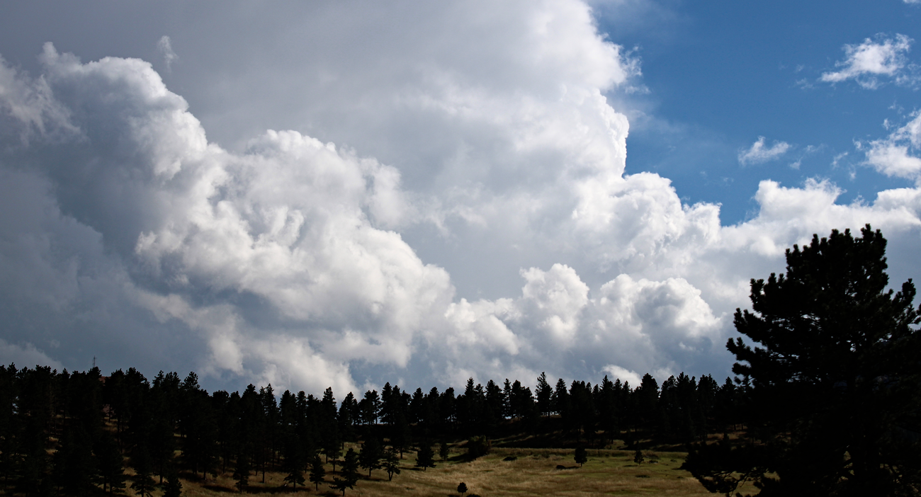
Figure 1. Final image submitted for Clouds First assignment

Background
This photograph was taken for the third visualization assignment of the Flow Visualization course: Clouds First. The image depicts several Cumulus Congestus merged, along with a long Cumulus Humilis cloud in the front. After hiking on some trails for an hour, I wanted to capture the storm moving over the NCAR Mesa Lab and this is the tail end of it. The Cumulus Humilis cloud on the front left looked oddly human, as if it were lying on its side, so I made sure to capture it.

Photo Orientation
This photo was shot out of a moving car, driving a quarter mile out of the NCAR Mesa Lab in Boulder, Colorado. It was taken August 27, 2025, at approximately 4:07pm MT. The camera was oriented southeast and slightly angled above the horizon.

Cloud Observations
Two cumulus cloud species can be seen in the photo: Cumulus Congestus and Cumulus Humilis. The storm developed, precipitated, and dissipated within the span of two hours, which is very characteristic of Boulder’s monsoon-like weather in late summer. The photo shows the end of the storm clearing up, evidenced by the blue skies towards the west. The clouds had passed over the tips of the Flatirons (just out of view in this photo), suggesting their bases are somewhere around 2,500 meters above sea level. According to NOAA, cumulus clouds can have bases around 2,000 meters above ground level, extending up to 6,000 meters high [1]. This aligns with the data in the following Skew-T diagram, taken from University of Wyoming [2].
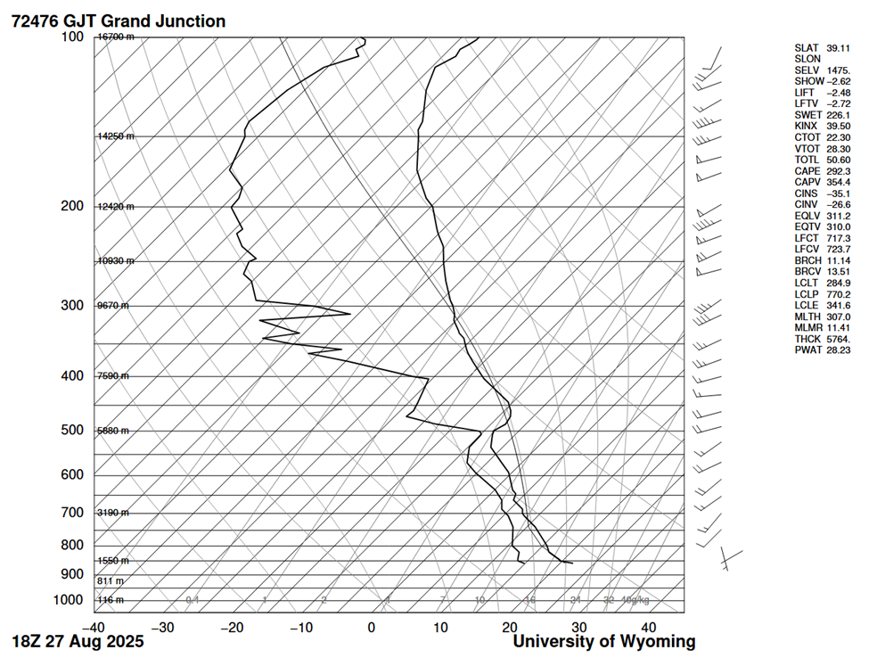
Figure 3. Skew-T plot for August 27, 2025, at 18:00 UTC (12pm MT)
Given the proximity of the dewpoint line to the measured temperature line, clouds were likely from 1,550 meters to 5,880 meters above sea level. Though there are altitude discrepancies and geological features (mountains) in comparing Boulder to Grand Junction, it makes sense for cumulus clouds to form 2,500 meters to 5,880 meters above sea level here in Boulder. There was a moderate amount of precipitation and low winds, suggesting a weak unstable atmosphere. The example temperature line appears the right of the balloon temperature line, suggesting an unstable atmosphere where rising air parcels will be warmer than the surroundings and continue rising upwards. The CAPE reads 292.3 for that day, further suggesting that the atmosphere was unstable, although relatively weak. No cumulus clouds grew into cumulonimbus, since no clouds were seen spreading across the tropopause, nor does the Skew-T support clouds reaching the tropopause (~13 kilometers). Cumulus clouds form as water vapor rises up into a warm region of air, called a thermal. These thermals rise and cool off, condensing some of their water vapor into visible droplets, making a small cumulus cloud. In condensation, the droplets release latent heat and warm up the surrounding air, sending thermals even higher and building the cumulus cloud into a cumulus congestus. The puffy shapes atop cumulus clouds are associated with this process, where thermals are rising rapidly in the cloud. Cumulus congestus will often rain their moisture down again, feeding thermals on the ground, and starting the cycle over [3].

Photographic Technique
Digital manipulations were used in the final product, the primary one being contrast equalization. Mid-range contrast was boosted to bring out highlights in the clouds and deepen the shadows. A slight amount of haze removal was used to make the blue sky come out. Finally, the image was cropped to focus on the cumulus humilis in the middle. I think the top portion of the original image did not have much to say as much as the combination of foreground and cumulus humilis. Not much thought had to be put into the camera specs as outside light was abundant and clouds filled the frame. The original image and camera specifications are listed below.
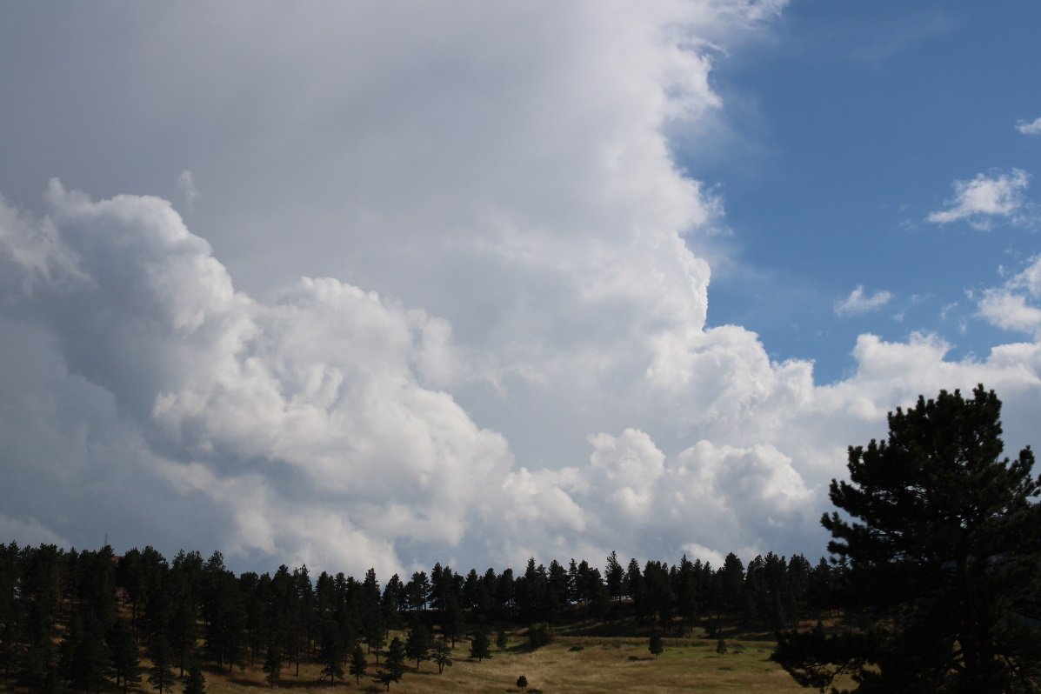
Figure 3. Original image

Table 1: Camera Specifications
Camera Make & Model | Canon EOS Rebel T7 1500D
Shutter Speed | 1/400
ISO | 100
Focal Length | 45 mm
Aperture | f/5.6
Original Image Size | 6000 x 4000 pixels
Final Image Size | 1300 x 702 pixels

Conclusion
The image reveals a group of cumulus clouds surging over the NCAR Mesa Lab. I like how I was able to capture the fluffy, white tops of the clouds and their rainy, dark bases. I think the foreground adds a good sense of scale and frames the composition. I dislike how much the trees were darkened because of the contrast equalization, so I am left wondering if another digital modifier could boost the greens in the trees. I believe my original intent to capture the human-shaped cumulus humilis was fulfilled. For the future, I want to capture more colors in the clouds. I think I can accomplish this by taking my camera out around sunset and going on more walks to see what happens.

References
[1] National Oceanic and Atmospheric Administration, “The Four Core Types of Clouds,” Mar
28 2023. Retrieved 17 October 2025.
[2] University of Wyoming, “Atmospheric Science Radiosonde Archive.” Retrieved 17 October
2025. https://weather.uwyo.edu/upperair/sounding.shtml
[3] Pretor-Pinney, G., “The Cloudspotter’s Guide: The Science, History, and Culture of Clouds,”
Penguin, 2006.

