Bubble Flow
  - Team First Assignment - MCEN 4151
  - October 26, 2025
  - Report By Hank Goodman
  - Team Members: Brian Terasaki and Juan Sanchez

Figure 1 - Final image of bubble with post-processing.

Context and Intent
The aim of this image was to beautifully showcase the form and reflective qualities of a soap bubble, illustrating how light dances on a thin liquid film to create stunning iridescent colors and delicate highlights. The goal was to highlight the surface tension that gives the bubble its smooth, organic curves while also delving into how light interference produces mesmerizing color variations. Although the original goal was to photograph a stable soap bubble, the selected image caught the bubble at the moment of rupture, effectively capturing both its stability and collapse in a single frame. Earlier iterations involved experimenting with different background colors and adding food coloring to the bubble solution, but in the end, this chosen photograph encapsulated the aesthetic beauty and physical intricacies of the flow.

Flow Apparatus and Physics
The image was captured in a study room at the ITLL using a green screen, which was later replaced with a black background for contrast. The materials used were distilled water, Dawn dish soap, glycerin, and gel food dye, mixed in a shallow baking tray. A rectangular bubble wand was constructed from yarn threaded through two plastic straws, forming a loop approximately 6 × 12 inches. The mixture used roughly 2 cups of distilled water, ¼ cup of dish soap, 1 tablespoon of glycerin, and 1 teaspoon of gel dye. One teammate dipped the wand into the solution and lifted it at various speeds, forming a soap film that rose and thinned before rupturing. For calculation purposes, velocity will be approximated at 1 m/s.
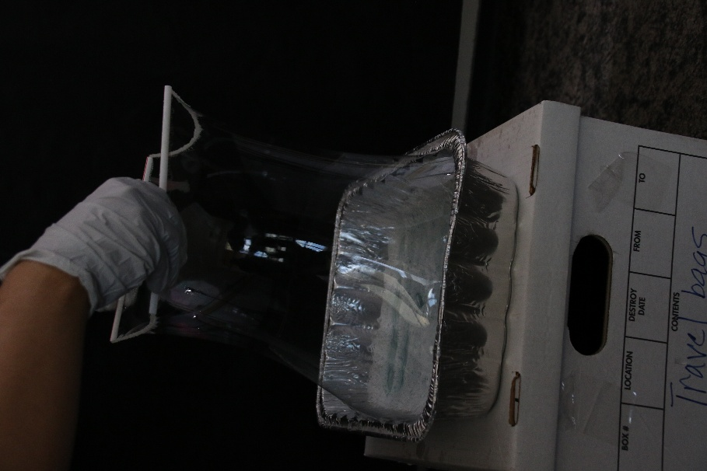
Figure 2 - Set up for creating soap films using a yarn-and-straw wand dipped in a soap-glycerin solution within an aluminum tray.
The characteristic length for this flow can be taken as the approximate film thickness (~0.5 mm) or wand width (~0.15 m). Using water’s kinematic viscosity at 20°C (1.0×10⁻⁶ m²/s) and a velocity of 1 m/s, the Reynolds number is roughly:
$$Re=\frac{UD}{ν}=\frac{(1.0)(0.15)}{1.0×{10}^{-6}}=1.5×{10}^{5}$$
indicating a flow dominated by inertial forces. Within the thin soap film, surface-tension gradients (Marangoni effects) create local thickness variations that produce visible color fringes from thin-film interference. As the film stretches and ruptures, capillary forces retract the liquid sheet at high speed, forming droplets and rim instabilities—the chaotic breakup visible in the image.

Visualization Technique
The visualization relied on the reflective and refractive properties of a soap film as the primary indicator of flow. The mixture of distilled water, dish soap, glycerin, and gel dye enhanced both color vibrancy and film stability; the glycerin extended the bubble’s lifetime by reducing evaporation. The initial trials used a green screen background, but the final shot returned to a black cloth to maximize contrast and reduce color contamination. The lighting setup consisted of two 23-watt, 6000 K LED bulbs, each diffused through a 33-inch translucent umbrella placed on either side between the bubble and the camera. No flash was used, but the ambient fluorescent room lighting and window light behind the screen contributed subtle highlights. The lights were intentionally angled to enhance surface reflections and emphasize the film's curvature.

Photographic Technique
The photograph was captured with a Canon EOS 7D Mark II using a Sigma 18–200 mm f/3.5–6.3 DC lens at a 28 mm focal length, f/6.3 aperture, 1/640 s shutter speed, and ISO 6400. The camera was positioned approximately 6 feet from the subject at a low angle on the floor, without a tripod, to achieve a more dramatic perspective and isolate the bubble against the dark background. The final frame measured 3670 × 5496 px and was cropped slightly to 3556 × 5469 px to refine the composition.
Post-processing was completed in Nik Collection Viveza 3, with the following global adjustments: brightness +40%, contrast +80%, saturation +20%, structure +25%, shadow –6%, warmth +5%, red –3%, green –5%, blue +5%, hue –5%. Selective tone adjustments included highlights at +15%, midtones at 0%, shadows at +5%, and blacks at –10%. These edits enhanced tonal range and midtone clarity while maintaining realistic color fidelity. The resulting image demonstrates a full contrast range with detailed highlights and shadows, sharp focus on the film surface, and time-resolved motion frozen by the high shutter speed. Minor noise reduction was applied to preserve texture in the dark background, ensuring a clean, artifact-free final image. The photograph meets all criteria for exposure balance, spatial and temporal resolution, and professional presentation.
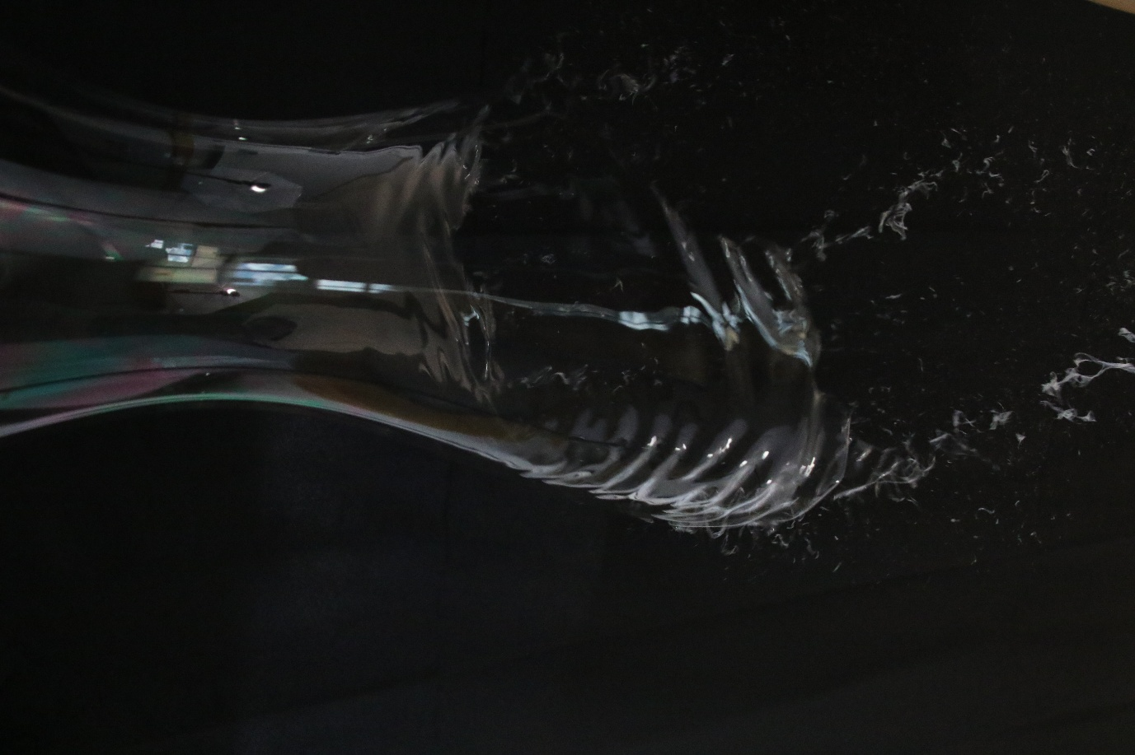
Figure 3 - Original photograph (jpg) before post-processing.

Interpretation and Reflection
This image reveals the interplay between surface tension and fluid instability during the rupture of a soap film. The captured frame illustrates both the cohesive nature of the bubble and its inherent fragility: the moment when surface tension forces can no longer balance the thinning liquid sheet. Artistically, the combination of bursting motion and retained structure gives the photograph a paradoxical sense of calm within chaos. The reflections on the bubble and the faint colors provide visual interest without overpowering the composition.
I particularly like how the image balances stillness and energy and how framing isolates the motion against a dark void. The main limitations are slight grain and a narrow depth of field, which softened parts of the flow. Including more of the bubble’s lower region could have provided a stronger spatial context. Overall, the intent was met: the photograph conveys the transient beauty and complexity of surface-tension-driven flow. Future explorations could include high-speed imaging or polarized lighting to further analyze the evolution of the interference pattern and the rupture dynamics.

References
Saulnier, Laurie & Champougny, Lorène & Bastien, Gaël & Restagno, Frédéric & Langevin, Dominique & Rio, Emmanuelle. (2014). A study of generation and rupture of soap films. Soft matter. 10. 2899-906. 10.1039/c3sm52433g. https://www.researchgate.net/publication/261104656_A_study_of_generation_and_rupture_of_soap_films
Lhuissier, H., & Villermaux, E. (2009). Soap Films Burst Like Flapping Flags. Physical Review Letters, 103(5), 054501. American Physical Society. https://journals.aps.org/prl/abstract/10.1103/PhysRevLett.103.054501?utm_source=chatgpt.com

